**Chapter 3** **Recording the Annual Budget**

The following budget for the General Fund of the City of Bingham was legally adopted for the fiscal year ending December 31, 2017.

**Very Important: Budget entries are input opposite from the normal balances. Therefore, estimated revenues will be debits.**

**Appropriations will be credits.**

**Estimated Revenues:**

Real Property Taxes $6,600,000

Sales Taxes 750,000

Interest and Penalties on Taxes 47,000

Licenses and Permits 480,000

Fines and Forfeits 510,000

Intergovernmental Revenue 525,000

Charges for Services 360,000

Miscellaneous Revenues    225,000

Total Estimated Revenues $9,497,000

**Appropriations:**

General Government $1,710,000

Public Safety 3,485,000

Public Works 1,735,000

Health and Welfare 965,000

Culture and Recreation 970,000

Miscellaneous 195,000

Total Appropriations $9,060,000

**Estimated Other Financing Uses:**

Interfund Transfers Out $ 50,000

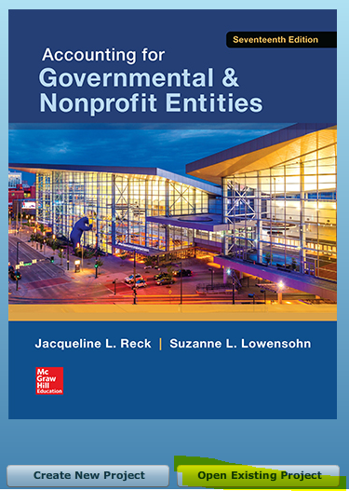

1. After opening the data file you created for Chapter 2 of this project, record the budget in the general journal, providing entries in the Detail Journal when directed. Begin by selecting **[General Fund]** in the **[Current Accounting Entity]** drop-down box and the **[Journal]** tab. In the **[Year]** box, be sure to select the year **2017**. Enter **Budget** in the **[Transaction Description]** box. Select “Estimated Revenues” in the drop down **[Account (# - Description)]** window.

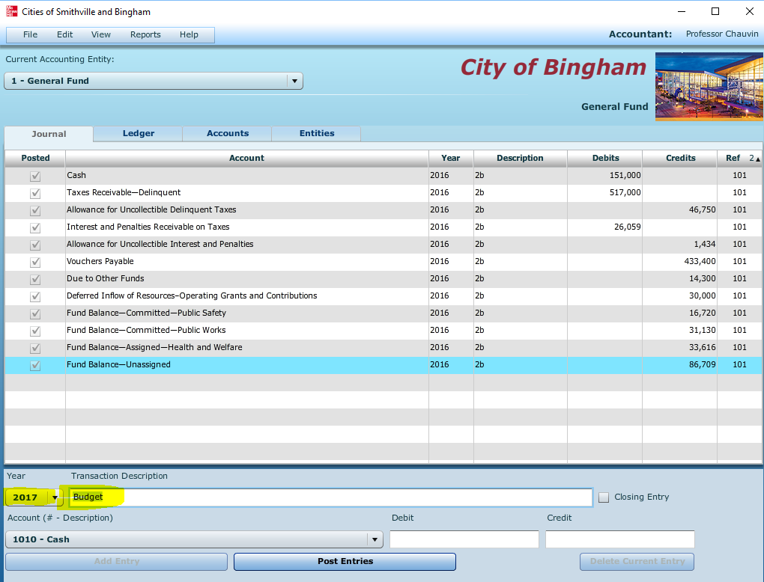

Input amounts for the first account—Estimated Revenues—ACCT 3010. Once you select this account, the program will take you automatically to the Detail Journal where you will enter the detail for each estimated revenue source. In the Detail Journal, select **“Budget Authorization**” from the drop-down menu for **[Transaction Description]**.

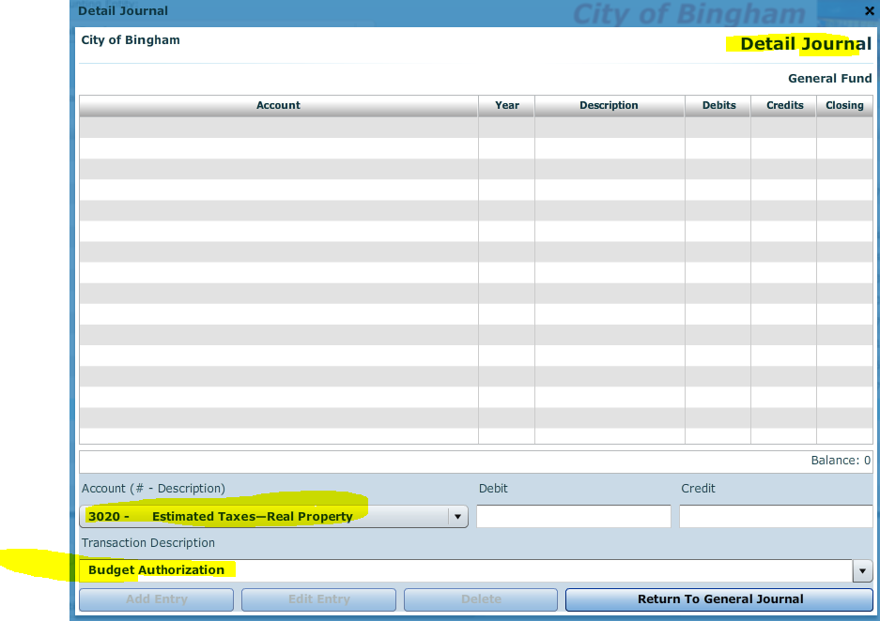

**Very Important: Budget entries are input opposite from the normal balances. Therefore, estimated revenues will be debits.**

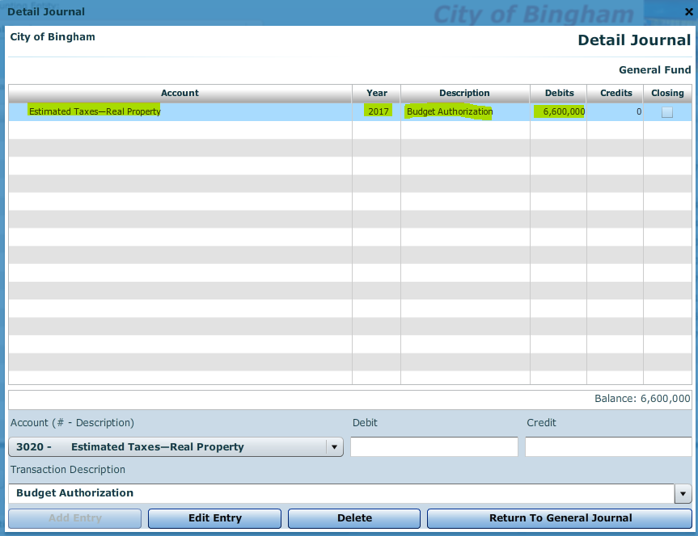

When you have finished entering the estimated revenue detail information, verify that the correct balance is shown in the Detail Journal, then click on **[Return to General Journal]** and the total estimated revenues will be entered in the general journal Estimated Revenues control account.

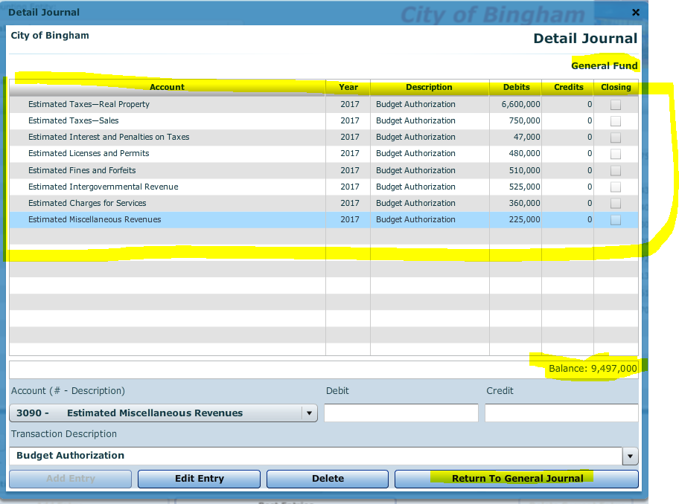

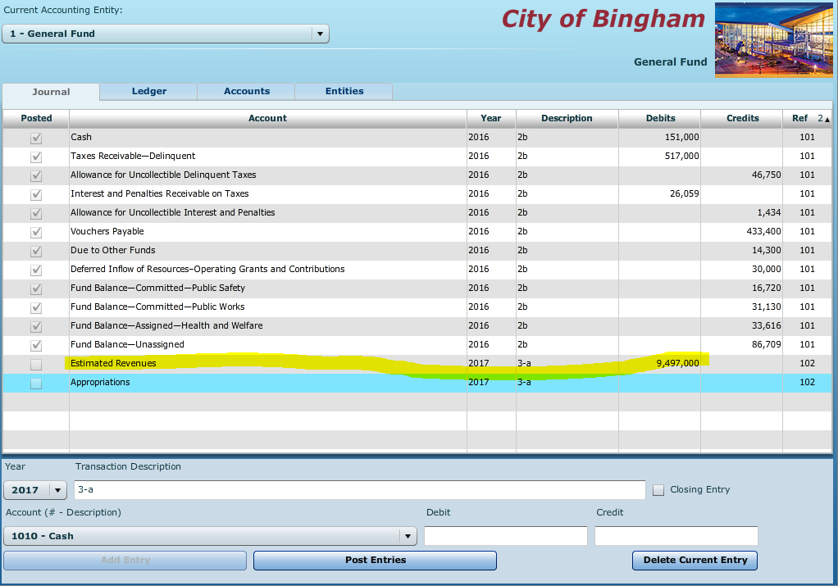

Follow the same procedure to record the budget detail for Appropriations --ACCT 5010

**Appropriations will be credits.**

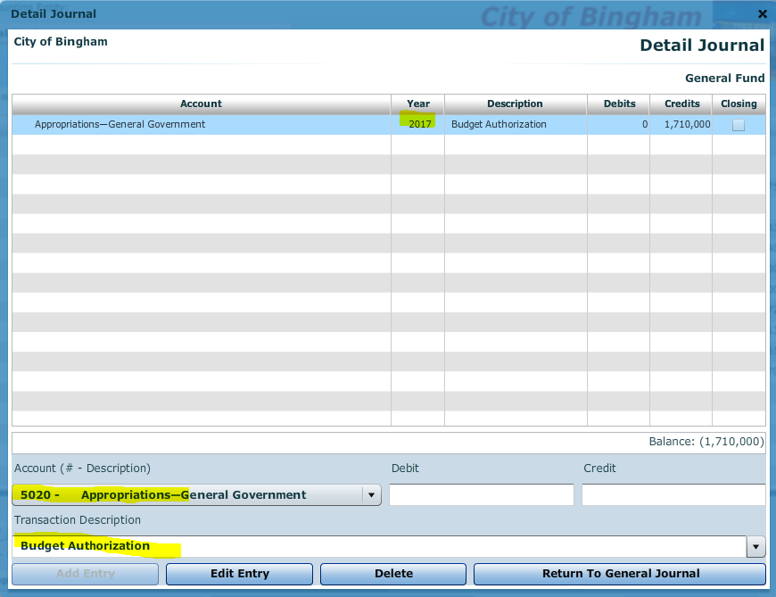

Once finished, return to the general ledger.

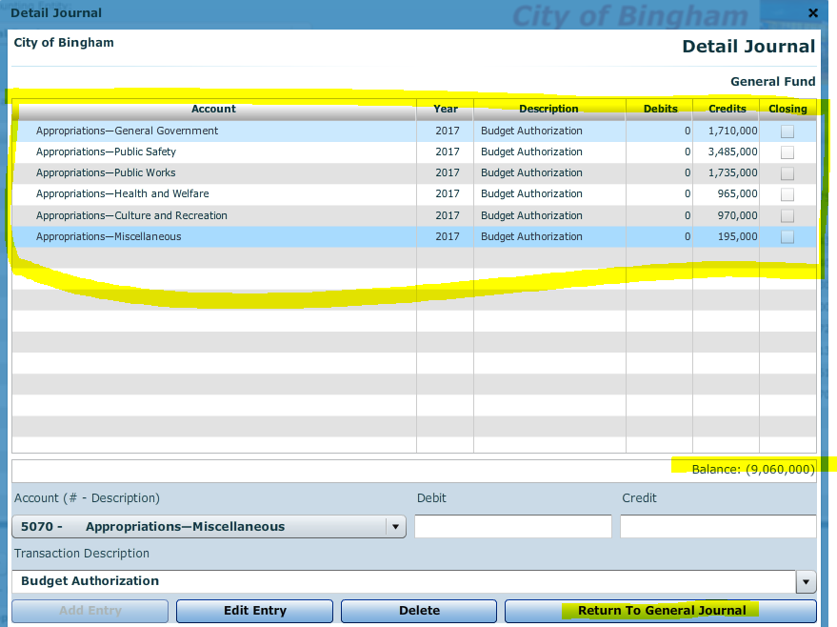

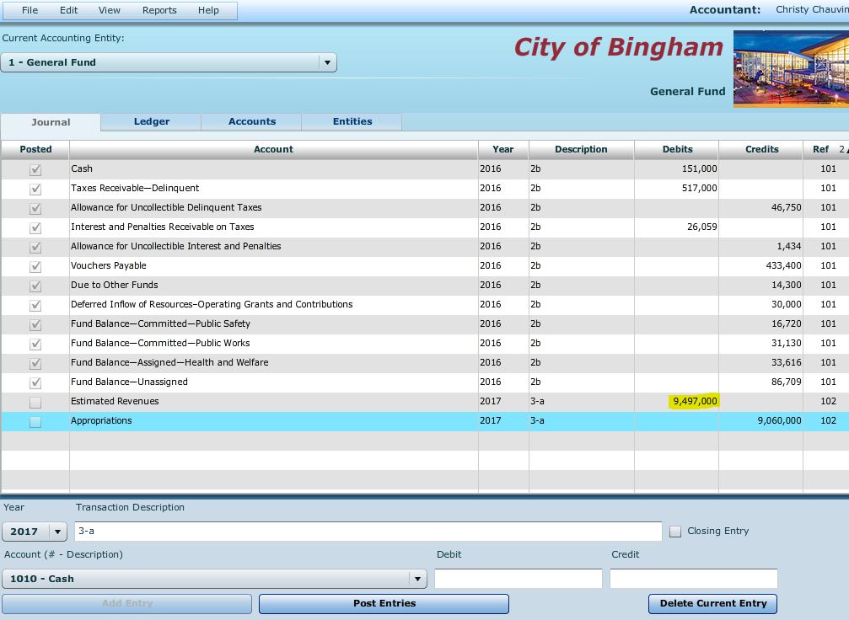

To complete the budgetary entry **credit** Estimated Other Financing Uses—Interfund Transfer Out—Acct 5160--and debit/credit Budgetary Fund Balance (Acct 2560) as appropriate to balance the budgetary entry. Determine fund balance by writing out the journal entry to determine debit or credit such as below.



**Note that budgetary entries have no effect on governmental activities at the government-wide level and thus the budget information is only recorded in the General Fund.**

When you are satisfied you have made the entries correctly, post them to the General Ledger by clicking on **[Post Entries]**.

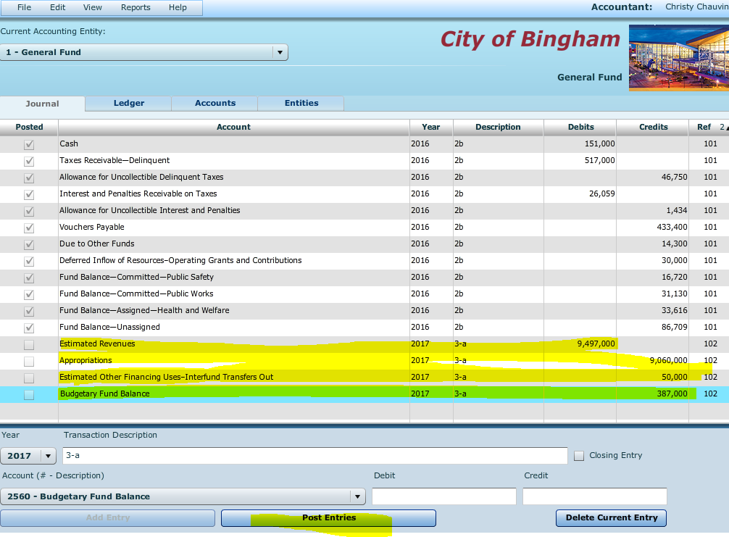

Before posting, or after unposting as described previously, you can edit your journal entries by placing the cursor in the line you want to edit, then right-clicking and selecting “Edit.” After unposting, any entry can be edited or deleted, and any omitted entry can be inserted above a highlighted entry. Note that the “Insert Entry” function will work if you are inserting an entry prior to a balance sheet account. However, it will not work when inserting an entry prior to any account that has an associated subsidiary ledger (e.g., estimated revenues, expenditures).

**Refer to list of documents to print out your work.**

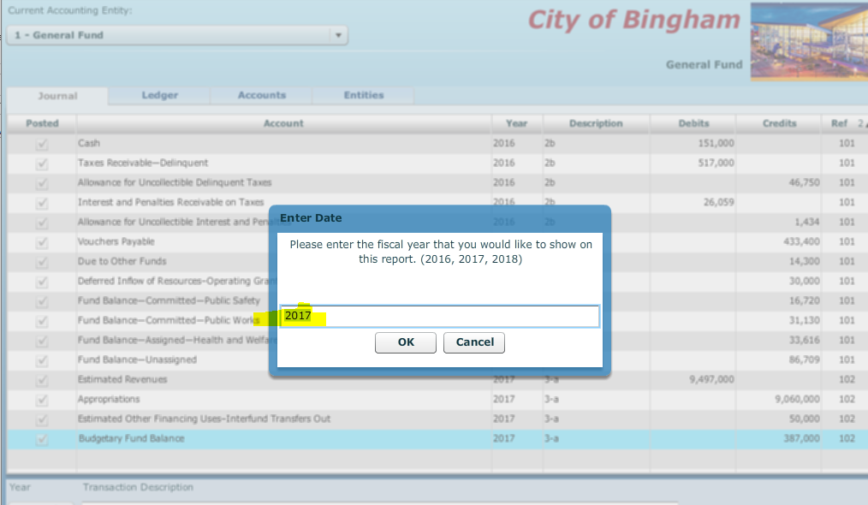

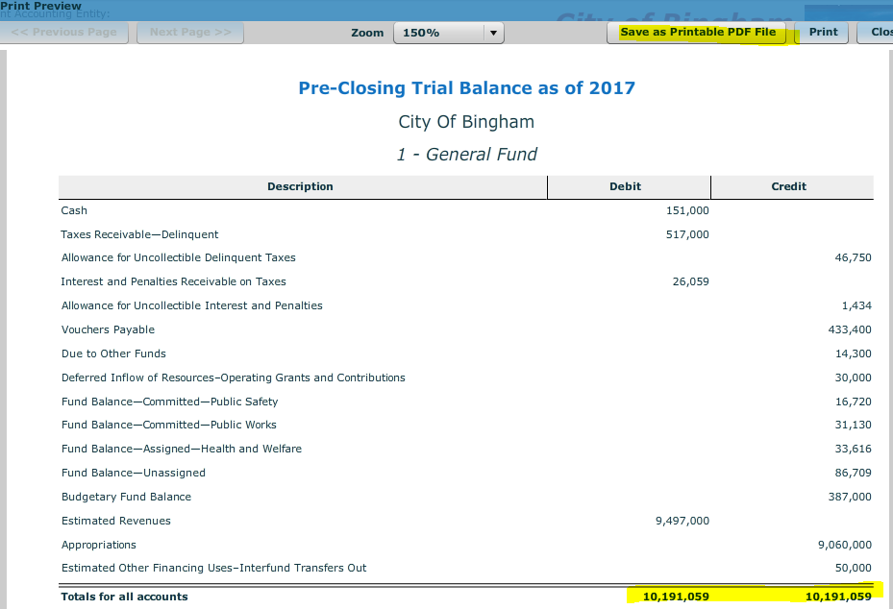

As of this time, only the budget has been recorded. **This is your last opportunity to print or export these documents with budget information only.** After operating transactions have been journalized and posted in Chapter 4, subsidiary ledgers and trial balances will contain both budgetary and operating accounts and balances.

**Before closing the *City of Bingham,* click on [File], and [Save/Save As] to save your work.** If you close the file by clicking on the [**X**] box you will be asked if you want to save your changes before closing.