**Chapter 4 Recording Operating Transactions Affecting the General Fund and Governmental Activities at the Government-wide Level** – Refer to Prof Chauvin’s Ch 4 Binghman instructions for additional help

Presented below are transactions for the City of Smithville that occurred during fiscal year 2017. Read **all** instructions carefully.

1. After opening the data file containing your data from Chapters 2 and 3 of this project, record the following transactions in the general journal for the General Fund and, if applicable, in the general journal for governmental activities at the government-wide level. For all entries, the date selected should be year **2017**. For each of the paragraphs that requires entries in both the General Fund and governmental activities journals, record them in both journals on a paragraph-by-paragraph basis. Refer to Ch4 instructions from Prof Chauvin for journal entry concepts.

For each entry affecting budgetary accounts or operating statement accounts, the Detail Journal will automatically open to allow you to record the appropriate amounts in the detail budgetary or actual accounts as was the case in Chapter 3.

**NOTE:** Use the para references as your transaction descriptions unless otherwise stated. Careful referencing by paragraph number is very helpful should you need to determine where you may have omitted a required journal entry or may have made an error. Remember the Detail Journals have different descriptions so pay attention to these unique descriptions.

1. **[Para. 4-a-1]** On January 2, 2017, **real property taxes** were levied for the year in the amount of $1,731,000. It was estimated that 3 percent of the levy would be uncollectible.

**Required**: Record this transaction in both the General Fund and governmental activities journal. In the Detail Journal for the General Fund enter “Accrued Revenue” in the **[Transaction Description]**

2. **[Para. 4-a-2]** Encumbrances were recorded in the following amounts for purchase orders issued against the appropriations indicated:

### General Government $ 98,453

### Public Safety 183,259

### Public Works 217,675

### Culture and Recreation 108,927

Total $608,314

**Required:** Record the encumbrances in the **General Fund** general journal and Detail Journal as appropriate. In the Detail Journal, describe as “Purchase Orders”

1. **[Para. 4-a-3]** Cash was received during the year in the total amount of $3,399,599 for collections from the following receivables and cash revenues, as indicated:

### Current Property Taxes $1,561,535

Delinquent Property Taxes 235,000

Interest and Penalties Receivable on Taxes 34,270

Due from State Government 165,000

Revenues: (total: $1,403,794)

Licenses and Permits 601,314

Fines and Forfeits 410,660

Intergovernmental 160,000

Charges for Services 231,820

Total $3,399,599

**Required:** Record the receipt of cash and the related credits to receivables and revenues accounts, as applicable, in both the General Fund and governmental activities journals. General Fund – Revenues - describe as “Cash Receipt” in the Detail Journal.

For purposes of the governmental activities entries at the government-wide level assume the following revenue classifications:

**Note:** Program Revenues—General Government—Charges for Services credits can be added together or recorded separately

General Fund   Governmental Activities

Licenses and Permits Program Revenues—General Government—

Charges for Services

Fines and Forfeits Program Revenues—General Government—

Charges for Services

Intergovernmental Program Revenues—Public Safety—Operating

Grants and Contributions

Charges for Services Program Revenues—General Government—

Charges for Services, $143,850

Program Revenues—Culture and Recreation—

Charges for Services, $87,970

1. **[Para. 4-a-4]** General Fund payroll(s) for the year totaled $2,638,220. Of that amount, $395,733 was withheld for employees' federal income taxes; $344,623 for federal payroll taxes; $98,933 for employees’ state income taxes; $194,545 for retirement funds administered by the state government; and the remaining $1,604,386 was paid to employees in cash. The City of Smithville does not record encumbrances for payrolls. The payrolls were chargeable against the following functions:

### General Government $ 518,022

### Public Safety 1,242,447

### Public Works 588,947

### Culture and Recreation 288,804

Total $2,638,220

**Required:** Make summary journal entries for payroll in both the General Fund and governmental activities general journals for the year.

1. **[Para. 4-a-5]** Invoices for *some* of the goods recorded as encumbrances in transaction 4-a-2 were received and vouchered for payment, as listed below. Related encumbrances were canceled in the amounts listed below. In Gen Fund Detail Journal, describe as “Elimination” for the encumbrances and “Vouchered for Payment” for expenditures.

**Required:** Record the receipt of these goods and the related vouchers payable in both the General Fund and governmental activities journals. At the government-wide level, you should assume the city uses the periodic inventory method. Thus, the invoiced amounts above should be recorded as expenses of the appropriate functions, except that $32,340 of the amount charged to the Public Works function was for a vehicle (debit Equipment for this item at the government-wide level).

Expenditures Encumbrances

General Government $ 94,776 $ 94,752 Public Safety 175,406 175,620

### Public Works 194,408 194,512

### Culture and Recreation 108,187 108,150

$572,777 $573,034

6**. [Para. 4-a-6]** During FY 2017, the City of Smithville received notification that the state government would send $115,000 at the beginning of the next fiscal year. Based on the city’s definition of “available for use,” the city considers the funds available for Public Safety’s use in the current reporting period. The budget for the current year included this amount as "Intergovernmental Revenue.”

**Required:** Record this transaction as a receivable and revenue in the General Fund and governmental activities journals. (Note: Describe as “Accrued Revenue” in the Detail Journal). At the government-wide level, assume that this item is an operating grant to the Public Safety function.



7. **[Para. 4-a-7]** Checks were written in the total amount of $1,721,571 during 2017. These checks were in payment of the following items:

Vouchers Payable $ 700,000

Due to Federal Government 731,506

Due to State Government 290,065

Total amount paid $1,721,571

**Required:** Record the payment of these items in both the General Fund and governmental activities general journals.

8. **[Para. 4-a-8]** Current taxes receivable uncollected at year-end, and the related Allowance for Uncollectible Current Taxes account, were both reclassified as delinquent.

**HINT:** Print out or produce a 2017 Pre-Closing Trial Balance for both funds at this juncture to see these amounts.

**Required:** Record this transaction in the General Fund and governmental activities journals.

9. **[Para. 4-a-9]** Interest and penalties receivable on delinquent taxes was increased by $11,000; $3,500 of this amount was estimated as uncollectible; thus, the remainder is considered revenue. In the General Fund, the $11,000 increase will be recorded as Interest and Penalties Receivable on Taxes.

**Required:** Record this transaction in the General Fund and Government Wide journals. In the Gen Fund Detail Journal, record in the appropriate account and describe as Int and Penalties on Delinquent Taxes.

10. **[Para. 4-a-10]** The city’s budget for 2017 was legally amended as follows:

**Required:** Record the budget amendments in the **General Fund General Journal** only. Budgetary items do not affect the government-wide accounting records.

**Estimated Revenues**:

Decreases Increases

Charges for Services $ 5,000

Total $ 5,000 $ 0

**Appropriations**:

Public Safety $ 11,000

Public Works $ 1,600

Culture and Recreation 37,500

$ 11,000 $ 39,100

Estimated Revenues: The charges for services will decrease by $5,000 so credit this account in the Detail Journal. Describe as “Budget Amendment.”

Appropriations: Describe as “Budget Amendment.”

The appropriations for Public Safety will decrease so debit this account for $11,000; Public Works increases, so credit this account for $1,600 and credit Culture and Recreation for $37,500. (Net effect will be $28,100)

The net effect of these amendment entries will decrease the balance of the Budgetary Fund Balance account by $33,100 so debit this account.

**Print out** 2017 Pre-Closing Trial Balances, Revenues Subsidiary Ledger and Appropriations Subsidiary Ledger for Gen Fund and before recording the closing entries and financial statements which are next. These documents will be helpful.

1. **Closing Entry – Make sure to select the entry as a closing entry.**

**HINT:** To prepare the closing entry for appropriations, estimated revenue, revenues and expenditures, use the revenue and appropriations/expenditures, etc. subsidiary ledgers which will provide details for the funds and types associated with each. You will need this detail for your entry into the detail ledger. These ledgers can be found in the reports menu. If you correctly named the type of transaction, it will be easy to figure out the amounts.

**Gen Fund – Closing the Budget**



**Appropriations:** Pay attention to the column entitled “Appropriations” to determine what amount should be closed to appropriations. (Appropriations are numbered in 5000’s). You will manually adjust some of the amounts due to budget amendments.

**Estimated Revenues:** Pay attention to the column entitled “Estimated Revenues” to determine appropriate closing amounts. (Appropriations are numbered in 3000’s). You will manually adjust some of the amounts due to budget amendments.

The difference between Appropriations and Estimated Revenues should be closed to Acct 2560 Budgetary Fund Balance.

**HINT:** To prepare the closing entry for appropriations, estimated revenue, revenues and expenditures, use the revenue and appropriations/expenditures, etc. subsidiary ledgers which will provide details for the funds and types associated with each. You will need this detail for your entry into the detail ledger. These ledgers can be found in the reports menu. If you correctly named the type of transaction, it will be easy to figure out the amounts.

**Gen Fund – Closing the Revenue and Expenditures**



**Revenues:** Pay attention to the column entitled “Revenues” to determine appropriate closing amounts. (Revenues are numbered in 4000’s). You will manually adjust some of the amounts.

**Expenditures:** Pay attention to the column entitled “Expenditures (Exp) Balance” to determine what amount should be closed to appropriations. (Expenditures are numbered in 6000’s).

The difference between Appropriations and Estimated Revenues should be closed to Acct 2550 Fund Balance - Unassigned.

**Gen Fund – Closing and reclassifying fund balances**

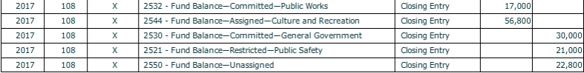

At year-end, an analysis by the city’s finance department determined the following constraints on fund balances in the General Fund. Prepare the appropriate closing/reclassification journal entry in the General Fund to reclassify amounts between Fund Balance—Unassigned and the fund balance accounts corresponding to the constraints shown below.

**HINT:** Use the Pre-Closing Trial Balance to help you. (Be careful to distinguish between committed, restricted and assigned.) You should consider the beginning of year balances in fund balance accounts in calculating the amounts to be reclassified. The difference between these debits and credits will go to 2550 – Fund Balance – Unassigned.

Account Ending Balance Should Be:

Fund Balance—Committed—General Government $30,000

Fund Balance—Restricted—Public Safety 36,000

Fund Balance—Committed—Public Works 12,700

Fund Balance—Assigned—Culture and Recreation 0

Note: **DO NOT PREPARE CLOSING ENTRIES FOR GOVERNMENTAL ACTIVITIES AT THIS TIME**. The governmental activities will not be closed until Chapter 9, after the capital projects fund (Chapter 5) and debt service fund (Chapter 6) transactions affecting governmental activities at the government-wide level have been recorded.

1. Select [**Export**] from the drop down **[File]** menu to create an Excel worksheet of the **General Fund post-closing trial balance as of December 31, 2017.** **Or** use Excel to prepare in good form a balance sheet for the General Fund as of December 31, 2017.

See the Bingham prototype below.

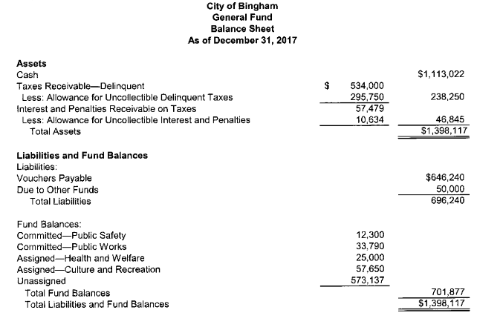

1. Select [**Export**] from the drop down **[File]** menu to create an Excel worksheet of the **General Fund pre-closing subsidiary ledger account balances for the year 2017.** **Or** use Excel to prepare in good form a statement of revenues, expenditures, and changes in fund balance for the General Fund for the year ended December 31, 2017.

See the Bingham prototype below.

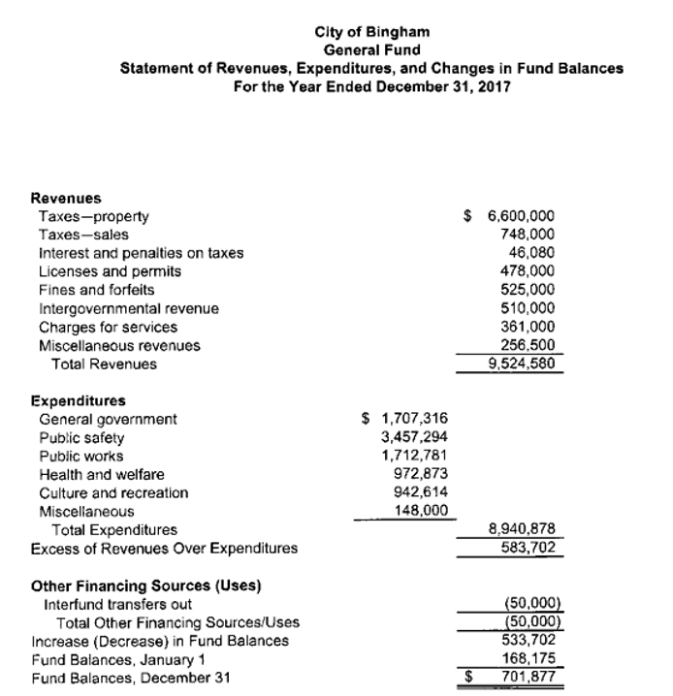

**Refer to the document listing for all reports required to be turned in for grading.**

**Before closing the *City of Smithville,* click on [File], and [Save/Save As] to save your work.** If you close the file by clicking on the [**X**] box you will be asked if you want to save your changes before closing. I suggest saving each chapter as a version of the project so you can go back to an original version if needed for corrections and re-submissions.