**Ch 3 Governmental Operating Statement Accounts; Budgetary Accounting**

**Government-Wide Financial Statements**

**Accounting Basis: Accrual**

**Financial Statements: Statement of Net Position and Statement of Activities (its Operating Statement)**

**Accountability Focus: Operational Accountability**

**Budget: Not formally integrated**

The central focus is the core government of the entity and present financial information for governmental activities and business-type activities. Operational accountability is key with a long-term view of operating efficiently and effectively.

**Government-Wide Statement of Activities – Revenues and Expenses**

The statement of activities is the city's operating statement reporting expenses classified by program or function and revenues derived directly from the programs or functions. Revenues derived directly from programs or functions can be user charges or resources received directly from external sources, such as grants and contributions. The format helps to determine if the function or program is self-sufficient.

The resulting net expense (i.e., program expense minus program revenue) of each program or function is reported in separate columns for governmental activities and business-type activities.

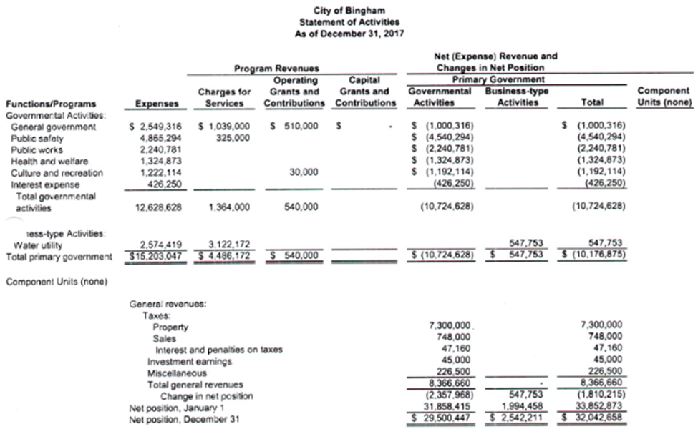

The format of this statement requires the government to distinguish between program revenues (reported at the top of the statement) and general revenues (reported at the bottom of the statement). When compared to specific expenses, the distinction allows financial statement users to evaluate whether specific functions or programs are self-sufficient or require general revenues to cover net costs.

**Program Revenues and General Revenues**

Program revenues reduce net expenses of the associated function/program. General revenues are not associated with any particular function or program.

**Program Revenues**

There are three (3) categories for program revenues

**Charges for Services**

From Citizens - Fees from licenses and permits such as business licenses and building permits, fines, assessments such as snow removal.

From Other Governmental entities – Charges for prisoner incarceration

**Operating Grants and Contributions**

If the function or program is operating under a grant or contribution, these revenues have been set aside to help the program operate

If the function or program is operating under a restricted endowment or permanent funds, earnings are categorized here (If the endowment or permanent fund is unrestricted, the earnings are reported in general revenue).

**Capital Grants and Contributions**

If the function or program is operating under a grant or contribution, these revenues have been set aside for capital purposes

**General revenues**

**All Taxes**

**Interfund Transfers**

**Special and Extraordinary Items**

**Special items** are reported below general revenue and capture items that are nonrecurring such as sales of assets. They are distinguished in this fashion to allow readers to see if the entity is balancing the budget by selling assets or another practice. Special items occur at the discretion of the decision makers.

**Extraordinary items** are unusual in nature and infrequent in occurrence.

**Significant items**, which are beyond management’s control, such as a riot or weather event are reported as normal expenses and disclosed in the financial statement notes.

**Fund Statements - Governmental Funds**

**Accounting Basis: Modified Accrual – No long-term assets or liabilities; Expenditures not expenses**

**Financial Statements: Balance Sheet and Statement of Revenue, Expenditures, and Changes in Fund Balance (its Operating Statement)**

**Accountability Focus: Fiscal Accountability**

**Budget: Formally integrated**

**General Fund**

All revenues and expenditures related to the core of the government. Everything belongs here if not segregated into one of the other governmental funds.

**Other Governmental Funds**

Governments engage in many activities financed by sources other than those available to the General Fund as result of legal or historical purposes.

**Special Revenue Fund** - Whenever a revenue source is restricted by an outside donor/grantor or a tax is authorized by a legislative body for a specified purpose, a government should create a special revenue fund to demonstrate that all revenue was used for the specified purpose only. Example: operation of a library or maintenance of roads, bridges, counseling youthful offenders

**Debt Service Fund** – Governmental bonds may be required by law or bond covenants to segregate funds to pay principal and interest.

**Capital Projects Fund** – Segregation of revenues or bond proceeds to purchase or construct buildings, highways, bridges, parks, etc.

**Permanent Fund** – Segregation of donor permanent endowments when the donor stipulates preservation of the donation in an investment but earnings are used for public purposes. Purpose is to benefit all citizens.

**Balance Sheet**

Only current assets and liabilities are reported. Only those liabilities to be paid with fund assets reported.

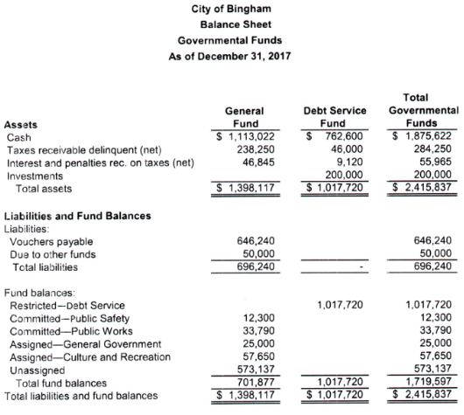

**Fund balance are classified as restricted, committed, assigned or unassigned.**

Restricted Fund Balance - Fund balance amounts that are restricted to specific purposes. Fund balance should be reported as restricted when constraints placed on the use of resources are either externally imposed by creditors (such as through debt covenants), grantors, contributors, or laws or regulations of other governments or imposed by law through constitutional provisions or enabling legislation.

Committed Fund Balance - Fund balance amounts that can only be used for specific purposes pursuant to constraints imposed by formal action of the government's highest level of decision-making authority should be reported as committed fund balance. Those committed amounts cannot be used for any other purpose unless the government removes or changes the specified use by taking the same type of action (e.g., legislation, resolution, ordinance) it employed to previously commit those amounts.

Assigned Fund Balance - Fund balance amounts that are constrained by the government's intent to be used for specific purposes but are neither restricted nor committed. Intent should be expressed by (1) the governing body itself or (2) a body (e.g., a budget or finance committee) or official to which the governing body has delegated the authority to assign amounts to be used for specific purposes.

Unassigned Fund Balance - The residual classification for the general fund that represents fund balance that has not been assigned to other funds and that has not been restricted, committed, or assigned to specific purposes within the general fund. The general fund should be the only fund that reports a positive unassigned fund balance amount.

**Statement of Revenue, Expenditures, and Changes in Fund Balance**

Revenues primarily are taxes as well as licenses and permits; they do not include interfund transfers and debt issue proceeds which are classified in Other Financing Sources. The term “Expenditures” is used in modified accrual basis and represents the cost to purchase a good or service.

Purchase of a long-term asset is not recorded here as an expenditure but is recorded in the government-wide governmental activities Statement of Net Position. No depreciation is recorded related to the asset in the Governmental Funds Statement of Revenues, Expenditures and Changes in Fund Balance.

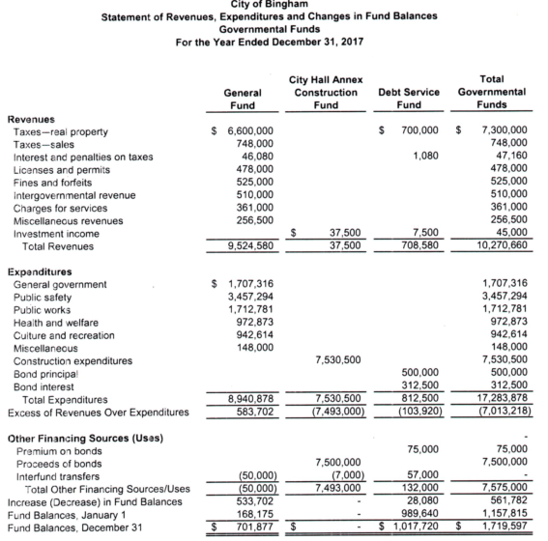

Other Financing Sources (Uses) are segregated from revenues and expenditures to provide additional information to readers.

**Budget**

The Budget is formally integrated into the Governmental Funds financial statements.

Since governments are responsible for public funds that often carry restrictions on their use, budgeting and financial management are among the most important aspects of a local government's operations. The budgeting process within a government is quite extensive and begins with budget projections at the program or departmental level, integration of budget projections by the budget office, public hearings, and final approval by the government's administrative body. The budget process is described within a government's notes to the financial statements.

The fact that budgets are legally binding upon administrators has led to the integration of budgetary accounts into the general ledgers of the General Fund and special revenue funds, and any other funds that are required by state laws to adopt a budget. GASB standards require that a budget to actual comparison schedule be provided for the General Fund and for each *major* special revenue fund for which a budget is legally adopted. The budget to actual comparison may be presented as a formal statement or as supplementary information.

Government budgets may be described as legally approved plans of financial operations embodying the authorization of expenditures for specified purposes and the proposed means of financing them.

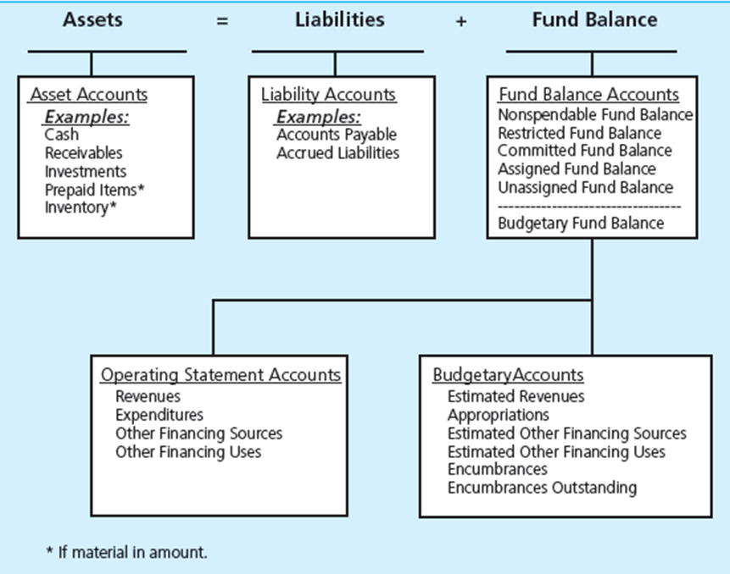

Each operating statement account has a complementary budgetary account.

**Revenues and Estimated Revenues**

Revenue forecasts help administrators to determine that proposed expenditures presented in the operating budget can be financed by resources available. *Revenue,* in the governmental budgeting sense, usually includes all financial resource inflows—all amounts that increase the fund balance of a fund. Examples include interfund transfers and debt issue proceeds, as well as taxes, licenses and permit fees, fines, etc. Governments sometimes budget a portion of the beginning of year fund balance to finance proposed expenditures, particularly if the fund balance exceeds the government's established minimum fund balance policy.

Governments and its funds may raise revenues only from sources available to them by law. Often, the law that authorizes a government to utilize a given revenue source to finance general governmental activities, or specific activities, also establishes the maximum rate that may be applied to a specified base in utilizing the source or establishes the maximum amount that may be raised from the source during the budget period.

**Revenue Sources for Budgeting**

* Taxes
  + Largest revenue source
  + Recorded when collections are expected. 60 days is the norm
  + Includes sales tax, income tax, death taxes as well as interest and penalties on overdue taxes
  + Includes property taxes for local govt based on property assessments on taxable properties
* Charges for Services
  + Special police services, court costs, parking meter receipts, library fees
* Licenses and permits
  + Building permits, vehicle licenses, amusement licenses, animal licenses, street permits
* Special Assessments
  + Related to citizen properties associated with specific improvements in a geographic area
* Fines and Forfeits
  + Levied for committing a statutory offense, including library fines
* Intergovernmental Revenues
  + Shared taxes with other govts
  + Grants from other govts
* Miscellaneous Revenues
  + Used sparingly for small and infrequent rev amounts.

The budget should include all expected revenue. The general fund will include all of these.

**Expenditures and Appropriations**

An appropriation is a legal authorization to expend cash or other financial resources for goods, services, and facilities to be used for specified purposes, in amounts not to exceed those authorized. When liabilities authorized by an appropriation have been incurred, the appropriation is said to be *expended.* Budgeted appropriations are sometimes called *estimated expenditures.*

Expenditures, then, are expended appropriations. According to GASB standards, expenditures should be primarily classified by fund—the basic fiscal and accounting entity of a government. Within each fund, expenditures are classified by

* Function or program
  + Function
    - Gen Govt, Health/Welfare, Public Safety, Highways/Streets, Culture/Recreation
  + Program
    - Corrections, Courts, Election, Transportation, Environment
* Organization unit or Department
  + Police, Fire, City Attorney, City Clerk, Building Safety, Personnel, Public Works

The key distinction between classifications of expenditures by program/function or organization unit is that responsibility for a dept is fixed, whereas a number of depts may be involved in the performance of a program/function. Both management control and rational allocation of resources require much more specific identification of expenditures than is provided by the major classifications.

* Activity
  + An **activity** is a specific and distinguishable line of work performed by an organization unit. Meaningful information is gathered if there is fixed performance responsibilities and standards to measure resources assigned in relation to service performed
    - Solid waste collection—residential
    - Solid waste collection—commercial
    - Solid waste disposal—landfill
    - Solid waste disposal—incineration
* Character
  + This refers to the fiscal period that benefits from the expenditure
    - Current
    - Capital outlays – current and future
    - Debt Service
      * Both principal and interest
      * Benefits past, current and future
      * Came from prior administrations
* Object
  + Subdivision of Character – Purpose of the expenditure (types of expenditures)

A common terminology and classification should be used consistently throughout the budget, the accounts, and the financial reports of each fund.

**Estimated Other Financing Sources and Estimated Other Financing Uses**

Budgeted amounts for interfund transfers and debt proceeds are recorded in these accounts.

**Encumbrances**

Accounts used to record the estimated amount of purchase orders, contracts, or salary commitments chargeable to an appropriation. The account is credited when goods or services are received and the actual expenditure is known.

**Encumbrances Outstanding**

A budgetary account that allows for double entry bookkeeping for originating encumbrances when purchase orders are placed and for reversing encumbrances when goods or services are received or purchase orders are canceled.

**Budget Comparison for General Fund Statement of Revenue, Expenditures and Changes in Fund Balances (its Operating Statement)**

Individual fund budgetary comparisons are required to be presented at the legal level of budgetary control, which represents the administrative level (e.g., fund, program, organization unit) at which expenditures may not exceed appropriations without a formal budgetary amendment. Meaningful budgetary comparisons also require that the actual amounts in the schedule be reported using the government's budgetary basis.

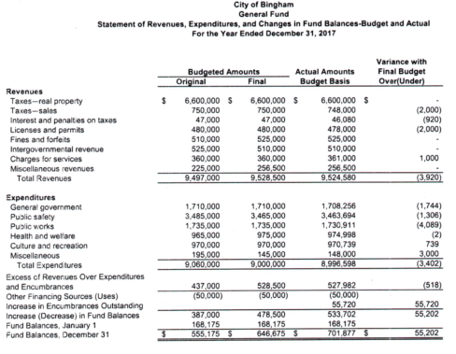

Some governments, for example, budget their revenues on the cash basis. If the Actual column of the budgetary comparison schedule (or statement) uses a non-GAAP budgetary basis, such as the cash basis, either the schedule captions or column heading for actual amounts should so indicate.

Reminder:

An expense represents the use, or expiration, of a resource or asset. An expenditure is the use of current financial resources or a decrease in fund financial resources other than transfers and other financing uses. Expenses are associated with the accrual basis of accounting, while expenditures are associated with the modified accrual basis of accounting.

**Normal Balances for Operating Statement Accounts and Budgetary Accounts**

The normal balances for the budgetary accounts are contra to the normal balances for the operating statement accounts. For example, revenues are credit based and estimated revenues are debit based and expenditures are debit based and appropriations are credit based.

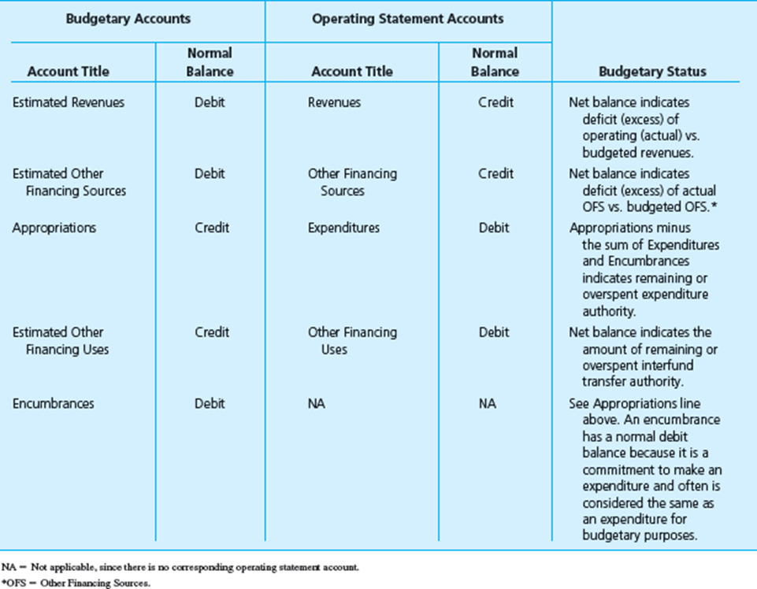

**Recording the Budget - Journal Entries**

Govts will record the total estimated revenues in the General Fund general ledger **control account**, and the amounts expected from each revenue source specified in the budget should be recorded in subsidiary ledger account. (Subsidiary ledgers augment the control account in the general ledger with more detail based upon revenue source. Comparison would be to accounts receivable having one total in the general ledger but the subsidiary ledger would have account balance for each customer).

**Budgeted Revenue:** The **budgeting** process yields the following sources of revenue. The corresponding journal entries are:



**Actual Revenues:** When money is received for licenses and permits. (Non-budgetary entry)



**Comparison of actual to budget**

Throughout the year, the actual revenues received are compared to the estimated budgeted revenues to determine if the govt is on track or needs to investigate.



**Appropriations, etc:** The **budgeting** process yields the following appropriations and other financing uses. Appropriations and other financing uses would be recorded in the general ledger control account. The amounts appropriated for each function are recorded in the function’s subsidiary ledger.

**Budgeted Appropriations, etc.**



**Appropriations and Encumbrances:**

As part of the budgeting process, a budget of estimated revenues and appropriations is prepared pursuant to the legal requirement to ensure the political subdivision does not incur a deficit.

Appropriation (Part of the Budgetary Process) – an amount of money set aside from the budget to pay for certain budgetary line items. At the beginning of the year you estimate how much money you will spend on general categories and that money is taken out of the money that is available to spend. This segregates these monies and indicates these monies are not available to be spent except for appropriated items.

An appropriation is considered *expended* when the authorized liabilities have been incurred. Penalties are imposed by law on an administrator who expends more than appropriated or who makes expenditures for any purpose not covered by an appropriation or after the authority to do so has expired. Each purchase order and each contract should be reviewed to determine that a valid and sufficient appropriation exists to which the expenditure can be charged.

Encumbrances (Not part of the budgetary process but product of the purchase order process) – an encumbrance is a reservation for a specific item of an appropriation. Most expenditures are required to be encumbered before a legal obligation is made to pay for the item. For example, if the township plans to buy a new road truck, before the item is ordered an encumbrance is taken from the equipment line item which reduces the available appropriation so that you know that this portion of the appropriated money is no longer available. Generally, encumbrances are carried from one year to the next, though they can be canceled at year end and reissued in the subsequent year.

When a purchase order or contract has been issued, it is important to record the fact that the appropriation has been *encumbered* in the amount of the purchase order or contract. The word *encumbered* is used, rather than the word *expended* because the amount is only an estimate of the liability that will be incurred when the purchase order is filled or the contract executed. (It should be noted encumbrances are not normally used for payroll.)

Note that the issuance of purchase orders and/or contracts has two effects:

(1) The encumbrance of the appropriation(s) that gave the government the authority to order goods or services and

(2) the starting of a chain of events that will result in the government expending resources when the purchase orders are filled and the contracts executed.

Both effects should be recorded in order to help administrators avoid over-expending appropriations and plan for payment of liabilities on a timely basis.

Encumbrances/Expenditures are recorded in the following order. (Example of a purchase order for related to general government and public safety)

1. **Encumbrances** – Estimated at $45,400 for **several** encumbrances



Encumbrances are based on **estimated** amounts.

1. **Reversal of original encumbrance estimate and recording actual purchase order**. Encumbrance entry reversed for **estimated** amounts – Original estimate for this encumbrance was $42,000
2. **Reversal of original encumbrance estimate**



Note: The remaining balance in Encumbrances and Encumbrances Outstanding will reflect the remaining encumbrances. ($45,400 minus $42,000 or $3,400) Balances for Encumbrances Outstanding will be covered later.

1. **Recording actual purchase order** as an expenditure – Based on actual amount $42,400



1. **Payment of invoice or Disbursement**

Vouchers Payable 42,400

Cash 42,400

