Segmented Income Statements and the Contribution Approach

Prepare a segmented income statement that differentiates traceable fixed costs from common fixed costs and use it to make decisions.
These segmented income statements are useful for analyzing the profitability of segments, making decisions, and measuring the performance of segment managers. Most companies are managed at the segment level and then aggregated to the total.
Traceable and Common Fixed Costs and the Segment Margin
Three new terms are needed to prepare segmented income statements using the contribution approach—traceable fixed cost, common fixed cost, and segment margin.
A traceable fixed cost (direct cost) of a segment is a fixed cost that is incurred because of the existence of the segment—if the segment had never existed, the fixed cost would not have been incurred; and if the segment were eliminated, the fixed cost would disappear.
- The salary of the Fritos product manager at PepsiCo is a traceable fixed cost of the Fritos business segment of PepsiCo.
- The maintenance cost for the building in which Boeing 747s are assembled is a traceable fixed cost of the 747 business segment of Boeing.
- The liability insurance at Disney World is a traceable fixed cost of the Disney World business segment of The Walt Disney Corporation.
A common fixed cost (indirect cost) is a fixed cost that supports the operations of more than one segment, but is not traceable in whole or in part to any one segment. Even if a segment were entirely eliminated, there would be no change in a true common fixed cost. For example:
- The salary of the CEO of General Motors is a common fixed cost of the various divisions of General Motors.
- The cost of heating a Safeway or Kroger grocery store is a common fixed cost of the store’s various departments—groceries, produce, bakery, meat, and so forth.
- The cost of the receptionist’s salary at an office shared by a number of doctors is a common fixed cost of the doctors. The cost is traceable to the office, but not to individual doctors.

To prepare a segmented income statement, variable expenses are deducted from sales to yield the contribution margin for the segment. The segment margin is obtained by deducting the traceable fixed costs of a segment from the segment’s contribution margin.
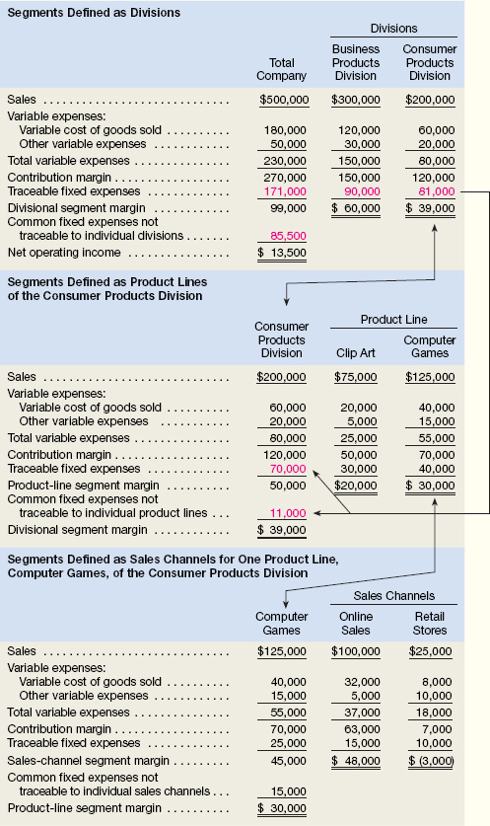

The segment margin represents the margin available after a segment has covered all of its own costs. The segment margin is the best gauge of the long-run profitability of a segment because it includes only those costs that are caused by the segment. If a segment can’t cover its own costs, then that segment probably should be dropped (unless it has important side effects on other segments). Notice, common fixed costs are not allocated to segments.
From a decision-making point of view, the segment margin is most useful in major decisions that affect capacity such as dropping a segment. By contrast, the contribution margin is most useful in decisions involving short-run changes in volume, such as pricing special orders that involve temporary use of existing capacity.

Identifying Traceable Fixed Costs
The distinction between traceable and common fixed costs is crucial in segment reporting because traceable fixed costs are charged to segments and common fixed costs are not. In an actual situation, it is sometimes hard to determine whether a cost should be classified as traceable or common.
The general guideline is to treat as traceable costs only those costs that would disappear over time if the segment itself disappeared.
For example, if one division within a company were sold or discontinued, it would no longer be necessary to pay that division manager’s salary. Therefore the division manager’s salary would be classified as a traceable fixed cost of the division. On the other hand, the president of the company undoubtedly would continue to be paid even if one of many divisions was dropped.
When assigning costs to segments, the key point is to resist the temptation to allocate costs (such as depreciation of corporate facilities) that are clearly common and that will continue regardless of whether the segment exists or not. Any allocation of common costs to segments reduces the value of the segment margin as a measure of long-run segment profitability and segment performance.
Traceable Costs Can Become Common Costs
Fixed costs that are traceable to one segment may be a common cost of another segment. For example, United Airlines might want a segmented income statement that shows the segment margin for a particular flight from Chicago to Paris further broken down into first-class, business-class, and economy-class segment margins. The airline must pay a substantial landing fee at Charles DeGaulle airport in Paris. This fixed landing fee is a traceable cost of the flight, but it is a common cost of the first-class, business-class, and economy-class segments. Even if the first-class cabin is empty, the entire landing fee must be paid. So the landing fee is not a traceable cost of the first-class cabin. But on the other hand, paying the fee is necessary in order to have any first-class, business-class, or economy-class passengers. So the landing fee is a common cost of these three classes.

Segmented Income Statements—Decision Making and Break-Even Analysis
Once a company prepares contribution format segmented income statements, it can use those statements to make decisions and perform break-even analysis.
Decision Making
Online Sales segment has a segment margin of $48,000 and the Retail Stores segment has a segment margin of $(3,000). Let’s assume that ProphetMax wants to know the profit impact of discontinuing the sale of computer games through its Retail Stores sales channel. The company believes that online sales of its computer games will increase 10% if it discontinues the Retail Stores sales channel. It also believes that the Business Products Division and Clip Art product line will be unaffected by this decision. How would you compute the profit impact of this decision?
The first step is to calculate the profit impact of the Retail Stores sales channel disappearing. If this sales channel disappears, we assume its sales, variable expenses, and traceable fixed expenses would all disappear. The quickest way to summarize these financial impacts is to focus on the Retail Stores’ segment margin. In other words, if the Retail Stores sales channel disappears, then its negative segment margin of $3,000 would also disappear. This would increase ProphetMax’s net operating income by $3,000.
The second step is to calculate the profit impact of increasing online sales of computer games by 10%. To perform this calculation, we assume that the Online Sales total traceable fixed expenses ($15,000) remain constant and its contribution margin ratio remains constant at 63% (= $63,000 ÷ $100,000). If online sales increase $10,000 (= $100,000 × 10%), then the Online Sales segment’s contribution margin will increase by $6,300 (= $10,000 × 63%). The overall profit impact of discontinuing the Retail Stores sales channel can be summarized as follows:
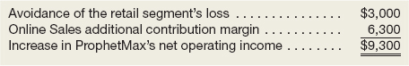

Break-Even Analysis
Compute companywide and segment break-even points for a company with traceable fixed costs.
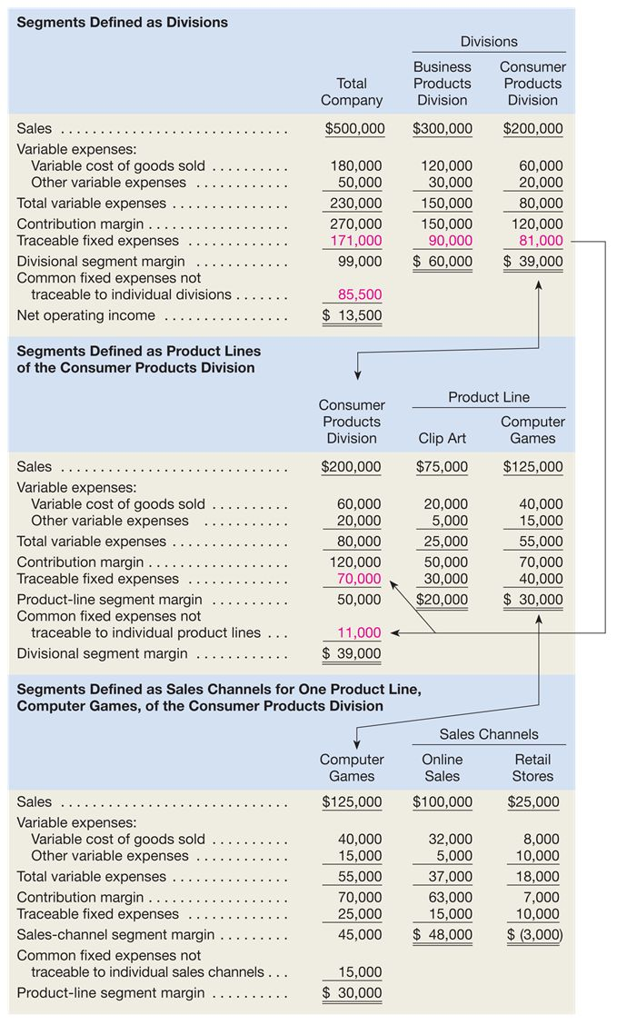
In the case of ProphetMax, we should begin by reviewing the information in the Total Company column. This column of data indicates that ProphetMax’s total traceable fixed expenses are $171,000 and its total common fixed expenses are $85,500. Furthermore, the company’s overall contribution margin of $270,000 divided by its total sales of $500,000 equals its overall CM ratio of 0.54. Given this information, ProphetMax’s companywide break-even point is computed as follows:
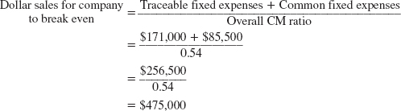
It is important to emphasize that this computation assumes a constant sales mix. In other words, in the ProphetMax example, it assumes that 60% of the total sales ($300,000 ÷ $500,000) will always come from the Business Products Division and 40% of the total sales ($200,000 ÷ $500,000) will always come from the Consumer Products Division.
To compute the break-even point for a business segment, the formula is as follows:
In the case of ProphetMax’s Business Products Division, the column of data indicates that the Business Products Division’s traceable fixed expenses are $90,000 and its CM ratio is 0.50 ($150,000 ÷ $300,000). Given this information, the Business Products Division’s break-even point is computed as follows:
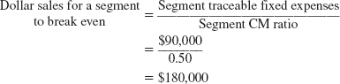
The same calculation can be performed for the Consumer Products Division
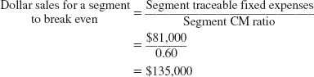

Notice that the sum of the segment break-even sales figures of $315,000 ($180,000 + $135,000) is less than the companywide break-even point of $475,000. This occurs because the segment break-even calculations do not include the company’s common fixed expenses. The exclusion of the company’s common fixed expenses can be verified by preparing income statements based on each segment’s break-even dollar sales as follows:
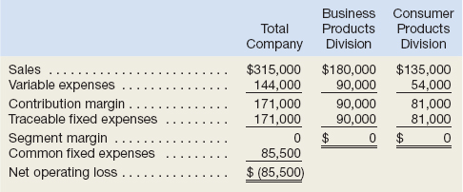
When each segment achieves its break-even point, the company’s overall net operating loss of $85,500 equals its common fixed expenses of $85,500. This reality can often lead managers astray when making decisions. In an attempt to “cover the company’s common fixed expenses,” managers will often allocate common fixed expenses to business segments when performing break-even calculations and making decisions. This is a mistake! Allocating common fixed expenses to business segments artificially inflates each segment’s break-even point. This may cause managers to erroneously discontinue business segments where the inflated break-even point appears unobtainable. The decision to retain or discontinue a business segment should be based on the sales and expenses that would disappear if the segment were dropped. Because common fixed expenses will persist even if a business segment is dropped, they should not be allocated to business segments when making decisions.

Segmented Income Statements—Common Mistakes
All of the costs attributable to a segment—and only those costs—should be assigned to the segment. Unfortunately, companies often make mistakes when assigning costs to segments. They omit some costs, inappropriately assign traceable fixed costs, and arbitrarily allocate common fixed costs.
Omission of Costs
The costs assigned to a segment should include all costs attributable to that segment from the company’s entire value chain. All of these functions, from research and development, through product design, manufacturing, marketing, distribution, and customer service, are required to bring a product or service to the customer and generate revenues.
However, only manufacturing costs are included in product costs under absorption costing, which is widely regarded as required for external financial reporting. To avoid having to maintain two costing systems and to provide consistency between internal and external reports, many companies also use absorption costing for their internal reports such as segmented income statements. As a result, such companies omit from their profitability analysis part or all of the “upstream” costs in the value chain, which consist of research and development and product design, and the “downstream” costs, which consist of marketing, distribution, and customer service. Yet these nonmanufacturing costs are just as essential in determining product profitability as are the manufacturing costs. These upstream and downstream costs, which are usually included in selling and administrative expenses on absorption costing income statements, can represent half or more of the total costs of an organization. If either the upstream or downstream costs are omitted in profitability analysis, then the product is undercosted and management may unwittingly develop and maintain products that in the long run result in losses.

Inappropriate Methods for Assigning Traceable Costs among Segments
In addition to omitting costs, many companies do not correctly handle traceable fixed expenses on segmented income statements. First, they do not trace fixed expenses to segments even when it is feasible to do so. Second, they use inappropriate allocation bases to allocate traceable fixed expenses to segments.
Failure to Trace Costs Directly.
Costs that can be traced directly to a specific segment should be charged directly to that segment and should not be allocated to other segments. For example, the rent for a branch office of an insurance company should be charged directly to the branch office rather than included in a companywide overhead pool and then spread throughout the company.
Inappropriate Allocation Base.
Some companies use arbitrary allocation bases to allocate costs to segments. For example, some companies allocate selling and administrative expenses on the basis of sales revenues. Thus, if a segment generates 20% of total company sales, it would be allocated 20% of the company’s selling and administrative expenses as its “fair share.” This same basic procedure is followed if cost of goods sold or some other measure is used as the allocation base.
Costs should be allocated to segments for internal decision-making purposes only when the allocation base actually drives the cost being allocated (or is very highly correlated with the real cost driver). For example, sales should be used to allocate selling and administrative expenses only if a 10% increase in sales will result in a 10% increase in selling and administrative expenses. To the extent that selling and administrative expenses are not driven by sales volume, these expenses will be improperly allocated—with a disproportionately high percentage of the selling and administrative expenses assigned to the segments with the largest sales.

Arbitrarily Dividing Common Costs among Segments
The third business practice that leads to distorted segment costs is the practice of assigning nontraceable costs to segments. For example, some companies allocate the common costs of the corporate headquarters building to products on segment reports. However, in a multiproduct company, no single product is likely to be responsible for any significant amount of this cost. Even if a product were eliminated entirely, there would usually be no significant effect on any of the costs of the corporate headquarters building. In short, there is no cause-and-effect relation between the cost of the corporate headquarters building and the existence of any one product. As a consequence, any allocation of the cost of the corporate headquarters building to the products must be arbitrary.
Common costs like the costs of the corporate headquarters building are necessary, of course, to have a functioning organization. The practice of arbitrarily allocating common costs to segments is often justified on the grounds that “someone” has to “cover the common costs.” While it is undeniably true that a company must cover its common costs to earn a profit, arbitrarily allocating common costs to segments does not ensure that this will happen. In fact, adding a share of common costs to the real costs of a segment may make an otherwise profitable segment appear to be unprofitable. If a manager eliminates the apparently unprofitable segment, the real traceable costs of the segment will be saved, but its revenues will be lost. And what happens to the common fixed costs that were allocated to the segment? They don’t disappear; they are reallocated to the remaining segments of the company. That makes all of the remaining segments appear to be less profitable—possibly resulting in dropping other segments. The net effect will be to reduce the overall profits of the company and make it even more difficult to “cover the common costs.”
Additionally, common fixed costs are not manageable by the manager to whom they are arbitrarily allocated; they are the responsibility of higher-level managers. When common fixed costs are allocated to managers, they are held responsible for those costs even though they cannot control them.

Review Problem 2: Segmented Income Statements
The business staff of the law firm Frampton, Davis & Smythe has constructed the following report that breaks down the firm’s overall results for last month into two business segments—family law and commercial law:
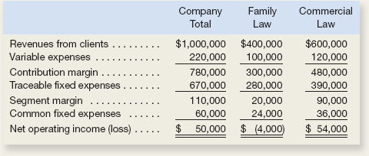
However, this report is not quite correct. The common fixed expenses such as the managing partner’s salary, general administrative expenses, and general firm advertising have been allocated to the two segments based on revenues from clients.
Required:
- Redo the segment report, eliminating the allocation of common fixed expenses. Would the firm be better off financially if the family law segment were dropped? (Note: Many of the firm’s commercial law clients also use the firm for their family law requirements such as drawing up wills.)
- The firm’s advertising agency has proposed an ad campaign targeted at boosting the revenues of the family law segment. The ad campaign would cost $20,000, and the advertising agency claims that it would increase family law revenues by $100,000. The managing partner of Frampton, Davis & Smythe believes this increase in business could be accommodated without any increase in fixed expenses. Estimate the effect this ad campaign would have on the family law segment margin and on the firm’s overall net operating income.
- Compute the companywide break-even point in dollar sales and the dollar sales required for each business segment to break even.

EXERCISE 6–11 Segmented Income Statement

Wingate Company, a wholesale distributor of electronic equipment, has been experiencing losses for some time, as shown by its most recent monthly contribution format income statement, which follows:
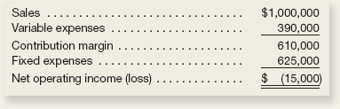
In an effort to isolate the problem, the president has asked for an income statement segmented by division. Accordingly, the Accounting Department has developed the following information:
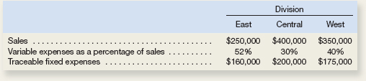
Required:
- Prepare a contribution format income statement segmented by divisions, as desired by the president.
- As a result of a marketing study, the president believes that sales in the West Division could be increased by 20% if monthly advertising in that division were increased by $15,000. Would you recommend the increased advertising? Show computations to support your answer.

