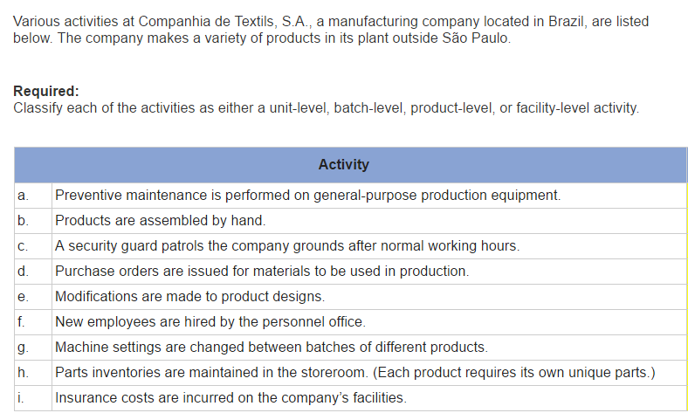

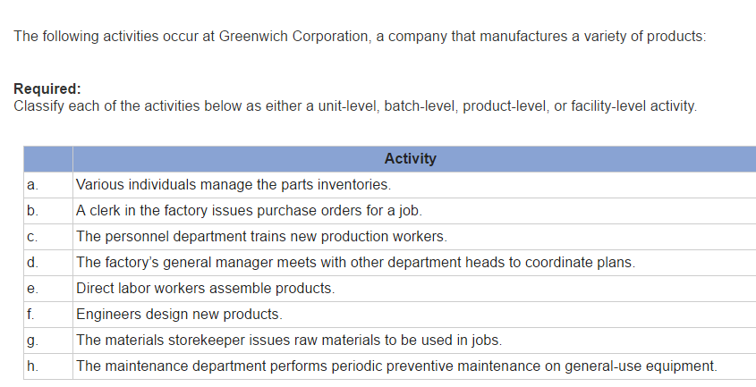

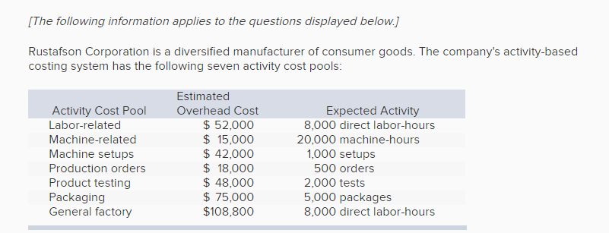

Compute the activity rate for each activity cost pool
Labor related ________ per DLH
Machine related __________ per HH
Machine set ups __________ per set up
Production order ________ per order
Product testing _______ per test
Packaging _________ per package
General Factory _______ per DLH

