**Chapter 2**

Financial statements report on the financial performance and condition of an organization. Knowledge of their preparation, organization, and analysis is important. A main goal of this chapter is to illustrate how transactions are recorded, how they are reflected in financial statements, and how they impact analysis of financial statements. Debits and credits are introduced and identified as a tool in helping analyze and process transactions.

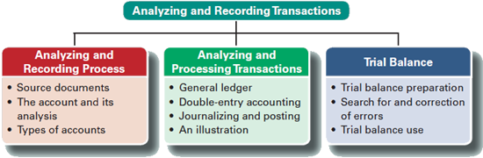

**ANALYZING AND RECORDING PROCESS**

The accounting process identifies business transactions and events, analyzes and records their effects, and summarizes and presents information in reports and financial statements.

Business transactions and events are the starting points. Relying on source documents, the transactions and events are analyzed using the accounting equation to understand how they affect company performance and financial position. These effects are recorded in accounting records, informally referred to as the *accounting books*, or simply the *books*.

**Steps to recording transactions in the books**

1. Review source documents
2. Review the chart of accounts to determine what accounts are affected.
3. Determine whether the accounts are increasing or decreasing and record the transaction in the general journal
4. Post the effects of the transaction in the general ledger (We will use T accounts)
5. Prepare the unadjusted trial balance to determine if records are in balance and look normal
6. **Review source documents**

**Source documents** identify and describe transactions and events entering the accounting process. They are the sources of accounting information and can be in either hard copy or electronic form. Examples are sales tickets, checks, purchase orders, bills from suppliers, employee earnings records, and bank statements.

Many cash registers record information for each sale on a tape or electronic file locked inside the register. This record can be used as a source document for recording sales in the accounting records. Source documents, especially if obtained from outside the organization, provide objective and reliable evidence about transactions and events and their amounts.

1. **Review the chart of accounts to determine what accounts are affected.**

The **chart of accounts** is a list of all accounts and includes an identification number assigned to each account. An **account** is a record of increases and decreases in a specific asset, liability, equity, revenue, or expense item.

1. **Determine whether the accounts are increasing or decreasing and record the transaction in the general journal.**

**Memorize this chart.** It is the basis for your quizzes and will expand as we go through more chapters. The “normal” balance for an account refers to what increases the balance. For example, cash has a **debit** normal balance, and accounts payable has **credit** normal balance.



**Shortened Versions**



**General Journal**

The general journal is a diary of each day’s transactions in order. A **journal** gives a complete record of each transaction in one place. It also shows debits and credits for each transaction. The process of recording transactions in a journal is called **journalizing.**

To record entries in a general journal, apply these steps

(1) Date the transaction: Enter the year at the top of the first column and the month and day on the first line of each journal entry. (We will number transactions in class to save time but this is the proper procedure).

(2) Enter titles of accounts debited and then enter amounts in the Debit column on the same line. Account titles are taken from the chart of accounts and are aligned with the left margin of the Account Titles and Explanation column. Thousands are in the larger space to the left, hundreds in the closer spaces, and cents in the larger space to the right and usually in superscript.

(3) Enter titles of accounts credited and then enter amounts in the Credit column on the same line. Account titles are from the chart of accounts and are **indented from the left margin** of the Account Titles and Explanation column to distinguish them from debited accounts.

(4) Enter a brief explanation of the transaction on the line below the entry (it often references a source document). This explanation is indented about half as far as the credited account titles to avoid confusing it with accounts, and it is italicized. (We will not do in class to save time but this is proper procedure).



**Double-Entry Accounting**

**Double-entry accounting** requires that for each transaction:

* At least two accounts are involved, with at least one debit and one credit.
* The total amount debited must equal the total amount credited.
* The accounting equation must not be violated. This means the sum of the debits for all entries must equal the sum of the credits for all entries.

1. **Post the effects of the transaction in the general ledger (We will use T accounts)**

The **general ledger**, or simply **ledger**, is a record containing all accounts used by a company. We will use T accounts to simulate the general ledger. A **T-account** represents a ledger account and is a tool used to understand the effects of one or more transactions.

The layout of a T-account is (1) the account title on top, (2) a left, or debit side, and (3) a right, or credit, side.

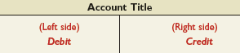

**Point: Think of *debit* and *credit* as accounting directions for left and right.**

The left side of an account is called the **debit** side, often abbreviated *Dr*. The right side is called the **credit** side, abbreviated *Cr*.

To enter amounts on the left side of an account is to *debit* the account. To enter amounts on the right side is to *credit* the account. We will add the number associated with the transaction as well in our in-class example.

**Do not make the error of thinking that the terms *debit* and *credit* mean increase or decrease.** Whether a debit or a credit is an increase or decrease depends on the account. (Use your accounting equation sheet to help you memorize the debits and credits for each account until you understand the system.)



The T-Account

The difference between total debits and total credits for an account, including any beginning balance, is the **account balance.**

To balance a T account, always do the same three steps

1. Add up all the debits
2. Add up all the credits
3. Take the smaller from the larger. The result will either be a debit or a credit balance. When the sum of debits equals the sum of credits, the account has a *zero balance*.

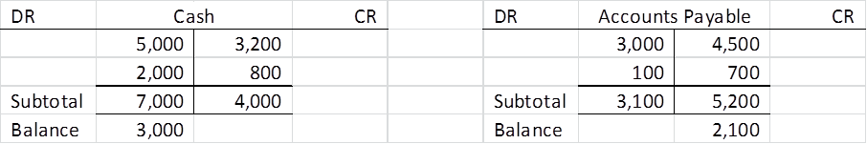

1. **Prepare the unadjusted trial balance to determine if records are in balance and look normal**

Double-entry accounting requires the sum of debit account balances to equal the sum of credit account balances. A trial balance is used to confirm this. A **trial balance** is a list of accounts and their balances at a point in time. Account balances are reported in their appropriate debit or credit columns of a trial balance. A trial balance can be used to confirm this and to follow up on any abnormal or unusual balances.

Preparing a trial balance involves three steps:

1. List each account title and its amount (from ledger) in the trial balance. If an account has a zero balance, list it with a zero in its normal balance column (or omit it entirely).
2. Compute the total of debit balances and the total of credit balances.
3. Verify (*prove*) total debit balances equal total credit balances.

**Using a Trial Balance to Prepare Financial Statements**

How financial statements are linked in time is illustrated. A balance sheet reports on an organization's financial position at a *point in time*. The income statement, statement of retained earnings, and statement of cash flows report on financial performance over a *period of time*.

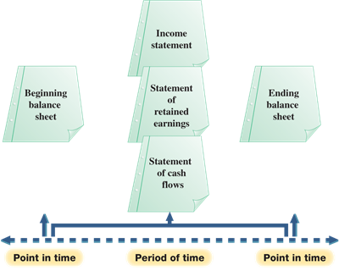

The Balance Sheet is as of a specific date. The following date, it will change. The income statement and Statement of Retained Earnings will be for a period of time such as the month ended, the quarter ended or the year ended.

**Chapter Example**

We return to the activities of FastForward to show how double-entry accounting is useful in analyzing and processing transactions. The following is a brief description of the transactions that are more fully described in your book.

Study each transaction thoroughly before proceeding to the next. The first 11 transactions are from Chapter 1, and we analyze five additional December transactions of FastForward (numbered 12 through 16).

1. Receive investment by Owner in exchange for common stock $30,000
2. Purchase Supplies (benefiting future periods) for Cash $2,500
3. Purchase Equipment for Cash $26,000
4. Purchase Supplies on Credit $7,100
5. Provide Consulting Services for Cash $4,200
6. Payment of Monthly Rent $1,000
7. Payment of Bi-Weekly Salaries $700
8. Provide Consulting Services ($1,600) and Rental ($300) on Credit
9. Receipt of Cash on Account $1,900

The *revenue recognition principle* requires revenue to be recognized when earned, which is when the company provides products and services to a customer. This is not necessarily the same time that the customer pays. A customer can pay before or after products or services are provided.

1. Partial Payment of Accounts Payable $900
2. Payment of Cash Dividend $200
3. Receipt of Cash for Future Services $3,000
4. Pay Cash for 24-month Insurance Coverage $2,400
5. Purchase Supplies for Cash $120
6. Payment of Utilities $230
7. Payment of Bi-Weekly Salaries $700



|  |  |  |  |  |
| --- | --- | --- | --- | --- |
| Account |  |  |  |  |
|  |  |  |  |  |
| Cash |  |  |  |  |
| Office Supplies |  |  |  |  |
| Accounts Receivable |  |  |  |  |
| Prepaid Insurance |  |  |  |  |
| Equipment |  |  |  |  |
| Accounts Payable |  |  |  |  |
| Unearned Revenue |  |  |  |  |
| Common Stock |  |  |  |  |
| Dividends |  |  |  |  |
| Service Revenue |  |  |  |  |
| Rent Revenue |  |  |  |  |
| Rent Expense |  |  |  |  |
| Salary Expense |  |  |  |  |
| Utilities Expense |  |  |  |  |
|  |  |  |  |  |
| Balance |  |  |  |  |
|  |  |  |  |  |