**Chapter 3. Adjusting Accounts and Preparing Financial Statements**

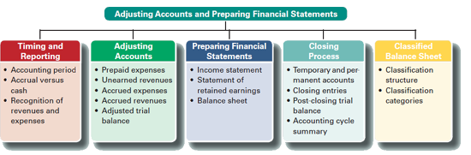

**TIMING AND REPORTING**

The value of information is often linked to its timeliness. Useful information must reach decision makers frequently and promptly. To provide timely information, accounting systems prepare reports at regular intervals. This results in an accounting process impacted by the time period (or periodicity) assumption. The **time period assumption** presumes that an organization's activities can be divided into specific time periods such as a month, a three-month quarter, a six-month interval, or a year.

**Recognizing Revenues and Expenses**

We use the time period assumption to divide a company's activities into specific time periods, but not all activities are complete when financial statements are prepared. Thus, adjustments often are required to get correct account balances.

We rely on two principles in the adjusting process: revenue recognition and expense recognition (the latter is often referred to as matching).

The ***revenue recognition principle*** requires that revenue be recorded when earned, not before and not after. Most companies earn revenue when they provide services and products to customers. A major goal of the adjusting process is to have revenue recognized (reported) in the time period when it is earned.

The **expense recognition** (or **matching**) **principle** aims to record expenses in the same accounting period as the revenues that are earned as a result of those expenses. This matching of expenses with the revenue benefits is a major part of the adjusting process.

We will learn about six adjustments

1. **Prepaid expenses**
2. **Supplies**
3. **Depreciation**
4. **Unearned revenue**
5. **Accrued expenses**
6. **Accrued revenues**

**ADJUSTING ACCOUNTS**

Adjusting entries are necessary so that revenues, expenses, assets, and liabilities are correctly reported. Specifically, an **adjusting entry** is made at the end of an accounting period to reflect a transaction or event that is not yet recorded. **Each adjusting entry affects one or more income statement accounts *and* one or more balance sheet accounts (but never the Cash account).**

**Prepaid Expenses**

**Prepaid expenses** refer to items *paid for* in advance of receiving their benefits. Prepaid expenses are assets. When these assets are used, their costs become expenses.

If one company has a prepaid expense, then another company has unearned revenue. More explanation on unearned revenue later in lecture.

We determine that the current balance of FastForward's prepaid insurance is equal to its $2,400 payment for 24 months of insurance benefits that began on December 1, 2016.

With the passage of time, the benefits of the insurance gradually expire and a portion of the Prepaid Insurance asset becomes expense. For instance, one month's insurance coverage expires by December 31, 2016. This expense is $100, or 1/24 of $2,400, which leaves $2,300.

The adjusting entry to record this expense and reduce the asset, along with T-account postings

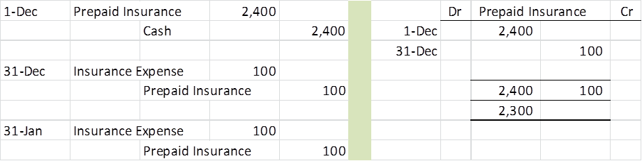

**Office Supplies**

FastForward purchased $9,720 of supplies in December and some of them were used during this month. When financial statements are prepared at December 31, the cost of supplies used during December must be recognized.

When FastForward computes (takes physical count of) its remaining unused supplies at December 31, it finds $8,670 of supplies remaining of the $9,720 total supplies. The $1,050 difference between these two amounts is December's supplies expense.

The adjusting entry to record this expense and reduce the Supplies asset account, along with T-account postings



**Depreciation**

**Plant assets** refers to long-term tangible assets used to produce and sell products and services. Plant assets are expected to provide benefits for more than one period. Examples of plant assets are buildings, machines, vehicles, and fixtures.

All plant assets, with a general exception for land, eventually wear out or decline in usefulness. The costs of these assets are deferred but are gradually reported as expenses in the income statement over the assets' useful lives (benefit periods).

**Depreciation** is the process of allocating the costs of these assets over their expected useful lives. Depreciation expense is recorded with an adjusting entry.

FastForward purchased equipment for $26,000 in early December to use in earning revenue. This equipment's cost must be depreciated.

The equipment is expected to have a useful life (benefit period) of four years and to be worth about $8,000 at the end of four years. This means the *net* cost of this equipment over its useful life is $18,000 ($26,000 − $8,000).

FastForward uses a method called **straight-line depreciation**, which allocates equal amounts of the asset's net cost to depreciation during its useful life. Dividing the $18,000 net cost by the 48 months in the asset's useful life gives a monthly cost of $375 ($18,000/48). If annual depreciation is being calculated, divide by four years. ($18,000/4years)

The adjusting entry to record monthly depreciation expense, along with T-account postings



Accumulated depreciation is kept in a separate contra account. A **contra account** is an account linked with another account, where the contra account has a normal balance opposite of the account it is linked with. It is reported as a subtraction from that other account's balance. This account will “accumulate” depreciation until either fully depreciated or the asset is removed from the books.

FastForward's contra account of Accumulated Depreciation — Equipment is subtracted from the Equipment account in the balance sheet. This contra account allows balance sheet readers to know both the full costs of assets and the total depreciation. Which company has the newer assets based on net book value?



**Unearned (Deferred) Revenues**

The term **unearned revenues** refers to **cash** received in advance of providing products and services. Unearned revenues are liabilities. When cash is accepted, an obligation to provide products or services is accepted. As products or services are provided, the unearned revenues become *earned* revenues. Adjusting entries for unearned revenues involve increasing revenues and decreasing unearned revenues.

Thus, if a company prepays for a service or product, that company has a prepaid asset but the company accepting the cash has an unearned revenue.

On December 26, the client paid the 60-day fee in advance, covering the period December 27 to February 24. The entry to record the cash received in advance is



This advance payment increases cash and creates an obligation to do consulting work over the next 60 days.

As time passes, FastForward earns this payment through consulting. By December 31, it has provided five days' service



The adjusting entry to reduce the liability account and recognize earned revenue, along with T-account postings, follows:



**Accrued Expenses**

**Accrued expenses** refer to costs that are incurred in a period but are both **unpaid and unrecorded.** Accrued expenses must be reported on the income statement of the period when incurred. Adjusting entries for recording accrued expenses involve increasing expenses and increasing liabilities. This adjustment recognizes expenses incurred in a period but not yet paid. Common examples of accrued expenses are salaries, interest, rent, and taxes.

Accrued Salaries Expense FastForward's employee earns $70 per day, or $350 for a five-day workweek beginning on Monday and ending on Friday.

Its employee is paid every two weeks on Friday. On December 12 and 26, the wages are paid, recorded in the journal, and posted to the ledger.

The calendar shows three working days after the December 26 payday (29, 30, and 31). This means the employee has earned three days' salary by the close of business on Wednesday, December 31, yet this salary cost has not been paid or recorded. The financial statements would be incomplete if FastForward fails to report the added expense and liability to the employee for unpaid salary from December 29, 30, and 31.



**This is the Hard Part – Since the AJE created a liability, it must be taken into consideration when subsequently the salaries are paid.**

To illustrate, FastForward recorded accrued salaries of $210. On the first payday of the next period, the following entry settles the accrued liability (salaries payable) and records salaries expense for seven days of work in January:



The $210 debit reflects the payment of the liability for the three days' salary accrued on December 31. The $490 debit records the salary for January as an expense of the new accounting period. The $700 credit records the total amount of cash paid to the employee.

**Accrued Interest Expense**

Companies commonly have accrued interest expense on notes payable and other long-term liabilities at the end of a period. Interest expense is incurred with the passage of time. Unless interest is paid on the last day of an accounting period, **we need to adjust for interest expense incurred but not yet paid**. This means we must accrue interest cost from the most recent payment date up to the end of the period. The formula for computing accrued interest is:

http://textflow.mheducation.com/figures/007742994X/wiL25389_eq0301.png

To illustrate, if a company has a $6,000 loan from a bank at 6% annual interest, then 30 days' accrued interest expense is $30 — computed as $6,000 × 0.06 × 30/360. The adjusting entry would be to debit Interest Expense for $30 and credit Interest Payable for $30.

**Accrued Revenues**

The term **accrued revenues** refers to revenues earned in a period that are both unrecorded and not yet received in cash (or other assets).

An example is a technician who bills customers only when the job is done. If one-third of a job is complete by the end of a period, then the technician must record one-third of the expected billing as revenue in that period — even though there is no billing or collection. Accrued revenues commonly arise from services, products, interest, and rent.

Accrued Services Revenue Accrued revenues are not recorded until adjusting entries are made at the end of the accounting period. These accrued revenues are earned but unrecorded because either the buyer has not yet paid for them or the seller has not yet billed the buyer. FastForward provides an example.

In the second week of December, it agreed to provide 30 days of consulting services for a fixed fee of $2,700. The terms of the initial agreement call for FastForward to provide services for 30 days of service.

At December 31, 20 days of services have already been provided. Since the contracted services have not yet been entirely provided, FastForward has neither billed the club nor recorded the services already provided. Still, FastForward has earned two-thirds of the 30-day fee.

Personally, I don’t agree with this treatment. I would prefer the more conservative approach of recording this when the contract is complete. However, for a bank to record its daily interest earned as of December 31 would be entirely proper since the contract with the bank calls for daily interest.



**This is the hard part. Since the AJE created a receivable, it must be taken into consideration when the cash is ultimately received for these services.**

Future Receipt of Accrued Revenues

FastForward made an adjusting entry for $1,800 to record 20 days' accrued revenue earned from its consulting contract. When FastForward receives $2,700 cash on January 10 for the entire contract amount, it makes the following entry

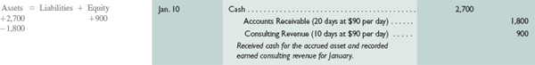

**Adjusted Trial Balance**

An **unadjusted trial balance** is a list of accounts and balances prepared *before* adjustments are recorded. An **adjusted trial balance** is a list of accounts and balances prepared *after* adjusting entries have been recorded and posted to the ledger.

Below is both the unadjusted and the adjusted trial balances for FastForward at December 31

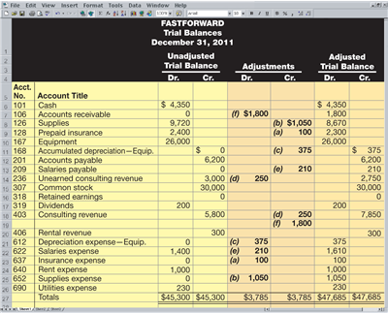

**PREPARING FINANCIAL STATEMENTS**

We can prepare financial statements directly from information in the *adjusted* trial balance. An adjusted trial balance includes all accounts and balances appearing in financial statements, and is easier to work from than the entire ledger when preparing financial statements.

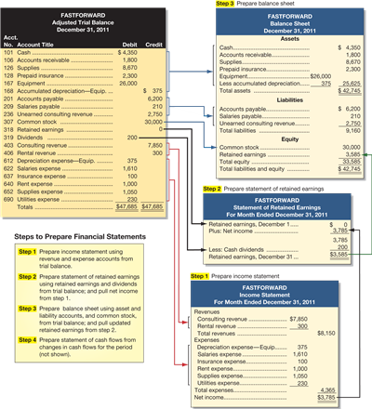

We prepare financial statements in the following order: income statement, statement of retained earnings, and balance sheet. The income statement information is needed in the Statement of Retained Earnings. The information from the Statement of Retained Earnings is used to prepare the Balance Sheet.

**CLOSING PROCESS**

The **closing process** is an important step at the end of an accounting period *after* financial statements have been completed. The preparation of the financial statements updates the balance in retained earnings and now accounting entries called “closing entries” are used to update the retained earnings balance in the general journal and ledger.

The closing process zeroes out all sub retained earnings accounts such as revenues, expenses and dividends and prepares these accounts for recording the transactions and the events of the *next* period.

In the closing process we (1) identify all revenue and expense accounts (2) record and post the closing entries to zero out these accounts, (3) close out the dividends account, and (4) prepare a post-closing trial balance. The closing process resets revenue, expense, and dividends account balances to zero at the end of each period. This is done so that these accounts can accumulate income and dividends for the next period. Owner’s wealth is comprised of the common stock and retained earnings account. The retained earnings account is updated through the closing process to record all accumulation of owner’s wealth during the period.

**Revenue, Expense and Dividend accounts (Inc Stmt and Stmt of RE accounts) are temporary** **accounts** which accumulate data related to one accounting period. Also included is an account entitled “Income Summary” which is used only in the closing process. More about this account later.

They are temporary because the accounts are opened at the beginning of a period, used to record transactions and events for that period, and then closed at the end of the period. *The closing process applies only to temporary accounts*.

**Balance Sheet accounts are permanent** **accounts** report on activities related to one or more future accounting periods. They carry their ending balances into the next period and generally consist of all balance sheet accounts. These asset, liability, and equity accounts (common stock and retained earnings) are not closed.

**An Example: The Closing Process**

The closing process uses an account entitled “income summary” to aid in the in the closing process. It is **only** used during this process. We will want to use T accounts for the income summary and retained earnings to avoid confusion in the closing process.

Steps in the closing process:

1. **Debit all revenue accounts and credit income summary.**

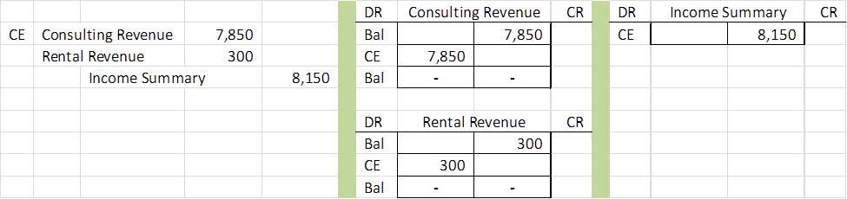

1. **Credit all expense accounts and debit income summary**

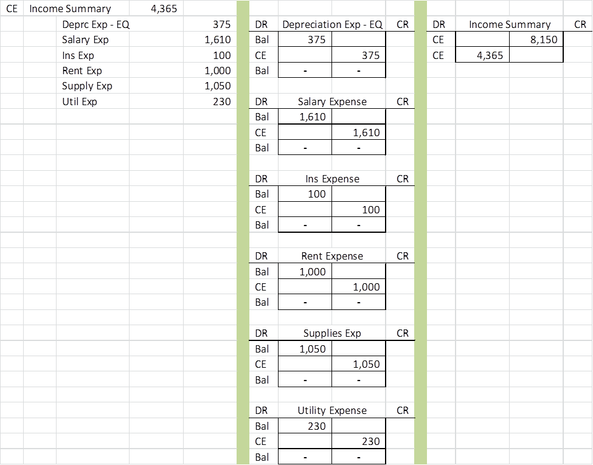

1. **Balance the income summary account and close it out to Retained Earnings**

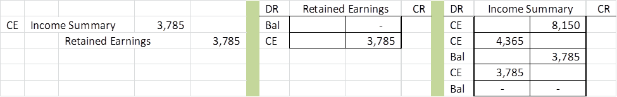

1. **Close out the Dividends account to Retained Earnings**

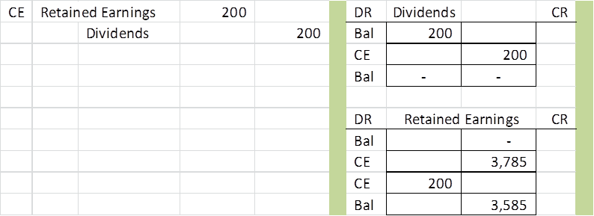

**Post-Closing Trial Balance –** The following shows all accounts after the closing process



A **post-closing trial balance** is a list of permanent accounts and their balances from the ledger after all closing entries have been journalized and posted. **It lists the balances for all accounts not closed.** These accounts comprise a company's assets, liabilities, and equity, which are identical to those in the balance sheet. The aim of a post-closing trial balance is to verify that (1) total debits equal total credits for permanent accounts and (2) all temporary accounts have zero balances.

**Memorize**

The term **accounting cycle** refers to the steps in preparing financial statements. It is called a *cycle* because the steps are repeated each reporting period.

Steps 1 through 2 usually occur regularly as a company enters into transactions. Steps 3 through 10 are done at the end of a period.

**Steps in the Accounting Cycle**

Step 1 Journal entries from external sources

Step 2 Post to general ledger

Step 3 Unadjusted trial balance

Step 4 Adjusting journal entries from internal sources

Step 5 Post to general ledger

Step 6 Prepare income statement, statement of owner’s equity, and balance sheet.

Step 7 Adjusted Trial Balance

Step 8 Closing entries

Step 9 Post to general ledger.

Step 10 Prepare a post-closing trial balance.

**CLASSIFIED BALANCE SHEET**

Our discussion to this point has been limited to unclassified financial statements. An **unclassified balance sheet** is one whose items are broadly grouped into assets, liabilities, and equity. A **classified balance sheet** organizes assets and liabilities into important liquidity subgroups that provide more information to decision makers.

A classified balance sheet has no required layout, but it usually contains the following categories. One of the more important classifications is the separation between current and noncurrent items for both assets and liabilities.

Current items are those expected to come due (either collected or owed) within one year or the company's operating cycle, whichever is longer.

The **operating cycle** is the time span from when *cash is used* to acquire goods and services until *cash is received* from the sale of goods and services.

Most accounting cycles are one year or less and we assume this cutoff for the course.

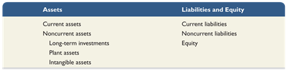

A balance sheet lists current assets before noncurrent assets and current liabilities before noncurrent liabilities. This consistency in presentation allows users to quickly identify current assets that are most easily converted to cash and current liabilities that are shortly coming due. Items in current assets and current liabilities are listed in the order of how quickly they will be converted to, or paid in, cash.

**New Accounting Equation for Chapter 3**

