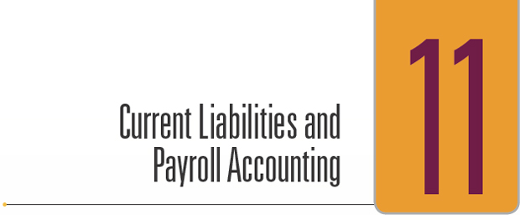

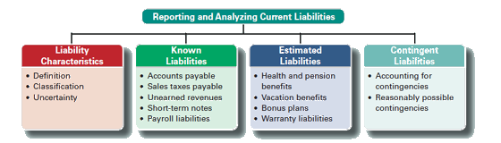

**CHARACTERISTICS OF LIABILITIES**

A *liability* is a probable future payment of assets or services that a company is presently obligated to make as a result of past transactions or events. This definition includes three crucial factors:

1. A past transaction or event.
2. A present obligation.
3. A future payment of assets or services.

For example, most companies expect to pay wages to their employees in upcoming months and years, but these future payments are *not* liabilities because no past event such as employee work resulted in a present obligation. Instead, such liabilities arise when employees perform their work and earn the wages.

**Classifying Liabilities**

**Current liabilities,** also called *short-term liabilities*, are obligations due within one year or the company's operating cycle, whichever is longer. They are expected to be paid using current assets or by creating other current liabilities. Common examples of current liabilities are accounts payable, short-term notes payable, wages payable, warranty liabilities, lease liabilities, taxes payable, and unearned revenues.

**Long-Term Liabilities** A company's obligations not expected to be paid within the longer of one year or the company's operating cycle are reported as **long-term liabilities.** They can include long-term notes payable, warranty liabilities, lease liabilities, and bonds payable. They are reported after current liabilities on the Balance Sheet. A single liability also can be divided between the current and noncurrent sections if a company expects to make payments toward it in both the short and long term.

**Uncertainty in Liabilities**

Accounting for liabilities involves addressing three important questions: Whom to pay? When to pay? How much to pay? Answers to these questions are often decided when a liability is incurred.

**Uncertainty in Whom to Pay** Liabilities can involve uncertainty in whom to pay. For instance, a company can create a liability with a known amount when issuing a note that is payable to its holder. In this case, a specific amount is payable to the note's holder at a specified date, but the company does not know who the holder is until that date. This arises because notes are negotiable and can be sold to another party. Despite this uncertainty, the company reports this liability on its balance sheet.

**Uncertainty in When to Pay** A company can have an obligation of a known amount to a known creditor but not know when it must be paid. For example, a legal services firm can accept fees in advance from a client who plans to use the firm's services in the future. This means that the firm has a liability that it settles by providing services at an unknown future date. Although this uncertainty exists, the legal firm's balance sheet must report this liability. These types of obligations are reported as current liabilities because they are likely to be settled in the short term.

**Uncertainty in How Much to Pay** A company can be aware of an obligation but not know how much will be required to settle it. For example, a company using electrical power is billed only after the meter has been read. This cost is incurred and the liability created before a bill is received. A liability to the power company is reported as an estimated amount if the balance sheet is prepared before a bill arrives.

**Categories of Liabilities**

I Known

II Estimated

III Contingent

**Known Liabilities**

Most liabilities arise from situations with little uncertainty. They are set by agreements, contracts, or laws and are measurable. These liabilities are **known liabilities**, also called *definitely determinable liabilities.* Known liabilities include accounts payable, notes payable, payroll, sales taxes, unearned revenues, and leases.

**Sales Taxes Payable**

Nearly all states and many cities levy taxes on retail sales. Sales taxes are stated as a percent of selling prices. The seller collects sales taxes from customers when sales occur and remits these collections (often monthly) to the proper government agency. Since sellers currently owe these collections to the government, this amount is a current liability.

To illustrate, if Home Depot sells materials on August 31 for $6,000 cash that are subject to a 5% sales tax, the revenue portion of this transaction is recorded as follows:



Sales Taxes Payable is debited and Cash credited when it remits these collections to the government. Sales Taxes Payable is not an expense. It arises because laws require sellers to collect this cash from customers for the government

**Unearned Revenues**

*Unearned revenues* are amounts received in advance from customers for future products or services. Advance ticket sales for sporting events or music concerts are examples. **Beyoncé**, for instance, has “deferred revenues” from advance ticket sales. To illustrate, assume that Beyoncé sells $5 million in tickets for eight concerts; the entry is

http://textflow.mheducation.com/figures/007742994X/wiL25389_utb0903.png

When a concert is played, Beyoncé would record revenue for the portion earned.

http://textflow.mheducation.com/figures/007742994X/wiL25389_utb0904.png

Unearned Ticket Revenue is an unearned revenue account and is reported as a current liability.

**Short-Term Notes Payable**

A **short-term note payable** is a written promise to pay a specified amount on a definite future date within one year or the company's operating cycle, whichever is longer.

These promissory notes are negotiable (as are checks), meaning they can be transferred from party to party by endorsement. The written documentation provided by notes is helpful in resolving disputes and for pursuing legal actions involving these liabilities. Most notes payable bear interest to compensate for use of the money until payment is made. Such notes also can arise when money is borrowed from a bank.

**Note Given to Extend Credit Period**

A company can replace an account payable with a note payable. A common example is a creditor that requires the substitution of an interest-bearing note for an overdue account payable.

To illustrate, let's assume that on August 23, Brady Company asks to extend its past-due $600 account payable to McGraw. After some negotiations, McGraw agrees to accept $100 cash and a 60-day, 12%, $500 note payable to replace the account payable. Brady records the transaction with this entry:

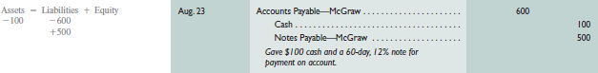

McGraw prefers the note payable over the account payable because it earns interest and it is written documentation of the debt's existence, term, and amount. When the note comes due, Brady pays the note and interest by giving McGraw a check for $510. Brady records that payment with this entry:





**Note Given to Borrow from Bank**

A bank nearly always requires a borrower to sign a promissory note when making a loan. When the note matures, the borrower repays the note plus *interest*. The *face value* of the note equals principal. Face value is the value shown on the face (front) of the note.

To illustrate, assume that a company needs $2,000 for a project and borrows this money from a bank at 12% annual interest. The loan is made on September 30, and is due in 60 days.

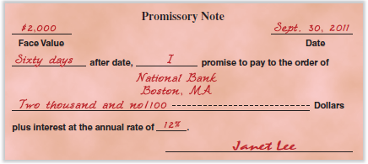

The borrower records its receipt of cash and the new liability with this entry:

http://textflow.mheducation.com/figures/007742994X/wiL25389_utb0907.png



When principal and interest are paid, the borrower records payment with this entry:



**End-of-period interest adjustment.**

When the end of an accounting period occurs between the signing of a note payable and its maturity date, the *matching principle* requires us to record the accrued but unpaid interest on the note.

To illustrate, a company borrows $2,000 cash on December 16, 2016. This 60-day note matures on February 14, 2017, and the company's fiscal year ends on December 31.



The borrower records this expense with the following adjusting entry:

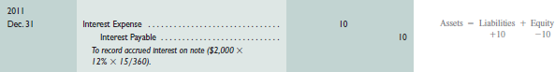



When this note matures on February 14, the borrower must recognize 45 days of interest expense for year 2012 and remove the balances of the two liability accounts:

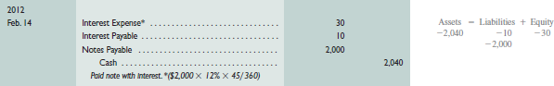

**Calculating date note is due:**

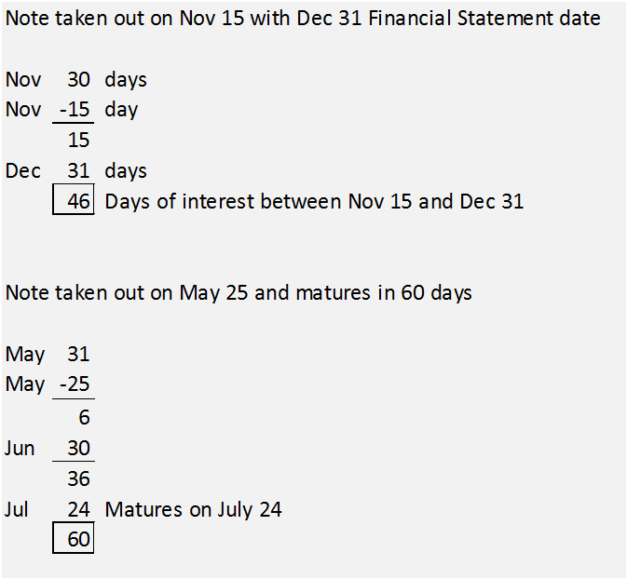**Payroll Liabilities**

An employer incurs several expenses and liabilities from having employees. These expenses and liabilities are often large and arise from salaries and wages earned, from employee benefits, and from payroll taxes levied on the employer.

**Employee Payroll Deductions**

**Gross pay** is the total compensation an employee earns including wages, salaries, commissions, bonuses, and any compensation earned before deductions such as taxes. (*Wages* usually refer to payments to employees at an hourly rate. *Salaries* usually refer to payments to employees at a monthly or yearly rate.)

**Net pay**, also called *take-home pay*, is gross pay less all deductions. **Payroll deductions**, commonly called *withholdings*, are amounts withheld from an employee's gross pay, either required or voluntary.

Required deductions result from laws and include income taxes and Social Security taxes.

Voluntary deductions, at an employee's option, include pension and health contributions, health and life insurance premiums, union dues, and charitable giving.

The employer withholds payroll deductions from employees' pay and is obligated to transmit this money to the designated organization. The employer records payroll deductions as current liabilities until these amounts are transmitted.

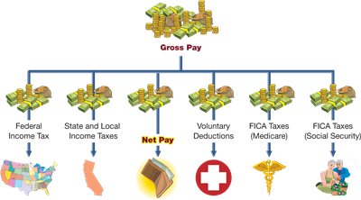

**Payroll Deductions**

**Employee FICA taxes.**

The federal Social Security system provides retirement, disability, survivorship, and medical benefits to qualified workers. Laws *require* employers to withhold **Federal Insurance Contributions Act (FICA) taxes** from employees' pay to cover costs of the system.

Employers usually separate FICA taxes into two groups: (1) retirement, disability, and survivorship and (2) medical.

For the first group, the Social Security system provides monthly cash payments to qualified retired workers for the rest of their lives. These payments are often called *Social Security benefits.* Taxes related to this group are often called *Social Security taxes.*

For the second group, the system provides monthly payments to deceased workers' surviving families and to disabled workers who qualify for assistance. These payments are commonly called *Medicare benefits;* like those in the first group, they are paid with *Medicare taxes* (part of FICA taxes).

Law requires employers to withhold FICA taxes from each employee's salary or wages on each payday. The taxes for Social Security and Medicare are computed separately.

For example, for 2014, the amount scheduled to be withheld from each employee's pay for Social Security tax is 6.2% of the first $117,000 the employee earns in the calendar year, or a maximum of $7,254

The Medicare tax is 1.45% of *all* amounts the employee earns; there is no maximum limit to Medicare tax.

Employers must pay withheld taxes to the Internal Revenue Service (IRS) on specific filing dates during the year. Until all the taxes are sent to the IRS, they are included in employers' current liabilities.

**Employee income tax.**

Most employers are required to withhold federal income tax from each employee's paycheck. The amount withheld is computed using tables published by the IRS. The amount depends on the employee's annual earnings rate and the number of *withholding allowances* the employee claims. Allowances reduce the amount of taxes one owes the government. Most states and many local governments require employers to withhold income taxes from employees' pay and to remit them promptly to the proper government agency.

Until they are paid, withholdings are reported as a current liability on the employer's balance sheet.

**Employee voluntary deductions.**

Beyond Social Security, Medicare, and income taxes, employers often withhold other amounts from employees' earnings. These withholdings arise from employee requests, contracts, unions, or other agreements. They can include amounts for charitable giving, medical and life insurance premiums, pension contributions, and union dues. Until they are paid, such withholdings are reported as part of employers' current liabilities.

**Recording employee payroll deductions.**

Employers must accrue payroll expenses and liabilities at the end of each pay period. To illustrate, assume that an employee earns a salary of $2,000 per month. At the end of January, the employer's entry to accrue payroll expenses and liabilities for this employee is

|  |
| --- |
| http://textflow.mheducation.com/figures/007742994X/wiL25389_utb0911.png |

**Salaries Expense** (debit) shows that the employee earns a gross salary of $2,000.

The first five payables (credits) show the liabilities the employer owes on behalf of this employee to cover FICA taxes, income taxes, medical insurance, and union dues.

The Salaries Payable account (credit) records the $1,524 net pay the employee receives from the $2,000 gross pay earned. When the employee is paid, another entry (or a series of entries) is required to record the check written and distributed (or funds transferred).

**Employer Payroll Taxes**

Employers must pay payroll taxes in addition to those required of employees. Employer taxes include FICA and unemployment taxes.

Employer FICA tax.

Employers must pay FICA taxes on their payroll to employees. For 2014, the employer must pay Social Security tax of 6.2% on the first $117,000 earned by each employee and a Medicare tax of 1.45% on all earnings of each employee.

Federal and state unemployment taxes.

The federal government participates with states in a joint federal and state unemployment insurance program. Each state administers its program. These programs provide unemployment benefits to qualified workers.

***Federal Unemployment Taxes (FUTA)*.**

Employers are subject to a federal unemployment tax on wages and salaries paid to their employees.

***State Unemployment Taxes (SUTA)*.**

All states support their unemployment insurance programs by placing a payroll tax on employers.

**Recording employer payroll taxes.**

Employer payroll taxes are an added expense beyond the wages and salaries earned by employees.

These taxes are often recorded in an entry separate from the one recording payroll expenses and deductions.

The entry to record the employer's payroll tax expense and related liabilities is

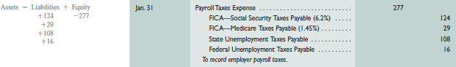

**ESTIMATED LIABILITIES**

An **estimated liability** is a known obligation that is of an uncertain amount but that can be reasonably estimated. Common examples are employee benefits such as pensions, health care and vacation pay, and warranties offered by a seller. We discuss each of these in this section. Other examples of estimated liabilities include property taxes and certain contracts to provide future services.

**Health and Pension Benefits**

Many companies provide **employee benefits** beyond salaries and wages. An employer often pays all or part of medical, dental, life, and disability insurance. Many employers also contribute to *pension plans*, which are agreements by employers to provide benefits (payments) to employees after retirement.

To illustrate, assume that an employer agrees to (1) pay an amount for medical insurance equal to $8,000 and (2) contribute an additional 10% of the employees' $120,000 gross salary to a retirement program. The entry to record these accrued benefits is



**Bonus Plans**

Many companies offer bonuses to employees, and many of the bonuses depend on net income. To illustrate, assume that an employer offers a bonus to its employees equal to 5% of the company's annual net income (to be equally shared by all). The company's expected annual net income is $210,000. The year-end adjusting entry to record this benefit is

|  |
| --- |
| http://textflow.mheducation.com/figures/007742994X/wiL25389_utb0917.png |

* Bonus Expense (B) equals 6% of net income, which equals $200,000 minus the bonus; this is computed as:



When the bonus is paid, Bonus Payable is debited and Cash is credited for $11,321

**Warranty Liabilities**

A **warranty** is a seller's obligation to replace or correct a product (or service) that fails to perform as expected within a specified period. Most new cars, for instance, are sold with a warranty covering parts for a specified period of time.

To comply with the *full disclosure* and *matching principles*, the seller reports the expected warranty expense in the period when revenue from the sale of the product or service is reported.

The seller reports this warranty obligation as a liability, although the existence, amount, payee, and date of future sacrifices are uncertain. This is because such warranty costs are probable and the amount can be estimated using, for instance, past experience with warranties.

To illustrate, a dealer sells a used car for $16,000 on December 1, 2016, with a maximum one-year or 12,000-mile warranty covering parts. This **dealer's experience** shows that warranty expense averages about 4% of a car's selling price, or $640 in this case ($16,000 × 4%). The dealer records the estimated expense and liability related to this sale with this entry:



The estimated warranty expense is reported on the 2016 income statement and the warranty liability on the 2016 balance sheet.

To further extend this example, suppose the customer returns the car for warranty repairs on January 9, 2017. The dealer performs this work by replacing parts costing $200. The entry to record partial settlement of the estimated warranty liability is



This entry reduces the balance of the estimated warranty liability. **Warranty expense** was previously recorded in 2016, the year the car was sold with the warranty. Note the credit is to auto parts inventory. **The expense is only recorded in the period when the product is sold.**

Finally, what happens if total warranty expenses are more or less than the estimated 4%, or $640? The answer is that management should monitor actual warranty expenses to see whether the 4% rate is accurate. If experience reveals a large difference from the estimate, the rate for current and future sales should be changed. Differences are expected, but they should be small.

**CONTINGENT LIABILITIES**

A **contingent liability** is a potential obligation that depends on a future event arising from a past transaction or event. An example is a pending lawsuit. Here, a past transaction or event leads to a lawsuit whose result depends on the outcome of the suit. Future payment of a contingent liability depends on whether an uncertain future event occurs.

**Accounting for Contingent Liabilities**

Accounting for contingent liabilities depends on the **likelihood that a future event will occur** and the ability to estimate the future amount owed if this event occurs.

Three different possibilities are identified in the following chart: record liability, disclose in notes, or no disclosure.

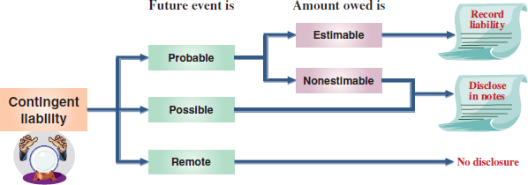

The conditions that determine each of these three possibilities follow:

1. The future event is ***probable*** (likely) and the amount owed can be *reasonably estimated.* We then record this amount as a liability. Examples are the estimated liabilities described earlier such as warranties, vacation pay, and income taxes.
2. The future event is ***reasonably possible*** (could occur). We disclose information about this type of contingent liability in **notes to the financial statements.**
3. The future event is *remote* (unlikely). We **do not record or disclose** information on remote contingent liabilities.

**Reasonably Possible Contingent Liabilities**

This section identifies and discusses contingent liabilities that commonly fall in the second category — when the future event is reasonably possible. Disclosing information about contingencies in this category is motivated by the *full-disclosure principle*, which requires information relevant to decision makers be reported and not ignored.

**Potential Legal Claims**

Many companies are sued or at risk of being sued. The accounting issue is whether the defendant should recognize a liability on its balance sheet or disclose a contingent liability in its notes while a lawsuit is outstanding and not yet settled.

The answer is that a potential claim is recorded in the accounts *only* if payment for damages is probable and the amount can be reasonably estimated.

If the potential claim cannot be reasonably estimated or is less than probable but reasonably possible, it is disclosed.

**Debt Guarantees**

Sometimes a company guarantees the payment of debt owed by a supplier, customer, or another company. The guarantor usually discloses the guarantee in its financial statement notes as a contingent liability. If it is probable that the debtor will default, the guarantor needs to record and report the guarantee in its financial statements as a liability.

**Other Contingencies**

Other examples of contingencies include environmental damages, possible tax assessments, insurance losses, and government investigations.

**Uncertainties That Are Not Contingencies**

All organizations face uncertainties from future events such as natural disasters and the development of new competing products or services. These uncertainties are not contingent liabilities because they are future events *not* arising from past transactions. Accordingly, they are not disclosed.

**Decision Tree**

* **These are possible liabilities arising from a past transaction that may not result in a future obligation**
* **If the future event is:**
  + **Probable and estimable, record the liability**
  + **Probable but cannot be estimated, disclose in financial statements notes**
  + **Possible but cannot be estimated, disclose in financial statement notes**
  + **Remote, disclosure is not required**