DCC 201 Sole Proprietor Adjusting Journal Entries In Class Assignments

QS 3-5
Prepaid (deferred) expenses adjustments P1
For each separate case below, follow the 3-step process for adjusting the prepaid asset account at December 31. Step 1: Determine what the current account balance equals. Step 2: Determine what the current account balance should equal. Step 3: Record the December 31 adjusting entry to get from step 1 to step 2. Assume no other adjusting entries are made during the year.
- Prepaid Insurance. The Prepaid Insurance account has a $4,700 debit balance to start the year. A review of insurance policies and payments shows that $900 of unexpired insurance remains at year-end.
- Prepaid Insurance. The Prepaid Insurance account has a $5,890 debit balance at the start of the year. A review of insurance policies and payments shows $1,040 of insurance has expired by year-end.
- Prepaid Rent. On September 1 of the current year, the company prepaid $24,000 for 2 years of rent for facilities being occupied that day. The company debited Prepaid Rent and credited Cash for $24,000.

QS 3-6.
Prepaid (deferred) expenses adjustments P1
For each separate case below, follow the 3-step process for adjusting the supplies asset account at December 31. Step 1: Determine what the current account balance equals. Step 2: Determine what the current account balance should equal. Step 3: Record the December 31 adjusting entry to get from step 1 to step 2. Assume no other adjusting entries are made during the year.
- Supplies. The Supplies account has a $300 debit balance to start the year. No supplies were purchased during the current year. A December 31 physical count shows $110 of supplies remaining.
- Supplies. The Supplies account has an $800 debit balance to start the year. Supplies of $2,100 were purchased during the current year and debited to the Supplies account. A December 31 physical count shows $650 of supplies remaining.
- Supplies. The Supplies account has a $4,000 debit balance to start the year. During the current year, supplies of $9,400 were purchased and debited to the Supplies account. The inventory of supplies available at December 31 totaled $2,660.

QS 3-8
Accumulated depreciation adjustments P1
For each separate case below, follow the 3-step process for adjusting the accumulated depreciation account at December 31. Step 1: Determine what the current account balance equals. Step 2: Determine what the current account balance should equal. Step 3: Record the December 31 adjusting entry to get from step 1 to step 2. Assume no other adjusting entries are made during the year.
- Accumulated Depreciation. The Krug Company's Accumulated Depreciation account has a $13,500 balance to start the year. A review of depreciation schedules reveals that $14,600 of depreciation expense must be recorded for the year.
- Accumulated Depreciation. The company has only one fixed asset (truck) that it purchased at the start of this year. That asset had cost $44,000, had an estimated life of five years, and is expected to have zero value at the end of the five years.
- Accumulated Depreciation. The company has only one fixed asset (equipment) that it purchased at the start of this year. That asset had cost $32,000, had an estimated life of seven years, and is expected to be valued at $4,000 at the end of the seven years.

QS 3-9
Adjusting for depreciation P1
- Barga Company purchases $20,000 of equipment on January 1, 2015. The equipment is expected to last five years and be worth $2,000 at the end of that time. Prepare the entry to record one year's depreciation expense of $3,600 for the equipment as of December 31, 2015.
- Welch Company purchases $10,000 of land on January 1, 2015. The land is expected to last indefinitely. What depreciation adjustment, if any, should be made with respect to the Land account as of December 31, 2015?

QS 3-11
Adjusting for unearned revenues P1
- Tao Co. receives $10,000 cash in advance for 4 months of legal services on October 1, 2015, and records it by debiting Cash and crediting Unearned Revenue both for $10,000. It is now December 31, 2015, and Tao has provided legal services as planned. What adjusting entry should Tao make to account for the work performed from October 1 through December 31, 2015?
- A. Caden started a new publication called Contest News. Its subscribers pay $24 to receive 12 monthly issues. With every new subscriber, Caden debits Cash and credits Unearned Subscription Revenue for the amounts received. The company has 100 new subscribers as of July 1, 2015. It sends Contest News to each of these subscribers every month from July through December. Assuming no changes in subscribers, prepare the journal entry that Caden must make as of December 31, 2015, to adjust the Subscription Revenue account and the Unearned Subscription Revenue account.

QS 3-13
Accruing salaries P1 A1
Molly Mocha employs one college student every summer in her coffee shop. The student works the five weekdays and is paid on the following Monday. (For example, a student who works Monday through Friday, June 1 through June 5, is paid for that work on Monday, June 8.) The coffee shop adjusts its books monthly, if needed, to show salaries earned but unpaid at month-end. The student works the last week of July—Friday is August 1. If the student earns $100 per day, what adjusting entry must the coffee shop make on July 31 to correctly record accrued salaries expense for July?
Problem 3-2A
Preparing adjusting and subsequent journal entries C1 A1 P1
Arnez Co. follows the practice of recording prepaid expenses and unearned revenues in balance sheet accounts. The company's annual accounting period ends on December 31, 2015. The following information concerns the adjusting entries to be recorded as of that date.
- The Office Supplies account started the year with a $4,000 balance. During 2015, the company purchased supplies for $13,400, which was added to the Office Supplies account. The inventory of supplies available at December 31, 2015, totaled $2,554.
- An analysis of the company's insurance policies provided the following facts.
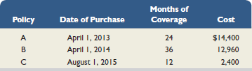
The total premium for each policy was paid in full (for all months) at the purchase date, and the Prepaid Insurance account was debited for the full cost. (Year-end adjusting entries for Prepaid Insurance were properly recorded in all prior years.)
- The company has 15 employees, who earn a total of $1,960 in salaries each working day. They are paid each Monday for their work in the five-day workweek ending on the previous Friday. Assume that December 31, 2015, is a Tuesday, and all 15 employees worked the first two days of that week. Because New Year's Day is a paid holiday, they will be paid salaries for five full days on Monday, January 6, 2016.
- The company purchased a building on January 1, 2015. It cost $960,000 and is expected to have a $45,000 salvage value at the end of its predicted 30-year life. Annual depreciation is $30,500.
- Since the company is not large enough to occupy the entire building it owns, it rented space to a tenant at $3,000 per month, starting on November 1, 2015. The rent was paid on time on November 1, and the amount received was credited to the Rent Earned account. However, the tenant has not paid the December rent. The company has worked out an agreement with the tenant, who has promised to pay both December and January rent in full on January 15. The tenant has agreed not to fall behind again.
- On November 1, the company rented space to another tenant for $2,800 per month. The tenant paid five months' rent in advance on that date. The payment was recorded with a credit to the Unearned Rent account.
Check (1b) Dr. Insurance Expense, $7,120 (1d) Dr. Depreciation Expense, $30,500

Required
- Use the information to prepare adjusting entries as of December 31, 2015.

PROBLEM SET A
Problem 3-1A
Identifying adjusting entries with explanations C3 P1
For each of the following entries, enter the letter of the explanation that most closely describes it in the space beside each entry. (You can use letters more than once.)
A.To record receipt of unearned revenue.
B.To record this period's earning of prior unearned revenue.
C.To record payment of an accrued expense.
D.To record receipt of an accrued revenue.
E.To record an accrued expense.
F.To record an accrued revenue.
G.To record this period's use of a prepaid expense.
H.To record payment of a prepaid expense.
I.To record this period's depreciation expense.

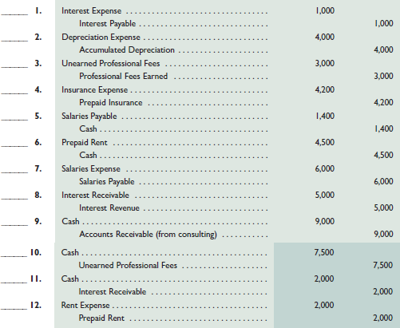

If there is enough time:
Problem 3-3A
Preparing adjusting entries, adjusted trial balance, and financial statements A1 P1 P2 P3
Wells Technical Institute (WTI), a school owned by Tristana Wells, provides training to individuals who pay tuition directly to the school. WTI also offers training to groups in off-site locations. Its unadjusted trial balance as of December 31, 2015, follows. WTI initially records prepaid expenses and unearned revenues in balance sheet accounts. Descriptions of items a through h that require adjusting entries on December 31, 2015, follow.
Additional Information Items
- An analysis of WTI's insurance policies shows that $2,400 of coverage has expired.
- An inventory count shows that teaching supplies costing $2,800 are available at year-end 2015.
- Annual depreciation on the equipment is $13,200.
- Annual depreciation on the professional library is $7,200.
- On November 1, WTI agreed to do a special six-month course (starting immediately) for a client. The contract calls for a monthly fee of $2,500, and the client paid the first five months' fees in advance. When the cash was received, the Unearned Training Fees account was credited. The fee for the sixth month will be recorded when it is collected in 2016.
- On October 15, WTI agreed to teach a four-month class (beginning immediately) for an individual for $3,000 tuition per month payable at the end of the class. The class started on October 15, but no payment has yet been received. (WTI's accruals are applied to the nearest half-month; for example, October recognizes one-half month accrual.)
- WTI's two employees are paid weekly. As of the end of the year, two days' salaries have accrued at the rate of $100 per day for each employee.
- The balance in the Prepaid Rent account represents rent for December.
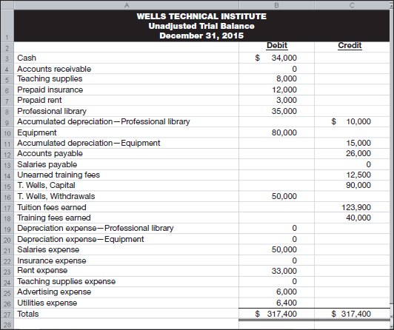
Required
- Prepare T-accounts (representing the ledger) with balances from the unadjusted trial balance.
- Prepare the necessary adjusting journal entries for items a through h and post them to the T-accounts. Assume that adjusting entries are made only at year-end.
- Update balances in the T-accounts for the adjusting entries and prepare an adjusted trial balance.
- Prepare Wells Technical Institute's income statement and statement of owner's equity for the year 2015 and prepare its balance sheet as of December 31, 2015.

