In Class Assignments Corporations Student Version Wild 22e
QS 13-2
Issuance of common stock P1
Prepare the journal entry to record Zende Company's issuance of 75,000 shares of $5 par value common stock assuming the shares sell for:
- $5 cash per share.
- $6 cash per share.

QS 13-3
Issuance of par and stated value common stock P1
Prepare the journal entry to record Jevonte Company's issuance of 36,000 shares of its common stock assuming the shares have a:
- $2 par value and sell for $18 cash per share.
- $2 stated value and sell for $18 cash per share.

Exercise 13-2
Accounting for par, stated, and no-par stock issuances P1
Rodriguez Corporation issues 19,000 shares of its common stock for $152,000 cash on February 20. Prepare journal entries to record this event under each of the following separate situations.
- The stock has a $2 par value.
- The stock has neither par nor stated value.
- The stock has a $5 stated value.

Exercise 13-3
Recording stock issuances P1
Prepare journal entries to record the following four separate issuances of stock.
- A corporation issued 4,000 shares of $5 par value common stock for $35,000 cash.
- A corporation issued 2,000 shares of no-par common stock to its promoters in exchange for their efforts, estimated to be worth $40,000. The stock has a $1 per share stated value.
- A corporation issued 2,000 shares of no-par common stock to its promoters in exchange for their efforts, estimated to be worth $40,000. The stock has no stated value.
- A corporation issued 1,000 shares of $50 par value preferred stock for $60,000 cash.
Exercise 13-4
Stock issuance for noncash assets P1
Sudoku Company issues 7,000 shares of $7 par value common stock in exchange for land and a building. The land is valued at $45,000 and the building at $85,000. Prepare the journal entry to record issuance of the stock in exchange for the land and building.

QS 13-11
Purchase and sale of treasury stock P3
On May 3, Zirbal Corporation purchased 4,000 shares of its own stock for $36,000 cash. On November 4, Zirbal reissued 850 shares of this treasury stock for $8,500. Prepare the May 3 and November 4 journal entries to record Zirbal's purchase and reissuance of treasury stock.

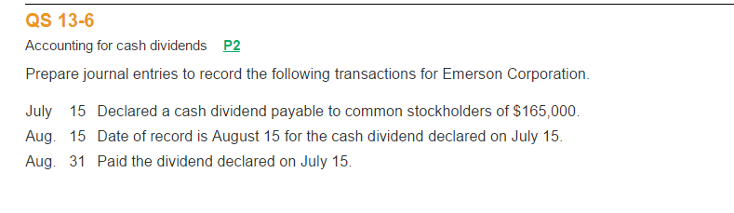
QS 13-9
Preferred stock issuance and dividends C2
- Prepare the journal entry to record Tamasine Company's issuance of 5,000 shares of $100 par value, 7% cumulative preferred stock for $102 cash per share.
- Assuming the facts in part 1, if Tamasine declares a year-end cash dividend, what is the amount of dividend paid to preferred shareholders? (Assume no dividends in arrears.)

Exercise 13-8
Dividends on common and noncumulative preferred stock C2
York's outstanding stock consists of 80,000 shares of noncumulative 7.5% preferred stock with a $5 par value and also 200,000 shares of common stock with a $1 par value. During its first four years of operation, the corporation declared and paid the following total cash dividends:
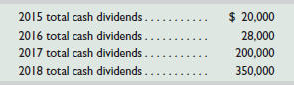
Determine the amount of dividends paid each year to each of the two classes of stockholders: preferred and common. Also compute the total dividends paid to each class for the four years combined.
Check 4-year total paid to preferred, $108,000

Exercise 13-9
Dividends on common and cumulative preferred stock C2
Use the data in Exercise 13-8 to determine the amount of dividends paid each year to each of the two classes of stockholders assuming that the preferred stock is cumulative. Also determine the total dividends paid to each class for the four years combined.

QS 13-7
Accounting for small stock dividend P2
The stockholders' equity section of Jun Company's balance sheet as of April 1 follows. On April 2, Jun declares and distributes a 10% stock dividend. The stock's per share market value on April 2 is $20 (prior to the dividend). Prepare the stockholders' equity section immediately after the stock dividend.
