Financial Statement Analysis
All financial statements are historical documents. They summarize what has happened during a particular period. However, most users of financial statements are concerned with what will happen in the future.
For example, stockholders are concerned with future earnings and dividends and creditors are concerned with the company's future ability to repay its debts.
While financial statements are historical in nature, they can still provide users with valuable insights. These users rely on financial statement analysis, which involves examining trends in key financial data, comparing financial data across companies, and analyzing financial ratios to assess the financial health and future prospects of a company.
Managers are also vitally concerned with the financial ratios discussed in this chapter.
First, the ratios provide indicators of how well the company and its business units are performing.
The specific ratios selected depend on the company's strategy. For example, a company that wants to emphasize responsiveness to customers may closely monitor the inventory turnover ratio discussed later in this chapter.
Second, because managers must report to stockholders and may want to raise funds from external sources, managers must pay attention to the financial ratios used by external investors.
An item on a balance sheet or income statement has little meaning by itself. Suppose a company's sales for a year were $250 million. In isolation, that is not particularly useful information. How does that stack up against last year's sales? How do the sales relate to the cost of goods sold? In making these kinds of comparisons, three analytical techniques are widely used:
- Dollar and percentage changes on statements (horizontal analysis).
- Common-size statements (vertical analysis).
- Ratios.

STATEMENTS IN COMPARATIVE AND COMMON-SIZE FORM

Dollar and Percentage Changes on Statements
Horizontal analysis (also known as trend analysis) involves analyzing financial data over time, such as computing year-to-year dollar and percentage changes within a set of financial statements.
The dollar changes highlight the changes that are the most important economically; the percentage changes highlight the changes that are the most unusual.
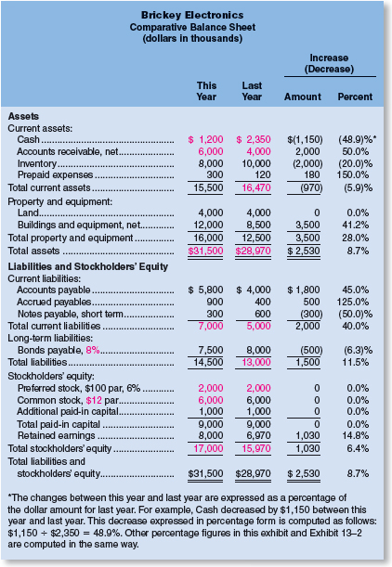

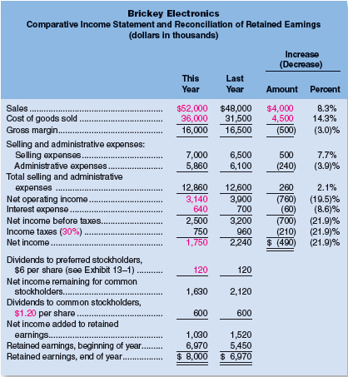
Horizontal analysis can be even more useful when data from a number of years are used to compute trend percentages. To compute trend percentages, a base year is selected and the data for all years are stated as a percentage of that base year.

Common-Size Statements
Horizontal analysis, which was discussed in the previous section, examines changes in financial statement accounts over time.
Vertical analysis focuses on the relations among financial statement accounts at a given point in time. A common-size financial statement is a vertical analysis in which each financial statement account is expressed as a percentage.
In income statements, all items are usually expressed as a percentage of sales. In balance sheets, all items are usually expressed as a percentage of total assets.
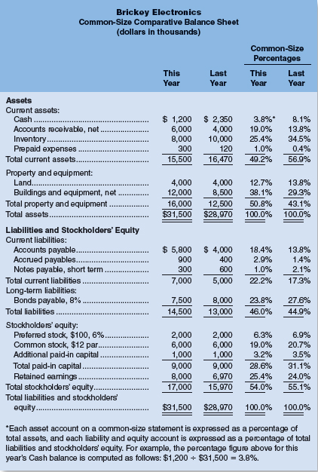
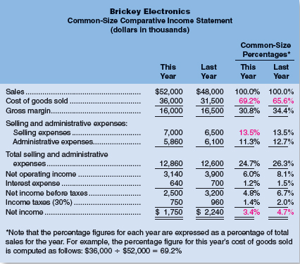
Placing all assets in common-size form clearly shows the relative importance of the current assets as compared to the noncurrent assets. It also shows that significant changes have taken place in the composition of the current assets over the last year. For example, accounts receivable have increased in relative importance and both cash and inventory have declined in relative importance. Judging from the sharp increase in accounts receivable, the deterioration in the cash balance may be a result of an inability to collect from customers.
Shifting now to the income statement, the cost of goods sold as a percentage of sales increased from 65.6% last year to 69.2% this year. Or looking at this from a different viewpoint, the gross margin percentage declined from 34.4% last year to 30.8% this year.
Managers and investment analysts often pay close attention to this measure of profitability. The gross margin percentage is computed as follows:

The gross margin percentage should be more stable for retailing companies than for other companies because the cost of goods sold in retailing excludes fixed costs.
Common-size statements are particularly useful when comparing the performance of different companies.

RATIO ANALYSIS—THE COMMON STOCKHOLDER
Common stockholders use financial ratios related to net income, dividends, and stockholders' equity to assess a company's financial performance. This section describes seven of those ratios. All calculations will be performed for this year.
Earnings per Share
An investor buys a stock in the hope of realizing a return in the form of either dividends or future increases in the value of the stock. Because earnings form the basis for dividend payments and future increases in the value of shares, investors are interested in a company's earnings per share.
Earnings per share is computed by dividing net income minus dividends paid to preferred stockholders is the net income available for common stockholders by the average number of common shares outstanding during the year.

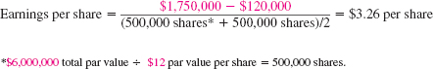
The number of common shares outstanding is calculated by taking the dollar amount of common stock shown in the balance sheet and dividing it by the common stock's par value per share.
Price Earnings Ratio
The price-earnings ratio expresses the relationship between a stock's market price per share and its earnings per share. If we assume that Brickey Electronics' stock has a market price of $40 per share at the end of this year, then its price-earnings ratio would be computed as follows:

A high price-earnings ratio means that investors are willing to pay a premium for the company's stock—presumably because the company is expected to have higher than average future earnings growth. Conversely, if investors believe a company's future earnings growth prospects are limited, the company's price-earnings ratio would be relatively low.
Return on Total Assets
The return on total assets is a measure of operating performance that is defined as follows:
Interest expense is added back to net income to show what earnings would have been if the company had no debt. Notice that the interest expense is placed on an after-tax basis by multiplying it by the factor (1 − Tax rate).
The return on total assets for Brickey Electronics is computed as follows
Brickey Electronics has earned a return of 7.3% on average total assets employed over the last year.
Return on Common Stockholders' Equity
The return on common stockholders' equity is based on the book value of common stockholders' equity. It is computed as follows:
where
For Brickey Electronics, the return on common stockholders' equity is computed as follows:
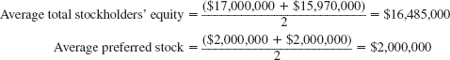
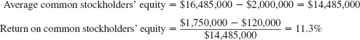
Compare the return on common stockholders' equity above (11.3%) with the return on total assets computed in the preceding section (7.3%). Why is the return on common stockholders' equity so much higher? The answer lies in financial leverage.
HELPFUL HINT
When the numerator of a financial ratio contains an amount from the income statement and the denominator contains an amount derived from the balance sheet, the denominator must be expressed as an average. This averaging process is done because the income statement summarizes performance for a period of time, whereas the balance sheet reflects a company's financial position at a point in time. The average for a balance sheet account is typically computed by taking the account's beginning balance plus its ending balance and dividing this sum by two.

RATIO ANALYSIS—THE SHORT-TERM CREDITOR
Short-term creditors, such as suppliers, want to be paid on time. Therefore, they focus on the company's cash flows and on its working capital because these are the company's short-term primary sources of cash. All calculations in this section will be performed for this year.
Working Capital
The excess of current assets over current liabilities is known as working capital.
The working capital for Brickey Electronics is computed as follows:
Ample working capital provides some assurance to short-term creditors that they will be paid by the company. However, maintaining large amounts of working capital isn't free.
A large and growing working capital balance may not be a good sign. For example, it could be the result of unwarranted growth in inventories. To put working capital into proper perspective, it should be supplemented with the following four ratios—the current ratio, the acid-test ratio, the accounts receivable turnover, and the inventory turnover—each of which will be discussed in turn.

Current Ratio
A company's working capital is frequently expressed in ratio form. A company's current assets divided by its current liabilities is known as the current ratio:
For Brickey Electronics, the current ratio is computed as follows:
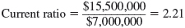
Although widely regarded as a measure of short-term debt-paying ability, the current ratio must be interpreted with great care.
A declining ratio might be a sign of a deteriorating financial condition, or it might be the result of eliminating obsolete inventories or other stagnant current assets. An improving ratio might be the result of stockpiling inventory, or it might indicate an improving financial situation. In short, the current ratio is useful, but tricky to interpret.
The general rule of thumb calls for a current ratio of at least 2. However, many companies successfully operate with a current ratio below 2.
The adequacy of a current ratio depends heavily on the composition of the assets. For example, as we see in the table below, both Worthington Corporation and Greystone, Inc., have current ratios of 2. However, they are not in comparable financial condition. Greystone is more likely to have difficulty meeting its current financial obligations because almost all of its current assets consist of inventory rather than more liquid assets such as cash and accounts receivable.
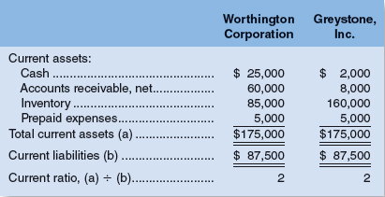

Acid-Test (Quick) Ratio
The acid-test (quick) ratio is a more rigorous test of a company's ability to meet its short-term debts than the current ratio. Inventories and prepaid expenses are excluded from total current assets, leaving only the more liquid (or “quick”) assets to be divided by current liabilities.
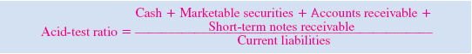
The acid-test ratio measures how well a company can meet its obligations without having to liquidate or depend too heavily on its inventory.
Ideally, each dollar of liabilities should be backed by at least $1 of quick assets.
The acid-test ratio for Brickey Electronics is computed below:
Although Brickey Electronics' acid-test ratio is within the acceptable range, an analyst might be concerned about several trends revealed in the company's balance sheet. Short-term debts are rising, while the cash balance is declining. Perhaps the lower cash balance is a result of the substantial increase in accounts receivable. In short, as with the current ratio, the acid-test ratio should be interpreted with one eye on its basic components.

Accounts Receivable Turnover
The accounts receivable turnover and average collection period ratios measure how quickly credit sales are converted into cash. The accounts receivable turnover is computed by dividing sales on account (i.e., credit sales) by the average accounts receivable balance for the year:
Assuming that all of Brickey Electronics' sales were on account, its accounts receivable turnover is computed as follows:

Average Collection Period
The accounts receivable turnover can then be divided into 365 days to determine the average number of days required to collect an account (known as the average collection period).
The average collection period for Brickey Electronics is computed as follows:
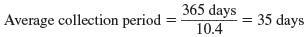
This means that on average it takes 35 days to collect a credit sale.
Whether this is good or bad depends on the credit terms Brickey Electronics is offering its customers. Many customers will tend to withhold payment for as long as the credit terms allow. If the credit terms are 30 days, then a 35-day average collection period would usually be viewed as very good. On the other hand, if the company's credit terms are 10 days, then a 35-day average collection period is worrisome.
A long collection period may result from having too many old uncollectible accounts, failing to bill promptly or follow up on late accounts, lax credit checks, and so on.

Inventory Turnover
The inventory turnover ratio measures how many times a company's inventory has been sold and replaced during the year. It is computed by dividing the cost of goods sold by the average level of inventory [(Beginning inventory balance + Ending inventory balance) ÷ 2]:
Brickey's inventory turnover is computed as follows:
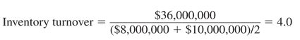

Average Sale Period
The number of days needed on average to sell the entire inventory (called the average sale period) can be computed by dividing 365 by the inventory turnover:
The average sale period varies from industry to industry. Grocery stores, with significant perishable stocks, tend to turn over their inventory quickly. On the other hand, jewelry stores tend to turn over their inventory slowly. In practice, average sales periods of 10 days to 90 days are common, depending on the industry.
A company whose inventory turnover ratio is much slower than the average for its industry may have too much inventory or the wrong sorts of inventory. Some managers argue that they must buy in large quantities to take advantage of quantity discounts. But these discounts must be compared to the added costs of insurance, taxes, financing, and risks of obsolescence and deterioration that result from carrying added inventories.

RATIO ANALYSIS—THE LONG-TERM CREDITOR
Long-term creditors are concerned with a company's ability to repay its loans over the long run.
For example, if a company paid out all of its available cash in the form of dividends, then nothing would be left to pay back creditors. Consequently, creditors often seek protection by requiring that borrowers agree to various restrictive covenants, or rules. These restrictive covenants typically include restrictions on dividend payments as well as rules stating that the company must maintain certain financial ratios at specified levels.
Times Interest Earned Ratio
The most common measure of a company's ability to provide protection to its long-term creditors is the times interest earned ratio. It is computed by dividing earnings before interest expense and income taxes (i.e., net operating income) by interest expense:
For Brickey Electronics, the times interest earned ratio for this year is computed as follows:
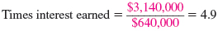
The times interest earned ratio is based on earnings before interest expense and income taxes because that is the amount of earnings that is available for making interest payments. Interest expenses are deducted before income taxes are determined; creditors have first claim on the earnings before taxes are paid.
A times interest earned ratio of less than 1 is inadequate because interest expense exceeds the earnings that are available for paying that interest. In contrast, a times interest earned ratio of 2 or more may be considered sufficient to protect long-term creditors.

Debt to Equity Ratio:
Long-term creditors are also concerned with a company's ability to keep a reasonable balance between its debt and equity. This balance is measured by the debt-to-equity ratio:
Brickey's debt-to-equity ratio for this year is computed as follows:
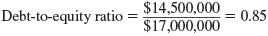
The debt-to-equity ratio indicates the relative proportions of debt and equity on the company's balance sheet. At the end of this year, Brickey Electronics' creditors were providing 85 cents for each $1 being provided by stockholders.
Because equity represents the excess of total assets over total liabilities, and hence a buffer of protection for the creditors, creditors would like to see less debt and more equity.
In practice, debt-to-equity ratios from 0.0 (no debt) to 3.0 are common. Generally speaking, in industries with little financial risk, creditors tolerate high debt-to-equity ratios. In industries with more financial risk, creditors demand lower debt-to-equity ratios.

LIMITATIONS OF FINANCIAL STATEMENT ANALYSIS
Comparing Financial Data across Companies
Comparisons of one company with another can provide valuable clues about the financial health of an organization. Unfortunately, differences in accounting methods between companies sometimes make it difficult to compare their financial data. Even with this limitation in mind, comparisons of key ratios with other companies and with industry averages often suggest avenues for further investigation.
Looking beyond Ratios
Ratios should not be viewed as an end, but rather as a starting point.
They raise many questions and point to opportunities for further analysis, but they rarely answer any questions by themselves.
In addition to ratios, analysts should evaluate industry trends, technological changes, changes in consumer tastes, changes in broad economic factors, and changes within the company itself.

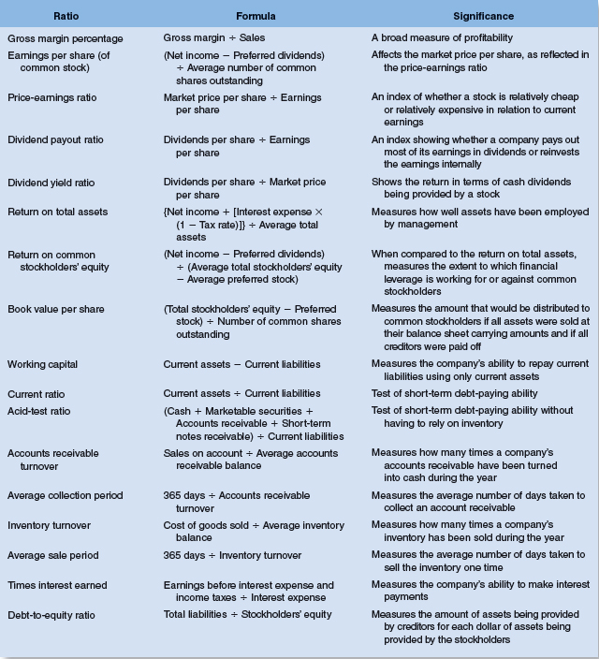
Your homework will include all ratios but for your test, you will not be responsible for:
Price Earnings Ratio
Dividend Payout Ratio
Dividend Yield Ratio
Times Interest Earned
Return on Common Stockholder’s Equity

