Issuing Bonds between Interest Dates
An issuer can sell bonds at a date other than an interest payment date. When this occurs, the buyers normally pay the issuer the purchase price plus any interest accrued since the prior interest payment date. This accrued interest is then repaid to these buyers on the next interest payment date.
To illustrate, suppose Avia sells $100,000 of its 9% bonds at par on March 1, 2016, 60 days after the stated issue date. The interest on Avia bonds is payable semiannually on each June 30 and December 31. Since 60 days have passed, the issuer collects accrued interest from the buyers at the time of issuance. This amount is $1,500 ($100,000 × 9% × 60/360 year).

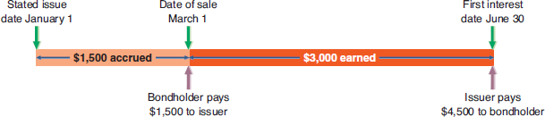
Accruing Interest between Interest Payment Dates at par
Avia records the issuance of these bonds on March 1 as follows:
Liabilities for interest payable and bonds payable are recorded in separate accounts.

When the June 30 semiannual interest date arrives, Avia pays the full semiannual interest of $4,500 ($100,000 × 9% × 1/2 year) to the bondholders. This payment includes the four months' interest of $3,000 earned by the bondholders from March 1 to June 30 plus the repayment of the 60 days' accrued interest collected by Avia when the bonds were sold. Avia records this first semiannual interest payment as follows:
The practice of collecting and then repaying accrued interest with the next interest payment is to simplify the issuer's administrative efforts.
To explain, suppose an issuer sells bonds on 15 or 20 different dates between the stated issue date and the first interest payment date. If the issuer does not collect accrued interest from buyers, it needs to pay different amounts of cash to each of them according to the time that passed after purchasing the bonds. The issuer needs to keep detailed records of buyers and the dates they bought bonds. Issuers avoid this recordkeeping by having each buyer pay accrued interest at purchase. Issuers then pay the full semiannual interest to all buyers, regardless of when they bought bonds.

