Quick Books second class project.
Take your time. I am not a QuickBooks expert and only want you to follow these exact steps. If you go someplace you didn’t want to go in the software, I can try to help you but most likely will tell you to start over again with a new company name.
We will go through these steps and save screen shots of what you are doing. I only want you to grab screen shots using the Snip tool. Here is the video link to the Snip instructions https://youtu.be/QfuaRMc59pY
Open up a word document and save the screenshots into it. You will then email it to me at the end of class to document your work.

Open up Quickbooks
- Under File in the top left-hand corner, fourth selection down – open a previous company
- Find Your Name Consulting Company on the drive where it is saved

Next Project: Customize the Chart of Accounts
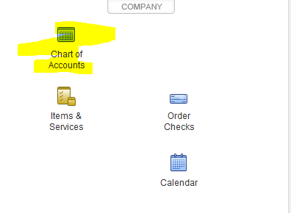
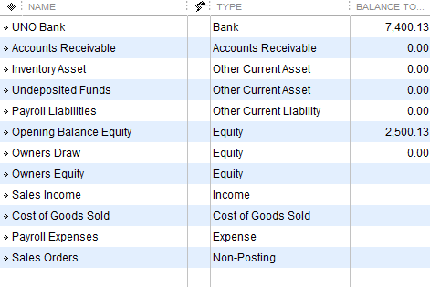

To show account numbers for the accounts
- Top left-hand corner, edit
- Last selection, preferences
- Top selection – Accounting
- Right Tab – Company preferences
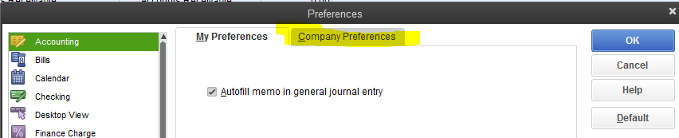
Click – Use Account numbers and OK
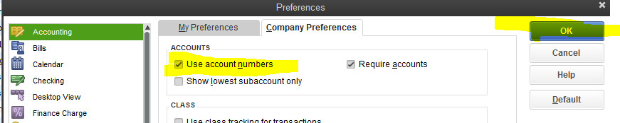
Will see account numbers now
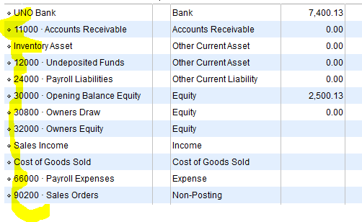

We will want to add an account number for UNO Bank
Click on UNO Bank and at the bottom of the chart of accounts, click Account
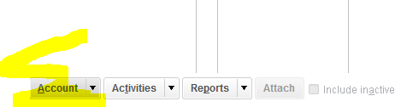
Select Edit Account and add number 10000 and save and close
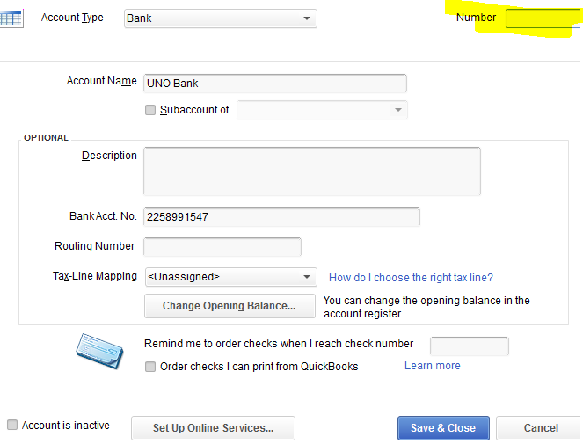
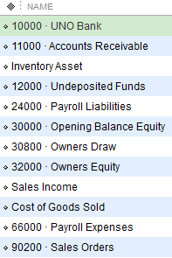

Next, we will add an account for advertising expense
Click on account at the bottom, select new. The following screen appears. Click expense and continue
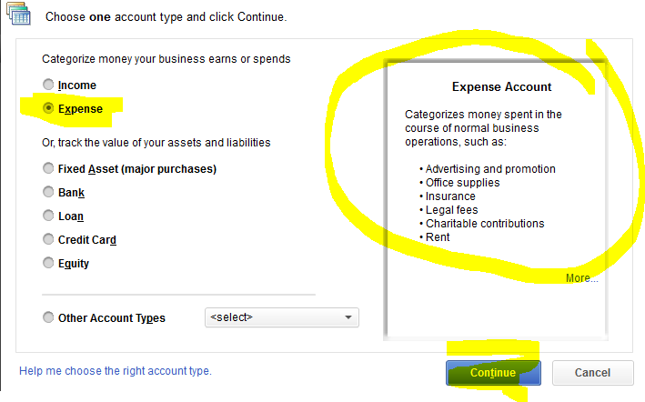

Fill out the following fields. Since the company is a sole proprietor, the tax schedules have been populated for a sole proprietorship. We will want to select, Schedule C advertising.
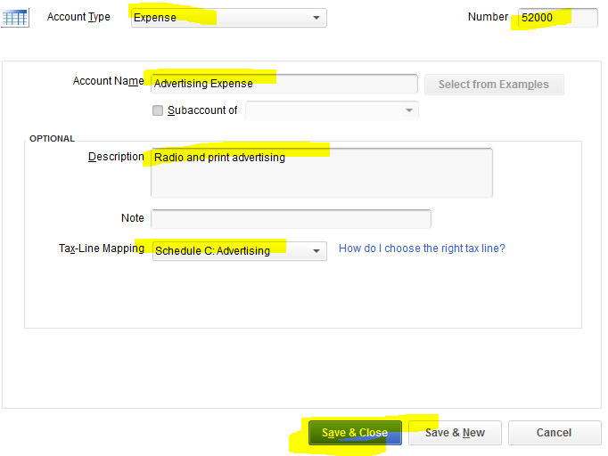

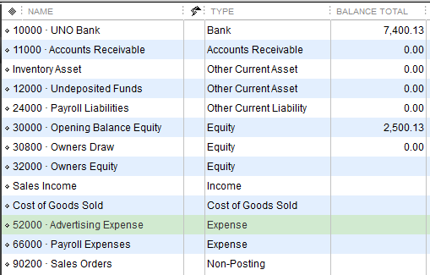
Next: Add account number (Don’t worry about tax schedules)
40000 to Sales Income and
50000 to Cost of Goods Sold

Next: Delete the account inventory asset because the company will not be selling inventory
- In the chart of accounts, select Inventory Asset
- At the bottom, select account
- In account, select Delete Account
- The program will ask if you are sure
- Click OK
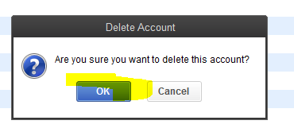

Your chart of accounts should look like this now:
GRAB A SCREENSHOT AND SAVE TO YOUR WORD DOCUMENT

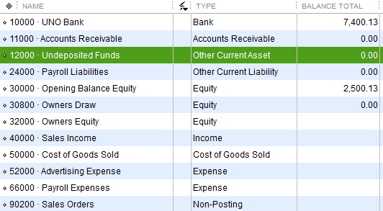
Next Project: Paying Bills
Close the chart of accounts view and you should be back to the module view
- In the module view, under vendors, select vendors
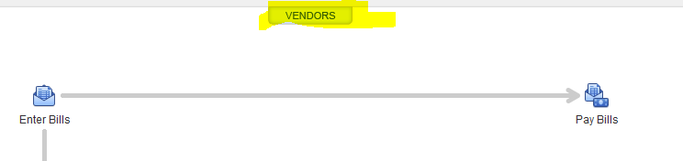
- In the top left hand corner, select new vendor
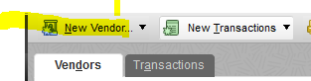

- Fill out the following
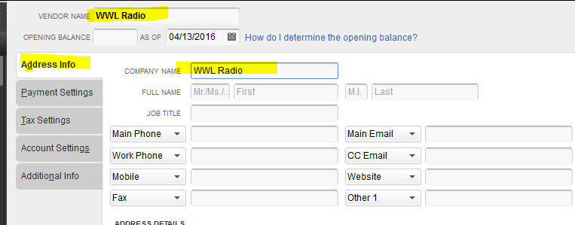
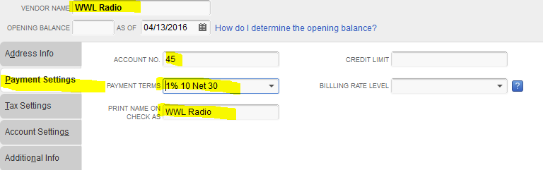
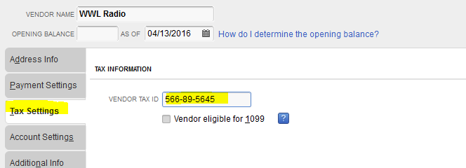
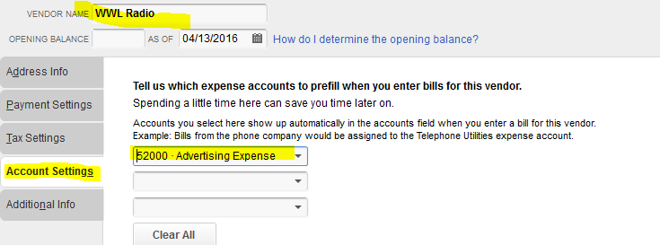
Under additional info, select new vendor type and add advertiser and click ok

Then click OK for to add vendor

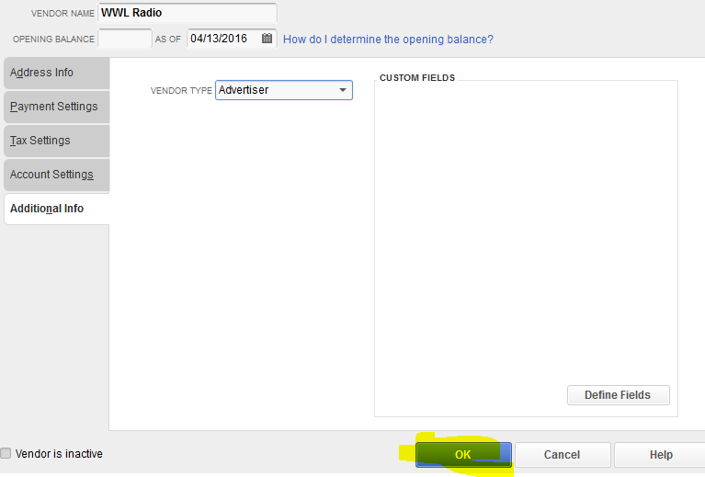

GRAB A SCREENSHOT AND SAVE TO YOUR WORD DOCUMENT

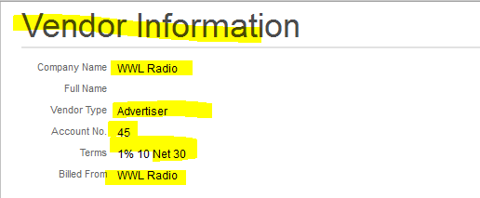

Close out screen and get back to module view
Under Banking, select write checks
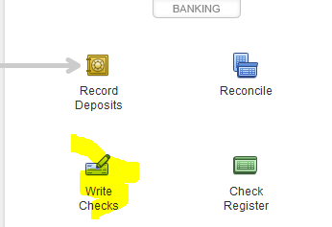

You will see a check prototype.
- In the pull down menu under Pay To the Order Of: Select WWL
- Fill in $100.00
- Click on Expenses
- Select Advertising expense
- Select Save & Close at bottom right hand corner
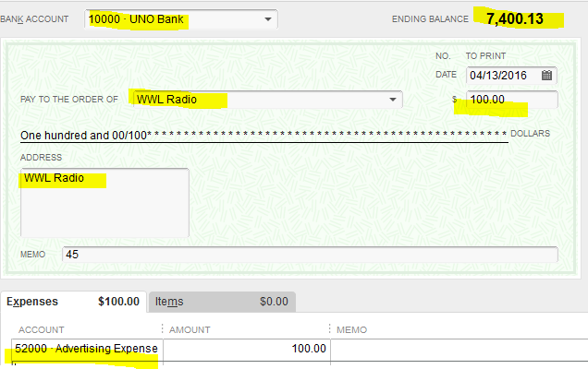
GRAB A SCREENSHOT AND SAVE TO YOUR WORD DOCUMENT
Next Project: View Check Register
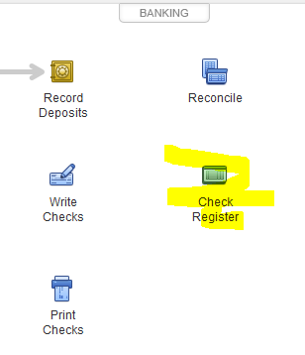
Click on check register. You should see this
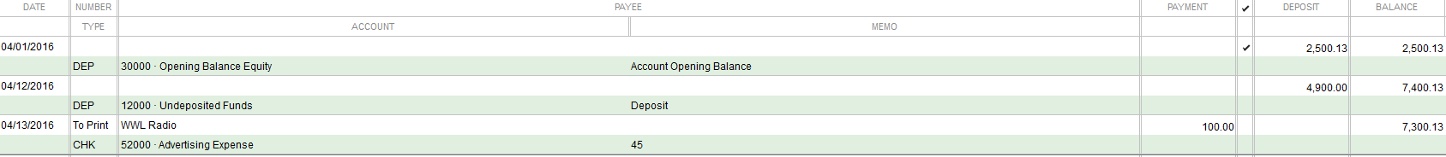
Exit screen and get back to module

Next Project: Print Journal Entries
In the module view,
- Select reports in top menu
- Go to Accountant and Taxes
- Select Journal in first box at the bottom
- You will see this message. Click OK
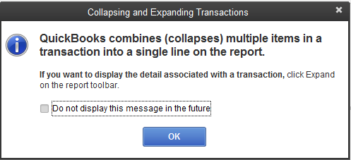

You will be brought to this screen
GRAB A SCREENSHOT AND SAVE TO YOUR WORD DOCUMENT
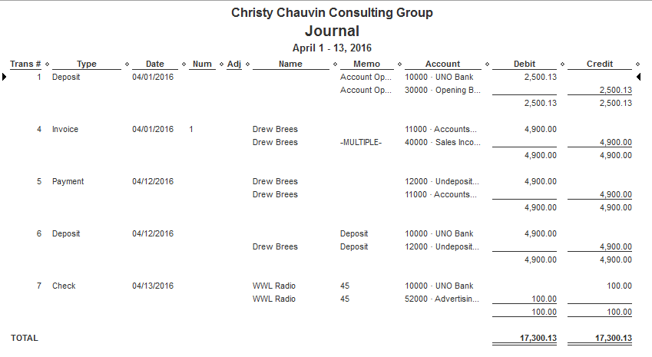

Next Project: Income Statement and Balance Sheet
Top Menu – Reports
- Select Company and Financial
- Select Profit and Loss Standard
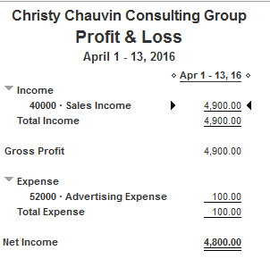
GRAB A SCREENSHOT AND SAVE TO YOUR WORD DOCUMENT

Go back to Reports Menu
- Select Company and Financial
- Select in second box, top selection, Standard Balance Sheet
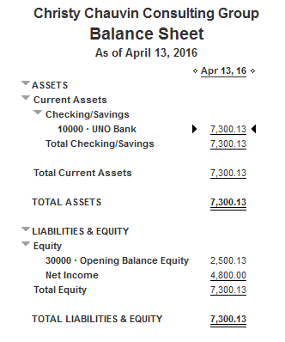
GRAB A SCREENSHOT AND SAVE TO YOUR WORD DOCUMENT

To Save:
- Select File in the top left hand corner
- Back up company
- Create local backup
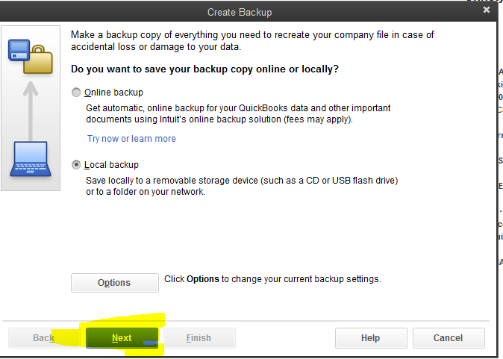

- Local back up has been selected for you.
- Click on Next
- The following screen will appear, under browse, select the drive to which you wish to save the back up (Should be your jump or portable drive)
- The recommended complete verification has been selected for you

- Click OK

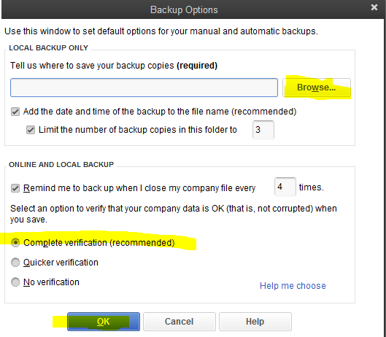

- You will see this message box and save it now has been selected for you, click next
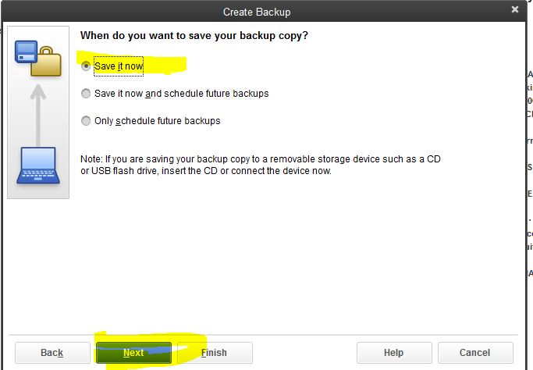

- You will see this message box, the software has named and dated your back up. Select save
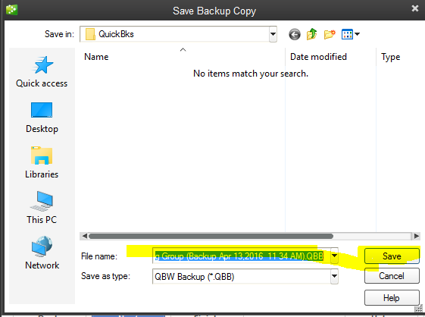

This is all for QuickBooks.

