DEMONSTRATION PROBLEM
After several months of planning, Jasmine Worthy started a haircutting business called Expressions. The following events occurred during its first month of business.
- On August 1, Worthy invested $3,000 cash and $15,000 of equipment in Expressions in exchange for its common stock.
- On August 2, Expressions paid $600 cash for furniture for the shop.
- On August 3, Expressions paid $500 cash to rent space in a strip mall for August.
- On August 4, it purchased $1,200 of equipment on credit for the shop (using a long-term note payable).
- On August 5, Expressions opened for business. Cash received from haircutting services in the first week and a half of business (ended August 15) was $825.
- On August 15, it provided $100 of haircutting services on account.
- On August 17, it received a $100 check for services previously rendered on account.
- On August 17, it paid $125 cash to an assistant for hours worked during the grand opening.
- Cash received from services provided during the second half of August was $930.
- On August 31, it paid a $400 installment toward principal on the note payable entered into on August 4.
- On August 31, it paid $900 in cash dividends to Worthy.
Required
- Arrange the following asset, liability, and equity titles in a table similar to the one in Show the effects of each transaction using the accounting equation.
- Prepare an income statement for August.
- Prepare a statement of retained earnings for August.
- Prepare a balance sheet as of August 31.

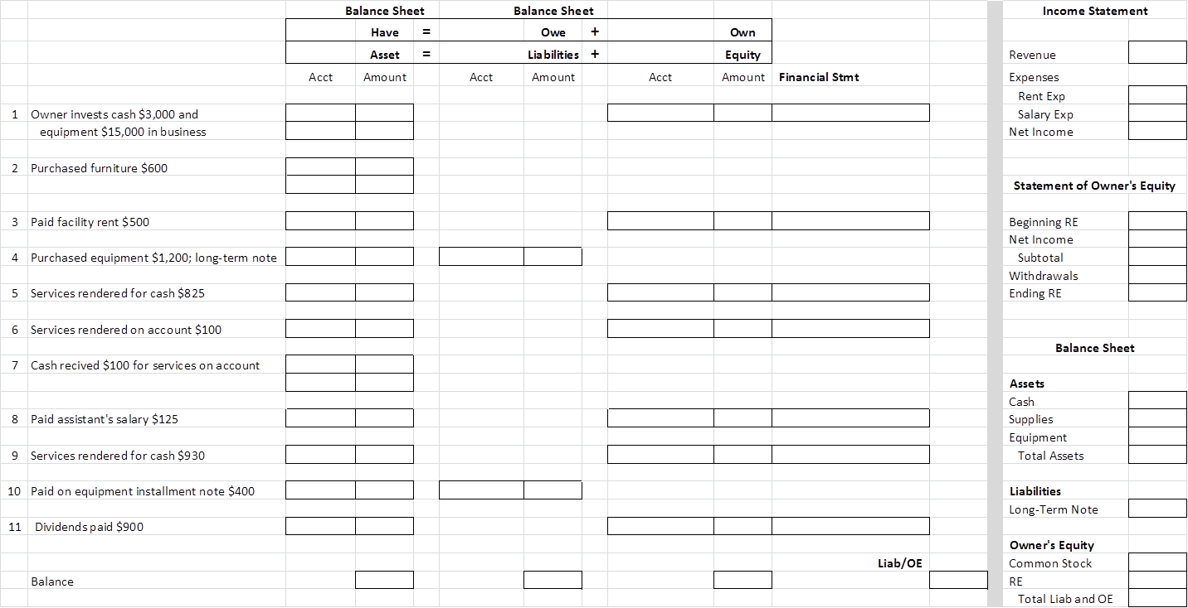
QS 1-8
Applying the accounting equation A1
- Use the accounting equation to compute the missing financial statement amounts (a), (b), and (c).
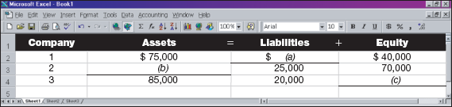
- Use the accounting equation to compute the missing financial statement amounts (a) and (b).
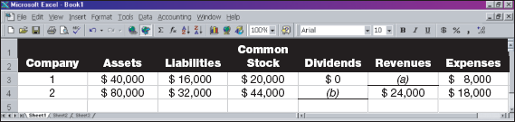

Exercise 1-8
Using the accounting equation A1 P1
Answer the following questions. (Hint: Use the accounting equation.)
- Office Store has assets equal to $123,000 and liabilities equal to $47,000 at year-end. What is the total equity for Office Store at year-end?
- At the beginning of the year, Addison Company's assets are $300,000 and its equity is $100,000. During the year, assets increase $80,000 and liabilities increase $50,000. What is the equity at the end of the year?
- At the beginning of the year, Quaker Company's liabilities equal $70,000. During the year, assets increase by $60,000, and at year-end assets equal $190,000. Liabilities decrease $5,000 during the year. What are the beginning and ending amounts of equity?

SOLUTION TO DEMONSTRATION PROBLEM
