**Bingham Chapter 8**

**Accounting for Fiduciary Activities – Agency and Trust Funds**

Governments are often involved in fiduciary activities whereby they hold assets that benefit individuals, organizations, or governments other than the reporting government. Because the resources related to such activities are not owned by the reporting government and cannot be used to support its programs, Governmental Accounting Standards Board (GASB) standards exclude the reporting of fiduciary activities in the government-wide financial statements. However, fiduciary activities are reported in fiduciary fund financial statements.

Four types of fiduciary funds are used to account for private-purpose activities in which a government holds assets as an agent or trustee

agency funds,

investment trust funds,

private-purpose trust funds, and

pension funds

Resources that are held in trust for the benefit of the government's own programs or its citizenry should be accounted for using a governmental fund rather than a fiduciary fund. We know from Chapter Four, such public-purpose trusts should be accounted for as special revenue funds if the resources are expendable for the trust purpose or as permanent funds if the trust principal is permanently restricted.

From an accounting perspective, the legal distinctions between trust and agency funds are not of major significance. The important and perhaps the sole consideration from an accounting standpoint is what can and what cannot be done with agency funds and trust funds assets in accordance with laws and other pertinent regulations. In general, examine the aggregate of factors involved such as the enactment that brought the relationship into existence and the regulations under which it operates.

Trust funds differ from agency funds principally in degree. Trust funds often exist over a longer period of time, represent and develop vested interests of a beneficiary to a greater extent, and involve more complex administration and financial accounting and reporting. Agency funds are used only if a government holds resources in a purely custodial capacity for others.

**Agency Funds**

Assets that are held in an agency fund belong to the party or parties for which the government acts as agent. **Therefore, agency fund assets are offset by liabilities equal in amount; no fund net position exists**. GASB requires agency fund assets and liabilities to be recognized on the accrual basis. Revenues and expenses are not recognized in the accounts of agency funds. The appropriate measurement focus would be economic resource measurement.

For example, local governments act as agents of the federal and state governments in the collection and remittance of employees’ withholding taxes, retirement contributions, and social security taxes. It is perfectly acceptable to account for the withholdings, and the remittance to federal and state governments, within the funds that account for the gross pay of the employees, as we saw in Chapter 4.

**Agency Fund for Special Assessment Debt Service**

GASB standards specify that a government that has no responsibility for the debt on special assessment debt in the event of property owners’ default but does perform the functions of billing property owners for the assessments, collecting installments of assessments and interest on the assessments, and paying interest and principal on the special assessment debt from these collections, should account for those activities by use of an agency fund.

**Tax Agency Funds**

An agency relationship that often results in the creation of an agency fund is the collection of taxes or other revenues by one government for several of the funds it operates and for other governments. State governments commonly collect sales taxes, gasoline taxes, and many other taxes that are apportioned to state agencies and to local governments within the state. At the local government level, it is common for an elected county official to serve as collector for all property taxes owed by persons or corporations owning property within the county. Taxes levied by all funds and governments within the county are certified to the county collector for collection. The county collector is required by law to make periodic distributions of tax collections for each year to each fund or government in the proportion that the levy for that fund or government bears to the total levy for the year. It is common for a government that collects taxes on behalf of other governments to be authorized to withhold a certain percentage from the collections for each government.

**“Pass-through” Agency Funds**

Grants, entitlements, or shared revenues from the federal or a state government often pass through one level of government (primary recipient) before distribution to a secondary recipient. Accounting for such “pass-through” grants depends on whether the primary recipient government is deemed to have *administrative involvement* or *direct financial involvement* in the grants.

According to GASB standards:

A recipient government has administrative involvement if, for example, it (a) monitors secondary recipients for compliance with program-specific requirements, (b) determines eligibility of secondary recipients or projects, even if using grantor-established criteria, or (c) has the ability to exercise discretion in how the funds are allocated. A recipient government has direct financial involvement if, for example, it finances some direct program costs because of a grantor-imposed matching requirement or is liable for disallowed costs.

If neither administrative nor financial involvement is deemed to exist, then a pass-through agency fund must be used and no revenue or expenditure/expense is recognized.

**TRUST FUNDS**

In addition to agency funds, the fiduciary fund classification includes three types of trust funds—investment trust funds, private-purpose trust funds, and pension trust funds.

Historically, trust funds have been created to account for assets received by the government in a trust agreement in which the assets are to be invested to produce income to be used for specified purposes (such as cultural or educational). The majority of such trusts benefit the government's own programs or its citizenry.

Trusts that benefit the government's own programs or citizens at large are accounted for as either special revenue funds or *permanent funds.* The type of fund used depends on whether the principal of the gift can be spent for the specified purposes (i.e., a special revenue fund) or is permanently restricted for investment, with only the earnings therefrom available to spend for the specified purposes (i.e., a permanent fund). Both special revenue funds and permanent funds are governmental fund types.

The GASB standards indicate that fiduciary funds are used when trusts benefit others, such as individuals, organizations, or other governments such as an investment pool, private purpose trust fund, or pension trust fund.

**Investment Pool**

It is common for governments to possess both long- and short-term investments, as well as idle cash within their funds. Effective management of investments can be enhanced by placing the investments of the funds in a pool under the control of the treasurer or a professional investment manager, either within the treasurer's office or in a financial institution such as a bank or investment firm.

If the investment pool is an internal investment pool (participating funds are all within the same government) an agency fund may be used to account for the investments in the pool.

If the investment pool has external participants (other governments or organizations outside the government administering the pool), an **external investment pool** is used. GASB standards require that an **investment trust fund** be used to account for the assets, liabilities, net position, and changes in net position corresponding to the equity of the external participants.The accounting for investment trust funds uses an economic resources measurement focus and the accrual basis of accounting.

When investments are transferred to the pool, they are transferred at their fair market value at the date of the transfer.

**Recording Transactions Affecting a Fiduciary Fund—An Investment Trust Fund**

The city council of the City of Bingham decided in late 2017 to create an investment pool that would put the city’s investments under professional management. The pool will be accounted for as an investment trust fund. The name of the fund, when it is established in early 2018, will be the Investment Pool Fund. The initial participants in the Investment Pool Fund will be the city’s debt service fund and the Bingham Consolidated School District (CSD).

The pool will be accounted for in accordance with GASB standards applicable to fiduciary funds; therefore, the city’s debt service fund assets managed by the investment pool will not be reported in the Investment Pool Fund financial statements.

Bingham as the administrator of the external investment pool also participates in the pool; therefore, its equity is considered internal and is not reported in the financial statements of the investment trust fund. Instead, the net position and changes in net position relating to the internal portion of the pool are presented in the financial statements of each participating fund and in the governmental activities and business-type activities of the sponsoring government's government-wide financial statements.

Unless there is a request for a withdrawal, investment earnings and changes in the fair value of investments are distributed to participants only at year-end. During the year, investment earnings are added to an Undistributed Earnings on Pooled Investments account and changes in fair value are added to or subtracted from an Undistributed Change in Fair Value of Investments Account.

1. Record the following transactions that occurred during **2018** in the Investment Pool Fund. Do not forget to click on **[Year]** to change the date to 2018.
   1. **[Para. 8-a-1]** On March 1, 2018, the Investment Pool Fund was formally established
2. **Record** the receipt of $220,000 in cash from the city’s own debt service fund (Acct 2031) Due to Debt Service Fund.
3. **Record** the receipt of an investment (Acct 1071) from the Bingham CSD of cash bonds having a market value of $622,000 on this date (Investments are recorded at market value on the date of receipt), and the receipt of Interest receivable in the amount of $3,100 (Acct 1090). Both of these receipts from the CSD will affect the amount recorded as Additions – Deposits in Pooled Investments (Acct 4800).

NOTE: The bonds purchased by the Bingham CSD had a book value of $620,000 on March 1, 2018. The bonds receive semi-annual interest of 3 percent per annum, on July 1 and January 1 each year.

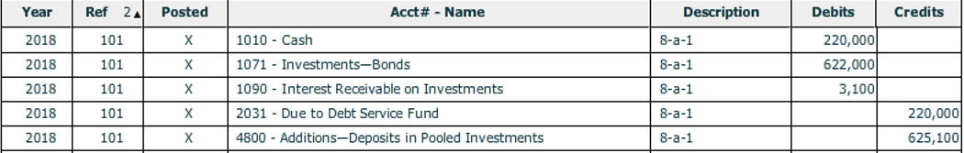

* 1. **[Para. 8-a-2]** The Investment Pool Fund manager purchased 4.5 percent bonds on March 1 in the amount of $200,000 (1071). Because the bonds pay interest semi-annually on January 1 and July 1, the fund manager had to prepay accrued interest on the bonds for this March purchase in the amount of $1,500 (Acct 1090).



* 1. **[Para. 8-a-3]** On March 1, the Investment Pool Fund manager also purchased a 9-month certificate of deposit (CD) for $10,000 (1072). The interest rate on the CD is 2 percent per annum.



* 1. **[Para. 8-a-4]** On July 1, interest on both bonds in the amount of $13,800 [Entries 8-a-1 and 8-a-2] was received in cash. Of this amount, $9,300 related to account 2480 – Undistributed Earnings on Pooled Investments and $4,500 related to account 1090 Interest Receivable on Investments.



NOTE TO ME: Authors instructions and my calculations validate this entry but author’s solution has a $9,200 and $4,600

My calculations



**Author’s instructions**

**[Para. 8-a-4]** On July 1, interest on both bonds in the amount of $13,800 ($9,300 and $4,500) was received in cash. (Note: Adjust for accrued interest.)

**Author’s solution**



* 1. **[Para. 8-a-5]** On November 30, the 9-month CD matured and interest was received.

Calculate interest as simple interest using banker’s days (360 days). Consider the CD to have been outstanding for 270 days and round up.

Record the receipt of the CD principal and interest. The interest will be recorded as in account 2480 – Undistributed Earnings on Pooled Investments.



* 1. **[Para. 8-a-6]** On December 31, interest was accrued on bond investments.

The bonds will not pay interest until January 1; therefore, the fund will accrue for the January payments to the fund as an adjusting journal entry on December 31.

There are two bonds in the fund which **pay interest twice a year**.

The Bingham CSD bond with a book value of $620,000 which receives interest of 3 percent per annum.

The Investment Pool Fund manager purchased a 4.5 percent bond in the amount of $200,000.

Only the accounts, Interest Receivable on Investments and Undistributed Earnings on Pooled Investments, would be affected by this transaction.



* 1. **[Para. 8-a-7]**. On December 31, the fair value of investments in bonds recorded in the general ledger of $822,00 was found to be $826,000 at year end. The fund will recognize the change in fair value. Credit Undistributed Change in Fair Value of Investments for the increase in fair value. The other account affected would be 1071 – Investments in Bonds.



* 1. **[Para**. **8-a-8]**. On December 31, the proportionate equities of the city’s debt service fund and the Bingham CSD were calculated and investment earnings and changes in fair value of investments were distributed accordingly. The Journal entry is

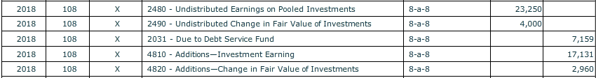

**NOTE TO ME: Changed from author’s solution because of error in 8-a-4**

* 1. **[Para**. **8-a-9].** Subsequent to the distribution of earnings and changes in fair value, the Bingham CSD withdrew $200,000 to meet certain obligations coming due. To provide the cash needed for the withdrawal, the Investment Pool Fund manager sold the 4.5 percent bonds on December 31 for $200,000, plus interest of $4,500, receiving in total $204,500 from the sale.

Record the sale of the bonds first. Recognize the cash received, the reduction in bond investments and Interest Receivable on Investments will be affected based on the interest received.

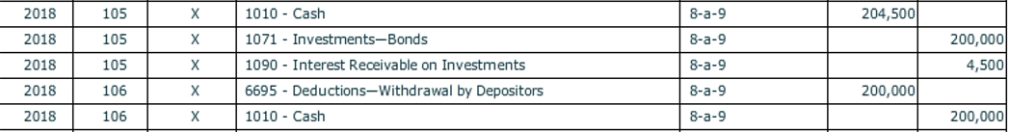

Then, recognize the withdrawal of cash by the CSD and debit Account 6695 Deductions – Withdrawals by Depositors.

1. Prepare entries to close the temporary accounts. Be sure and click on the check mark for **[Closing Entries]** and check that “Closing Entry” appears in the **[Transaction Description]** box for each account closed.

Run a pre-closing trial balance to see where these amounts are coming from. The difference between the additions and deductions are recorded to Net Position Held in Trust for Depositors.

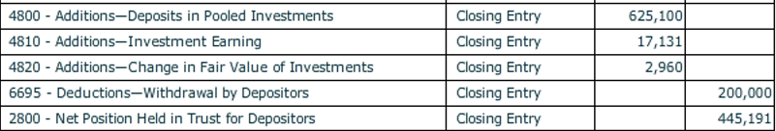

1. **Before closing the *City of Bingham,* click on [File], and [Save/Save As] to save your work.** If you close the file by clicking on the [**X**] box you will be asked if you want to save your changes before closing.
2. **Refer to documents to be graded to show your work.**

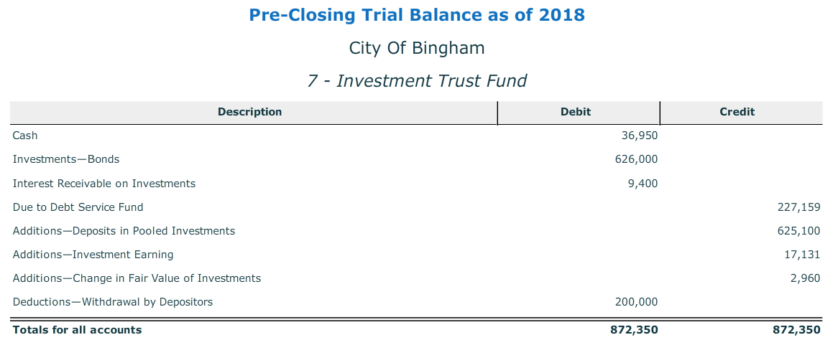

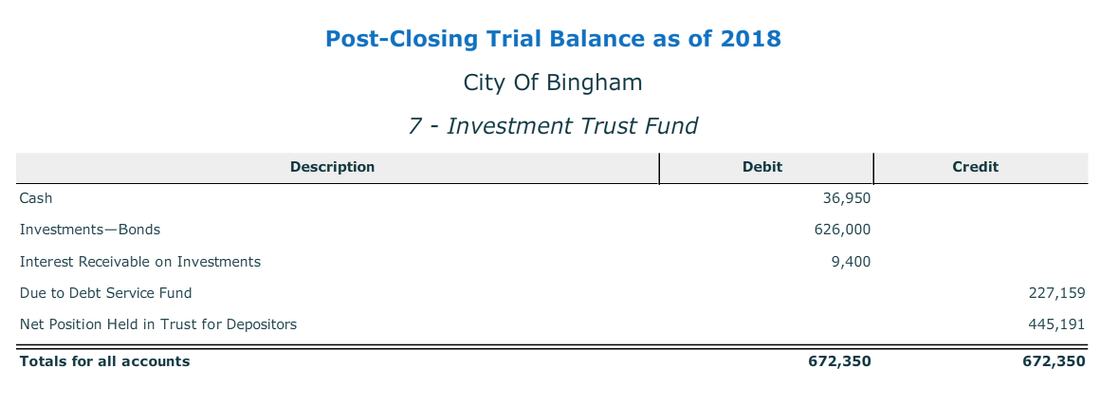

**PRIVATE-PURPOSE TRUST FUNDS**

Individuals or organizations may establish trust agreements to confer assets (or management of the assets) to another party at the present time or at a future date. The fair value of assets placed in trust is referred to as the *principal* or *corpus* of the trust. If the principal of the trust must be held intact (nonexpendable) to produce income, the trust is often called an *endowment.*

The income from the assets of an endowment may be used only for the purposes specified by the trustor. Not all trusts require that the principal be held intact. Some trusts allow the principal to be spent (expended) for the purpose specified by the trust. Additionally, not all trusts make distinctions between the use of principal and income.

Governments may act as administrators of trust agreements that provide public or private benefit.

*Public trust funds* are those whose principal or income, or both, must be used for some public purpose.

The beneficiaries of *private trust funds* are private individuals, organizations, or other governments.

A common example of a private trust fund is a state-sponsored 529 savings plan, structured such that parents make after-tax contributions to an investment fund managed by the state government. Contributions are maintained by the government until withdrawn by parents or students to pay educational costs of the student.

Another example is a local civic group which donates money to the government to pay the utility bills of indigent individuals.

**Permanent Funds:** Because most trusts administered by governments are created for public purposes (for example, to maintain parks and cemeteries or to acquire art for public buildings), they are considered governmental rather than fiduciary activities under GASB standards. Thus, nonexpendable public-purpose trusts are accounted for as permanent funds, and expendable public-purpose trusts are accounted for as special revenue funds.

An example of a permanent fund would be a contribution to the government **the earnings of which are to be used for the public good** such as an enhancement to a public park.

**PENSION TRUST FUNDS**

GASB standards provide comprehensive guidance on pension accounting and financial reporting for defined benefit pension plans and for the plan sponsor and employer.

**General Characteristics of Governmental Pension Plans**

Pension plans are of two general types, *defined contribution plans* and *defined benefit plans.*

A **defined contribution plan** specifies the amount or rate of contribution, often a percentage of covered salary, that the employer and employees must contribute to the members’ accounts in the pension plan. The level of benefits payable upon retirement is determined by the total amount of contributions to a member's account and earnings on investments. Because future benefits are neither formula based nor guaranteed, the risk associated with defined contribution plans rests primarily with employees; the employer's responsibility essentially ends once the required contribution is made.

Such plans ordinarily are *not* administered on an actuarial basis; therefore, accounting and financial reporting requirements for both the plan and the employer are straightforward and present few complications. Essentially, the plan reports the fair value of pension assets and any liability for accrued plan benefits; the employer reports expenditures/expenses for the amount contributed to the plan.

A **defined benefit plan** provides a specified amount of benefits to a retiree based on a formula that may include factors such as age, salary, and years of employment. Determining the present value of projected pension benefits involves numerous factors, such as employee mortality, employee turnover, salary progression, and investment earnings.

To ensure that plan assets will be adequate to cover future benefits, professional actuaries are engaged to calculate the present value of benefits and the required contributions that must be made by employers and, in some cases, employees. The basic assumptions underlying actuaries’ projections may change over time, giving rise to periodic revisions in the required contributions. Because of the need to rely extensively on actuaries’ estimates, it is not surprising that accounting for defined benefit plans is much more complex than for defined contribution plans.

**OTHER POSTEMPLOYMENT BENEFITS (OPEB)**

In addition to accounting and reporting of pension plans, GASB also requires accounting and reporting for **other postemployment benefits (OPEB).** OPEB includes benefits other than pensions, such as health care, life insurance, and long-term care, among others. The accounting and reporting for OPEB has historically been quite similar to that of defined benefit pension plans; however, the GASB issues separate standards for OPEB