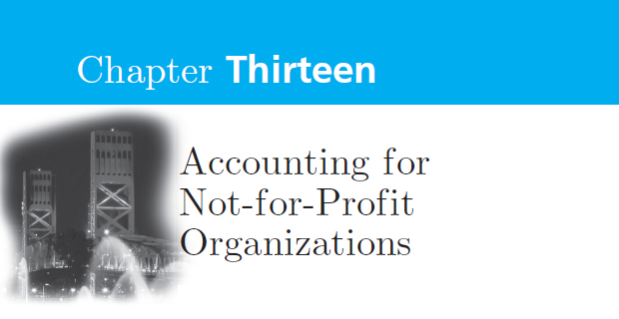
The not-for-profit sector serves a critically important role in the United States by providing a vast array of community services, including emergency and disaster assistance; health and human services; education and research; furthering the arts, sciences, and human development; and protecting the environment.

DEFINING THE NOT-FOR-PROFIT SECTOR
A widely accepted definition of an NFP is one whose goals involve something other than earning a profit for owners, usually the provision of services. Lack of defined ownership and the related profit motive present control and reporting problems for not-for-profit managers. Rather than measuring success with profits, success is measured by how much the organization contributes to the public well-being with the resources available to it.

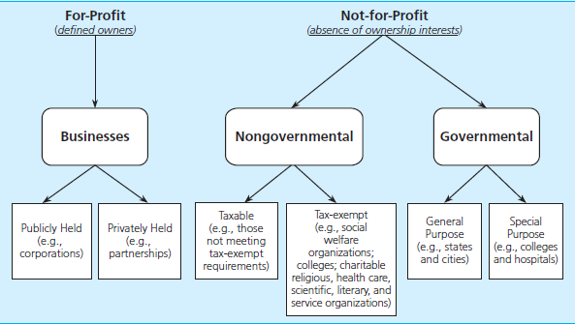

Governmental not for profits can be distinguished from private section not for profits in one significant way—governmental not for profits have an ability to impose taxes on citizens.

There are numerous ways that NFPs can be categorized. For example, the Internal Revenue Service classifies NFPs for tax-exempt purposes into ten functional categories (arts, culture, and humanities; education; environment and animals; health; human services; international/foreign affairs; public/societal benefit; religion related; mutual/membership benefit; and unknown/unclassified) and 26 major group areas.

The categories used in this textbook are voluntary health and welfare organizations and other nonprofit organizations such as colleges and universities, and health care entities.

Voluntary health and welfare organizations (VHWO), such as the American Diabetes Association, are organizations that receive contributions from the public at large. VHWOs use contributions for purposes related to solving health and welfare problems of society or for community services. In many cases VHWOs assist individuals by providing services for a nominal fee or for no fee at all.

Other nonprofit organizations (ONPOs) encompass a wide variety of not-for-profit organizations serving a wide variety of purposes and include organizations such as cemetery organizations, civic organizations, fraternal organizations, labor unions, libraries, museums, cultural institutions, performing arts organizations, political parties, private schools, professional and trade associations, social and country clubs, research and scientific organizations, and religious organizations.

GAAP FOR NONGOVERNMENTAL NFP ORGANIZATIONS
The Financial Accounting Standards Board (FASB) assumed primary responsibility for providing guidance on generally accepted accounting principles for not-for-profit entities in 1979 with the FASB Codification.

FINANCIAL REPORTING
The FASB's objectives of financial reporting for not-for-profit organizations are to provide information useful in (1) making resource allocation decisions, (2) assessing services and ability to provide services, (3) assessing management stewardship and performance, and (4) assessing economic resources, obligations, net resources, and changes in them. Common phrases heard today when speaking of financial reporting of any organization include accountability and transparency to stakeholders. Stakeholders of NFPs that use not-for-profit financial statements include donors, grantors, members, lenders, consumers, and others who provide resources to NFPs.

Although some NFPs may use the cash basis of accounting for internal accounting, external financial statements must be prepared on the accrual basis to be in conformity with GAAP. FASB Codificatioservic es requires, as a minimum, that all NFPs present:
- a statement of financial position
- a statement of activities,
- a statement of cash flows that present financial information for the entity as a whole.

In addition, voluntary health and welfare organizations are required to present a statement of functional expenses. Comparative financial statements are encouraged but not required.

In addition to reporting financial information for the entity as a whole, FASB permits NFPs to present additional disaggregated information, such as fund information that may be useful to internal management, donors, and others.

Statement of Financial Position
This statement, also known as a balance sheet, shows total assets, total liabilities, and the difference, net assets, for the organization as a whole.

Typically, these are categorized into the three classes:
- unrestricted net assets,
- temporarily restricted net assets,
- permanently restricted net assets.

Unrestricted net assets can arise from the following sources: contributions for which either no donor restrictions exist or the restrictions have expired, revenues for services provided, and investment income. Unrestricted net assets can be separated into undesignated and board designated.

Board-designated net assets are unrestricted net assets appropriated or set aside for specific purposes by the governing board rather than an external donor. Purposes for which the board may set aside net assets include future capital acquisitions or additions to an endowment (see quasi-endowment in the following paragraph). It is useful for the stakeholders if the specific board-designated purposes are identified on the face of the financial statement or in the notes.

Temporarily restricted net assets result from contributions on which the donor imposes restrictions as to purpose (how the asset may be used) or time (when the asset may be used). When the restrictions are met, these net assets are “released from restrictions” and reported as increases in unrestricted net assets. For example, a donor may provide that a gift can be spend right away but may give instructions on how the gift is to be used would be considered a temporarily restricted asset.

Permanently restricted net assets are assets for which the donor states that the assets be held in perpetuity but allows the organization to spend any income earned from investing those assets. These gifts are also called endowments and are nonexpendable.

Endowments may take the form of pure or permanent endowments, term endowments, or quasi-endowments.

Term endowments are classified as temporarily restricted net assets because as the term expires, the assets can be used at the discretion of the NFP.

Quasi-endowments or “funds functioning as endowments” are those the board sets aside; however, since the board can reverse that decision, this form of endowment is classified as an unrestricted net asset.

Permanently restricted net assets may also be in the form of artwork, land, or other assets that must be used for a certain purpose and may not be sold. Information on temporarily and permanently restricted net assets can be reported on the face of the statement of financial position or disclosed in the notes to the financial statements.

At a minimum, the FASB standards require that the statement of financial position provide the amounts for total assets, total liabilities, total net assets, and the totals for each of the net asset classifications. FASB also requires that assets and liabilities be reported in reasonably homogeneous groups and that information about liquidity be provided by either listing the assets and liabilities by nearness to cash or by classifying them as current or noncurrent, or both. Or relevant information about liquidity can be disclosed in the notes to the financial statements.

In some instances there may be restrictions on an asset that limits its use to a long-term purpose. If an asset has such a limitation on its use, information on the restriction needs to be displayed on the statement of financial position or disclosed in the notes to the financial statements. When displaying the restriction on the statement of financial position, the asset would appear on a separate line under a heading such as “assets whose use is limited.”
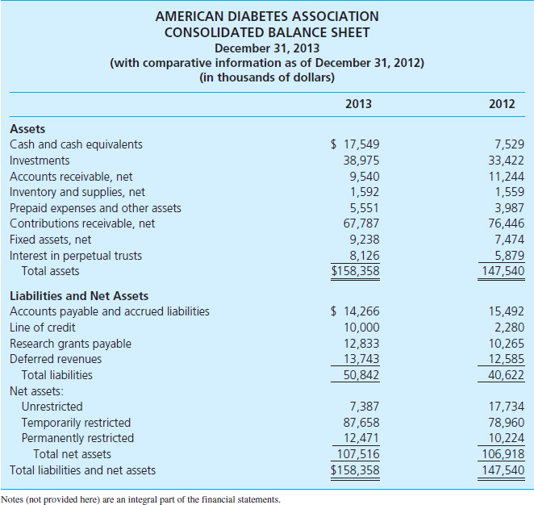

Statement of Activities
The statement of activities is an operating statement that presents, in aggregated fashion, all changes in unrestricted net assets, temporarily restricted net assets, permanently restricted net assets, and total net assets for the reporting period.

These changes take the form of revenues, gains, expenses, and losses. A common format for presenting the changes in net assets is the four column display. In this format, a column is used to show changes occurring in each net asset class (unrestricted, temporarily restricted, and permanently restricted) during the reporting period.

Reclassifications are made for (1) satisfaction of program or purpose restrictions, (2) satisfaction of equipment acquisition restrictions, sometimes measured by depreciation expense, and (3) satisfaction of time restrictions, either actual donor or implied restrictions.

FASB provides NFPs with considerable flexibility in presenting financial information as long as it is useful and understandable to the reader. If desired, NFPs can use additional classifications to report financial information, such as operating and non-operating, expendable and nonexpendable, earned and unearned, and recurring and nonrecurring.

In general, revenues and expenses should be reported on the statement of activities at their gross amounts. Exceptions include activities peripheral to the entity's central operations and investment revenue, which may be reported net of related expenses, if properly disclosed.

Although revenues are categorized into three net asset classes, all expenses are reported as reductions of unrestricted net assets.

In addition, expenses must be reported by their functional classification (e.g., program or supporting) either in the statement of activities or in the notes to the financial statements. Gains and losses on investments and other assets are reported as changes in unrestricted net assets unless their use is temporarily or permanently restricted.
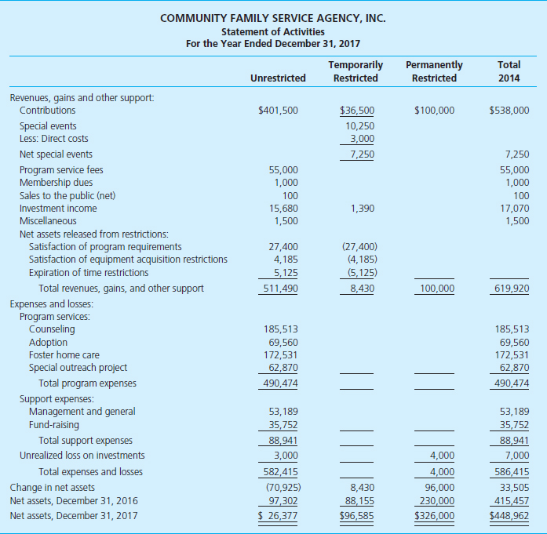
Statement of Cash Flows
FASB require NFPs to prepare a statement of cash flows using the same guidance as business entities--in three categories: operating, investing, and financing. Either direct or indirect method may be used.

Statement of Functional Expenses
The FASB requires that VHWOs prepare a statement of functional expenses and encourages other NFPs to do so.

The Financial Reporting Executive Committee of the AICPA has encouraged organizations that receive contributions of 20 percent or more of total revenue and support to prepare a statement of functional expenses.

The illustration shows the usual format with functional expenses reported in the columns and the natural classification of expenses shown as rows. Functional expenses are those that relate to either the program or mission of the organization (program expenses) or the management and general and fund-raising expenses required to support the programs (support expenses). The natural classification of expenses, or object of expense, includes salaries, supplies, occupancy costs, interest, and depreciation, among other categories the organization considers useful to the readers. Depreciation is typically assigned to the function to which it most closely relates. Watchdog agencies, donors, and others often use the ratio of program expenses to total expenses as a measure of an NFP's performance.

Expense amounts by natural classification can be determined from the statement of functional expenses, as can the expense amounts for program services and supporting services categories.

The AICPA Audit and Accounting Guide indicates that expenses that relate to more than one function (such as occupancy costs and interest and other expenses) be allocated to the programs or functional expenses to which they pertain. It is not difficult to assign direct expenses (such as travel) to various functions; however, in order to allocate indirect expenses (such as occupancy costs or interest expense), a reasonable allocation basis must be used. A reasonable basis might include square footage of space occupied by each program or personnel costs.
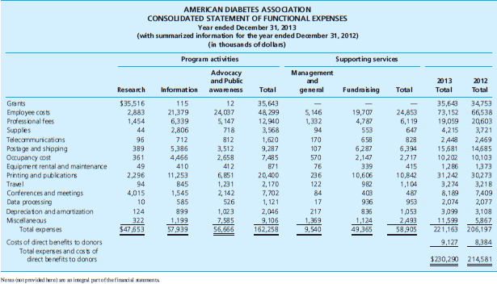
Notes to the Financial Statements
The notes to the financial statements are an integral part of the financial statements of NFPs. Disclosures include principles applicable to for-profit entities unless there is a specific exemption for not-for-profit organizations. The nature and amounts of unrestricted, temporarily restricted, and permanently restricted net assets must be disclosed if not displayed on the face of the financial statements. Notes are encouraged to report the detail of reclassifications, investments, and promises to give. Policy statements regarding whether restricted gifts received and expended in the same period are reported first as temporarily restricted must also be disclosed.
ACCOUNTING FOR NFP ORGANIZATIONS
Revenues and Gains
Not-for-profit organizations have traditionally distinguished revenues, gains, and support.

Revenues in the traditional sense, represent increases in unrestricted net assets arising from exchange transactions in which the other party to the transaction is presumed to receive direct tangible benefit commensurate with the resources provided. Examples are membership dues, program service fees, sales of goods and services, and investment income. Additionally, an increase in net assets from investment income would be labeled revenue rather than support.

Gains, such as realized gains on investment transactions and gains on sale or disposal of equipment, are increases in net assets that relate to peripheral or incidental transactions of the entity and often are beyond the control of management.

Support is a category of revenues arising from contributions of resources or non-exchange transactions and includes only amounts for which the donor derives no tangible benefits from the recipient agency. Membership dues may be part exchange revenue and part contribution revenue (support) if the value received by the member is less than the dues payment.

A government grant is usually considered support unless it is essentially a purchase of services, in which case the recipient is considered a vendor and the grant is classified as exchange revenue.

Revenues and gains generally should be recognized on the accrual basis and reported at gross amounts to be in conformity with GAAP, although some NFPs (e.g., colleges and universities) report some revenues net of certain deductions. Revenue that is restricted by an agreement, such as fees or dues dedicated for a specific purpose, is reported in unrestricted net assets because it does not arise from a restricted gift by a donor.

Contributions

Not-for-profit organizations, in particular voluntary health and welfare organizations, are heavily dependent on contribution revenue (i.e., support) for their operations. Money received from a fund-raising campaign is considered contribution revenue.

A contribution is a voluntary, unconditional and nonreciprocal transfer of cash or other asset to a NFP (or a settlement or cancellation of its liabilities) by an entity external to the NFP.

Donors can give gifts without restrictions (unrestricted). However, they can also require that their gift be used for a specific purpose (purpose restriction), or they can specify that their gift be used in a certain time period (time restriction).

As can be seen from the following examples, consideration must be given to the existence of restrictions on gifts and how the gift is classified for reporting purposes. In general, FASB requires that both unrestricted and restricted gifts be recognized as support and at fair value at the time the gift is given. Depending on the type of restriction, the gift increases unrestricted, temporarily restricted, or permanently restricted net assets.
Gifts Given | Type of Restriction | Net Asset Classification
$3,000 to be used as desired | None | Unrestricted
$1,000 to be used for research | Purpose | Temporary
$9,000 to be added to endowment | Purpose | Permanent
$5,000 to be used next year | Time | Temporary

Promises to give assets to an organization (commonly called pledges) can be conditional or unconditional.
A conditional promise to give depends on the occurrence of a specified future and uncertain event to bind the promissor, such as obtaining matching gifts by the recipient. A conditional promise to give is not recognized as support until the conditions on which it depends have been substantially met.

An unconditional promise to give depends only on the passage of time or demand by the promisee for performance. These promises are recorded as support in the year made. Unconditional promises to give that will not be received until future periods must be reported as temporarily restricted net assets unless explicit donor stipulations or the circumstances surrounding the promise make it clear that the donor intended the contribution to support activities of the current period.

FASB indicates that if unconditional pledges will be received in less than a year, they can be recognized at net realizable value. To determine net realizable value, an NFP calculates the allowance for uncollectible pledges based on the NFP's history and expectations concerning the collectibility of the pledges. The NFP records the allowance in a manner similar to businesses, debiting an expense account such as Provision for Uncollectible Pledges and crediting Allowance for Uncollectible Pledges.

Long-term unconditional pledges (those that will not be collected within one year) are measured at fair value. If the present value technique is used to value pledges, the difference between the pledged amount and the present value is recorded as a discount. For example, The Helping Hand entity received $90,000 in unconditional pledges that will be collected five years from the current date. Applying a 3 percent present value rate to the amount, the Helping Hand recorded the following journal entry:

When the contributions are received, the discount is removed by recording a debit to the discount account and a credit to Contributions—Unrestricted. Pledges or intentions to give are not recorded until they have the characteristics of an unconditional promise to give, for example, a written document, partial payment, or a public announcement by the donor.

Contributions can take the form of cash, securities, capital assets, materials, or services. Cash contributions require that a strong system of internal controls over the safeguarding of cash be in place; however, cash contributions pose no unusual accounting or reporting problems. Donated securities may be received for any purpose, although generally they are received as a part of the principal of an endowment. They are recorded at their fair value at the date of the gift. The fair value rule is also applied to capital assets received either as a part of an endowment or for use in the operations of the organization.

Donated Materials and Services

One of the basic characteristics distinguishing not-for-profit organizations from commercial organizations is their reliance on noncash contributions or gifts in kind. Sheltered workshops for persons with disabilities often depend heavily on donations of clothing and furniture, thrift shops receive their inventory from donations, and health agencies may obtain contributions of drugs from pharmaceutical firms. Office space may be furnished rent free; and television, radio, and periodicals may publicize fund drives, special events, or the general work of NFPs at no charge. All unconditional gifts, including material amounts of donated materials, are to be reported at fair value. The gift would be regarded as both contribution revenue and an expense or a noncash asset. An objective, clearly measurable basis for fair value can be established by proceeds from resale by the organization, price lists, market quotations, or appraisals. Consideration should be given to the quantity and quality of gifts when determining fair value. Donated materials used or consumed in providing services should be reported as part of the cost of the services.

The services of unpaid workers may well make the difference between an effective organization and one that fails to achieve its objectives. Voluntary health and welfare organizations typically rely on the efforts of volunteer workers to supplement the efforts of paid employees. FASB requires recognition of contributed services at their fair value if the services received (1) create or enhance nonfinancial assets or (2) require specialized skills, are provided by individuals possessing those skills, and typically would need to be purchased if not provided by donation (e.g., accountants). Although FASB does not provide an example of the first criterion, a logical example would be recognition of support for donated architectural, legal, or carpentry services related to construction of a building addition. Contributed services of an attorney would be considered both a contribution and an expense.

Donated Land, Building, and Equipment

At the time of donation, land, buildings, and equipment are recorded at their fair value. The donations are reported as contributions or support on the statement of activities and would be classified as unrestricted, temporarily restricted, or permanently restricted on the financial reports. If the donor does not indicate how the asset should be used, the gift is classified as unrestricted. If the donor does impose restrictions, such as how long the asset must be used as a building, or if the NFP has a policy implying a time restriction over the useful life of the asset, the contribution is classified as temporarily restricted. An NFP with a policy implying a time restriction should clearly state the policy in the notes to the financial statements.

For buildings and equipment classified as temporarily restricted, an amount equal to annual depreciation expense is typically reclassified from temporarily restricted to unrestricted net assets each year. The reclassification is intended to reflect that the cost of “using up” the asset's service potential satisfies the donor's imposed restriction.

If an NFP receives the use of a building for a reduced rate, the difference between the rent paid and the fair market rental value should be reported as a contribution that is unrestricted. In certain cases an NFP could receive a donation of land, building or equipment that it intends to sell rather than use, in such cases the contribution should be reported as an increase in unrestricted net assets.

Donated securities are recorded at fair value at the date of the gift.

Special Events

Special events are fund-raising activities that provide a direct benefit to those attending. The contribution to attend the special event exceeds the cost (expense) of the direct benefit provided, resulting in contribution revenue for the entity sponsoring the event. Dinners, dances, golf outings, bazaars, card parties, fashion shows, concerts, and bake sales are typical “special events.” The special events category of revenue is reserved for those events sponsored by the NFP or by an organization over which it has control. If a completely independent organization sponsors an event for the NFP's benefit, the amount given to the NFP should be reported as contribution revenue not special event revenue.

FASB requires that revenues from special events be reported at gross in the statement of activities with the direct expenses of providing the benefit reported separately. If the special event is peripheral to the NFP, the direct expenses can be netted against the revenues. If desired, NFPs can provide more detailed reporting of special events, either on the face of the statement of activities or in the notes to the financial statements.

Expenses of promoting and conducting special events, such as expenses of printing tickets and posters, mailings, fees and expenses of public relations and fund-raising consultants, and salaries of employees of the NFP attributable to planning, promoting, and conducting special events are reported as fund-raising expenses and are not charged against special events revenue.

Accounting for Expenses
Generally accepted accounting principles require that all expenses of NFPs be measured on the accrual basis and be reported as decreases in unrestricted net assets on the statement of activities. Depreciation of capital assets with a limited life, including contributed capital assets, used in the operation of the organization is required by the FASB.

Functional Expenses

NFPs have long been required to report expenses by functional classifications, such as major program and support classifications. Program classifications result from the provision of goods or services that help achieve the major purposes or mission of the NFP. Support activities assist the NFP in carrying out its mission and include such functional classifications as fund-raising and management and general. The FASB allows the reporting of functional classifications on the face of the financial statements or in the notes to the statements.

A fund-raising organization, such as the United Way, that is intended to allocate most of its inflows to participating agencies rather than to engage directly in offering program services to the public, will report program services that are quite different from those of other NFP organizations. For example, it may report under program services functions such as “campaign and public relations,” and “investor relations.” It would also report support functions such as “management and general,” and “fund-raising.”

Fund-raising—Allocation of Joint Costs

Not-for-profit organizations often conduct activities that combine a program or administrative activity with fund-raising. An example is a door-to-door campaign to improve neighborhood safety and solicit contributions. FASB provides guidance on allocating joint costs of such activities, making it more difficult to include fund-raising expenses as a part of program expenses.

The FASB provides the following:
- The total cost of activities that include a fund-raising appeal should be reported as fund-raising costs unless a bona fide program or management and general function has been conducted in conjunction with the appeal for funds.
- The joint costs of a bona fide program or management and general function should be allocated between the bona fide program or management and general function and fund-raising using an equitable allocation method. An equitable allocation method is one that is rational and systematically applied to yield a reasonable allocation of the costs to fund-raising and a program and/or the management and general function.
- Criteria of purpose, audience, and content must be met in order to conclude that a bona fide program or management and general function has been conducted in conjunction with the appeal for funds.

The criteria provided by FASB are quite detailed. The purpose criterion may be met if the joint activity helps accomplish a program purpose or management function. Generally, the joint activity needs to ask the audience to take a specific action that will help accomplish the NFP's mission. The purpose criterion will not be met if the majority of the compensation or fees received by those conducting the joint activity are based on the contributions raised as part of the activity. The audience criterion is met if the audience was selected primarily for program or management reasons rather than its ability to make a contribution or donation. Finally, the content criterion is met if the content of the joint activity either motivates the audience to take action to further the NFP's mission, or the joint activity meets a management responsibility. If the NFP determines that joint costs can be allocated, the FASB requires that certain note disclosures be made.

Fund-raising expenses include the costs of television and radio announcements that request contributions, including the costs of preparing the announcements and purchasing or arranging for the time; the costs of postage, addressing, and maintenance of mailing lists and other fund drive records; the costs of preparing or purchasing fund-raising materials; the costs of public meetings to “kick off” a fund drive; and an appropriate portion of the salaries of personnel who supervise fund-raising activities or keep records of activities.

Management and General Expenses

Management and general expenses include the cost of publicity and public relations activities designed to keep the organization's name before prospective contributors. Costs of informational materials that contain only general information regarding the NFP's program and the costs of informational materials distributed to potential contributors, but not as a part of a fund drive, are considered management and general expenses. The costs of budgeting, accounting, reporting, legal services, office management, purchasing, and similar activities are examples of expenses properly classifiable as management and general expenses.

Accounting for Assets
Generally, assets of NFPs are recorded in a manner similar to those of for-profit entities. The following topics identify some areas where accounting and reporting for NFP assets does differ.

Assets with Restrictions on Use
Assets that are not available for current operating purposes because donors have limited their use to a long-term purpose (e.g., capital asset acquisition) are considered restricted. FASB indicates that such assets should be classified separately from current assets on the face of the statement of financial position. Examples would include cash contributed for a new building.

Investments

Securities that are contributed are initially measured at fair value. Fair values are determined by quoted market prices, if available; selling price of similar securities; or valuation techniques, such as discounted cash flows. At fiscal year-end, NFPs report equity securities with readily determinable fair values and debt securities at fair value.

Unlike businesses, but similar to governments, NFPs are not required to classify their investments into trading, available-for-sale, and held-to-maturity categories. Similar to businesses, the guidance provided by FASB does not apply to investments with no readily determinable fair value, securities reported under the equity method, or consolidations.

When reporting investments at fair value, the difference between the carrying value (book value) and the fair value of the investment can result in an unrealized gain or loss. Because NFPs do not report other comprehensive income, they report unrealized gains or losses on the current period's statement of activities. Similarly, realized gains and losses, along with income earned on the investments (i.e., interest and dividends) are reported on the current period's statement of activities.

Investment income, unrealized or realized gains, and unrealized or realized losses are reported as adjustments to unrestricted net assets unless their use is restricted by the donor or state law. Based on the type of restriction, investment income is reported as an increase in either temporarily or permanently restricted net assets. Similarly, if a restriction exists, the type of restriction dictates whether the gains and losses on investments are reported as temporarily or permanently restricted.

The rules concerning the reporting of gains and losses on investments also apply to endowment investments if the donor or law has not specified otherwise.

FASB requires extensive investment disclosures, such as (1) the makeup of the investment return, (2) a reconciliation of investment return to amounts reported in the statement of activities, (3) the aggregate carrying amount of investments by major type of investment (e.g., equity securities, U.S. Treasury securities, or corporate debt securities), (4) disclosures about all significant concentrations of credit risk arising from all financial instruments, (5) the nature of and carrying amount for each individual investment or group of investments that represents a significant concentration of market risk, and (6) information about realized and unrealized gains and losses and about historical costs of investments if it is useful.

Collection Items
Certain not-for-profit organizations, particularly museums and libraries, have significant collections. FASB defines collections as works of art, historical treasures, or similar assets that are
- Held for public exhibition, education, or research in furtherance of public service rather than financial gain.
- Protected, kept unencumbered, cared for, and preserved.
- Subject to an organizational policy that requires the proceeds of items that are sold to be used to acquire other items for collection.

An NFP may adopt the policy of recognizing collections as assets or not recognizing them; however, selective capitalization is not allowed. The following note from the American Museum of Natural History shows that the Museum has elected not to capitalize its unusual collections. In accordance with FASB standards, the Museum defines its collections in terms of its policy for exhibiting, maintaining and investing in the collections.

Selected American Museum of Natural History Note Disclosures Collections
The Museum has extensive collections of specimens and artifacts that constitute a record of life on Earth. These valuable, and sometimes irreplaceable, collections have been acquired through field expeditions, contributions, and purchases since the Museum's inception and represent one of the largest natural history collections in the world. New collection areas include the Museum's frozen tissue collection of DNA and tissue samples and access to large scientific databases of genomic and astrophysical data. The collections provide a resource for scientists around the world and grows significantly each year.

In conformity with accounting policies generally followed by museums, the value of the Museum's collections are not reflected in the consolidated statement of net position. If the assets used to purchase the collection items are from restricted funds, proceeds from the sale of those items are recorded as increases in temporarily restricted net assets in that fund until an acquisition is made.

If an NFP capitalizes its collections, it should recognize the collections as assets in the period in which they are acquired, either at cost or fair market value, if contributed. Contributed collections should be recorded in the appropriate net asset category, depending on any restrictions placed on the contribution by the donor. If the organization chooses not to capitalize, it should provide note disclosure of its collections.

FASB states that capitalized art or historical treasures do not need to be depreciated so long as their economic benefit is used up so slowly that their estimated useful lives are extraordinarily long. This characteristic exists if (1) the assets individually have cultural, aesthetic, or historic value that is worth preserving perpetually and (2) the holder has the technological and financial ability to protect and preserve essentially undiminished the service potential of the asset and is doing that.

