**Assignment #1**

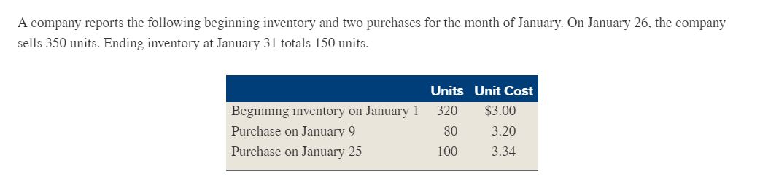

Prepare a schedule of ending inventory and costs of goods sold for the FIFO, LIFO and Weighted Average methods.

**Assignment #2**

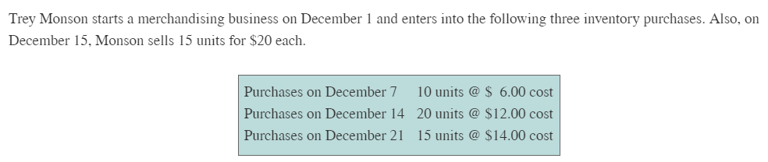

Prepare a schedule of ending inventory and costs of goods sold for the FIFO, LIFO, Weighted Average, and Specific Identification methods. For Specific Identification: assume of the 15 units sold—eight (8) were from the Dec 7 purchase and seven (7) are from the Dec 14 purchase.















