Differential Analysis: The Key to Decision Making
Managers must decide what products to sell, whether to make or buy component parts, whether to accept special orders at special prices, and to sell at one juncture or process further. Making such decisions is often a difficult task that is complicated by numerous alternatives and massive amounts of data, only some of which may be relevant.
Every decision involves choosing from among at least two alternatives. In making a decision, the costs and benefits of one alternative must be compared to the costs and benefits of other alternatives. The key to making such comparisons is differential analysis—focusing on the costs and benefits that differ between the alternatives.
A difference in cost between any two alternatives is known as a differential cost.
A difference in revenue between any two alternatives is known as differential revenue.
Differential costs and revenues are relevant to decision making, whereas costs and revenues that do not differ between alternatives are irrelevant to decision making. Because differential costs and differential revenues are also often referred to as relevant costs and relevant benefits.
In general, ask
- What costs are associated with each alternative = potentially relevant
- Is the cost common to both alternatives? Yes = Irrelevant No = Relevant
Distinguishing between relevant and irrelevant costs and benefits is critical for two reasons. First, irrelevant data can be ignored—saving decision makers tremendous amounts of time and effort. Second, bad decisions can easily result from erroneously including irrelevant costs and benefits when analyzing alternatives.
As a practical matter, some managers will ask for all costs to be listed to determine no costs were overlooked. However, the focus would remain on those costs that are relevant.
One cost that is never relevant
Sunk cost – A cost that has already been incurred in the past. Because it occurred in the past, it is never relevant for future decisions. Any depreciation expense related to the truck is irrelevant in making decisions. This is true because depreciation is a noncash expense that simply spreads the cost of the truck over its useful life. Sunk costs are always the same no matter what alternatives are being considered; therefore, they are irrelevant and should be ignored when making decisions.
What is relevant in one situation may be irrelevant in another. We will walk through several scenarios to learn this skill.

Identify relevant and irrelevant costs and benefits in a decision.
Another term for relevant costs are avoidable costs.
Assume you are trying to decide whether to go to a movie or rent a DVD for the evening. The rent on your apartment is irrelevant. Whether you go to a movie or rent a DVD, the rent on your apartment will be exactly the same and is therefore irrelevant to the decision.
On the other hand, the cost of the movie ticket and the cost of renting a movie from Apple TV would be relevant in the decision because they are avoidable costs.
An avoidable cost is a cost that can be eliminated by choosing one alternative over another. By choosing the alternative of going to the movie, the cost of renting the Apple TV movie can be avoided. By choosing the alternative of renting the movie, the cost of the movie ticket can be avoided. Therefore, the cost of the movie ticket and the cost of renting the movie are both avoidable costs.
Another term for irrelevant costs are unavoidable costs.
Unavoidable Cost On the other hand, the rent on your apartment is not an avoidable cost of either alternative. You would continue to rent your apartment under either alternative.
Opportunity costs also need to be considered when making decisions. An opportunity cost is the potential benefit that is given up when one alternative is selected over another.
Different Costs for Different Purposes
We need to recognize a fundamental concept from the outset of our discussion—costs that are relevant in one decision situation are not necessarily relevant in another. This means that managers need different costs for different purposes. For one purpose, a particular group of costs may be relevant; for another purpose, an entirely different group of costs may be relevant. Thus, each decision situation must be carefully analyzed to isolate the relevant costs.

EXERCISE 12–1 Identifying Relevant Costs [LO12–1]
A number of costs are listed below that may be relevant in decisions faced by the management of Svahn, AB, a Swedish manufacturer of sailing yachts:
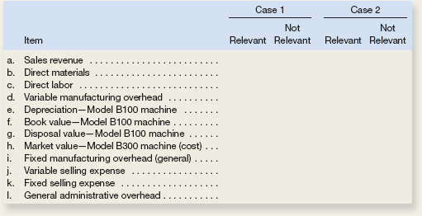
Place an X in the appropriate column to indicate whether each item is relevant or not relevant in the following situations. Requirement 1 relates to Case 1 above, and requirement 2 relates to Case 2.
- The company chronically has no idle capacity and the old Model B100 machine is the company’s constraint. Management is considering purchasing a Model B300 machine to use in addition to the company’s present Model B100 machine. The old Model B100 machine will continue to be used to capacity as before, with the new Model B300 machine being used to expand production. This will increase the company’s production and sales. The increase in volume will be large enough to require increases in fixed selling expenses and in general administrative overhead, but not in the fixed manufacturing overhead.

- The old Model B100 machine is not the company’s constraint, but management is considering replacing it with a new Model B300 machine because of the potential savings in direct materials with the new machine. The Model B100 machine would be sold. This change will have no effect on production or sales, other than some savings in direct materials costs due to less waste.
Reconciling the Total and Differential Approaches
Oak Harbor Woodworks is considering a new labor-saving machine that rents for $3,000 per year. The machine will be used on the company’s butcher block production line. Data concerning the company’s annual sales and costs of butcher blocks with and without the new machine are shown below:
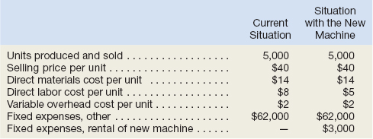

Total and Differential Costs
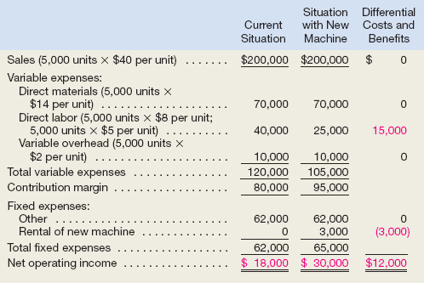
We could have arrived at the same solution much more quickly by completely ignoring the irrelevant costs and benefits.
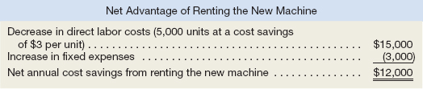

The Make or Buy Decision
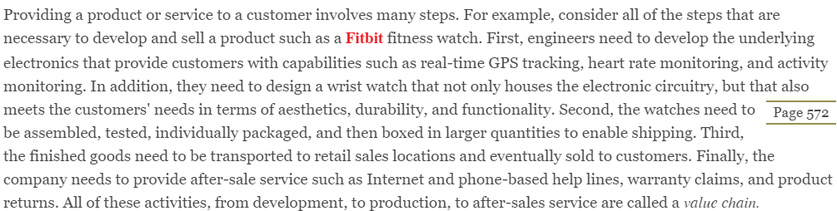
Separate companies may carry out each of the activities in the value chain or a single company may carry out several. When a company is involved in more than one activity in the entire value chain, it is vertically integrated. Some companies control all of the activities in the value chain from producing basic raw materials right up to the final distribution of finished goods and provision of after-sales service. Other companies are content to integrate on a smaller scale by purchasing many of the parts and materials that go into their finished products.
A decision to carry out one of the activities in the value chain internally, rather than to buy externally from a supplier, is called a make or buy decision. Quite often these decisions involve whether to buy a particular part or to make it internally.
Strategic Aspects of the Make or Buy Decision
Vertical integration provides certain advantages. An integrated company is less dependent on its suppliers and may be able to ensure a smoother flow of parts and materials for production than a nonintegrated company. For example, a tariff affecting a major parts supplier can interrupt the operations of a nonintegrated company for many months, whereas an integrated company that is producing its own parts would be able to continue operations. Also, some companies feel that they can control quality better by producing their own parts and materials, rather than by relying on the quality control standards of outside suppliers.
The advantages of vertical integration are counterbalanced by the advantages of using external suppliers. By pooling demand from many companies, a supplier may be able to enjoy economies of scale. These economies of scale can result in higher quality and lower costs than if the purchasing company were to make these components or provide these services as a company.

HELPFUL HINT
Use the following three steps to quantify the financial impact of make or buy decisions:
Step 1: Calculate the total amount that would be paid to the supplier if the buy option is chosen.
Step 2: Calculate the total differential manufacturing costs. These are the variable manufacturing costs and traceable fixed manufacturing costs that will be incurred if the company chooses to make, but avoided if the company chooses to buy.
Step 3: Calculate the difference between the amounts from steps 1 and 2. If the amount from step 1 exceeds the amount from step 2, then choose the make option. If the amount from step 1 is less than the amount from step 2, then choose the buy option.
While you may need to add additional steps when solving complex problems, these three steps will help organize your analysis.
EXERCISE 12–3 Make or Buy a Component [LO12–3]
Troy Engines, Ltd., manufactures a variety of engines for use in heavy equipment. The company has always produced all of the necessary parts for its engines, including all of the carburetors. An outside supplier has offered to sell one type of carburetor to Troy Engines, Ltd., for a cost of $35 per unit. To evaluate this offer, Troy Engines, Ltd., has gathered the following information relating to its own cost of producing the carburetor internally:
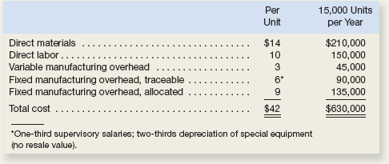
- Assuming that the company has no alternative use for the facilities that are now being used to produce the carburetors, should the outside supplier’s offer be accepted? Show all computations.

- Suppose that if the carburetors were purchased, Troy Engines, Ltd., could use the freed capacity to launch a new product. The segment margin of the new product would be $150,000 per year. Should Troy Engines, Ltd., accept the offer to buy the carburetors for $35 per unit? Show all computations.

Special Orders
Managers must often evaluate whether a special order should be accepted, and if the order is accepted, the price that should be charged.
A special order is a one-time order that is not considered part of the company’s normal ongoing business.
HELPFUL HINT
Use the following three steps to quantify the financial impact of accepting a special order:
Step 1: Calculate the total revenue generated by the special order.
Step 2: Calculate the total incremental costs that will be incurred to produce the special order.
Step 3: Take the amount in step 1 and subtract from it the amount in step 2. If the result is a positive number, then accept the special order. If it is a negative number, then reject the special order.
While you may need to add additional steps when solving complex problems, these three steps will help organize your analysis.
EXERCISE 12–4 Evaluating a Special Order [LO12–4]
Imperial Jewelers is considering a special order for 20 handcrafted gold bracelets to be given as gifts to members of a wedding party. The normal selling price of a gold bracelet is $189.95 and its unit product cost is $149.00 as shown below:
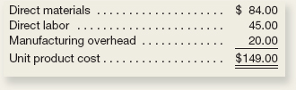
Most of the manufacturing overhead is fixed and unaffected by variations in how much jewelry is produced in any given period. However, $4.00 of the overhead is variable with respect to the number of bracelets produced. The customer who is interested in the special bracelet order would like special filigree applied to the bracelets. This filigree would require additional materials costing $2.00 per bracelet and would also require acquisition of a special tool costing $250 that would have no other use once the special order is completed. This order would have no effect on the company’s regular sales and the order could be fulfilled using the company’s existing capacity without affecting any other order.
Required:
- What effect would accepting this order have on the company’s net operating income if a special price of $169.95 per bracelet is offered for this order? Should the special order be accepted at this price?
UTILIZATION OF A CONSTRAINED RESOURCE
Managers routinely face the problem of deciding how constrained resources are going to be used. A department store, for example, has a limited amount of floor space and therefore cannot stock every product that may be available. A manufacturer has a limited number of machine-hours and a limited number of direct labor-hours at its disposal.
When a limited resource of some type restricts the company's ability to satisfy demand, the company has a constraint. Because the company cannot fully satisfy demand, managers must decide which products or services should be cut back. In other words, managers must decide which products or services make the best use of the constrained resource. Fixed costs are usually unaffected by such choices, so the course of action that will maximize the company's total contribution margin should ordinarily be selected.
Contribution Margin per Unit of the Constrained Resource
If some products must be cut back because of a constraint, the key to maximizing the total contribution margin may seem obvious—favor the products with the highest unit contribution margins. Unfortunately, that is not quite correct. Rather, the correct solution is to favor the products that provide the highest contribution margin per unit of the constrained resource.
To illustrate, in addition to its other products, Mountain Goat Cycles makes saddlebags for bicycles called panniers. These panniers come in two models—a touring model and a mountain model. Cost and revenue data for the two models of panniers follow:
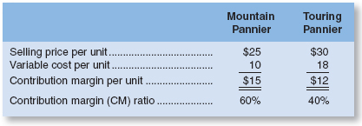
The mountain pannier appears to be much more profitable than the touring pannier. It has a $15 per unit contribution margin as compared to only $12 per unit for the touring model.
But now let us add one more piece of information—the plant that makes the panniers is operating at capacity. If the plant as a whole cannot produce any more units, some machine or process must be operating at capacity. The machine or process that is limiting overall output is called the bottleneck—it is the constraint.

At Mountain Goat Cycles, the bottleneck (i.e., constraint) is a stitching machine. The mountain pannier requires two minutes of stitching time per unit, and the touring pannier requires one minute of stitching time per unit. The stitching machine is available for 12,000 minutes per month, and the company can sell up to 4,000 mountain panniers and 7,000 touring panniers per month. Producing up to this demand for both products would require 15,000 minutes, as shown below:
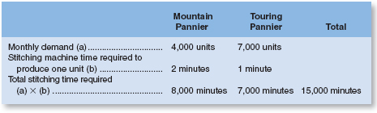
Producing up to demand would require 15,000 minutes, but only 12,000 minutes are available.
The stitching machine is a bottleneck. It does not have enough capacity to satisfy the existing demand for mountain panniers and touring panniers Therefore, some orders for the products will have to be turned down.
To answer this question, they should focus on the contribution margin per unit of the constrained resource. This figure is computed by dividing a product's contribution margin per unit by the amount of the constrained resource required to make a unit of that product. These calculations are carried out below for the mountain and touring panniers:
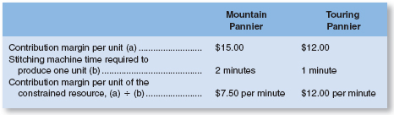
It is now easy to decide which product is less profitable and should be deemphasized. Each minute on the stitching machine that is devoted to the touring pannier results in an increase of $12.00 in contribution margin and profits. The comparable figure for the mountain pannier is only $7.50 per minute.

HELPFUL HINT
Use the following four steps to help determine the most profitable use of a constrained resource:
Step 1: Calculate each product's contribution margin per unit.
Step 2: Identify the constraining resource and the quantity of that resource that is consumed to make one unit of each product.
Step 3: Calculate each product's contribution margin per unit of the constraining resource.
Step 4: Rank the products from the highest contribution margin per unit of the constraining resource to the lowest.
If you start by completing these four steps, it will help you compute the most profitable use of a constrained resource.
EXERCISE 12–5 Utilizing a Constrained Resource [LO12–5]
Outdoor Luggage Inc. makes high-end hard-sided luggage for sports equipment. Data concerning three of the company’s most popular models appear below.
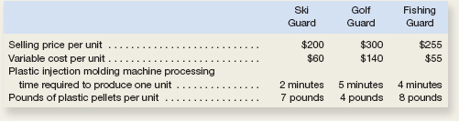

- The total time available on the plastic injection molding machine is the constraint in the production process. Which product would be the most profitable use of this constraint? Which product would be the least profitable use of this constraint?

- A severe shortage of plastic pellets has required the company to cut back its production so much that the plastic injection molding machine is no longer the bottleneck. Instead, the constraint is the total available pounds of plastic pellets. Which product would be the most profitable use of this constraint? Which product would be the least profitable use of this constraint?

Joint Product Costs and the Contribution Approach
In some industries, a number of end products are produced from a single raw material input. Maria Wool Cooperative of New Mexico buys raw wool from local sheepherders, separates the wool into three grades—coarse, fine, and superfine—and then dyes the wool using traditional methods that rely on pigments from local materials.
Santa Maria Wool Cooperative
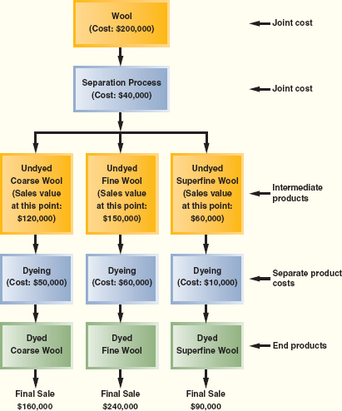
At Santa Maria Wool Cooperative, coarse wool, fine wool, and superfine wool are produced from one input—raw wool.
Two or more products that are produced from a common input are known as joint products.
The split-off point is the point in the manufacturing process at which the joint products can be recognized as separate products. This does not occur at Santa Maria Wool Cooperative until the raw wool has gone through the separating process. The term joint cost is used to describe the costs incurred up to the split-off point.
At Santa Maria Wool Cooperative, the joint costs are the $200,000 cost of the raw wool and the $40,000 cost of separating the wool. The undyed wool is called an intermediate product because it is not finished at this point. Nevertheless, a market does exist for undyed wool—although at a significantly lower price than finished, dyed wool.
The Pitfalls of Allocation
Joint costs are common costs that are incurred to simultaneously produce a variety of end products. These joint costs are often allocated among the different products at the split-off point. A typical approach is to allocate the joint costs according to the relative sales value of the end products.
Although allocation of joint product costs is needed for some purposes, such as balance sheet inventory valuation, allocations of this kind are extremely misleading for decision making.
Sell or Process Further Decisions
Joint costs are irrelevant in decisions regarding what to do with a product from the split-off point forward. Once the split-off point is reached, the joint costs have already been incurred and nothing can be done to avoid them. None of the joint costs are economically attributable to any one of the intermediate or end products. The joint costs are a common cost of all of the intermediate and end products and should not be allocated to them for purposes of making decisions about the individual products.
Decisions of this type are known as sell or process further decisions. It is profitable to continue processing a joint product after the split-off point so long as the incremental revenue from such processing exceeds the incremental processing cost incurred after the split-off point. Joint costs that have already been incurred up to the split-off point are always irrelevant in decisions concerning what to do from the split-off point forward.
HELPFUL HINT
For each end product, use the following three steps to make sell or process further decisions:
Step 1: Calculate the sales value if processed further minus the sales value at the split-off point.
Step 2: Determine the cost of further processing beyond the split-off point.
Step 3: Take the amount in step 1 and subtract from it the amount in step 2. If the result is a positive number, then choose to process further. If it is a negative number, then choose to sell at the split-off point.
While you may need to add additional steps when solving complex problems, these three steps will help organize your analysis.

Each of these products can be sold as is without further processing. It may be that the company would be better off selling one or more of the products prior to dyeing to avoid the dyeing costs. The appropriate way to make this choice is to compare the incremental revenues to the incremental costs from further processing as follows:
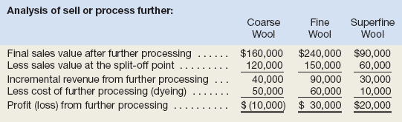
As this analysis shows, the company would be better off selling the undyed coarse wool as is rather than processing it further. The other two products should be processed further and dyed before selling them.
Note that the joint costs of the wool ($200,000) and of the wool separation process ($40,000) play no role in the decision to sell or further process the intermediate products. These joint costs are relevant in a decision of whether to buy wool and to run the wool separation process, but they are not relevant in decisions about what to do with the intermediate products.

EXERCISE 12–7 Sell or Process Further [LO12–7]
Dorsey Company manufactures three products from a common input in a joint processing operation. Joint processing costs up to the split-off point total $350,000 per quarter. The company allocates these costs to the joint products on the basis of their relative sales value at the split-off point. Unit selling prices and total output at the split-off point are as follows:
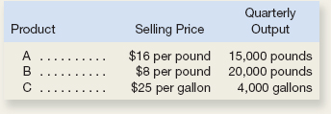
Each product can be processed further after the split-off point. Additional processing requires no special facilities. The additional processing costs (per quarter) and unit selling prices after further processing are given below: Which product or products should be sold at the split-off point and which product or products should be processed further?
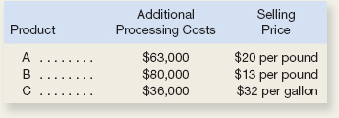

In Class Assignments

The Foundational 15
Cane Company manufactures two products called Alpha and Beta that sell for $120 and $80, respectively. Each product uses only one type of raw material that costs $6 per pound. The company has the capacity to annually produce 100,000 units of each product. Its unit costs for each product at this level of activity are given below:
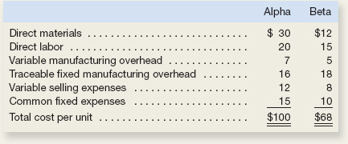
The company considers its traceable fixed manufacturing overhead to be avoidable, whereas its common fixed expenses are deemed unavoidable and have been allocated to products based on sales dollars.
Required:
(Answer each question independently unless instructed otherwise.)
- What is the total amount of traceable fixed manufacturing overhead for the Alpha product line and for the Beta product line?

- What is the company’s total amount of common fixed expenses?

- Assume that Cane expects to produce and sell 80,000 Alphas during the current year. One of Cane’s sales representatives has found a new customer that is willing to buy 10,000 additional Alphas for a price of $80 per unit. If Cane accepts the customer’s offer, how much will its profits increase or decrease?

- Assume that Cane expects to produce and sell 90,000 Betas during the current year. One of Cane’s sales representatives has found a new customer that is willing to buy 5,000 additional Betas for a price of $39 per unit. If Cane accepts the customer’s offer, how much will its profits increase or decrease?

- Assume that Cane normally produces and sells 90,000 Betas per year. If Cane discontinues the Beta product line, how much will profits increase or decrease?

- Assume that Cane normally produces and sells 40,000 Betas per year. If Cane discontinues the Beta product line, how much will profits increase or decrease?

- .Assume that Cane normally produces and sells 60,000 Betas and 80,000 Alphas per year. If Cane discontinues the Beta product line, its sales representatives could increase sales of Alpha by 15,000 units. If Cane discontinues the Beta product line, how much would profits increase or decrease?

- Assume that Cane expects to produce and sell 80,000 Alphas during the current year. A supplier has offered to manufacture and deliver 80,000 Alphas to Cane for a price of $80 per unit. If Cane buys 80,000 units from the supplier instead of making those units, how much will profits increase or decrease?

- Assume that Cane expects to produce and sell 50,000 Alphas during the current year. A supplier has offered to manufacture and deliver 50,000 Alphas to Cane for a price of $80 per unit. If Cane buys 50,000 units from the supplier instead of making those units, how much will profits increase or decrease?

- How many pounds of raw material are needed to make one unit of Alpha and one unit of Beta?

- What contribution margin per pound of raw material is earned by Alpha and Beta?

- Assume that Cane’s customers would buy a maximum of 80,000 units of Alpha and 60,000 units of Beta. Also assume that the company’s raw material available for production is limited to 160,000 pounds. How many units of each product should Cane produce to maximize its profits?

- If Cane follows your recommendation in requirement 12, what total contribution margin will it earn?

EXERCISE 12–8 Utilization of a Constrained Resource
Barlow Company manufactures three products: A, B, and C. The selling price, variable costs, and contribution margin for one unit of each product follow:
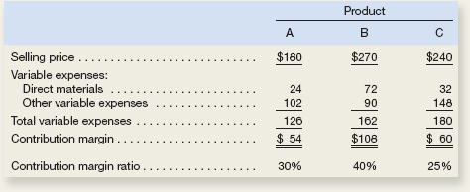
The same raw material is used in all three products. Barlow Company has only 5,000 pounds of raw material on hand and will not be able to obtain any more of it for several weeks due to a strike in its supplier’s plant. Management is trying to decide which product(s) to concentrate on next week in filling its backlog of orders. The material costs $8 per pound.
- Compute the amount of contribution margin that will be obtained per pound of material used in each product.

- Which orders would you recommend that the company work on next week—the orders for product A, product B, or product C? Show computations.

EXERCISE 12–13 Sell or Process Further [LO12–7]
Wexpro, Inc., produces several products from processing 1 ton of clypton, a rare mineral. Material and processing costs total $60,000 per ton, one-fourth of which is allocated to product X15. Seven thousand units of product X15 are produced from each ton of clypton. The units can either be sold at the split-off point for $9 each, or processed further at a total cost of $9,500 and then sold for $12 each.
  - Should product X15 be processed further or sold at the split-off point?

