**Cash**

**Cash Over and Short.**

Differences between the count of the cash in a cash register and the record from the register of cash receipts yield cash over and short journal entries. **Cash Over and Short** is an income statement account recording the income effects of cash overages and cash shortages. Cash Over and Short account usually is combined with other miscellaneous expenses on the income statement.

To record cash over and short, follow these simple rules:

1. Record the cash count as a debit to Cash (Physically how much cash the company has)
2. Record the cash register record as a credit to Sales (Theoretically how much cash the company should have from the cash register report)
3. The difference will be either a debit or a credit to Cash Over and Short

If a cash register's record shows $600 should be in the register but the cash count from the register is $595, the journal entry is:

Cash 595

Cash Over and Short 5

Sales 600

If a cash register's record shows $600 should be in the register but the cash count from the register is $607, the journal entry is:

Cash 607

Sales 600

Cash Over and Short 7

**Check Basics**

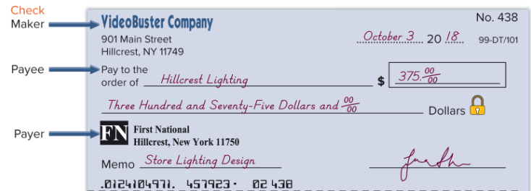

**Bank Reconciliation**

The balance of a checking account reported on the bank statement rarely equals the general ledger cash balance in the accounting records. There are timing difference between the bank and the general ledger because the bank is not up to date with amounts in the general ledger. There are amounts on the books of the company that will not be recorded until the bank statement arrives.



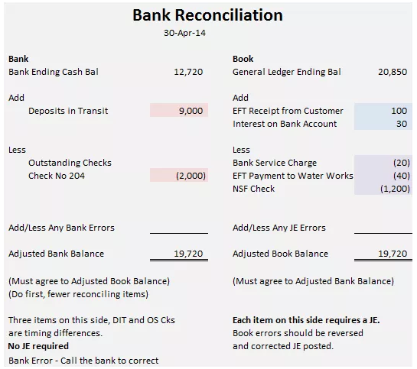

**Bank Side**

In preparing a bank reconciliation, always reconcile the bank side (left side below) first because there are generally only two reconciling items – deposits in transits (deposits not yet recorded by the bank but recorded in the general ledger) and outstanding checks (checks written and recorded by the company but not yet received by the bank). The ending Adjusted Bank Balance will help you determine if you have properly recognized all reconciling items from the book or right-hand side. **NOTE: Deposits in Transit, Outstanding Checks and Bank Errors do not require a journal entry.**

The ending Adjusted Bank Balance must agree to the ending Adjusted Book Balance.

**Book or General Ledger Side**

Reconciling items on the book side. **These will come from the bank statement. Each will require a journal entry.**

Add: Any interest received, any collections from your customers which the bank has performed on behalf of the company, and any previously unrecorded deposits.

Subtract: Any bank service charges, EFT payments, insufficient funds (NSF) checks you deposited, any fees for NSF checks, and any loan payments to the bank. (This is not an exhaustive list but a review of the bank statement will show what has been deducted from the bank account).

Journal Entry Errors: 1) Reverse the original entry as though it did not happen (easier to explain and also to remember) and 2) Record the proper amount.

**Assignment #1 Bank reconciliation**

Del Gato Clinic deposits all cash receipts on the day when they are received and it makes all cash payments by check. At the close of business on June 30, its Cash account shows an $11,589 debit balance. Del Gato Clinic's June 30 bank statement shows $10,555 on deposit in the bank. Prepare a bank reconciliation for Del Gato Clinic using the following information:

1. Outstanding checks as of June 30 total $1,829.
2. The June 30 bank statement included a $16 charge for bank services.
3. Check No. 919, listed with the canceled checks, was correctly drawn for $467 in payment of a utility bill on June 15. Del Gato Clinic mistakenly recorded it with a debit to Utilities Expense and a credit to Cash in the amount of $476.
4. The June 30 cash receipts of $2,856 were placed in the bank's night depository after banking hours and were not recorded on the June 30 bank statement.

Prepare the adjusting journal entries that Del Gato Clinic must record as a result of preparing the bank reconciliation

**Assignment #2 Bank reconciliation**

Wright Company deposits all cash receipts on the day when they are received and it makes all cash payments by check. At the close of business on May 31, its Cash account shows a $27,500 debit balance. The company's May 31 bank statement shows $25,800 on deposit in the bank. Prepare a bank reconciliation for the company using the following information.

1. The May 31 bank statement included a $100 charge for bank services; the company has not yet recorded the cost of these services.
2. Outstanding checks as of May 31 total $5,600.
3. May 31 cash receipts of $6,200 were placed in the bank's night depository after banking hours and were not recorded on the May 31 bank statement.
4. In reviewing the bank statement, a $400 check written by Smith Company was mistakenly drawn against Wright's account.
5. The bank statement shows a $600 NSF check from a customer; the company has not yet recorded this NSF check.

