Instructor: Professor Christy Lynch, CPA, CFE, MSA

Office: GW 500

Office Hours: T/Th Noon to 1pm (Zoom)

Class Meeting Day & Time
T/R 1:30p - 5:00p (Zoom)
Office Phone: 504.314.7921 (inactive – use email)

E-mail: clynch8@tulane.edu

Canvas: https://tulane.instructure.com/2217564

Class Location: Online

Course Description
ACCN 3010 examines how managers use accounting information to formulate plans, control operations and make informed managerial decisions. Students will learn cost behavior and how to use cost information in managerial decisions. Students will also learn how to develop a corporate budget and gather feedback to ensure that the budget is either properly executed or adjusted.

Course Prerequisites
Prerequisite: ACCN 2010

Course Goals
This course is designed to teach you the uses of accounting information for both planning and control of business organizations, which help managers achieve organizations’ strategic objectives. A major goal of the course is to develop your understanding of the relevance of accounting to internal management, from the procedures used to generate accounting data through to the types of analyses required to effectively use the information for managerial decision making. The topics of the course, especially opportunity costs, relevant costs, and other analysis techniques, are directly and immediately relevant to not only your professional careers, but also your personal success. We will also emphasize cost accounting and financial reporting of inventories for manufacturers.
Student Learning Objectives
As the result of this course, students should be able to:
- Understand how costs flow through organizations, and how costs are accumulated and reported
- Use these costs and associated revenues to make decisions about the best level of operations
- Prepare a budget
- Compare actual results to budgeted results and evaluate performance
- Use appropriate relevant costing data to analyze business decisions such as outsourcing and pricing,
- Evaluate the results of these decisions

Course Material
Text: Managerial Accounting, 16th Edition with Connect Plus access, by Garrison, Noreen and Brewer, McGraw-Hill/Irwin. If you purchase the hard copy of the textbook or rent the textbook, please ensure your textbook is packaged with the Connect access code.

NOTE: I encourage you to purchase the electronic version of this textbook (ebook). We will extensively use my notes in this class as the basis for tests and all work in Connect. Therefore, you will not need to purchase the text but must purchase the homework access code.

The access to the ebook ends with the semester but an older edition would be a great thing to have as part of your accounting library.

Connect website for this class: https://connect.mheducation.com/class/c-lynch-ses-2-accn-3010-sum-2020

Lecture Website: Produced by your professor – NumberKnowledge.com
Case-sensitive password for this course is TUL3010Learn

NOTE: All course material links can be found in Canvas and NumberKnowledge.

Evaluation Procedures and Grading Criteria
Your performance in this course will be graded based upon your performance on the following components:

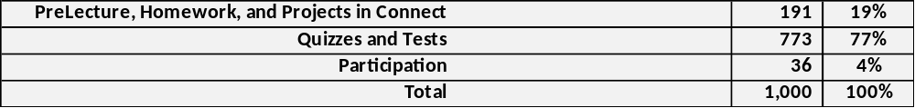

This course follows the faculty approved grading guidelines of a maximum class average GPA in the range of 2.700 to 3.000 for core classes and a maximum class average GPA in the range of 3.000-3.333 for business elective classes. Please note the stated average class GPA range is a maximum average range and the class average GPA range could be lower.

Grade | A | A- | B+ | B | B- | C+ | C | C- | D+ | D | D- | F
Points | 100-94 | 93-90 | 89-87 | 86-  83 | 82-80 | 79-  77 | 76-  73 | 72-70 | 69-67 | 66-  63 | 62-  60 | 59-  or less

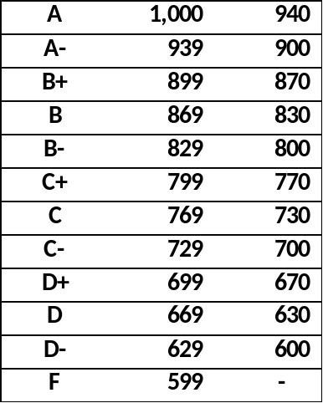

After each test, your total grade will be updated.

There is no extra credit available for this course unless provided by me. Please see relevant section in NumberKnowledge.com and Connect

You are responsible for all due dates as noted in the published schedule. If there are any changes, the schedule will be updated in Canvas and in NumberKnowledge. An email will also be sent. Be certain to be able to find all assignments in Connect—don’t expect Connect to keep you organized as some assignments are due over a long period of time.

Instructors are authorized to lower the grades of students who are absent excessively without a satisfactory excuse or do not make up work missed because of absences.

Class Attendance Statement

Attendance is taken and participation graded.

Students are expected to attend all Zoom classes unless they are prevented from attending by exceptional circumstances. Student who find it necessary to miss class are responsible for obtaining notes on material covered in lectures or other class sessions. Students are responsible for notifying instructors about absences. (One exception would be if a student is in a country where class times are not within normal parameters. In this instance, the student will send an email stating they have viewed the class Zoom recording. This arrangement must be requested and approved by me.)

Class sessions are made up of lecture and problem-solving components. Most class time will be spent on the reasoning, concepts, and relationships that make up the decision models that managers use to make decisions within (internal to) business organizations. A typical class will introduce a component of our topic and working through problem sets before moving onto the next component. The class is very interactive, and I will be calling upon students while problem solving.

To improve your understanding of the relevant topics, it is important that you attend class, participate in class discussions, and support peer learning. I will determine your participation grade based on your attendance, attention and attitude in class, and the quality of your participation in class discussions. This method of instruction has been selected to aid in your retention of the material as it is expected you will remember more by doing than by simply reading or listening to a lecture.

Zoom Session attendance
- Find a quiet and appropriate room/setting (Not your bed)
- Dress as though you are in class
- Use the Zoom sign in information from Canvas or NK to access the class
- Sign in using your Tulane email and credentials – Needed for Zoom features such as attendance
- Establish a live video feed – no static windows
- Your video feed should have your name on it
- You must use your proper first and last name to record attendance.
- Classes will be recorded.

Instructors are authorized to lower the grades of students who are absent excessively without a satisfactory excuse or do not make up work missed because of absences.

Course Policies

ACCN 3010 will make many demands on your analytical, verbal, and quantitative skills. It requires that you assimilate material, understand it in some depth, and then apply it to decision situations. The complexity of the material presented in this class is not conducive to last minute “cramming.” The problems are challenging, and you will have to work hard. However, you will develop and refine analytical problem-solving skills that will be extremely valuable to you in your future career (even if your future career is not in accounting!)

The volume of the material makes it difficult to stay current and review old material simultaneously. Therefore, it is essential that you stay current with your attendance and homework. I strongly encourage you to seek help when you need help.

Tests
You should expect to take every test. If you miss the first test, your second test will be cumulative. If you miss your second test, you must take a cumulative final on a date I designate. All second test cumulative finals will be given on the same date and are comprised of 200 plus questions.

Only the most extreme circumstances will warrant a test extension. Ordinary circumstances such as illness, forgetting, etc. are not considered extreme circumstances.

Tests are comprised of multiple choice questions but are not a reiteration of homework problems but rather solving problems understanding how concepts work in relation to formulas. You must grasp the theory as well as any formulas.

There will be two versions of the test—one for the regular amount of time and another for extended, Goldman time.

Grade challenges
After a test, all grades will be updated alongside the tests grade. Grades must be challenged within two (2) business days of the test otherwise, the grade will not change—no exceptions.
Assignments in Connect

Due dates for assignments – Follow the Published Schedule

Only exceptional circumstances will warrant an extension. Extensions are granted before, not after an assignment is due. An online class requires extensive organizational skills. You should diary all due dates. You will use these skills throughout your business life. You may work ahead.

- Pre-Lecture and Homework -- unlimited attempts – due by the beginning of class unless otherwise noted
- Quizzes -- two attempts – due at 10pm
- Projects – three attempts – due at 10pm
- Tests – one attempt – due at 10pm

To find the complete list of assignments, click on the podium icon on the left-hand side of the student interface and select your class. Otherwise, Connect shows only those assignments that are due within the next seven (7) days. Be certain to be able to find all assignments in Connect—don’t expect Connect to keep you organized as some assignments are due over a long period of time.

Pre-Lecture Assignments
All chapters have pre-lecture assignments. The lecture material for each chapter forms the basis for these assignments. These are (unless otherwise indicated) quick videos from your book publisher with some elementary questions on the video. You can click on the right-hand side (I believe) and obtain the transcript of the video.

Homework
In addition to the homework assignments, practice sets of homework (located at the bottom of the Connect homework assignments) can be used to practice for tests after the due date. These will not close until the semester ends and can be used to study for tests/final.

Projects in Connect - There are three projects in Connect. See the schedule for due dates.

Performance Measurement
The assignment consists of viewing the publisher’s video on this material. There are only three (3) attempts allowed for this assignment. There is no lecture for this material. While it is important for you to be exposed to these concepts, the concept does not warrant class time.

Budget
This is a lengthy project. You will have unlimited attempts but only three check my work for this project.

Serial Problem
The assignment is comprised of using financial information in a variety of situations and is based upon cumulative information.

Problems with the Connect System: The help number for Connect is 1-800-331-5094. The Connect system is a closed system; you must call them. Don’t wait until the last minute to call them with a problem. You should call them in sufficient time to iron out any problems. Connect works best with Firefox, Chrome and Safari. No extensions will be granted for homework unless there is a documented Connect case number or internet outage.

Class Communication
I will use Canvas and email to communicate outside of class. Please check these often to remain abreast of changes. Please follow up any verbal communication with an email.

Office Hours
Office hours are not tutoring sessions if you miss class. They are designed to answer specific questions or discuss matters of concern to you.

Syllabus Changes
Circumstances may warrant additions or clarifications to the Syllabus for anything except your grade determination. I reserve the right to make any changes.

Emergency Preparedness & Response
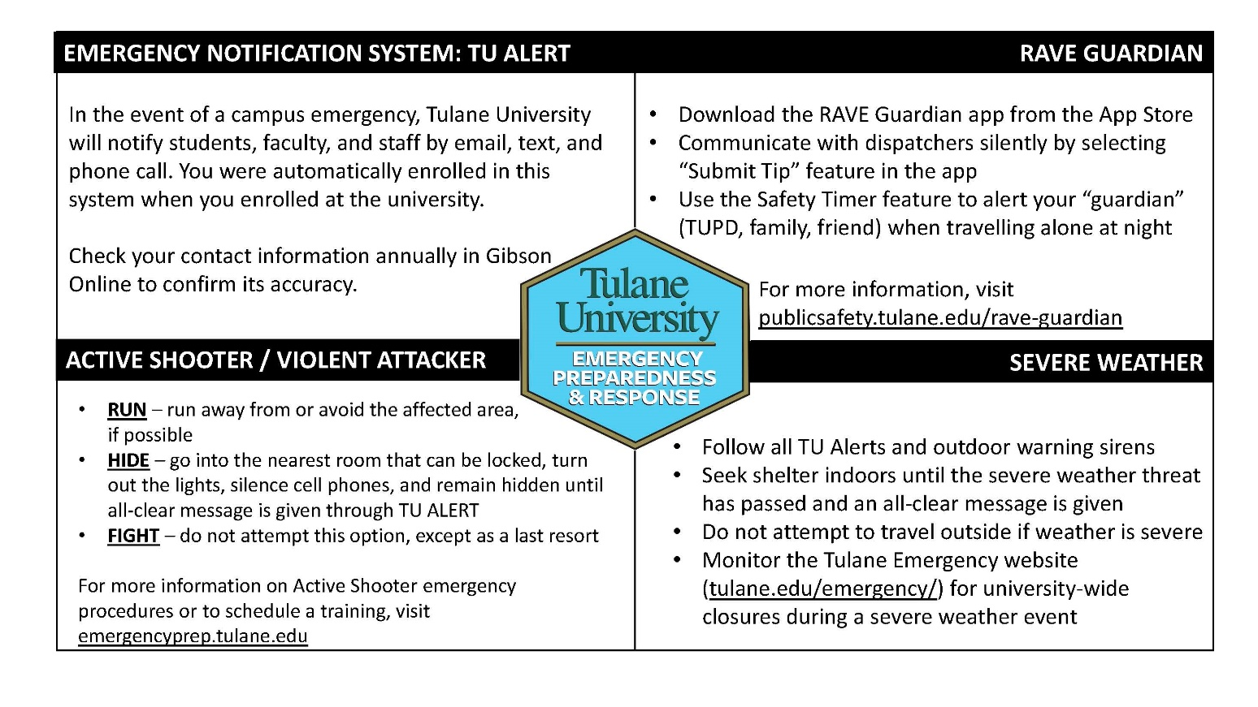

- Freeman Educational Norms and Expectations
This class is in full accordance with Freeman’s Educational Norms and Expectations.

- Goldman Center for Student Accessibility and ADA/Accessibility Statement
Any students with disabilities or other needs, who need special accommodations in this course, are invited to share these concerns or requests with the instructor and should contact Goldman Center for Student Accessibility: http://accessibility.tulane.edu or 504.862.8433.

- Statement about Academic Integrity
The Code of Academic Conduct applies to all undergraduate students, full-time and part-time, in Tulane University. Tulane University expects and requires behavior compatible with its high standards of scholarship. By accepting admission to the university, a student accepts its regulations (i.e., Code of Academic Conduct and Code of Student Conduct) and acknowledges the right of the university to take disciplinary action, including suspension or expulsion, for conduct judged unsatisfactory or disruptive.
- Title IX
Tulane University recognizes the inherent dignity of all individuals and promotes respect for all people. As such, Tulane is committed to providing an environment free of all forms of discrimination including sexual and gender-based discrimination, harassment, and violence like sexual assault, intimate partner violence, and stalking. If you (or someone you know) has experienced or is experiencing these types of behaviors, know that you are not alone. Resources and support are available: you can learn more at allin.tulane.edu. Any and all of your communications on these matters will be treated as either “Confidential” or “Private” as explained in the chart below. Please know that if you choose to confide in me I am mandated by the university to report to the Title IX Coordinator, as Tulane and I want to be sure you are connected with all the support the university can offer. You do not need to respond to outreach from the university if you do not want. You can also make a report yourself, including an anonymous report, through the form at tulane.edu/concerns.

Confidential | Private
Except in extreme circumstances, involving imminent danger to one’s self or others, nothing will be shared without your explicit permission. | Conversations are kept as confidential as possible, but information is shared with key staff members so the University can offer resources and accommodations and take action if necessary for safety reasons.
Counseling & Psychological Services (CAPS) | (504) 314-2277 or  The Line (24/7) | (504) 264-6074 | Case Management & Victim Support Services | (504) 314-2160 orsrss@tulane.edu
Student Health Center | (504) 865-5255 | Tulane University Police (TUPD) | Uptown - (504) 865-5911. Downtown – (504) 988-5531
Sexual Aggression Peer Hotline and Education (SAPHE) | (504) 654-9543 | Title IX Coordinator | (504) 314-2160 or msmith76@tulane.edu

PUBLISHED SCHEDULED – Follow this document for due dates.

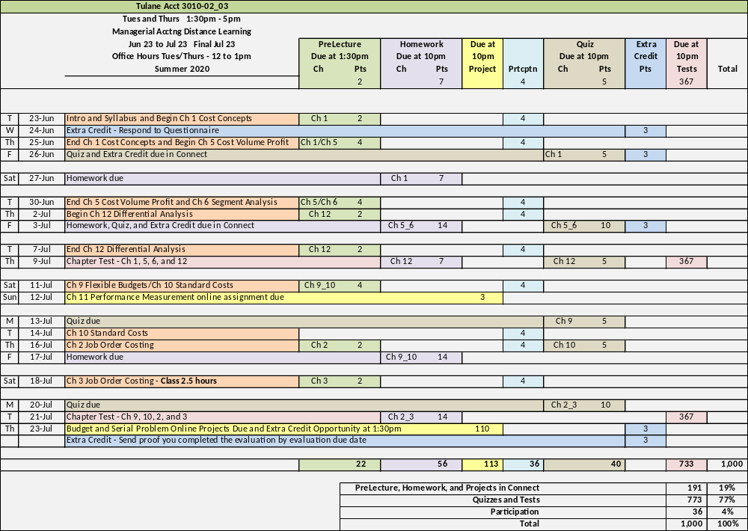

A.B. FREEMAN SCHOOL OF BUSINESS
SUMMER 2020 CLASS TEMPLATE
M/W Class Schedule
Tuesday, June 23
Thursday, June 25
Tuesday, June 30
Thursday, July 2
Tuesday, July 7
Thursday, July 9
Saturday, July 11
Tuesday, July 14
Thursday, July 16
Saturday July 18 (2.5 Class hours )
Tuesday, July 21
Thursday, July 23 | FINAL Exam

