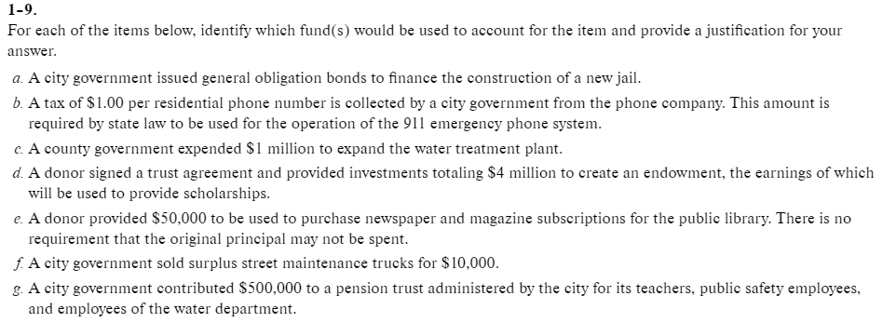
Your choices are:
- Private-purpose trust fund
- Enterprise fund
- Special revenue fund
- Capital projects fund
- General fund
- Permanent fund
- Or several funds including ???

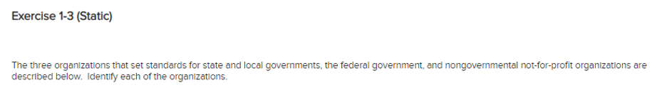
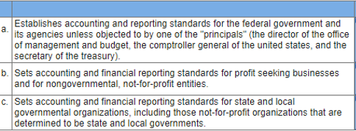
Your choices are:
- GASB
- FASB
- Federal Accounting Standards Advisory Board

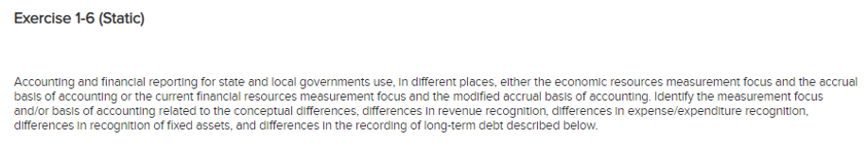
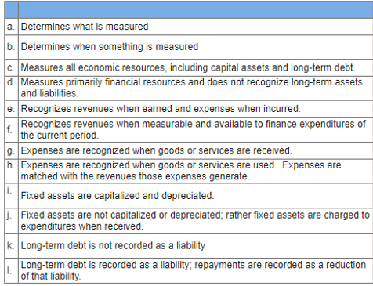
Your choices are
- Current financial resources measurement focus
- Accrual basis of accounting
- Measurement focus
- Economic resources measurement focus
- Modified accrual basis of accounting
- Basis of Accounting
- Economic resources measurement focus and accrual basis of accounting
- Current financial resources measurement focus and modified basis of accounting

