Use the following information for the Exercises 12-13 below.
Del Gato Clinic's cash account shows an $12,423 debit balance and its bank statement shows $11,949 on deposit at the close of business on June 30.
- Outstanding checks as of June 30 total $2,316.
- The June 30 bank statement lists a $100 bank service charge.
- Check No. 919, listed with the canceled checks, was correctly drawn for $489 in payment of a utility bill on June 15. Del Gato Clinic mistakenly recorded it with a debit to Utilities Expense and a credit to Cash in the amount of $498.
- The June 30 cash receipts of $2,699 were placed in the bank’s night depository after banking hours and were not recorded on the June 30 bank statement.

QS 6-12 (Algo) Bank reconciliation LO P3
Organic Food Co.'s cash account shows a $7,000 debit balance and its bank statement shows $6,210 on deposit at the close of business on August 31.
- August 31 cash receipts of $2,740 were placed in the bank’s night depository after banking hours and were not recorded on the August 31 bank statement.
- The bank statement shows a $270 NSF check from a customer; the company has not yet recorded this NSF check.
- Outstanding checks as of August 31 total $2,620.
- In reviewing the bank statement, an $230 check written by Organic Fruits was mistakenly drawn against Organic Food’s account.
- The August 31 bank statement lists $170 in bank service charges; the company has not yet recorded the cost of these services.
Prepare a bank reconciliation using the above information.
Prepare journal entries.

Problem 6-5A Preparing a bank reconciliation and recording adjustments as of September 30
Chavez Company reconciled its bank statement and book balances of cash on August 31, and it reported two checks outstanding, No. 5888 for $1,046 and No. 5893 for $510. Check No. 5893 was still outstanding as of September 30.

Bank Statements
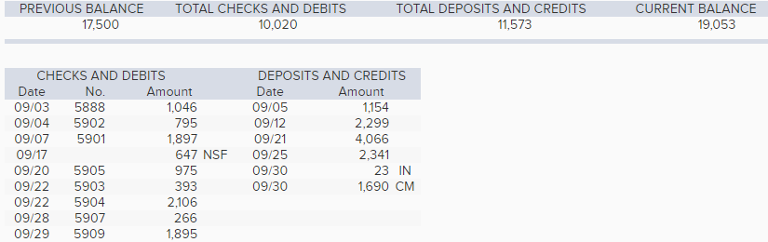
Accounting Records
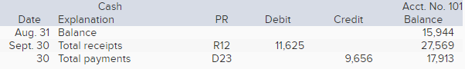
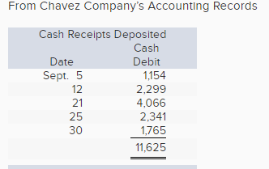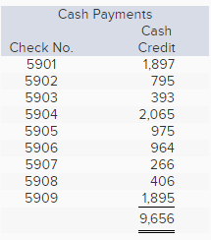
- (a) Check No. 5904 is correctly drawn for $2,106 to pay for computer equipment; however, the recordkeeper misread the amount and recorded a debit to Computer Equipment and a credit to Cash of $2,065.
- (b) The NSF check shown in the statement was originally received from a customer, S. Nilson, in payment of her account. Its return has not yet been recorded by the company.
- (c) The credit memorandum (CM) is from the collection of a $1,690 note for Chavez Company by the bank. The collection is not yet recorded.

