S 7-2
Direct write-off method P1
Solstice Company determines on October 1 that it cannot collect $50,000 of its accounts receivable from its customer P. Moore. Apply the direct write-off method to record this loss as of October 1.
QS 7-3
Recovering a bad debt P1
Refer to the information in QS 7-9. On October 30, P. Moore unexpectedly paid his account in full to Solstice Company. Record Solstice's entry(ies) to reflect this recovery of this bad debt.
QS 7-5
Allowance method for bad debts P2
Gomez Corp. uses the allowance method to account for uncollectibles. On January 31, it wrote off a $800 account of a customer, C. Green. On March 9, it receives a $300 payment from Green.
- Prepare the journal entry or entries for January 31.
- Prepare the journal entry or entries for March 9; assume no additional money is expected from Green.
QS 7-6
Percent of accounts receivable and the percent of sales methods P2
Warner Company's year-end unadjusted trial balance shows accounts receivable of $99,000, allowance for doubtful accounts of $600 (credit), and sales of $280,000. Uncollectibles are estimated to be 1.5% of accounts receivable.
- Prepare the December 31 year-end adjusting entry for uncollectibles.
- What amount would have been used in the year-end adjusting entry if the allowance account had a year-end unadjusted debit balance of $300?
- Assume the same background facts as above except that Warner estimates uncollectibles as 0.5% of sales. Prepare the December 31 year-end adjusting entry for uncollectibles.
Exercise 7-6
Percent of accounts receivable method P2
At each calendar year-end, Mazie Supply Co. uses the percent of accounts receivable method to estimate bad debts. On December 31, 2013, it has outstanding accounts receivable of $55,000, and it estimates that 2% will be uncollectible. Prepare the adjusting entry to record bad debts expense for year 2013 under the assumption that the Allowance for Doubtful Accounts has (a) a $415 credit balance before the adjustment and (b) a $291 debit balance before the adjustment.

Exercise 7-7
Aging of receivables method P2
Daley Company estimates uncollectible accounts using the allowance method at December 31. It prepared the following aging of receivables analysis.
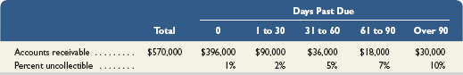
- Estimate the balance of the Allowance for Doubtful Accounts using the aging of accounts receivable method.
- Prepare the adjusting entry to record Bad Debts Expense using the estimate from part a. Assume the unadjusted balance in the Allowance for Doubtful Accounts is a $3,600 credit.
- Prepare the adjusting entry to record Bad Debts Expense using the estimate from part a. Assume the unadjusted balance in the Allowance for Doubtful Accounts is a $100 debit.

QS 7-11
Disposing receivables C3
Record the sale by Balus Company of $125,000 in accounts receivable on May 1. Balus is charged a 2.5% factoring fee.

QS 7-10
Note receivable P3
Daw Company's December 31 year-end unadjusted trial balance shows a $10,000 balance in Notes Receivable. This balance is from one 6% note dated December 1, with a period of 45 days. Prepare any necessary journal entries for December 31 and for the note's maturity date assuming it is honored.

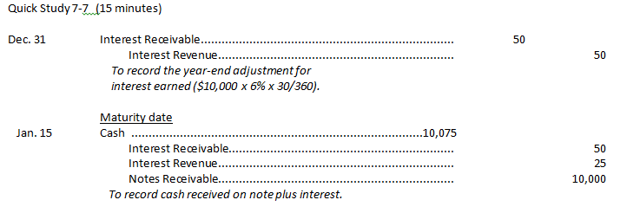

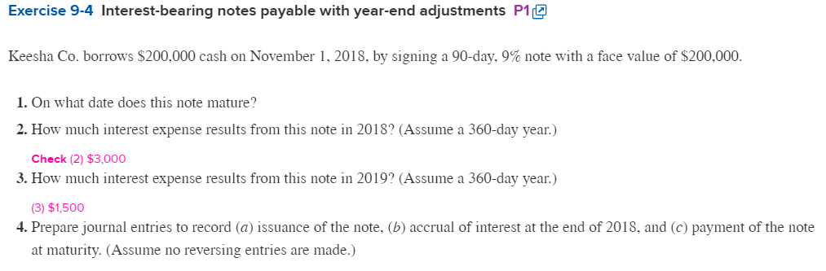Exercise 9-4 (30 minutes)

1. Maturity date = November 1 + 90 days = January 30, 2019.

2. |  | Principal |  | $200,000
 |  | x Interest rate |  | 9%
 |  | x Fraction of year (Nov. 1 – Dec. 31) |  | 60/360
 |  |  | Total interest in 2018 | $ 3,000

3. |  | Principal |  | $200,000
 |  | x Interest rate |  | 9%
 |  | x Fraction of year (Jan. 1 – Jan. 30) |  | 30/360
 |  |  | Total interest in 2019 | $ 1,500

4a.

2018
Nov. 1 | Cash | 200,000
 | Notes Payable |  | 200,000
 | Borrowed cash by issuing an interest-bearing note.

4b.

2018
Dec. 31 | Interest Expense | 3,000
 | Interest Payable |  | 3,000
 | Accrued interest on note payable.

4c.
2019
Jan. 30 | Interest Expense | 1,500
 | Interest Payable | 3,000
 | Notes Payable | 200,000
 | Cash |  | 204,500
 | Repaid note plus interest.

