How to find all assignments and practice set/test prep folders in Connect

Connect displays the assignments currently due. To find all your assignments, use the following instructions:
Look for the menu on the left-hand side
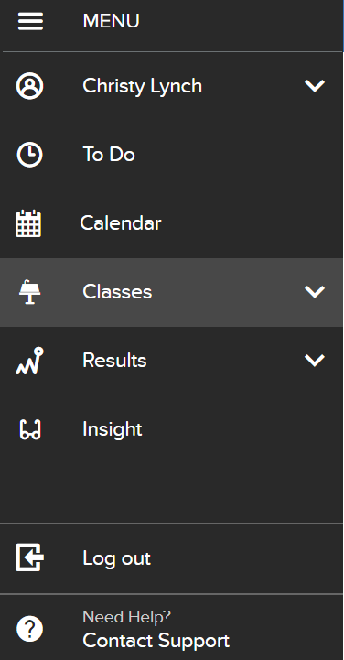

Click on Classes
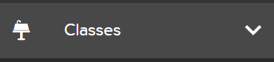

Find your class
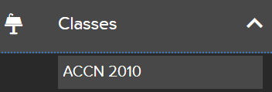.

Click on the class and the entire listing of all assignments will be there. You will then be able to find practice set or test prep folders
