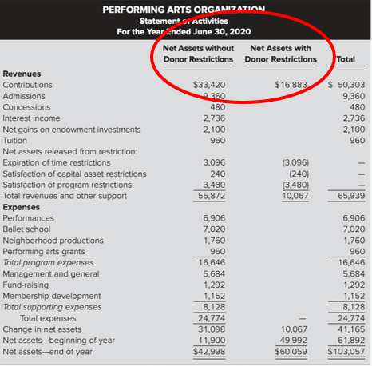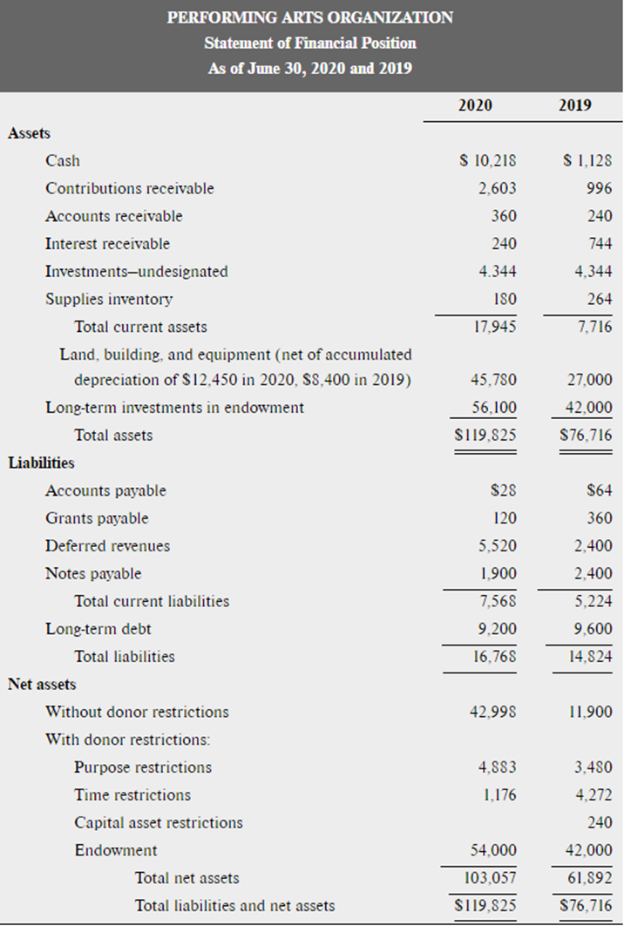
HOMEWORK Question #5
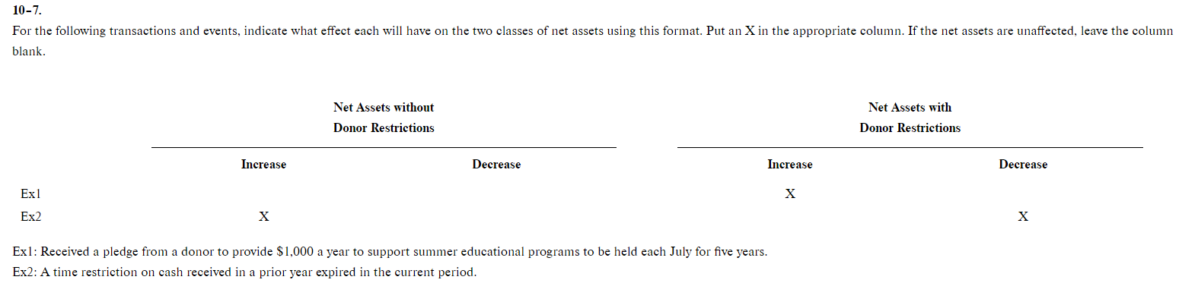
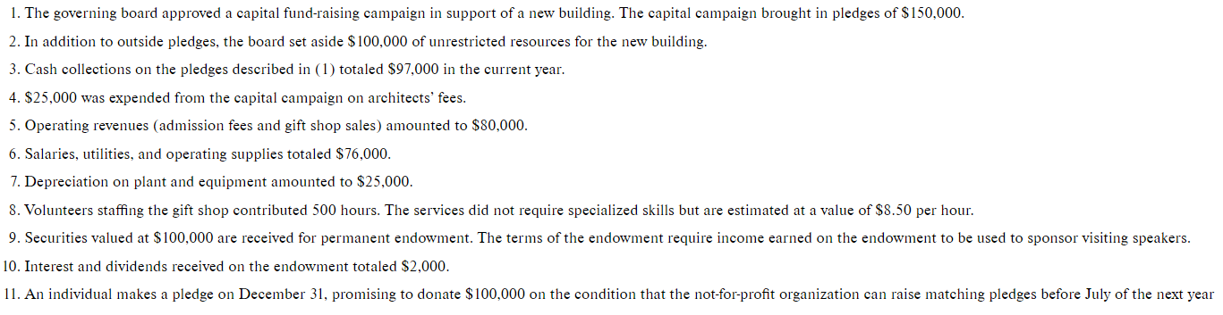

HOMEWORK Question #6

Exercise 10-10

On October 1, 2020, the Voluntary Action Agency (which has a December 31 fiscal year-end) received a cash contribution of $450,000 restricted to the purchase of buses to be used in transporting senior citizens as part of the organization's "Active Seniors Program."

On January 2, 2021, buses were purchased with the $450,000 cash. The buses are expected to be used for five years and have no salvage value at the end of that time.

Record the journal entries on October 1, 2020, January 2, 2021, and December 31, 2021 for the receipt of cash, the purchase of buses, and one year's depreciation.

Homework Question #2

Exercise 10-11

On January 1, 2020, a foundation made a pledge to pay $15,000 per year at the end of each of the next five years to the Cancer Research Center, a nonprofit voluntary health and welfare organization, as a salary supplement for a well-known researcher.

On December 31, 2020, the first payment of $15,000 was received and paid to the researcher.
- On the books of the Cancer Research Center, record the pledge in January, assuming the appropriate discount rate is 5 percent on an annual basis. The appropriate present value annuity factor is 4.32948
- Record the increase in the present value as of December 31.
- Record the receipt of the first $15,000 on December 31 and the payment to the researcher.

Homework Question #3

Exercise 10-12
The Evangelical Private School follows FASB standards of accounting and reporting.
- Cash contributions were received as follows: (a) $968,000 for any purpose desired by the school, (b) $300,000 designated by donors for salary supplements for school faculty, (c) $417,000 designated by donors to be used during the next fiscal year in any manner desired by the school, (d) $550,000 designated by donors for the construction of a new auditorium, and (e) $400,000 designated by donors to be invested permanently, with the income to be used as desired by the school. The school’s policy is to record all restricted gifts as with donor restrictions and then reclassify when the restriction is lifted.
- The school expended $400,000 of the $968,000 mentioned in 1(a) for school furniture.
- The school expended the $280,000 for salary supplements as directed by the donor in 1(b).
- The $417,000 in 1(c) was retained for use next year, as directed by the donor.
- $780,000 was expended for the construction of the new auditorium.
- The $400,000 mentioned in 1(e) was invested permanently, as directed by the donor, and in the year ended June 30, 2020, the school received interest of $19,000, none of which was expended.

