**Chapter 4 Recording Operating Transactions Affecting the General Fund and Governmental Activities at the Government-wide Level**

Presented below are a number of transactions for the City of Bingham that occurred during the 2017 fiscal year; the year for which the budget given in Chapter 3 was recorded. Read **all** instructions carefully.

**DUAL-TRACK ACCOUNTING APPROACH**

Governmental fund operating activities and transactions have different effects on the government-wide financial statements and fund financial statements.

Certain activities (e.g., those relating to the General Fund budget) have no effect on the government-wide financial statements.

Most operating activities or transactions affect both the General Fund and governmental activities at the government-wide level, but in different ways.

Still other activities, such as recording depreciation expense or accruing interest on general long-term debt, affect only the government-wide financial statements and are not recorded at all in the General Fund or in any other governmental fund.

To capture the dual effects of transactions at the government-wide and governmental fund levels, this text adopts a dual-track approach to analyzing and recording transactions based on manual accounting procedures. Although this approach is designed to facilitate ease of learning, it also provides all the accounting information needed to prepare both government-wide and fund financial statements.

1. After opening the data file containing your data from Chapters 2 and 3 of this project, record the following transactions in the general journal for the General Fund and, if applicable, in the general journal for governmental activities at the government-wide level. **For all entries, the date selected should be year 2017.**

For each of the paragraphs that requires entries in both the General Fund and governmental activities journals, record them in both journals on a paragraph-by-paragraph basis.

For each entry affecting budgetary accounts or operating statement accounts, the Detail Journal will automatically open to allow you to record the appropriate amounts in the detail budgetary or actual accounts.

1. **[Para. 4-a-1]** Property taxes were levied in the amount of $6,875,000. It is estimated that 4 percent of the tax will be uncollectible.

Earlier, we recorded the budgeted amount of property taxes in the amount of:



This amount represents the amount the government expects to collect out of its property tax levy of $6,875,000. It expects to collect 96% of the $6,875,000; therefore, the estimated revenue is $6,600,000.

In many states, a county official prepares bills for all taxes levied on property within the county; another county official acts as collector of all property taxes levied for the county and all governments within the county. Although the billing and collecting functions may be centralized, the taxes levied for each fund must be recorded as an asset of that fund. If the accounts are to be kept in conformity with generally accepted accounting principles, the portion of the taxes expected to be collectible (0.96 of the total levy, in this example) must be recorded as revenues of that fund, and the portion expected to be uncollectible (0.04 of the total levy), must be recorded in a “contra-asset” account.

Property tax revenue is classified under GASB standards as an **imposed nonexchange revenue,** and a receivable should be debited when there is an enforceable claim, as in the case of a property tax levy. The revenue should be credited in the year for which the tax was levied.

In the General Fund fund (or any fund), the revenue is recognized when measurable and available. For property taxes, GASB specifies that available means collected within the current period or within 60 days of year end. In this case, Bingham expects to collect the revenues within this time frame.

(If the town expected to collect a portion of the $2,600,000 later than 60 days after fiscal year-end, it should credit that portion to Deferred Inflow of Resources—Property Taxes and reclassify it to Revenues in the period in which the revenues are collected.)

Even if a portion of revenues is deferred in the General Fund because of the availability criterion, the full amount is recognized as General Revenues—Property Taxes in the governmental activities journal at the government-wide level. This is so because availability to finance current expenditures is not a revenue recognition criterion under the accrual basis used at the government-wide level.

**Required: Record this $6,875,000 transaction in both the General Fund and Government Activities – Gov-Wide general journal using reference 4-a-1.**



NOTE: Careful referencing by paragraph number is very helpful should you need to determine where you may have omitted a required journal entry or made an error.)

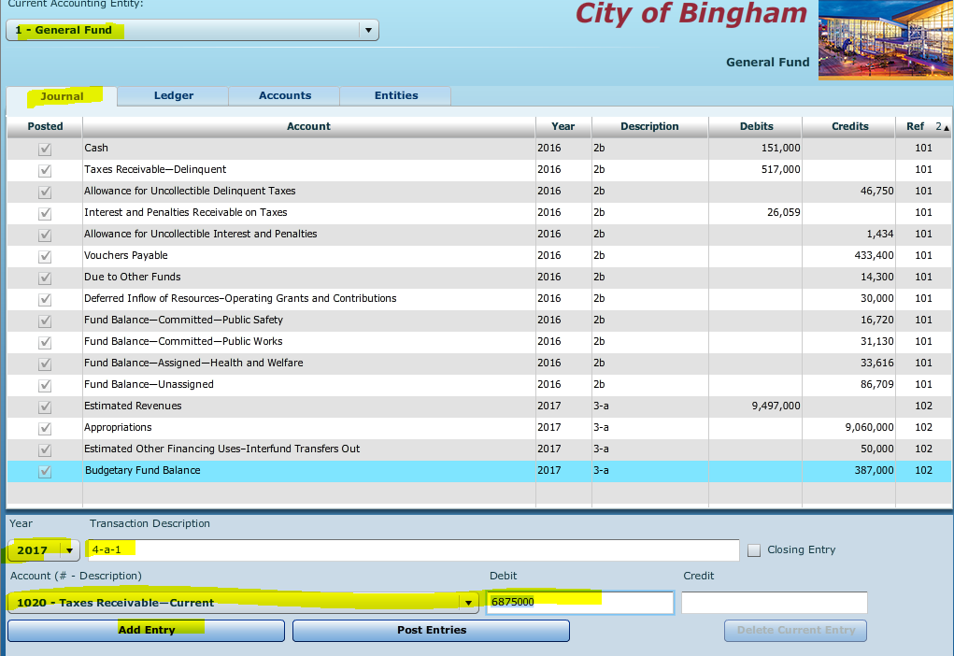

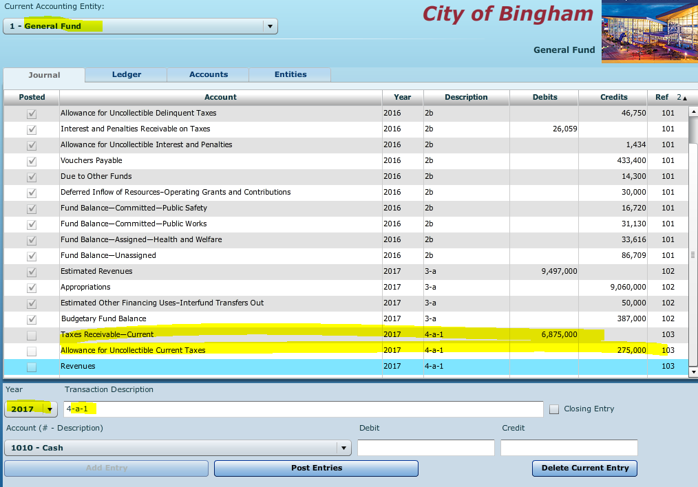

When you begin to input revenues, you will be taken to the detail input screen

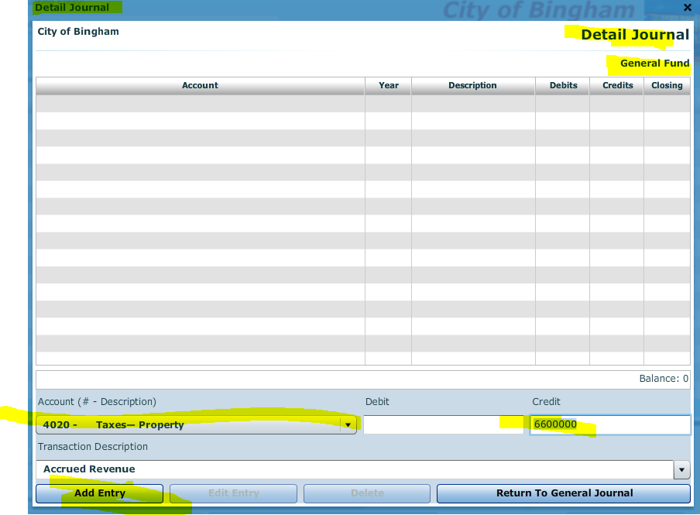

Add entry (It will be account number 4020) and then click on the button to return to the general journal

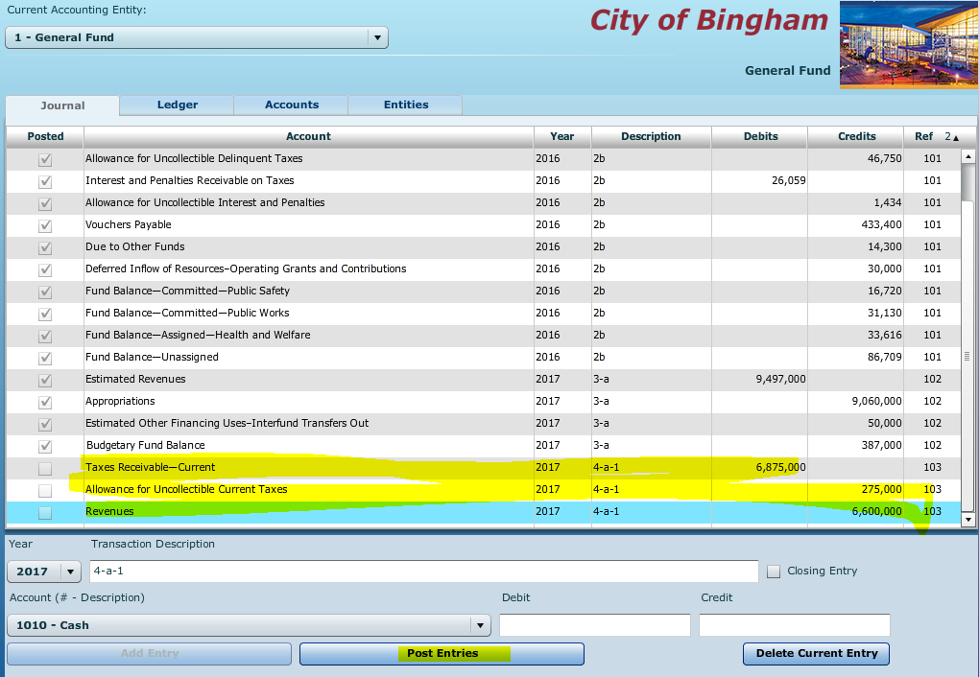

**Post the entry**

**Record the same in the Governmental Activities – Government wide general journal**



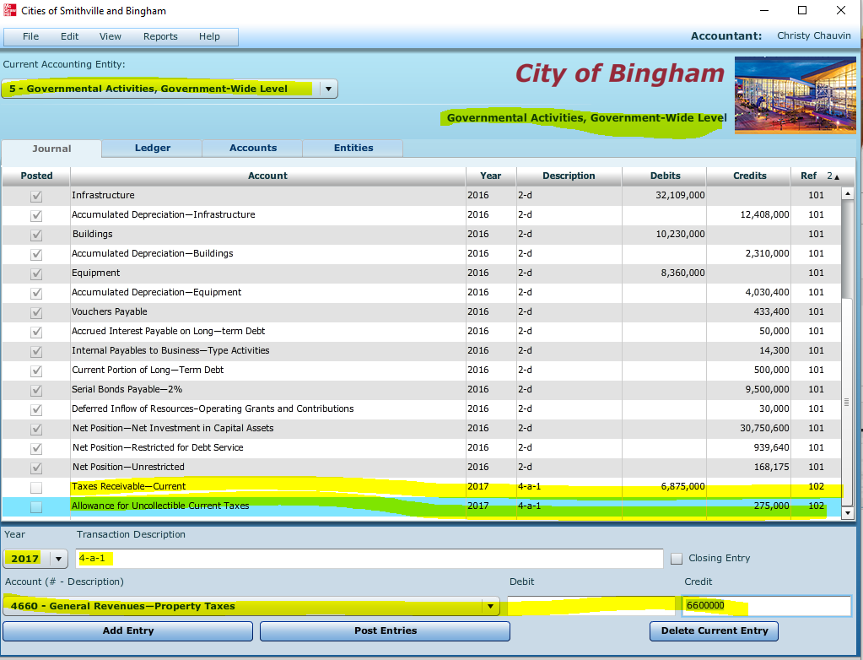

**Then post the entry –** Should see a check mark next in the posted box. 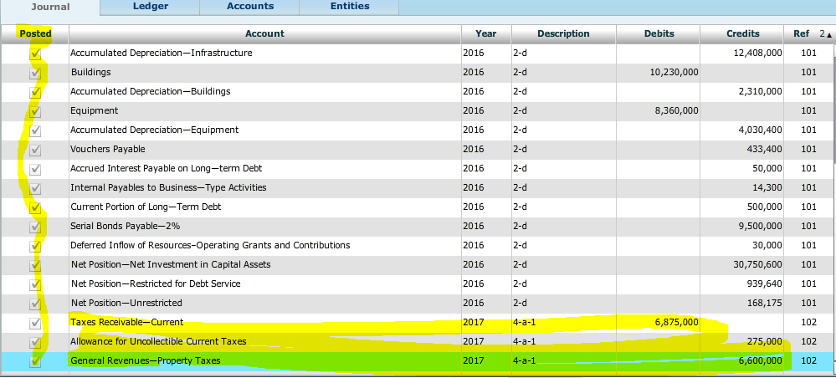

1. **[Para. 4-a-2]** Tax anticipation notes were issued in the amount of $500,000.

Should tax revenues be received later than needed to pay vendors on a timely basis, governments typically issue tax anticipation notes to meet those short-term cash needs.

**Tax anticipation notes** are notes issued by states or municipalities to finance current operations before tax revenues are received. When the issuer collects the taxes, the proceeds are then used to retire this debt.

The interest income is exempt from federal income tax for the recipient—a treatment similar to that for interest income from municipal bonds. Tax anticipation notes are short term notes, issued at a discount, with a maturity period usually less than a year or a stated future date. Tax anticipation notes are used by municipalities to bridge funding gaps.

When the 2016 post closing trial balance was recorded for the beginning of the 2017 year, the cash on hand in the general fund (151,000) was not sufficient to pay the vouchers payable (433,400). Often property taxes are collected twice a year and the government must pay vendors throughout the year, therefore a tax anticipation note is taken out to augment cash in anticipation of tax collections.

**Required:** Record the issuance of this note in both the General Fund and governmental activities general journals using the reference **4-a-2**



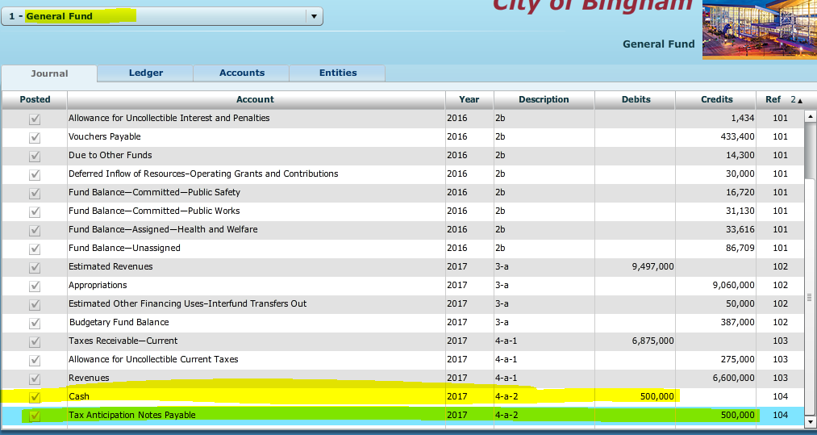

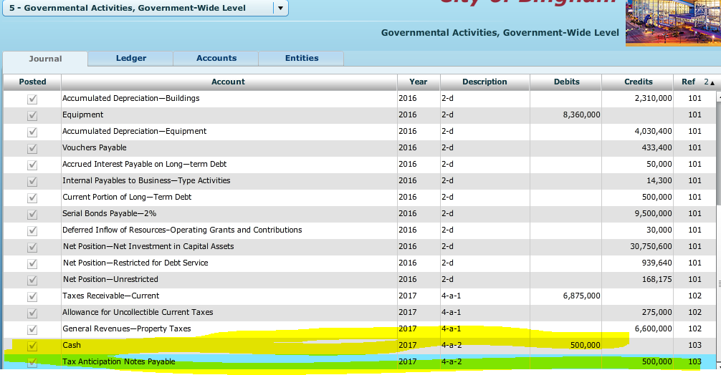

1. **[Para. 4-a-3]** Purchase orders, contracts, and other commitment documents were issued in the following amounts for the following functions:

An appropriation is considered *expended* when the authorized liabilities have been incurred.

When a purchase order or contract has been issued, it is important to record the fact that the appropriation has been *encumbered* in the amount of the purchase order or contract. The word *encumbered* is used, rather than the word *expended* because the amount is only an **estimate** of the liability that will be incurred when the purchase order is filled or the contract executed.

7020 General Government $ 395,000

7030 Public Safety 1,095,000

7040 Public Works 945,750

7050 Health and Welfare 665,725

7060 Culture and Recreation 625,125

7070 Miscellaneous 138,000

Total $3,864,600

**Required:** Record the encumbrances in the General Fund general journal and Detail Journal as appropriate. In the Detail Journal, select “Purchase Orders” from the drop down **[Transaction Description]** menu. You can also type in an alternative description, if desired.

A journal entry is required to record the estimated cost of supplies ordered and service contracts signed. Sound budgetary control dictates the entry. The amounts chargeable to specific appropriations of 2017 are debited to detail accounts in the Encumbrances Subsidiary Ledger. (Recall that budgetary entries affect only funds for which a budget is legally adopted; they have no effect at the government-wide level.)

**NOTE:** When you enter **Account 7010** to record the Encumbrances, the detail journal (Encumbrances subsidiary ledger) screen will open up immediately. Enter each type of encumbrance here from above as a debit.



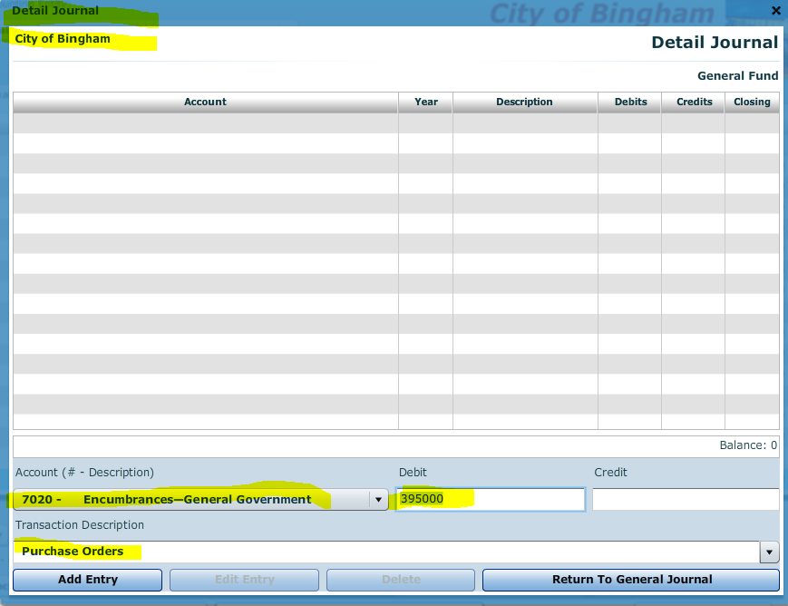

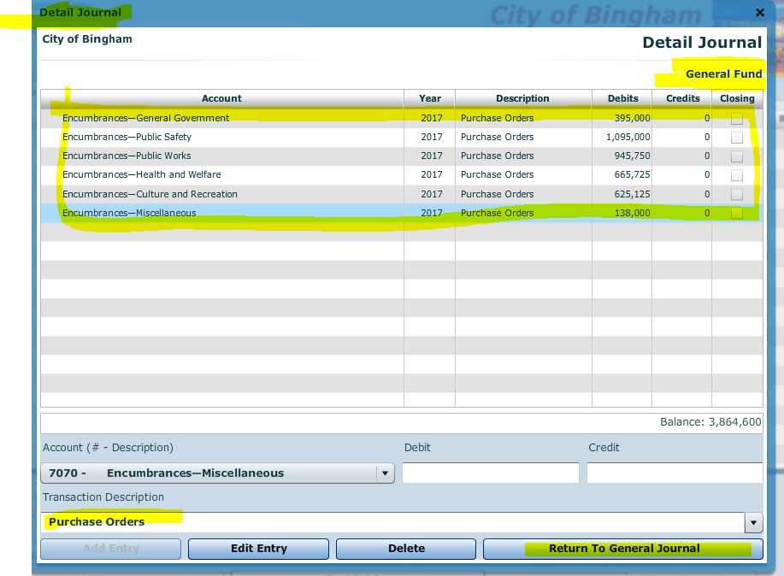

**Return to GJ and finish entry**

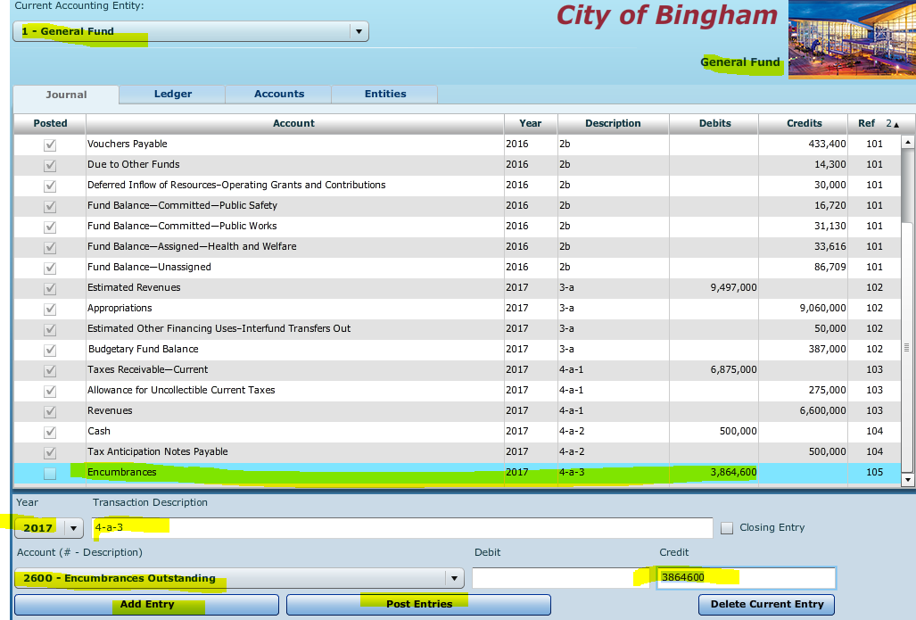

1. **[Para. 4-a-4]** Grant funds of $30,000 recorded as Deferred Inflow of Resources-Operating Grants and Contributions at the end of FY 2016 were recognized as revenue when timing requirements were met.

**A word about deferred inflows and outflows**

Deferred outflow/inflow of resources are not assets, liabilities, revenues or expenses/expenditures. Unlike revenues and expenses, which are inflows and outflows of resources related to the period in which they occur, deferrals are related to future periods. They are the result of past transactions but the recognition is deferred until the future period to which they are related. (Expense=Accrual Basis, Expenditure=Modified Accrual Basis)

An example of a deferred inflow of resources would be resources received in a period prior to when the resources can be used (a timing issue). Since such an advance payment does not meet the definition of a liability (think unearned revenues), GASB standards require that it be recognized as a deferred inflow of resources.

WHY IS IT IMPORTANT TO REPORT DEFERRALS SEPARATELY?

The GASB requires that deferred outflows of resources be reported in the financial statements apart from assets, and deferred inflows of resources apart from liabilities. The simplest reason is that deferrals are not assets or liabilities and not revenues or expense (expenditures), and reporting them as such risks distorting a government’s actual financial position.

**Required:** Record **JE 4-a-4** the revenue in both the General Fund and governmental activities general journals by debiting Deferred Inflow of Resources-Operating Grants and Contributions and crediting Revenue.

**NOTE:** When you record the General Fund revenue in Acct 4010, the Detail Journal will populate, select Acct 4090, Misc Revenue and record the credit. Add entry and return to GJ and post the entry.



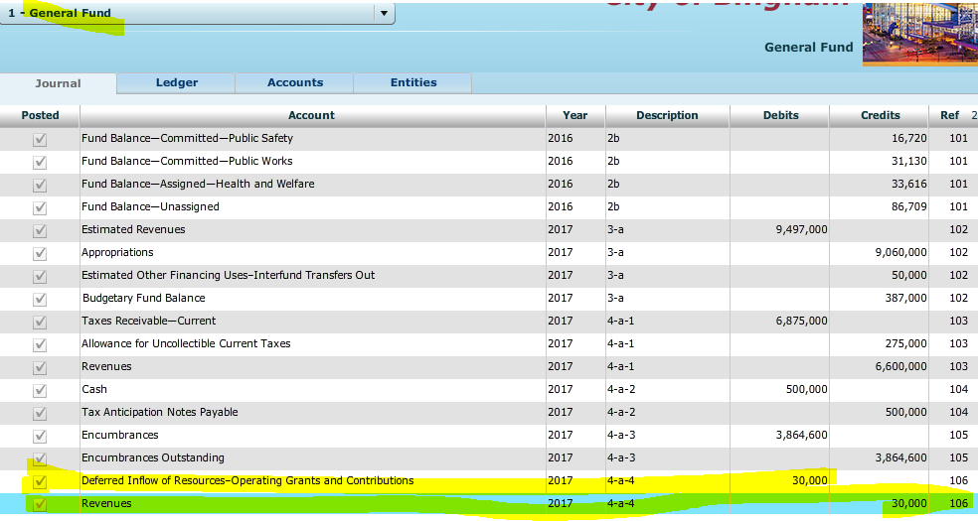

**Next record the entry for the Gov Activities Fund and use the above account numbers. Add the entries and post.**

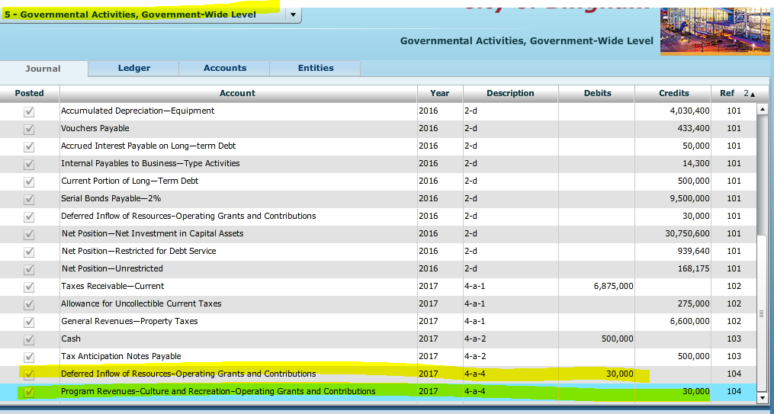

1. **[Para. 4-a-5]** The General Fund paid $385,000 on the vouchers payable that were outstanding at the end of **FY 2016.**

**Required:** Record **JE 4-a-5** the payment of this amount in both the General Fund and governmental activities general journals.



**Add entries for both the fund and activities general journals and post**

1. **[Para. 4-a-6]** The General Fund collected the following amounts in cash:

Current year Real Property Taxes $6,364,000

Delinquent Taxes 468,000

Interest and Penalties Receivable on Taxes 23,860

Sales Taxes 748,000

Licenses and Permits 478,000

Fines and Forfeits 525,000

Intergovernmental Revenues 510,000

Charges for Services 361,000

Miscellaneous Revenues 226,500

Total $9,704,360

**Required:** Record **JE 4-a-6** the receipt of cash and the related credits to receivables and revenues accounts, as applicable, in both the General Fund and governmental activities journals.

Collections on current year receivables are a credit to Taxes Receivable- Current but any portion not expected to be paid in the current period is classified as Taxes Receivable – Delinquent and the attendant interest and penalties associated with the delinquent taxes would be recorded as Interest Penalties Receivable on Taxes.

NOTE: When you begin to enter revenue amounts in the Revenues control account (ACCT 4010), the detail journal will populate. There you will record revenues by type. Select “**Received in Cash**” in the drop down **[Transaction Description]** menu in the Detail Journal related to the General Fund revenue entries.) NOTE: You will continually repopulate the transaction description “Received in Cash” each time. Revenues represent all items above except for Taxes Receivable – Current, Taxes Receivable – Delinquent and Interest and Penalties Receivable on Taxes.

**General Fund**



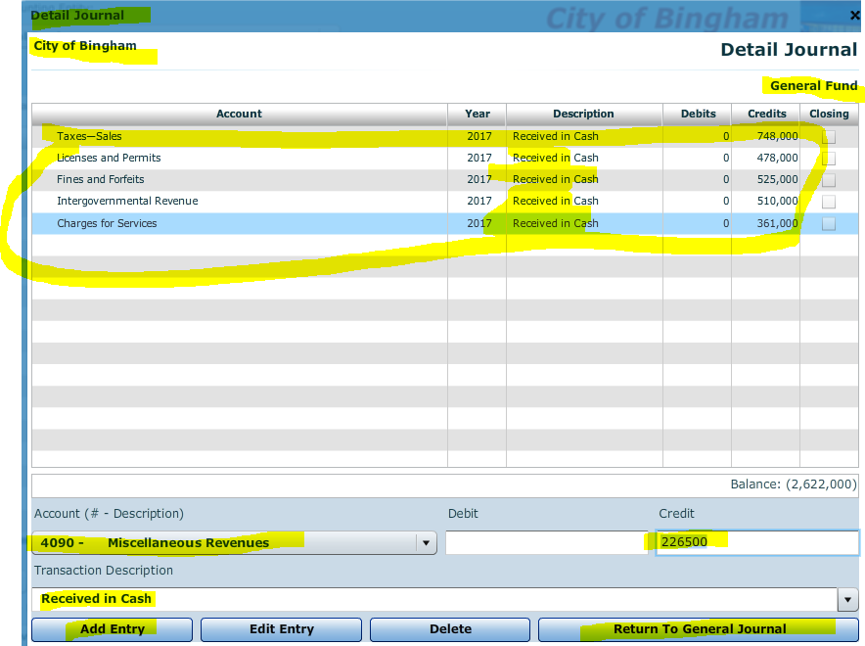

**Add and post entries**

**Governmental Activities at the Government-Wide Level**

All Licenses and Permits and Charges for Services were attributable to the General Government function as Program Revenue.

NOTE: Fines and forfeits were collected by General Government departments in the amount of $200,000 and by Public Safety departments in the amount of $325,000.

Intergovernmental Revenues should be credited to “Program Revenues—General Government—Operating Grants and Contributions.”



Add and post entries

If you have a number input error, you can always right click on the entry and modify it to the correct amount.

1. **[Para. 4-a-7]** The General Fund paid the $14,300 reported as Due to Other Funds at the end of FY 2016. This amount was reported as Internal Payables to Business-type Activities at the government-wide level.

**Required:** Record JE **4-a-7** the payment of this amount in both the General Fund and governmental activities general journals.



**Add and post entries**

1. **[Para. 4-a-8]** Delinquent taxes receivable in the amount of $26,000 were written off as uncollectible. Interest and penalties accrued on these taxes in the amount of $1,300 were also written off.

**Write-off of Uncollectible Delinquent Taxes.** Officers of a government review aged trial balances of taxes receivable and other receivables. Although the levy of property taxes creates a lien against the underlying property in the amount of the tax, accumulated taxes may exceed the market value of the property, or, in the case of personal property, the property may have been removed from the jurisdiction of the government. When delinquent taxes are deemed uncollectible, the related interest and penalties must also be written off.



**Required:** Record the writeoffs in both the General Fund and governmental activities general journals and post

1. **[Para. 4-a-9]** General Fund payrolls for the year totaled $5,083,038. Of that amount, $772,395 was withheld for employees' federal income taxes; $860,456 for federal payroll taxes; $290,798 for employees’ state income taxes; $320,152 for retirement funds administered by the state government; and the remaining $2,839,237 was paid to employees in cash. The City of Bingham does not record encumbrances for payrolls. The payrolls were chargeable against the following functions’ appropriations:

General Government $ 1,300,376

Public Safety 2,331,644

Public Works 790,481

Health and Welfare 311,673

Culture and Recreation 348,864

Total $5,083,038

**Required:** Make summary journal entries for payroll in both the General Fund and governmental activities general journals for the year.

**General Fund.** The gross pay is chargeable to the appropriations in the General Fund as indicated by the Expenditures Ledger debits. Only the portions due to the federal and state governments is segregated as an amount due.

**NOTE:** When you enter the amount in ACCT 6010 Expenditures, the detail journal will open. Record the expenditures by functions from above there. When all are entered, the total will be $5,083,038



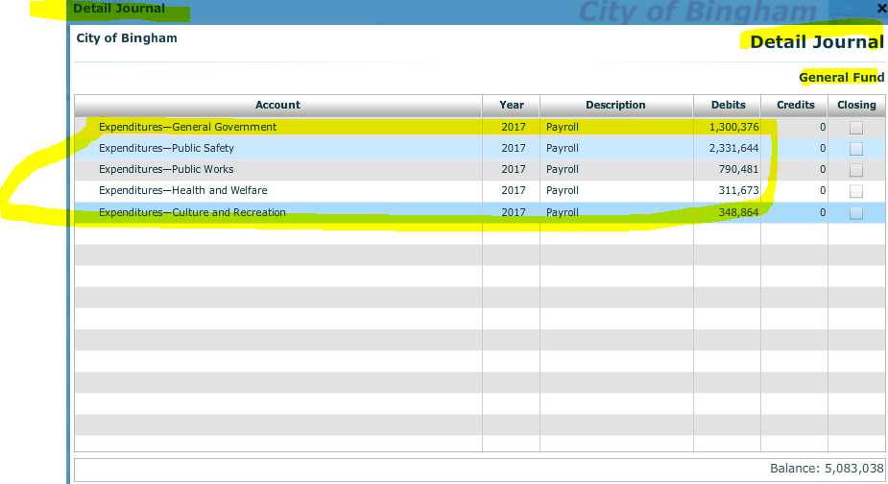

**After posting, return to general journal, complete the remainder of the entry and post.**

**Gov Activities - Government-Wide Level.**

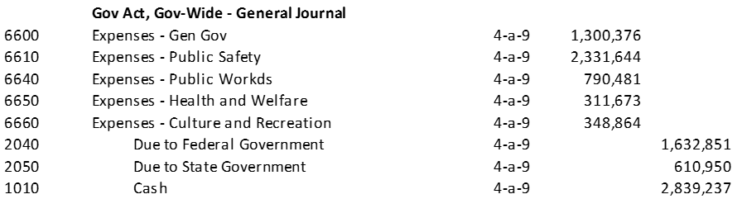

**Record and post**

1. **[Para. 4-a-10]** Invoices for *some* of goods and services ordered in transaction **4-a-3** were received and vouchered for later payment. (**Select “Elimination” in the drop down** [Transaction Description] menu in the Detail Journal):

*Actual* ***Estimated***

General Government $ 395,940 $ 394,060

Public Safety 1,086,650 1,088,600

Public Works 922,300 927,620

Health and Welfare 661,200 663,600

Culture and Recreation 593,750 597,000

Miscellaneous 138,000 138,000

Totals $3,797,840 $3,808,880

**Encumbrances and Purchasing Transactions**

When supplies and services ordered during the current year have been received and found to be acceptable, the billing documents are approved for payment. The estimated liability for each order was previously recorded as a debit in the Encumbrances control account in the general ledger, as well as in subsidiary Encumbrance Ledger accounts, entries must be made to reverse the encumbrances entries for the **originally estimated amounts**. In addition, entries are required to record the **actual charges** in the Expenditures control account and subsidiary Expenditures Ledger accounts. Expenses and/or assets must also be recorded in governmental activities accounts at the government-wide level, as appropriate.

**Note:** Use of ACCT 7010 will open the detail journal for encumbrances where you will enter the **estimated** amounts by function. Transaction description should be “Elimination.” (You will have to populate “Elimination” as the Transaction Description for each entry.

Use of ACCT 6010 will open the detail journal for expenditures where you will enter the **actual** amounts by function and use **“Goods received”** in the Transaction Description. (You will have to populate “Goods Received” each time you enter the expenditure). At present, there are two Culture and Recreation 6060 accounts in the software – use the first one.

**General Fund**



**Gov Wide**

Transaction Description 4-a-10. Assume the city uses the periodic inventory method. The invoiced amounts above should be recorded as expenses of the appropriate functions, except for $72,500 of playground equipment ordered by Culture and Recreation. The equipment meets the city’s threshold for capitalization (debit Equipment for this item at the government-wide level). The amount attributable to Culture and Recreation is $72,500 for the equipment and $521,250 for expenses totaling to $593,750



1. **[Para. 4-a-11]** The General Fund paid vouchers during the year in the amount of $3,200,000 as well as its liabilities for employees’ federal and state income taxes withheld and payroll taxes. Description 4-a-11

**Required:** Record the payment of these items in both the General Fund and governmental activities general journals.



1. **[Para. 4-a-12]** The General Fund transferred $50,000 to the debt service fund so the debt service fund could make a bond interest payment. Description 4-a-12

**Required:** Record this transaction in the General Fund only. The transaction has no effect at the government-wide level since it occurs between two governmental activities. (Do not record this transaction in the debt service fund until instructed to do so in Chapter 6 of this case.)



1. **[Para. 4-a-13]** Tax anticipation notes issued by the General Fund were paid at maturity at the face amount plus interest of $10,000. Description 4-a-13

**Required:** Record the payment of these items in both the General Fund and governmental activities general journals. Gen Fund - USE of ACCT 6010 will open Detail journal, charge **Acct 6070** **Miscellaneous** for the interest expenditure. Describe as Interest on Tax Anticipation Note.



1. **[Para. 4-a-14]** There is a liability of $50,000 to other funds for services and is related to the Water Utility Fund during the year. Of this amount, $39,000 should be charged to Public Safety and $11,000 to General Government. Description 4-a-14

**Gen Fund** - USE of ACCT 6010 will open detail journal; record by function and use Water Utility as the description.



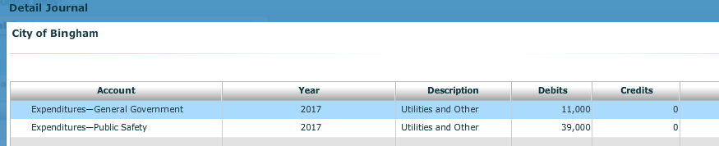

**Gov Wide** - At the government-wide level the liability should be credited to Internal Payables to Business-type Activities. **Do not record these items in the Water Utility Fund** until instructed to do so in Chapter 7 of this case.



1. **[Para. 4-a-15]** The balances in the current taxes receivable and related estimated uncollectible accounts were reclassified as delinquent by the government. This reclassification also results in recording Interest and Penalties Receivable on Taxes of $56,580, of which $10,500 was estimated to be uncollectible. Describe as 4-a-15. Hint: Run a pre-closing trial balance to see where these amounts come from. (This will be helpful when you perform a similar transaction for Smithville.

**Gen Fund** – Use of Revenues will trigger Detail Journal. Record as Interest and Penalties on Taxes Acct 4040 and Description is Accrued Revenue.



1. **[Para. 4 a-16]** In view of unexpected revenue and expenditure developments the city council revised the budgets for the current year as shown below:

Budget Adjustments

Estimated Revenues:

Intergovernmental Revenue - Acct 3070 15,000 decrease - credit

Fines and Forfeits- Acct 3060 15,000 increase - debit

Miscellaneous Rev – Acct 3090 31,500 increase - debit

Appropriations:

Public Safety – Acct 5030 20,000 decrease - debit

Health and Welfare – Acct 5050 10,000 increase - credit

Miscellaneous – Acct 5070 50,000 decrease - debit

**Required:** Record the budget amendments in the General Fund general journal only. Budgetary items do not affect the government-wide accounting records**. (Note: Select “Budget Amendment” in the [Transaction Description] box in the Detail Journal.)**

Estimated Revenues will trigger detail journal. Describe as Budget Amendment (Note the net effect of the transaction will be $31,500 since the $15,000 entries offset one another but you should record each entry in its respective account).

Appropriations will trigger detail journal. Describe as Budget Amendment and use detail from above and describe as Budget Amendment. Net effect of the entries above will yield a debit of $60,000.



**Refer to list of documents to print**

**Note: It is vital you print the General Fund 2017 Pre-Closing Trial Balance. You will need this document to record the closing entries.**

**Chapter 4 Recording Operating Transactions Affecting the General Fund and Governmental Activities at the Government-wide Level**

**General Fund. – Describe as Closing Entry**

**Background:**

Following the instructions in the next paragraph, prepare and post the entries to close the Gen Fund

**You will be given the closing entry for this project as well as the Smithville project.** We will close the books in the following order.

1. Close the budget
2. Close the revenues, expenditures, etc. to unassigned fund balance
3. Close other financing uses – inter-fund transfers out to unassigned fund balance
4. Recording fund constraints

**A word about recording fund constraints**. At year-end, an analysis by the city’s finance department determined the following constraints on resources in the General Fund. Prepare the appropriate journal entry in the General Fund to reclassify amounts between Fund Balance—Unassigned and the fund balance accounts corresponding to the constraints shown below. **The ending balances will be**

Account Amount

Fund Balance—Assigned—Culture and Recreation $57,650

Fund Balance—Assigned— Health and Welfare 25,000

Fund Balance—Committed—Public Safety 12,300

Fund Balance—Committed—Public Works 33,790

Note: **WE WILL NOT PREPARE CLOSING ENTRIES FOR GOVERNMENTAL ACTIVITIES AT THIS TIME** since governmental activities will not be closed until Chapter 9, after the capital projects fund (Chapter 5) and debt service fund (Chapter 6) transactions affecting governmental activities at the government-wide level have been recorded.

**Recording the Closing Entries:**

**To close the temporary accounts, you must click on the check mark for [Closing Entry], “Closing Entry” will appear in the [Transaction Description] box. Be sure the check mark in the box for [Closing Entry] is showing before closing each individual account.**

Also, with the exception of Estimated Other Financing Uses—Inter-fund Transfers Out and Other Financing Uses—Inter-fund Transfers Out, you will be sent to the **Detail Journal** where you must close each individual budgetary or operating statement account.

To determine the closing amounts for both General Ledger and subsidiary ledger accounts, you should first print the pre-closing version of these **ledgers** for year 2017 from the **[Reports]** menu.

1. **Closing the Budget**

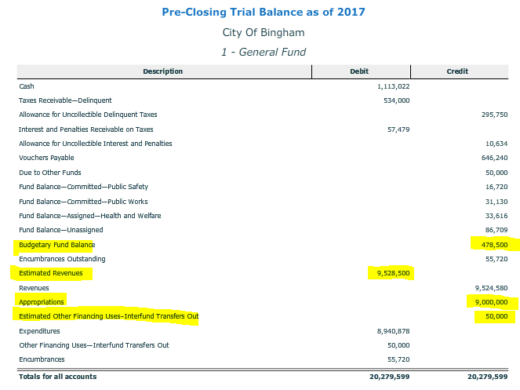

**Before you begin to record the closing entry, make sure closing entry is checked.**



Debit appropriation as follows in the detail journal. Credit revenues as follows in the detail journal. Remember, these were budget entries and we credited appropriations, so we will debit to close—we debited revenues and will credit to close.



**Closing the Revenue, Expenditures, etc. Accounts**

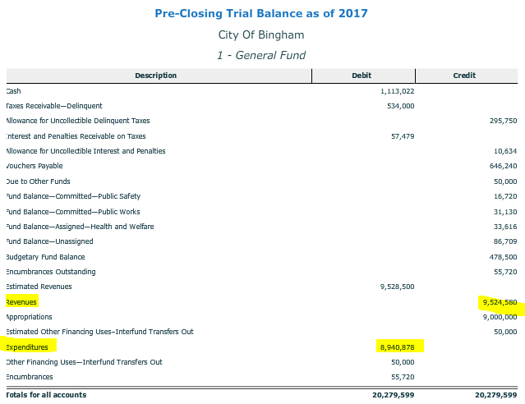





1. Close other financing uses – Inter-fund transfers out to unassigned fund balance

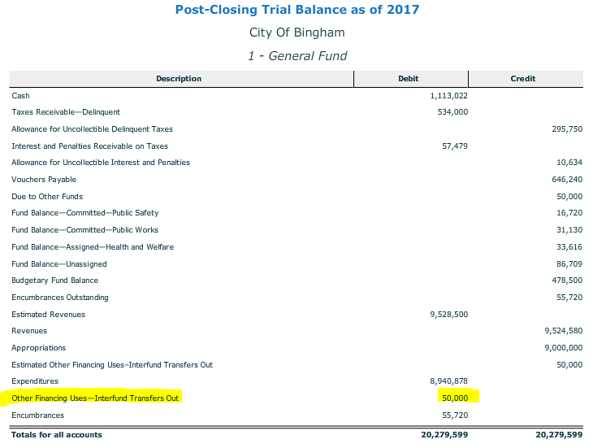



1. Recording fund constraints



**Illustration of pre-closing trial balance and post-closing trial balance**. Note Because the City of Bingham honors all outstanding encumbrances at year-end, it is not necessary to close Encumbrances to Encumbrances Outstanding at year-end since encumbrances do not affect the General Fund balance sheet or statement of revenues, expenditures, and changes in fund balances.

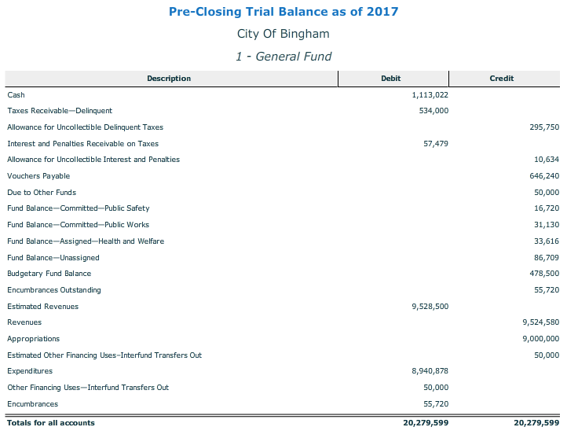

1. Print the General Fund Post Closing Trial Balance

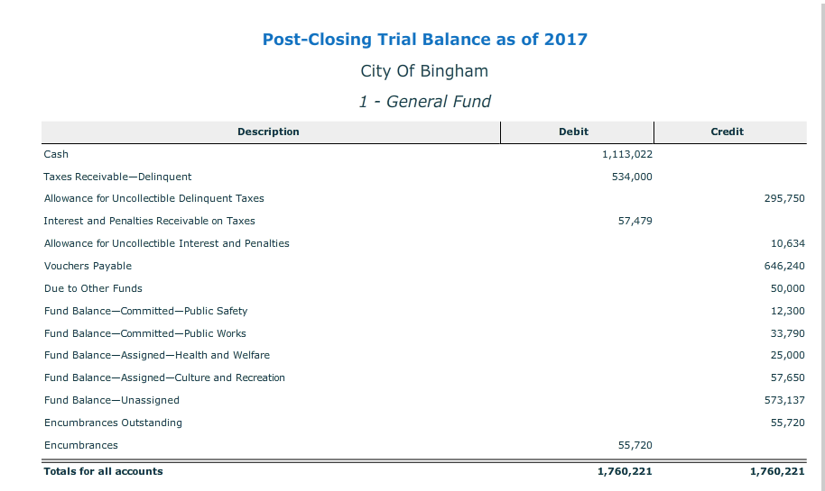

**Refer to list of documents to determine what to hand in.**

1. Review the following financial statements. You will prepare these financial statements for the Smithville Project. The authors recommend the use of excel to prepare these from the information.

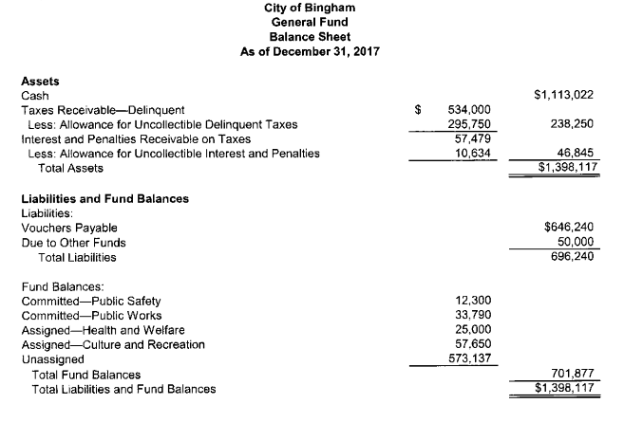

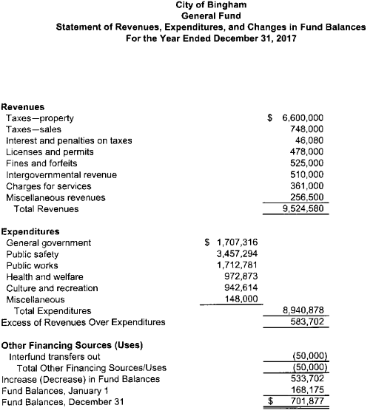

**Before closing the *City of Bingham,* click on [File], and [Save/Save As] to save your work.** If you close the file by clicking on the [**X**] box you will be asked if you want to save your changes before closing.