Smithville Chapter 6 Transactions Affecting General Long-term Liabilities and
Debt Service

The City of Smithville created a Street Improvement Bond Debt Service Fund to be used to retire the bonds issued for the purposes described in Chapter 5 of this cumulative problem, and to pay the interest on the bonds.

The 12 year $2,000,000 face value bonds issued during 2017 are dated January 1, 2017, but were not issued until May 6, 2017. The bonds bear interest of 4 percent per annum, and interest is paid on July 1 and January 1 of each year until bond maturity.

The bondholders will receive six months of interest on July 1, 2017 in the total amount of $40,000, but since they were sold on May 6 after the issue date of January 1, they were required to prepay $28,000 for unearned interest from January 1 to May 6.

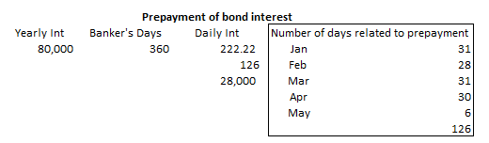

Of this issue, bonds in the amount of $500,000 are to mature five years (January 1, 2022) after the date of the bonds (January 1, 2017). Thereafter, $100,000 is to mature January 1 of each year thereafter until all the bonds have been retired in 12 years. These bonds are deferred serial bonds. (If the first installment is delayed for a period of more than one year after the date of the issue but subsequent installments fall due on a regular basis, the bonds are known as deferred serial bonds. Conversely, If the total principal of an issue is repayable in a specified number of equal annual installments over the life of the issue, it is a regular serial bond issue.)

Make entries as instructed in the following paragraphs. As the bond issue was not made until May 2017, the city will not levy debt service property taxes until next year.

Bond covenants related to this bond issue require the city to levy property taxes sufficient to make principal and interest payments until the bonds have been retired. The city council has approved a resolution to enable the property tax levy, beginning in fiscal year 2018.

- Prepare general journal entries, as necessary to record the transactions described below in the Street Improvement Bond Debt Service Fund general journal and, if applicable, in the governmental activities general journal. Use account titles listed under the drop down menu. Be sure the year 2017 is selected and the appropriate paragraph number shown in bold-face font below is in the [Transaction Description] box.

- [Amended Budget] In early May 2017, an amendment to the annual budget for 2017 was approved by the city council for inflows and outflows in the Street Improvement Bond Debt Service Fund related to the bond issue. The debt service fund budget amendment provides for estimated other financing sources of $42,000 for the premium on bonds (Acct 3410) sold and estimated revenues of $28,000 for accrued prepaid interest on bonds sold (Acct 3130); and appropriations (Account 5010) in the amount of the one interest payment of $40,000 to be made on July 1, 2017. The Budgetary Fund Balance account number is 2530.

Required: Record the amended budget for the Street Improvement Bond Debt Service Fund for year 2017. Budgetary entries have no effect on the government-wide accounting records.

- [Para. 6-a-2] On May 6, 2017, the premium and accrued prepaid interest on bonds sold were received by the Street Improvement Bond Debt Service Fund.

Required: Record this transaction in the Street Improvement Debt Service Fund. No entry is required at this time in the governmental activities general journal since the bond issue, together with related premium and accrued interest, was recorded in the governmental activities general journal in transaction 5-a-3.

NOTE: When recording the accrued interest, this would be considered revenue not other financing sources.

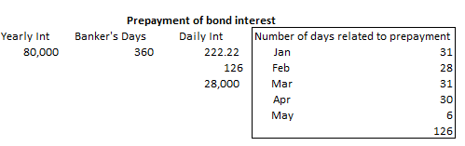
- [Para. 6-a-3] The July 1, 2017, interest payment was made in the amount of $40,000. Be sure to look at what entries for Bingham match to this type of entry.

Required: Record this transaction in both the Street Improvement Debt Service Fund and the governmental activities general journals.

For the entry in the governmental activities journal, assume that the appropriate amount of amortization of the Premium on Deferred Serial Bonds Payable (Acct 2450) for the period the bonds have been outstanding (May 6 to July 1) is $585.

Record this cash interest payment as a debit to Expenses – Interest on Long-Term Debt, less amortization of the premium of $585.

(Note: Although premiums and discounts on bonds issued are not amortized in a debt service fund, they should be amortized at the government-wide level since the accrual basis of accounting is used at that level.)

- [Para. 6-a-4] Make the required journal entry in the governmental activities general journal to accrue six months of interest payable on the 4% deferred serial bonds from the July 1 interest payment until the end of the fiscal year, December 31, 2017. Total accrued interest payable (Acct 2320) on the long-term debt is $40,000. For this entry, assume that the appropriate amount of amortization of the Premium on Deferred Serial Bonds Payable is $1,750. (Note: Recognition of the premium amortization will affect the bond interest expense).
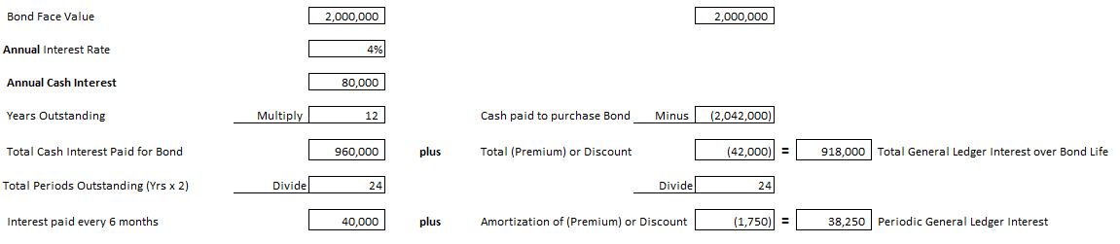
Interest is not accrued for the period July 1 to December 31, 2017 in the debt service fund as no appropriation exists for this expenditure and the interest is not due this fiscal year.

- Verify the accuracy of journal entries, including dates and paragraph numbers, and, if you have not already done so, post all entries to the general ledger of both the Street Improvement Bond Debt Service Fund and governmental activities by clicking on [Post Entries].

Make the entries needed to close the budgetary and operating statement accounts at the end of fiscal year 2017. Make this entry only in the Street Improvement Debt Service Fund journal. Accounts should be closed to Budgetary Fund Balance and Fund Balance—Restricted, as appropriate. Be sure that for each account being closed that the check mark for [Closing Entry] is on and that “Closing Entry” appears in the [Transaction Description] box. (Note: Closing entries for governmental activities at the government-wide level will be made in Chapter 9 of this cumulative problem.)

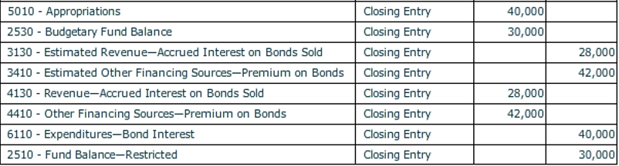

- Before closing the City of Smithville, click on [File], and [Save/Save As] to save your work. If you close the file by clicking on the [X] box you will be asked if you want to save your changes before closing.

- Refer to documents to be graded in NumberKnowledge.com to show your work

