Chapter 9 Adjusting and Closing Entries for Governmental Activities, Government-wide Level; Preparation of Government-wide and Major Fund Financial Statements

- Prior to preparing financial statements at the end of FY 2017, it is necessary to record depreciation expense for the year for governmental activities at the government-wide level.

Based on general capital assets assigned to specific functions, depreciation expense related to equipment and infrastructure is allocated to functions as shown below:

Equipment Infrastructure Buildings
General Government $ 54,920 $47,700
Public Safety 187,840 78,150
Public Works 125,596 $ 98,620 50,980
Culture and Recreation 72,244 32,170
Totals $440,600 $ 98,620 $209,000

Required: [Para. 9-a] Record depreciation expense for the year 2017 in the governmental activities general journal at the government-wide level. Post to the general ledger by clicking [Post Entries].

Add across the types of assets to obtain the total for each function and debit to Expenses for that function. Credit the asset type and use Accumulated Depreciation.

- Closing Entries. Although closing entries were made in each fund in Chapters 4 through 6 of this cumulative problem, they have not yet been recorded at the government-wide level.

Run the pre-closing trial balance to see where these amounts are coming from.

Required: Record the journal entries required on December 31, 2017 to close all temporary accounts for governmental activities at the government-wide level. These entries should also recognize changes in the accounts
1. Net Position—Net Investment in Capital Assets,
2. Net Position—Restricted for Public Safety
3. Net Position—Restricted for Capital Projects
(Note: Due to the need to deduct accrued interest on long-term debt in calculating the December 31, 2017 balance of Net Position—Restricted for Debt Service you will end up with no restriction on net position for debt service.)
For each account to be closed or reclassified, be sure and click on the check mark for [Closing Entry] and that “Closing Entries” appears in the [Transaction Description] box. Post the closing entries to the general ledger by clicking on [Post Entries].

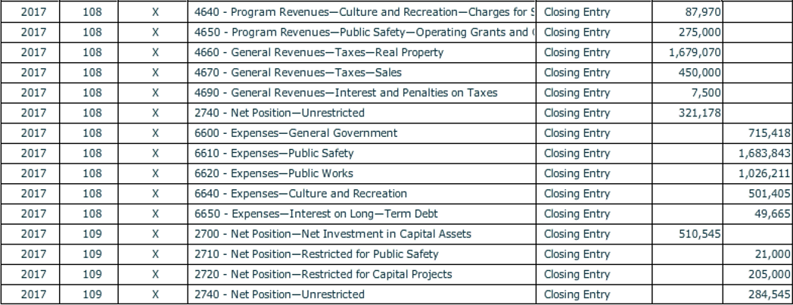
Before closing the City of Smithville, click on [File], and [Save/Save As] to save your work. If you close the file by clicking on the [X] box you will be asked if you want to save your changes before closing.

