**City of Bingham – Documents for Project**

**Print for ease of entering information**

**Chapter 2**

**CITY OF BINGHAM**

**General Fund**

**Post-closing Trial Balance**

**As of December 31, 2016**

Account Title Debits Credits

Cash $ 151,000

Taxes Receivable—Delinquent 517,000

Allowance for Uncollectible Delinquent Taxes $ 46,750

Interest and Penalties Receivable on Taxes 26,059

Allowance for Uncollectible Interest and Penalties 1,434

Vouchers Payable 433,400

Due to Other Funds 14,300

Deferred Inflow of Resources—Operating

Grants and Contributions 30,000

Fund Balance—Committed—Public Safety 16,720

Fund Balance—Committed—Public Works 31,130

Fund Balance—Assigned—Health and Welfare 33,616

Fund Balance—Unassigned 86,709

Totals $ 694,059 $ 694,059

**Chapter 2**

**Governmental Activities, Government-wide Level**

**Post-closing Trial Balance**

**As of December 31, 2016**

Account Title Debits Credits

Cash $ 1,101,000

Taxes Receivable—Delinquent 602,000

Allowance for Uncollectible Delinquent Taxes $ 100,750

Interest and Penalties Receivable on Taxes 35,659

Allowance for Uncollectible Interest and Penalties 2,394

Land 1,210,000

Improvements Other than Buildings 9,900,000

Accumulated Depreciation—Improvements

Other Than Buildings 2,310,000

Infrastructure 32,109,000

Accumulated Depreciation—Infrastructure 12,408,000

Buildings 10,230,000

Accumulated Depreciation—Buildings 2,310,000

Equipment 8,360,000

Accumulated Depreciation—Equipment 4,030,400

Vouchers Payable 433,400

Accrued Interest Payable on Long-term Debt 50,000

Internal Payables to Business-type Activities 14,300

Current Portion of Long-term Debt 500,000

Serial Bonds Payable—2% 9,500,000

Deferred Inflow of Resources—Operating Grants

and Contributions 30,000

Net Position—Net Investment in Capital Assets 30,750,600

Net Position—Restricted for Debt Service 939,640

Net Position—Unrestricted 168,175

Totals $63,547,659 $63,547,659

**Chapter 3**

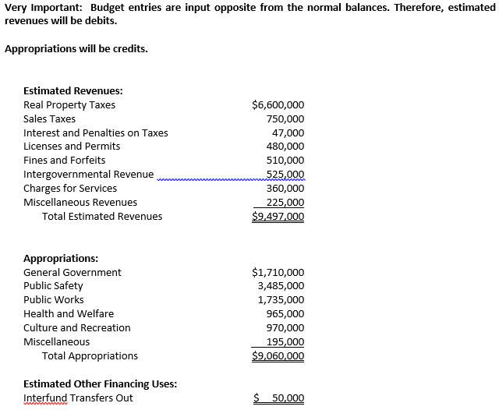

**Chapter 4**

**Property Taxes**



**Tax Anticipation Notes**



**Encumbrances**

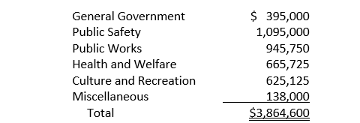



**Grant Funds**



**Collections**

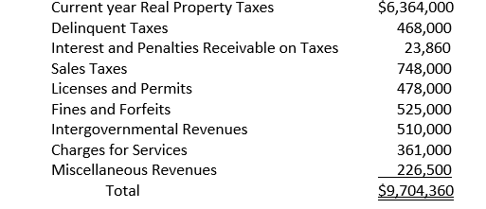





**Payment of amounts due to other funds in previous year**

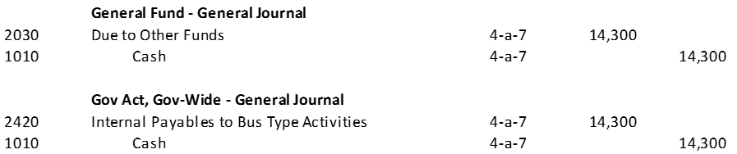

**Write-off of Uncollectible Delinquent Taxes**

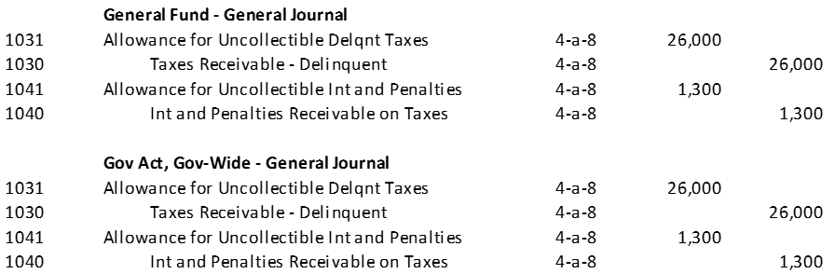

**Payroll**

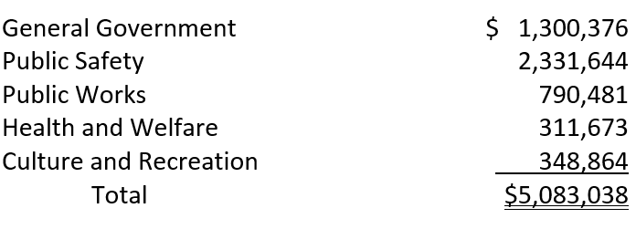

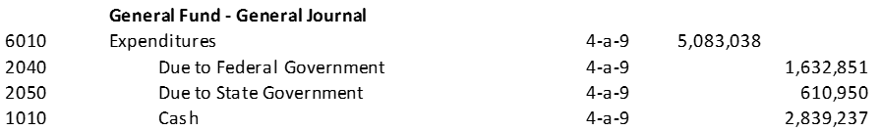



**Emcumbrances and Purchasing Transactions**

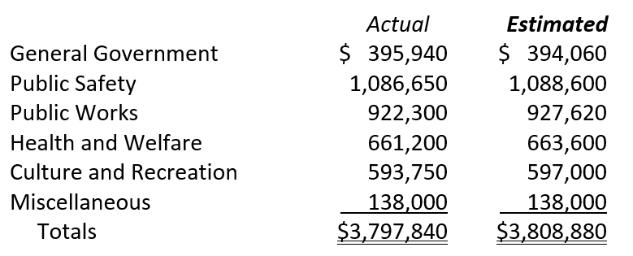





**Payment of Vouchers and Remittance of taxes due to Federal and State Gov**



**Transfer to Debt Service Fund from General Fund**



**Payoff of Tax Anticipation Note Plus Interest**



**Records amounts payable to Water Utility for Public Safety and General Gov**



**Reclassification of remaining current receivables to delinquent and recording interest and penalties on the delinquent taxes**



**Revision of Budget**



**Closing the General Fund Books**













**Chapter 5 – City Annex Construction Fund**

**Bond proceeds**



**Temporary investment of bonds proceeds**



**Land purchase**



**Signed architect’s contract**



**Bond issue captializable costs**



**Architectural fees vouchered**



**Construction contract signed**



**Eliminate remaining encumbrance for architectural services and record actual expenditure**



**Temporary investment matures and pays interest**



**Contractor billing**



**Contractor paid and percentage retained until construction completion in accordance with contract**



**Vouchers approved and paid**



**Furniture and equipment ordered**



**Remaining encumbrance eliminated and completed contractor invoice recorded**



**Final payment on construction including retained percentage**



**Furniture and equipment received**



**Outstanding liabilities are paid**



**Remaining cash transferred to debt service fund**



**Closing Entries**

