Chapter 2 - Principles of Accounting and Financial Reporting for State and Local Governments
Activities of General Purpose Governments
Governments provide three main types of service activities:
- Governmental
- Business (type)
- Fiduciary
In general, governmental activities are to be classified as governmental or business-type activities.
Governmental activities Chapters 3 through 6

General purpose governments provide certain core services: those related to protection of life and property (e.g., police and fire protection), public works (e.g., streets and highways, bridges, and public buildings), culture and recreation facilities and programs, educational and social services.

Governments must also incur costs for general administrative support such as data processing, finance, and personnel. Core governmental services, together with general administrative support, comprise the major part governmental activities.

Public-purpose agency and trust activities, those that primarily benefit the general public and the government's own programs, are treated as governmental activities for accounting and financial reporting purposes.

Business-Type Activities Chapter 7
These activities include, among others, public utilities (e.g., electric, water, gas, and sewer utilities), transportation systems, toll roads, toll bridges, hospitals, parking garages and lots, golf courses, and swimming pools. Many of these activities are intended to be self-supporting by charging users for the services they receive. Operating subsidies from general tax revenues are not uncommon, however, particularly for transportation systems.

Fiduciary Activities Chapter 8
Governments often act in a fiduciary capacity, either as an agent or trustee, for parties outside the government. For example, a government may serve as an agent for other governments in administering and collecting taxes. Governments may also serve as a trustee for investments of other governments in the government's investment pool, for escheat properties that revert to the government when there are no legal claimants or heirs to a deceased individual's estate, and for assets being held for employee pension plans, among other trustee roles.

Private-purpose agency benefits individuals, private organizations, and other government and are reported as fiduciary activities. If agency is a public purpose agency—benefits all citizens or the government’s own programs--it is classified as a governmental activity.

Financial Reporting Model
The minimum required reporting includes 1) Management discussion and analysis 2) basic financial statements on a government-wide and fund basis and 3) any required supplementary information.
The major point of emphasis will be in the different reporting requirements for government-wide statements and fund statements.
Seven elements common to both financial statements
- An inflow of resources such as cash or receivables related to the current period as well as revenues
- An outflow of resources such as expenses or expenditures (for items such as inventory) or the use of resources during the current period (Expense=Accrual Basis, Expenditure=Modified Accrual Basis)
- Assets – Resources controlled by the government with capacity to provide present services
- Liabilities – Obligations the government cannot avoid which require present resources
- A deferred outflow of resources – consumption of net assets related to a future reporting period
- A deferred inflow of resources – acquisition of net assets related to a future reporting period
A word about deferred inflows and outflows which are shown in separate sections

Deferred outflow/inflow of resources are not assets, liabilities, revenues or expenses/expenditures. Unlike revenues and expenses, which are inflows and outflows of resources related to the period in which they occur, deferrals are related to future periods. They are the result of past transactions but the recognition is deferred until the future period to which they are related. (Expense=Accrual Basis, Expenditure=Modified Accrual Basis)

An example of a deferred inflow of resources would be resources received in a period prior to when the resources can be used (a timing issue). Since such an advance payment does not meet the definition of a liability (think unearned revenues), GASB standards require that it be recognized as a deferred inflow of resources.

WHY IS IT IMPORTANT TO REPORT DEFERRALS SEPARATELY?
The GASB requires that deferred outflows of resources be reported in the financial statements apart from assets, and deferred inflows of resources apart from liabilities. The simplest reason is that deferrals are not assets or liabilities and not revenues or expense (expenditures), and reporting them as such risks distorting a government’s actual financial position.

- Net position is defined as assets + deferred outflows of resources (future consumption of assets) minus liabilities + deferred inflows of resources (future acquisition of assets). Net position appears in a statement of financial position.

Net position is the difference between assets and deferred outflows, on the one hand, and liabilities and deferred inflows, on the other. Revenues increase net position—which makes a government look healthier financially, all other factors being equal. Expenses reduce net position—which makes a government look less healthy. If total revenues for the year exceed total expenses, then net position increases overall and financial health improves; the opposite is true if total expenses exceed total revenues.
This relationship is key to the concept of interperiod equity—a government raising sufficient resources each year to cover that year’s costs. If a government does not raise sufficient resources during the year, it either must consume surplus resources accumulated in prior years or push some costs off to the future. Providing users with information to assess whether a government is achieving interperiod equity is an important objective of financial reporting by state and local governments.
To get a sense of whether interperiod equity has been achieved, any inflows or outflows that took place during the fiscal year, but which actually relate to future period, should not be included. Those inflows and outflows are kept out of the assessment of interperiod equity by being reported as deferred inflows and deferred outflows rather than recognized as revenues and expenses.

All of these concepts will become clearer as we work on the records of the City of Bingham.

Government-wide Financial Statements – Accrual basis Long-Term and Short-Term Assets and Liabilities
The government-wide financial statements report on the governmental reporting entity as a whole but focus on the primary government. The government-wide statements present the financial information for the governmental activities and business-type activities of the primary government in separate columns with a total column for the primary government.

The government-wide statements present all financial information using the economic resources measurement focus and the accrual basis of accounting—similar to the measurement focus and basis of accounting used in the financial statements of for-profit business organizations. These statements focus on government's operational accountability and help to assess whether the government is covering the full cost of services over the long run. Long Term Assets and Liabilities recorded along with depreciation.

Government-Wide Statement of Net Position

There are some similarities to the business entity balance sheet in that assets are listed in the order of liquidity and liabilities are separated into current and noncurrent. Unlike the Fund financial statements, long-term assets and liabilities are found on the government-wide financial statements.

Net position (Equity) is segregated into three categories
- Net investment in capital assets – Capital assets used for General Fund departments
- Restricted (defined by purpose)
- Unrestricted

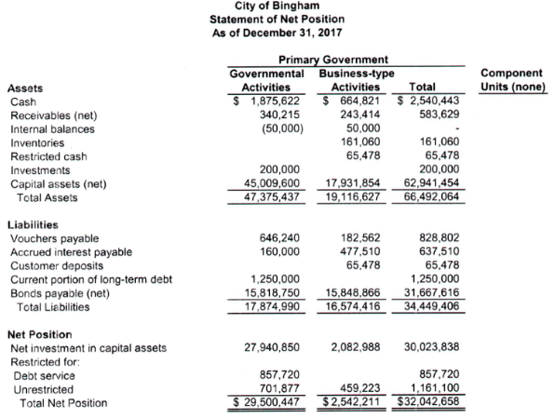

Note: We are not covering components this semester.

Because the government-wide financial statements display information in multiple columns, they are not fully consolidated in the manner of corporate financial statements. Receivables and payables between two or more programs or functions that are reported in the Governmental Activities column or between business-type segments reported in the Business-type Activities column are eliminated in preparing the financial statements.

Receivables/payables between governmental and business-type activities, however, are not eliminated because they are reported in different columns.

Government-Wide Statement of Activities

The statement of activities is the city's operating statement reporting expenses classified by program or function and revenues derived directly from the programs or functions. Revenues derived directly from programs or functions can be user charges or resources received directly from external sources, such as grants and contributions.

The resulting net expense (i.e., program expense minus program revenue) of each program or function is reported in separate columns for governmental activities and business-type activities.

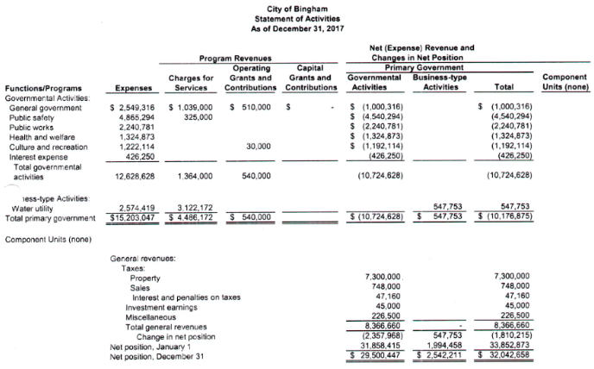

General revenues, such as taxes of all kinds and transfers between governmental and business-type activities, often make up the bulk of a government's revenues and are reported in the bottom portion of the statement. The change in net position for the year results in an increase (decrease) in the net position reported on the statement of net position.

Interfund transfers are recognized in the period when the receivable and payable arise.

Fund Accounting
Fund accounting allows the government to report on government-wide, general purpose activities in the general fund and also to report on activities that are legally or contractually constrained in other funds. Only those funds required by law, GASB standards and sound financial administration should be established.

A fund is a fiscal and accounting entity with a self-balancing set of accounts recording cash and other financial resources, together with all related liabilities and residual equities or balances and changes which are segregated for the purpose of carrying on specific activities or attaining certain objectives in accordance with special regulations, restrictions, or limitations.
The concept of fund is fundamental to governmental accounting and reporting. As the definition states, a fund is a separate fiscal entity, which means it has its own resources, its own liabilities, and its own operating activity for the fiscal period. Furthermore, a fund conceptually has its own set of accounting records (e.g., journals and ledgers) allowing it to prepare separate financial statements. Thus, it is a separate accounting entity as well. However, not all funds are a reporting entity.

There is a general fund which contains all the activities of the government not carried out in another fund. Other, different funds are intended to achieve different objectives. Funds may be established by grant or contract provisions imposed by external resource providers, by constitutional provisions or enabling legislation of state or local governments, or by the discretionary action of reporting governments. The variety of purposes that may be served by different fund categories and types will become apparent in the discussion that follows.

Governments must present fund financial statements for each of the three fund categories: governmental, proprietary, and fiduciary. These categories correspond closely to the governmental, business-type, and fiduciary activities but they are not identical to each category.

Major Fund – Decision to separate funds into a major fund for governmental or enterprise category
Governments are required to segregate assets, etc. into a major fund which is defined those funds whose revenues, expenditures/expenses, assets or liabilities are at least 10 percent of the total for their fund category (governmental or enterprise) and 5 percent of the aggregate of all governmental and enterprise funds in total. (Expense=Accrual Basis, Expenditure=Modified Accrual Basis) But nonmajor funds are still part of the fund financial statements.

Governmental - Modified Accrual Basis No Long-Term Assets or Liabilities
Types
General Fund
Most governmental activities are reported in the General Fund. The government accounts for everything here not reported in another fund.
Other funds
GASB standards recommend that governments establish only the minimum number of funds needed to comply with legal requirements and to provide sound management. Using too many funds creates undue complexity and contributes to inefficient financial administration
Special Revenue Fund - When tax, grant, private gifts are restricted or committed for particular operating purposes, such as the operation of a library or maintenance of roads, bridges, counseling youthful offenders

Debt Service Fund – Governmental bonds may be required by law or bond covenants to segregate funds to pay principal and interest.

Capital Projects Fund – Segregation of revenues or bond proceeds to purchase or construct buildings, highways, bridges, parks, etc.

Permanent Fund – Segregation of donor permanent endowments when the donor stipulates preservation of the donation in an investment but earnings are used for public purposes. Purpose is to benefit all citizens.

Financial Statements
Balance Sheet
Statement of Revenue, Expenditures and Changes in Fund Balance
Accountability Focus
Fiscal accountability is the flow of resources or use of resources in the short-term.
This measurement focus emphasizes control and accountability over the raising and spending of public money. Financial reporting for governmental fund activities allows stakeholders to assess whether sufficient resources (generally cash and other liquid assets) existed to finance the current period’s activities. This assessment is particularly important to those who pay taxes and receive services. It also shows whether resources were obtained and used in accordance with the legally adopted budget and in compliance with other finance-related legal or contractual requirements.
Basis of Accounting
Modified accrual basis of accounting which
- recognizes revenues when measurable and available for paying current obligations

- expenditures (not expenses) are recognized when incurred (create an obligation to be paid from current financial resources) Expenditures related to modified accrual basis

Classification of Fund Balances
The GASB requires that fund balances reported on the governmental fund balance sheet be classified according to the constraints on the use of the fund balances.
Following are the fund balance classifications and classification descriptions identified in the financial reporting standards.
- Nonspendable fund balance. These are amounts that are (a) not in spendable form or (b) legally or contractually required to be maintained intact. Example Inventories, prepaid amounts, long-term notes receivable, a permanent endowment, etc.
- Restricted fund balance. These are amounts that can be spent only for the specific purposes designated by external providers, constitutionally, or through enabling legislation. Restrictions are changed or lifted only with the consent of resource providers. Examples of external resource providers include creditors, grantors, and donors.
- Committed fund balance. These are amounts that can only be used for the specific purposes determined by a formal action. Commitments can only be changed or removed by taking the same formal action that imposed the constraint originally. Committed funds can be used for another purpose by reversing the formal action that committed the resources.
- Assigned fund balance. These are amounts intended to be used by the government for specific purposes that are neither restricted nor committed. Intent can be expressed in one of two ways:
(a) the governing body can express its intent to use resources for a specific purpose or
(b) the governing body can delegate authority to a body (e.g., a budget or finance committee) or an official (e.g., city manager) to express intent to use amounts for specific purposes.
Additionally, it is implied that the amounts reported in special revenue, capital project, debt service, or permanent funds that have not been designated as restricted or committed are assigned. For example, the positive fund balance in a special revenue fund must at a minimum be reported as assigned.
- Unassigned fund balance. This is the residual amount for the General Fund and includes all amounts that have not been classified as nonspendable, restricted, committed, or assigned. Unassigned amounts are technically available for any purpose.
The General Fund is the only fund that will have a positive unassigned fund balance. If any other fund has expenditures that exceed the amounts restricted, committed, or assigned, it may be necessary for the fund to report a negative unassigned fund balance. The GASB does not allow negative restricted, committed, or assigned fund balances.

Proprietary Funds – Business Type Activities
Users are charged for goods and services provided. Full costing needed to determine prices or fees and whether to produce internally or outsource.
Types
Internal Service Funds
Businesslike in operation but serve departments in the same government not the public on a cost-reimbursement basis. Examples are central purchasing, motor pools, data processing. Usually a part of governmental activities and are included in the governmental category in general purpose government-wide financial statements.
Major Enterprise Funds (Business-type activities)
These are purely business-type activities serving the public and found only in the business activities of the general purpose government-wide financial statements. Prices charged include covering costs plus needed capital outlays.
Financial Statements
Both types of funds operate essentially as self-supporting entities and, therefore, follow accounting and reporting practices similar to those of business organizations.

Statement of Net Position
Statement of Revenues, Expenses, and Changes in Fund Net Position
Statement of Cash Flows
Accountability Focus
Operational Accountability
Basis of Accounting
Accrual – Long Term Assets and Liabilities recorded along with depreciation
Exchange transactions – Free will transactions with equal value; revenues recognized when earned. (Comparable to revenue or sales for a business).

Fiduciary –
Resources the government holds or manages as an agent or trustee for another
Cannot be used to support government’s own programs.
Not permitted to be reported in government-wide financial statements.
Types
Agency Funds – Taxes collected on behalf of another government (Assets=Liab)
Trust Funds
Investment – Reports equity of government’s investment pool to outside participants
Pension – Assets held in trust for employee retirement benefits
Private Purpose – Ex: Scholarships for children of police and fire fighters killed in the line of duty
Financial Statements
Statement of Fiduciary Net Position
Statement of Changes in in Fiduciary Net Position
Accountability Focus
Operation Accountability
Basis of Accounting
Accrual - Long Term Assets and Liabilities recorded along with depreciation

Summary

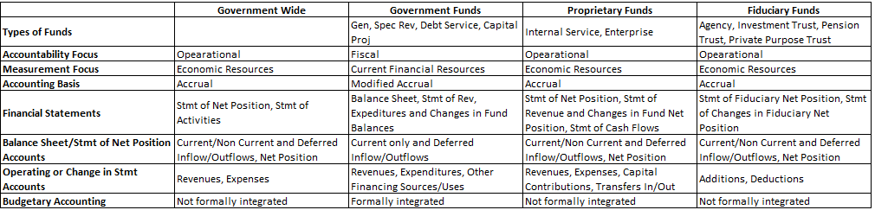
Measurement focus describes what is measured; that is, the nature of the resources, claims against resources, and flows of resources that are measured and reported by a fund or activity.
The economic resources measurement focus reports on the balances and flows of both current and noncurrent assets and liabilities.
The current financial resources focus reports only on the balances and flows of current assets and liabilities.
The basis of accounting describes when things are measured.
The accrual basis of accounting recognizes revenues when earned and expenses when incurred.
The modified accrual basis recognizes revenues when measurable and available for current spending and expenditures when a current liability has been incurred.
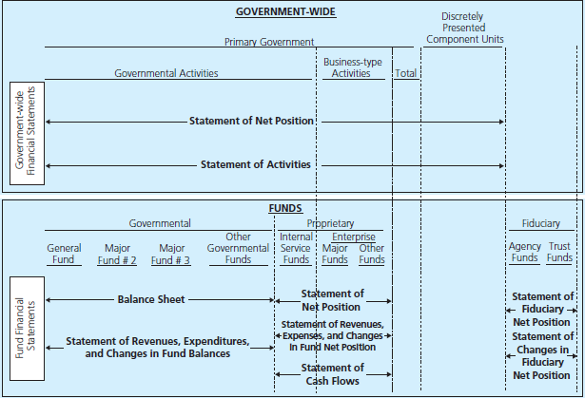
ILLUSTRATION 2–2
The GASB Integrated Accounting and Financial Reporting Model
In-Class and Graded Project
Preparing the required government-wide financial statements and governmental fund financial statements with two different bases of accounting
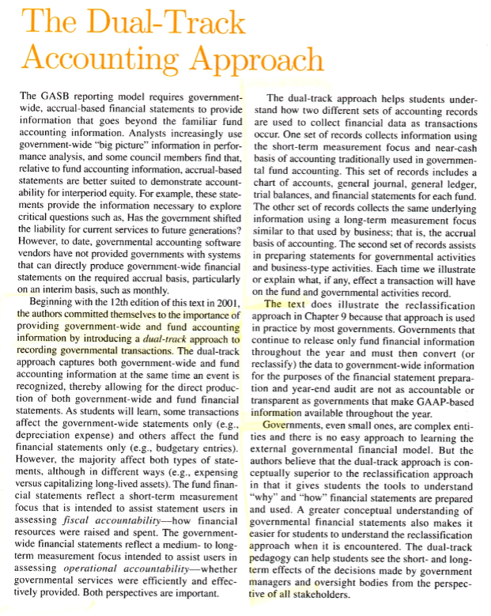We will, therefore, learn how to record for both types of financial statements in recording and reporting for the City of Bingham—our in-class assignments. You will do a similar set of records and reports for the City of Smithville.

