**Bingham Chapter 6 Transactions Affecting General Long-Term Liabilities and Debt Service**

The use of long-term debt is a traditional part of the fiscal policy of state and local governments, particularly for financing the acquisition of general capital assets. Although some governments have issued taxable debt, the interest earned on most debt issued by state and local governments is exempt from federal taxation and, in some states, from state taxation. The tax-exempt feature enables governments to raise large amounts of capital at relatively low cost.

Because of the relative ease with which governments can issue debt, most states have acted in the public interest to impose statutory limits on the debt that can be incurred by state and local governments. Consequently, effective management of state and local governmental debt requires good legal advice and a sound understanding of public finance.

This chapter describes the types of debt and other long-term liabilities that are termed “general long-term liabilities.” **General long-term liabilities** are those that arise from activities of governmental funds and that **are not reported** as fund liabilities of a proprietary or fiduciary fund. General long-term liabilities are reported as liabilities in the Governmental Activities column of the government-wide statement of net position but are not reported as liabilities of governmental funds. Proprietary funds and certain private-purpose trust funds account for both long-term debt serviced by the fund and short-term debt to be repaid from fund assets.

Governmental fund types (General, special revenue, capital projects, debt service, and permanent funds) account for only short-term liabilities (vouchers payable, contracts payable, etc.) to be paid from fund assets. While, the proceeds of long-term debt may be placed in one of these fund types (usually a capital projects fund), the long-term liability itself must be recorded in the governmental activities accounting records at the government-wide level. As a general rule, entries are made in the governmental activities general journal at the government-wide level to reflect increases or decreases in general long-term liabilities.

**Debt Limit and Debt Margin**

The legal limit on the amount of long-term indebtedness that may be outstanding at a given time in proportion to the assessed value of property within the government's jurisdiction is an important matter. Because a government's power to issue bonds constitutes an ever-present hazard to the welfare of its property owners in particular and its taxpayers in general, this authority is ordinarily limited by legislation. The purpose of legislative limitation is to obtain a prudent balance between public welfare and the rights of individual citizens. In some jurisdictions, most bond issues must be approved by referendum; in others, by petition of a specified percentage of taxpayers.

**Debt limit** means the total amount of indebtedness of specified kinds that is allowed by law to be outstanding at any one time. The limitation is likely to be in terms of a specified percentage of the assessed or actual valuation of property within the government's jurisdiction. Debt limitation exists as a device for protecting property owners from confiscatory taxation. For that reason, tax-paying property only should be used in regulating maximum indebtedness. In many governmental jurisdictions, certain property is legally excluded even from assessment. This includes property owned by governments, churches, charitable organizations, and some others, depending on state laws. Exemptions, which apply to property subject to assessment, are based on homestead or mortgage exemption laws, military service, and economic status, among others. Both exclusions and exemptions reduce the amount of tax-paying property.

Debt margin is the difference between the debt limit and the amount of outstanding debt subject to the debt limitation.

**Overlapping Debt**

Debt limitation laws ordinarily establish limits that may not be exceeded by each separate governmental entity affected by the laws. This means the county government may incur indebtedness to the legal limit, a township within that county may do likewise, and a city within the township may become indebted to the legal limit, with no restriction because of debt already owed by larger territorial units in which it is located. As a result, a given parcel of real estate or object of personal property may be the basis of debt beyond the legal limit and also may be subject at a given time to assessments for the payment of taxes to retire bonds issued by two or more governments. When this situation exists, it is described as **overlapping debt.**

The extent to which debt may overlap depends on the number of governments represented within an area that are authorized to incur long-term indebtedness. These may include the state, county, township, city, and various special purpose governments, such as a school district. To show the total amount of indebtedness being supported by taxable property located within the boundaries of the reporting government, a statement of direct and overlapping debt should be prepared. Direct debt is the debt that is being serviced by the reporting government. To this direct debt should be added amounts owed by other governments that levy taxes against the same properties on which the direct debt is based.

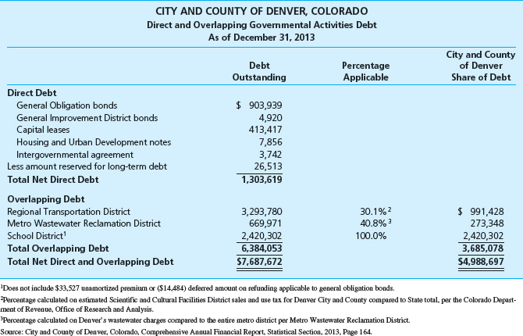

**Long-term Liability Disclosures**

In any given year, it is common for new debt issues to be authorized, for previously authorized debt to be issued, and for older issues to be retired or debt to be refunded. When a combination of liability events takes place, a schedule detailing changes in long-term debt is needed to inform report users of the details of how long-term liabilities have changed. The general long-term liability disclosures required by GASB reporting standards effectively meet these needs by providing detail of beginning of period long-term liabilities, additions to and reductions of those liabilities, ending liabilities, and the portion of the liabilities payable within one year. Debt information disclosed within governmental financial statements is monitored closely by bond rating analysts and others

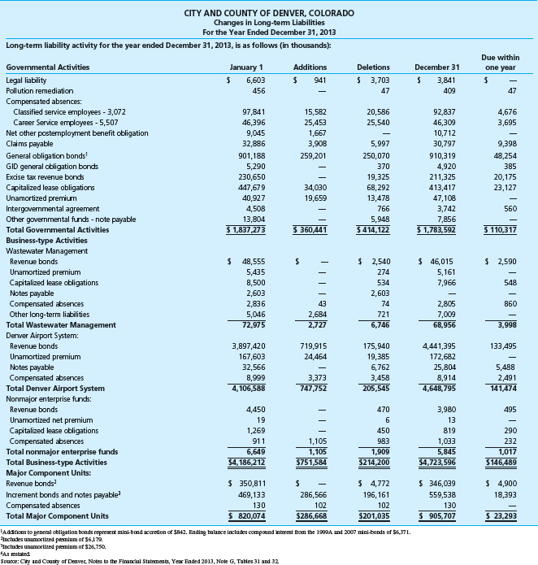

**DEBT SERVICE FUNDS**

When long-term debt has been incurred for capital or other purposes, revenues must be raised in future years to make debt service payments. Debt service payments, including both periodic interest payments and the repayment of debt principal when due, are typically specified in a *bond indenture,* the legal document which describes key terms of the bond offering. Revenues from taxes that are restricted for debt service purposes are usually recorded in a *debt service fund,* as are subsequent expenditures for payments of interest and principal. A debt service fund is used only for debt service activities related to *general* long-term liabilities—those reported in the Governmental Activities column of the government-wide statement of net position. Debt service related to long-term liabilities reported in proprietary (enterprise) and fiduciary funds is reported in those funds, not in a debt service fund.

Governmental fund liabilities and expenditures for debt service on general long-term debt are generally recognized in the reporting period that debt payments are due.

**Number of Debt Service Funds**

In addition to debt service for bond liabilities, debt service funds may be required to service debt arising from the use of notes or warrants having a maturity more than one year after date of issue. Debt service funds can also be used to make periodic payments required by capital lease agreements. Although each issue of long-term or intermediate-term debt is a separate obligation and may have legal restrictions and servicing requirements that differ from other issues, GASB standards provide that, if legally permissible, a single debt service fund can be used to account for the service of all issues of tax-supported and special assessment debt. Subsidiary records of that fund can provide needed assurance that budgeting and accounting meet the restrictions and requirements relating to each issue. If legal restrictions do not allow for the debt service of all issues of tax-supported and special assessment debt to be accounted for by a single debt service fund, as few additional debt service funds as is consistent with applicable laws should be created.

The City of Bingham utilizes a single debt service fund to account for the service of all issues of tax-supported and special assessment long-term debt. As of December 31, 2016, one issue of tax-supported serial bonds was outstanding.

The post-closing trial balance of the debt service fund as of December 31, 2016, is shown below. The issue of tax-supported serial bonds issued on October 1, 2016 and outstanding on December 31, 2016, amounted to $10,000,000. Bonds of this issue in the amount of $500,000 mature on September 30 of each year, beginning in 2017. This bond issue bears interest at the annual rate of 2 percent, payable on March 31 and September 30 each year. The cash balance of the debt service fund on December 31, 2016, is restricted for the repayment of tax-supported bond principal and interest payments, such as the principal maturing on September 30, 2017, and bond interest due in 2017.

1. **Debt Service Fund: Record the following accounts and balances in the debt service fund general journal,** selecting **2016** and using **Beginning Balance** for the **[Transaction Description]**. When completed, post the entries in the general ledgers.

**Govt Wide:** For the government wide, governmental activities, these opening balances were previously recorded in Chapter 2 of this project.

**CITY OF BINGHAM**

**Debt Service Fund**

**Trial Balance**

**As of December 31, 2016**

*Debits Credits*

Cash **(1010)** $ 950,000

Taxes Receivable—Delinquent **(1030)** 85,000

Allowance for Uncollectible Delinquent $ 54,000

Taxes **(1031)**

Interest and Penalties Receivable on Taxes **(1040)**  9,600

Allowance for Uncollectible Interest and

Penalties **(1041)** 960

Fund Balance—Restricted **(2510)** 989,640

Totals $1,044,600 $1,044,600

On January 1, 2017, the City of Bingham sold a 12-year issue of tax-supported serial bonds to finance the construction and equipping of an annex to City Hall. As described in Chapter 5, the total amount of bonds issued on that date was $7,500,000, sold at 101. The issue bears interest at the annual rate of 3 percent, payable on January 1 and July 1 of each year; bonds in the amount of $375,000 will mature on January 1, 2018, and every six months thereafter until maturity. The premium on these bonds will be amortized using the straight-line method over 24 periods. Cash for the payment of interest in 2017 will be provided by the General Fund.

Bonds:

1. 2016 Bond - $10,000,000
   1. 10-Year bonds
   2. 2% interest
   3. $500,000 principal matures each Sep
   4. Bond Int payable each Mar 31 and Sep 30
   5. Amortized over 20 periods (10 years)
2. 2017 Bond - $7,500,000
   1. 12-Year bonds
   2. Sold at 101—Premium is 1% of $7,500,000 or $75,000
   3. Amortized over 24 periods (12 years) equals $75,000/24 = $3,125
   4. 3% interest
   5. $375,000 matures each Jan, starting Jan 2018
   6. Bond Int payable each Jan 1 and Jul 1

(Hint: Do this for Smithville)

A large majority of tax-supported bond issues are serial bond issues in which the principal matures in installments allowing the issuer to make payments of principal that match revenue expectations over that time period. Four types of serial bond issues are found in practice: regular, deferred, annuity, and irregular. If the total principal of an issue is repayable in a specified number of equal annual installments over the life of the issue, it is a **regular serial bond** issue.

**Required:**

**b.** Prepare general journal entries, as necessary to record the following transactions in the debt service fund general journal and, if applicable, in the governmental activities general journal. Be sure the year **2017** is selected and the appropriate paragraph number shown in bold-face font below is in the **[Transaction Description]** box.

1. **[Use Budget as the Transaction Description]** From the data given about the bond issue already outstanding on January 1, 2017, and the City Hall Annex Construction Fund bond issue sold on that date, city officials adopted a legal budget for the fiscal year ended December 31, 2017.

**Budgeting for Debt Service**

In addition to possible bond indenture requirements, good politics and good financial management suggest that the debt service burden on the taxpayers be spread evenly rather than lumped in the years that debt issues or installments happen to mature. To assist with sound financial management, the debt service fund is considered both a budgeting and an accounting entity.

As such, a budget is prepared for the debt service fund. If taxes for payment of interest and principal on long-term debt are recorded directly in the debt service fund, they are budgeted as estimated revenues of the debt service fund. Interest on the investments recorded in the debt service fund is also budgeted as estimated revenue by the debt service fund.

When recognized, taxes and interest earnings are recorded as revenues. Transfers made from other funds to the debt service fund are budgeted as an estimated other financing source and when the transfers are recognized, they are recorded as *interfund transfers in.*

If resources, such as taxes, are to be raised by another fund and transferred to the debt service fund, they must be included in the revenues budget of the fund that will raise the revenue (often the General Fund). The amount to be transferred to the debt service fund will be budgeted as an estimated other financing use and recorded as an *interfund transfer out* when the transfer of funds to the debt service fund is recognized.

The appropriations budget of a debt service fund must provide for the payment of all interest and principal on general long-term debt that will become legally due during the budget year.

GASB standards require debt service fund accounting to be on the same basis as is required for general and special revenue funds. One peculiarity of the modified accrual basis used by governmental fund types (which is not discussed in Chapter 3 because it relates primarily to debt service funds) is that interest on long-term debt is generally not accrued in the debt service fund but is accrued at the government-wide level.

Accounts recommended for use by debt service funds are similar to but not exactly the same as those recommended for use by the General Fund. Because the number of sources of revenues and other financing sources is relatively small in a typical debt service fund, as is the number of purposes for which expenditures are made, it is generally not necessary to use control and subsidiary accounts such as those used by the General Fund. Moreover, because debt service funds do not issue purchase orders or contracts for goods and services, the use of encumbrance accounting is unnecessary.

Governmental fund liabilities and expenditures for debt service on general long-term debt are generally recognized in the reporting period that debt payments are due.

**Required:** Record the budget for the Bingham Debt Service Fund for year 2017. Budgetary entries have no effect on the government-wide accounting records. In the Debt Service Fund, the City opts not to budget for the subsequent year January 1 interest payment.

Appropriations of $812,500 were provided as follows:

**Interest**  
$10,000,000 bond – two interest payments on Mar 31 and Sep 30

Calculation $10,000,000 x 2% = 200,000 x 6/12 (twice a year) = 100,000 x 2 (twice in one year) = $200,000

$7,500,000 bond – (issued in Jan 2017- only interest payment in 2017 would be on Jul 1)

Calculation $7,500,000 x 3% = 225,000 x 6/12 (twice a year) = 112,500 x 1 (once this year) = $112,500

**Maturity of principal**

$10,000,000 bond – principal matures Sep = $500,000

$7,500,000 bond – no principal maturity in 2017

**Total = $812,500**

(Hint: Needed also for Smithville)



Bond Premium – see (5-a-1) je for City Hall Annex

Interfund transfers in – See budget info in Ch 3 in Gen Fund where it is budgeted as Interfund transfers out

2. **[Para. 6-b-2]** Taxes were levied by the debt service fund in the amount of $705,000. Of this amount, $5,000 was expected to be uncollectible.

**Required:** Record these transactions in both the debt service fund and governmental activities journals.

Debt Service Fund

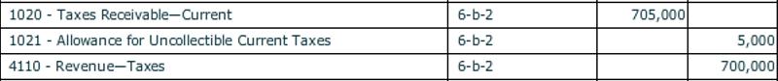

Governmental Activities

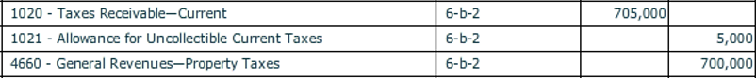

3. **[Para. 6-b-3]** Cash in the amount of the $75,000 premium on the bonds sold on January 1, 2017 was received and recorded in the debt service fund.

**Required:** Record this transaction in the debt service fund. No entry is required at this time in the governmental activities general journal since the bond issue, including the related premium and accrued interest, was recorded in the governmental activities general journal in transaction 5-a-1.

Debt Service Fund



4. **[Para. 6-b-4]** Temporary investments were purchased in the amount of $500,000.

**Required:** Record this transaction in both the debt service fund and governmental activities journals.

Debt Service Fund



Governmental Activities



5. **[Para. 6-b-5]** Checks were written and mailed to bondholders for interest payable on March 31, 2017.

**Required:** Record this transaction in both the debt service fund and governmental activities journals. In the governmental activities general journal, debit Accrued Interest Payable for the portion of these amounts expensed on December 31, 2016, the end of the preceding fiscal year—See beginning balances for this fund.

Debt Service Fund



Governmental Activities

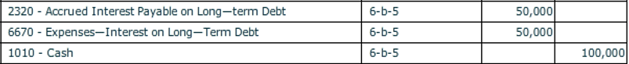

6. **[Para. 6-b-6]** Current taxes receivable were collected in the amount of $675,000. Also, delinquent taxes receivable were collected in the amount of $10,000, along with Interest and Penalties Receivable on Taxes of $600.

**Required:** Record these transactions in both the debt service fund and governmental activities journals.

Debt Service Fund

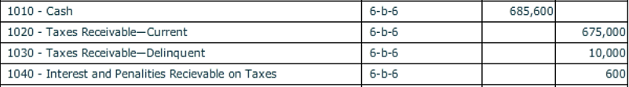

Governmental Activities

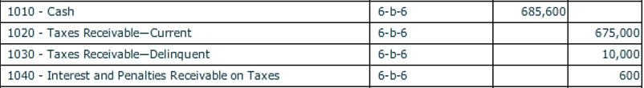

7. **[Para. 6-b-7]** Interest on temporary investments was received in cash in the amount of $7,500.

**Required:** Record this transaction in both the debt service fund and governmental activities journals.

Debt Service Fund



Governmental Activities



8. **[Para. 6-b-8]** Temporary investments amounting to $300,000 were sold at par.

**Required:** Record this transaction in both the debt service fund and governmental activities journals.

Debt Service Fund



Governmental Activities



9**. [Para. 6-b-9]** On July 1, the debt service fund received $50,000 from the General Fund for interest payment on the 3% serial bonds. Checks were written and mailed to bondholders for the interest payments due July 1, 2017.

**Required:** Record the transfer in the debt service fund and the interest payment in both the debt service fund and governmental activities journals. At the government-wide level, $3,125 was debited for amortization of the premium on the 3% serial bonds.

Debt Service Fund

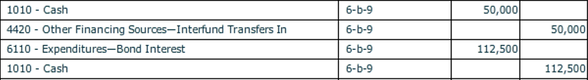

Governmental Activities

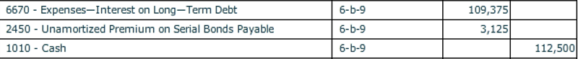

(Bond Interest Expense is affected by the cash bond interest payment and amortization of premium)

10. **[Para. 6-b-10]** Cash to close the City Hall Annex Construction Fund was received in the amount of $7,000. (See Chapter 5, JE 5-a-18). The city council authorized a budget amendment for this unexpected transfer.

**Required:** Record the budget amendment and transfer in the debt service fund. This transaction involves two governmental funds, thus it has no effect on the governmental activities general journal.

Debt Service Fund

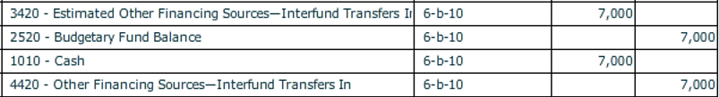

11. **[Para. 6-b-11]** On September 30, the debt service fund made the principal and interest payments associated with the 2% serial bond.

**Required:** Record this transaction in both the debt service fund and governmental activities journals.

Debt Service Fund

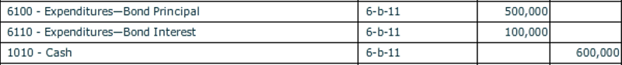

Governmental Activities

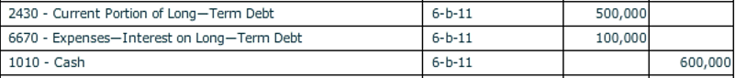

12. **[Para. 6-b-12]** The uncollected balance of current taxes receivable and the related estimated uncollectible account were reclassified as delinquent. Interest and penalties of $1,200 were accrued, of which $120 was estimated to be uncollectible.

**Required:** Record this transaction in both the debt service fund and governmental activities journals.

Debt Service Fund

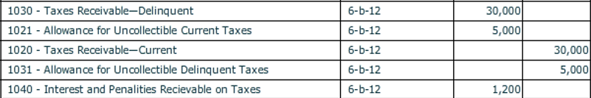



Governmental Activities



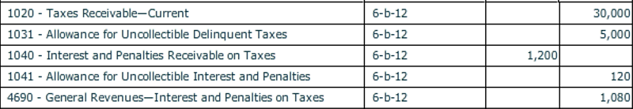

13. **[Para. 6-b-13]** At December 31, 2017, accrued interest expense on the two outstanding bond issues was recorded in the governmental activities general journal. Amortization of the premium on the 3% bonds sold was also recorded in the amount of $3,125.

**Required:** Record the accrual in the governmental activities journal.

Governmental Activities

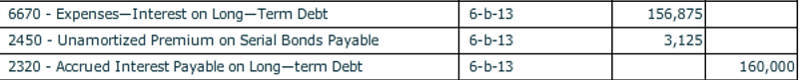

**Interest accrual –**

1. $10,000,000 bond has been reduced by the principal payment of $500,000 in 6-b-11. Therefore, the interest accrual should be calculated $9,500,000 ($10,000,000 minus $500,000). The interest rate is 2% and would be calculated on three months at December 31. (Interest last paid on September 30)
2. $7,500,000 bond has an interest rate of 3% and would be calculated on six months. (Interest last paid on July 1).

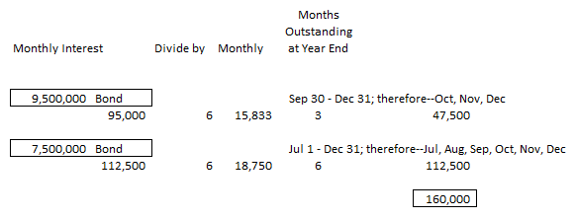

14. For the debt service fund only, make the entries needed to close the budgetary and operating statement accounts at the end of fiscal year 2017 and post them to the fund’s general ledger. (Note: You must click on the box for **[Closing Entry]** to check mark it; “Closing Entry” will appear in the **[Transaction Description]** box for the account being closed. Be sure the check mark is present for each account being closed.) Click **[Post Entries]** to post the closing entry. Closing entries will be made in the governmental activities general journal in Chapter 9.

Debt Service Fund

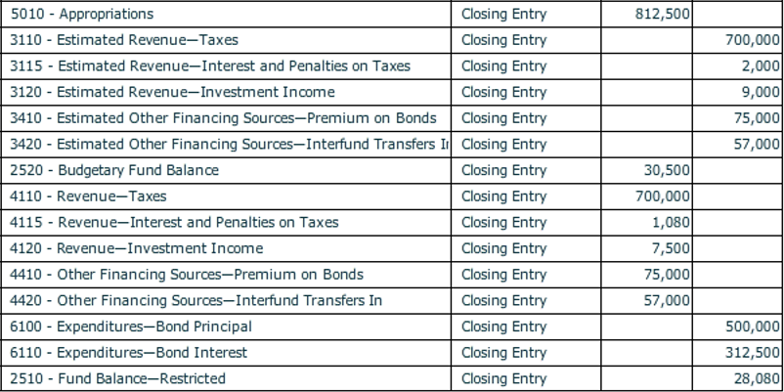

**Before closing the *City of Bingham,* click on [File], and [Save/Save As] to save your work.** If you close the file by clicking on the [**X**] box you will be asked if you want to save your changes before closing.

C i. Refer to documents to be graded in NumberKnowledge.com for Bingham.

ii. Compare the 2017 Pre-Closing Trial Balance to the Statement of Revenues, Expenditures and Fund Balances. The fund balance at December 31, 2017, can be found on the Post-Closing Trial Balance.

iii. Compare the 2017 Post Closing Trial Balance to the Balance Sheet. You will prepare this financial statement for Smithville.

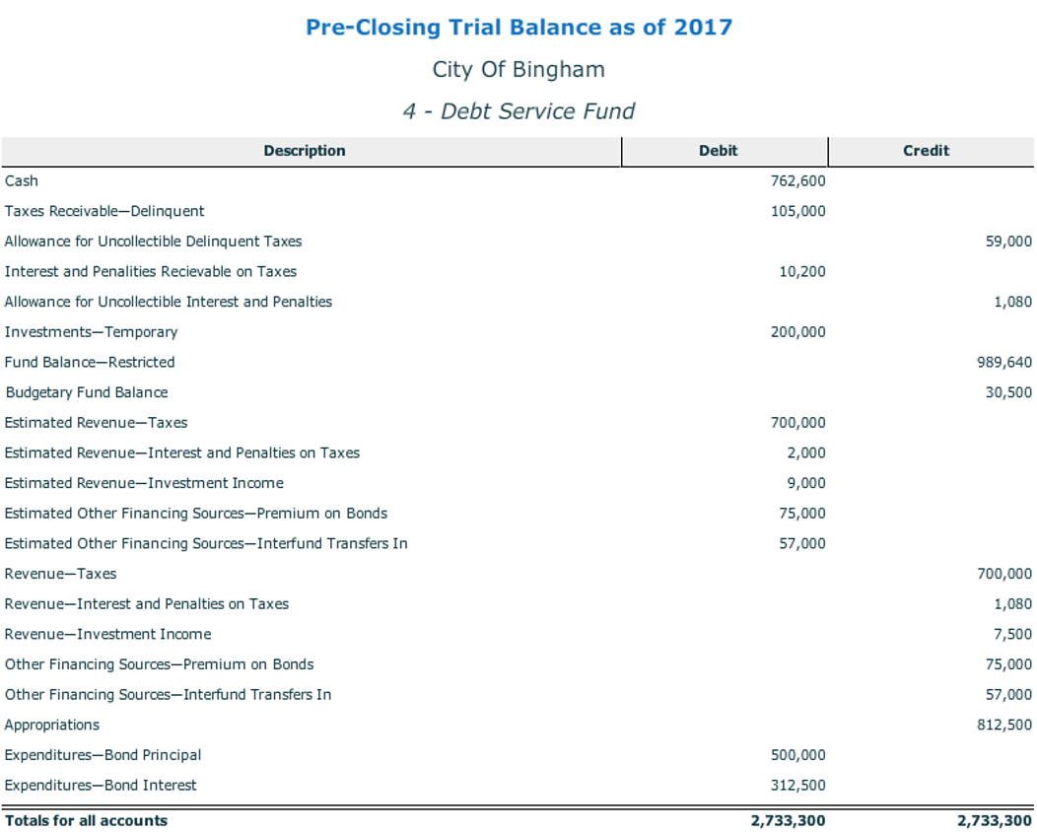

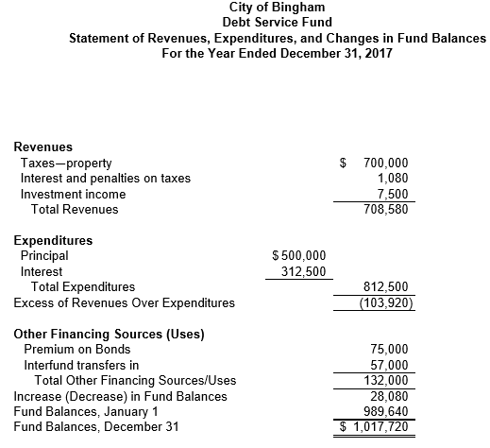

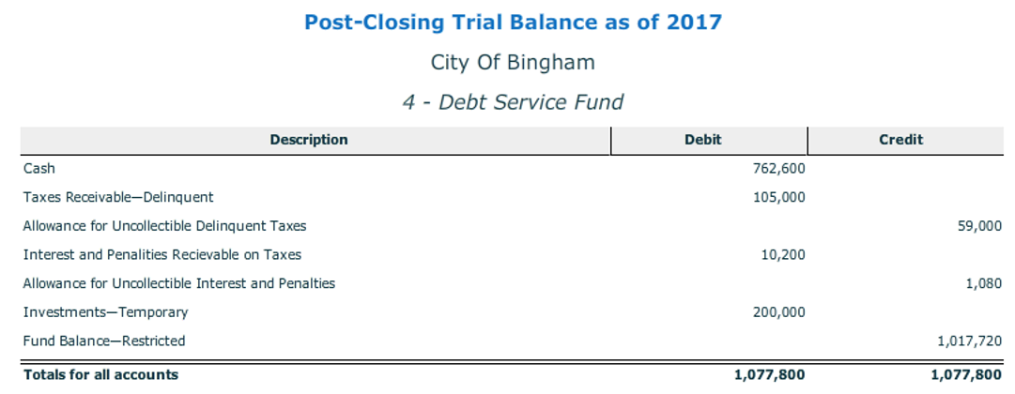

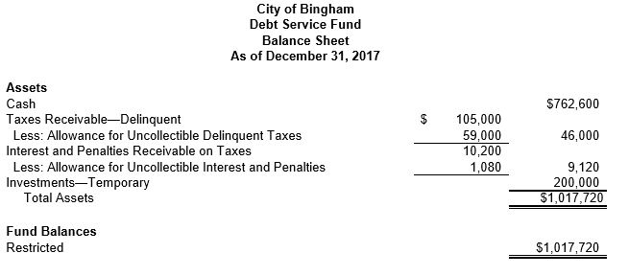

**Debt Service Accounting for Special Assessment Debt**

Special assessment projects typically follow the same pattern as transactions of other capital projects. Specifically, construction activities are usually completed, using either interim financing from the government or proceeds of special assessment debt issuances (bonds or notes) to pay construction costs to contractors.

Either at the beginning of the project or, more commonly, when construction is completed, assessments for debt service are levied against property owners in the defined special benefit district. The portion of the total assessment and applicable interest to be borne by each parcel of property within the district must be determined as specified by laws of the relevant jurisdiction.

Often the amount to be paid by each owner is so large that laws allow the total special assessment against each parcel to be paid in equal installments over a specified period of years. Total annual assessment installments receivable and interest on the balance of unpaid installments usually approximate the amount of debt principal and interest payable during the same year.

If the government is obligated in some manner to make the debt service payments when the amounts collected from benefited property owners are insufficient, the debt should be recorded in the governmental activities journal at the government-wide level and a debt service fund should be used to account for debt service activities.

The portion of the special assessment debt that will be repaid from property owner assessments should be reported as “special assessment debt with governmental commitment” to recognize governmental backing of the debt, while the portion of special assessment debt that will be repaid from general resources of the government (the public benefit portion or the amount assessed against government-owned property) should be reported like other general long-term liabilities.