Accounting Equation In Class Assignments Sole Proprietor Wild 22e

QS 1-8

Applying the accounting equation A1

1. Use the accounting equation to compute the missing financial statement amounts (*a*), (*b*), and (*c*).

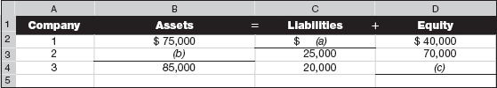

1. Use the expanded accounting equation to compute the missing financial statement amounts (*a*) and (*b*).

