List of Ratios – Know All Ratios Listed
Study by memorizing and using the practice set in Connect
Current Ratio = current assets/current liab.
Profit Margin Ratio = net income / net sales
Gross Margin Ratio = net sales – cost of goods sold / net sales
Earnings Per Share = net income – pref. Div. / weighted avg. shares outstanding
Price Earnings Ratio = market price per share / earnings per share
Dividend Yield = Annual cash dividends per share/ Market value per share
Book Value per Share = shareholders equity to common shares/common shares outstanding

Current Ratio An important use of financial statements is to help assess a company's ability to pay its debts in the near future. Such analysis affects decisions by suppliers when allowing a company to buy on credit. The current ratio is one measure of a company's ability to pay its short-term obligations. It is defined as current assets divided by current liabilities.
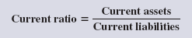

Profit Margin A company's operating efficiency and profitability can be expressed by two components. The first is profit margin, which reflects a company's ability to earn net income from sales. This ratio is interpreted as reflecting the percent of profit in each dollar of sales.
Calculated as Net Income/Net Sales
Gross Margin Ratio The cost of goods sold makes up much of a merchandiser's expenses. Without sufficient gross profit, a merchandiser will likely fail. Users often compute the gross margin ratio to help understand this relationship. It differs from the profit margin ratio in that it excludes all costs except cost of goods sold. The gross margin ratio (also called gross profit ratio) is defined as gross margin (net sales minus cost of goods sold) divided by net sales.
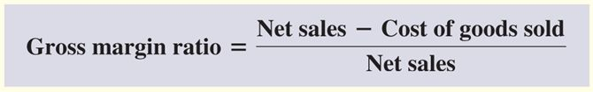

Earnings per Share The income statement reports earnings per share, also called EPS or net income per share, which is the amount of income earned per each share of a company's outstanding common stock. When a company has no preferred stock, then preferred dividends are zero. The weighted-average common shares outstanding is measured over the income reporting period; its computation is explained in advanced courses.
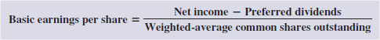
To illustrate, assume that Quantum Co. earns $40,000 net income in 2011 and declares dividends of $7,500 on its noncumulative preferred stock. Quantum has 5,000 weighted-average common shares outstanding during 2011. Its basic EPS is
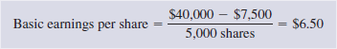

Price-Earnings Ratio A stock's market value is determined by its expected future cash flows. A comparison of a company's EPS and its market value per share reveals information about market expectations. This comparison is traditionally made using a price-earnings (or PE) ratio. Some analysts interpret this ratio as what price the market is willing to pay for a company's current earnings stream.
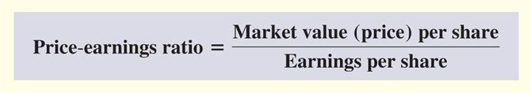

Dividend Yield Investors buy shares of a company's stock in anticipation of receiving a return from either or both cash dividends and stock price increases. Stocks that pay large dividends on a regular basis, called income stocks, are attractive to investors who want recurring cash flows from their investments.
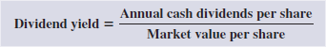

Book Value per Share Book value per common share reflects the amount of equity applicable to common shares on a per share basis. To illustrate, we use Dillon Snowboards has 30,000 outstanding common shares, and the stockholders' equity applicable to common shares is $365,000. Dillon's book value per common share is $12.17, computed as $365,000 divided by 30,000 shares.

