IMPORTANCE OF ACCOUNTING
Accounting is an information and measurement system that identifies, records, and communicates relevant, reliable, and comparable information about an organization's business activities.
Identifying business activities requires selecting transactions and events relevant to an organization.
Recording business activities requires keeping a chronological log of transactions and events measured in dollars and classified and summarized in a useful format.
Communicating business activities requires preparing accounting reports such as financial statements. It also requires analyzing and interpreting such reports.
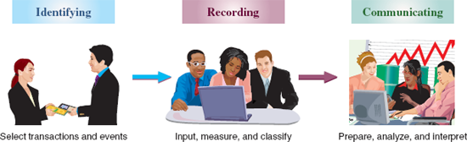

Recordkeeping, or bookkeeping, is the recording of transactions and events, either manually or electronically. This is just one part of accounting. Accounting also identifies and communicates information on transactions and events, and it includes the crucial processes of analysis and interpretation.

Users of Accounting Information
Accounting is often called the language of business because all organizations set up an accounting information system to communicate data to help people make better decisions.
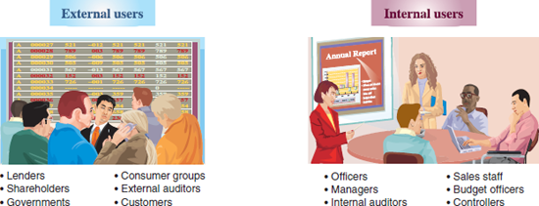
EXHIBIT 1.2
Users of Accounting Information
External users of accounting information are not directly involved in running the organization. They include shareholders (investors), lenders, directors, customers, suppliers, regulators, lawyers, brokers, and the press. External users have limited access to an organization's information. Yet their business decisions depend on information that is reliable, relevant, and comparable.
Financial accounting is the area of accounting aimed at serving external users by providing them with general-purpose financial statements. The term general-purpose refers to the broad range of purposes for which external users rely on these statements.
Each external user has special information needs depending on the types of decisions to be made.
Lenders (creditors) loan money or other resources to an organization. Banks, savings and loans, co-ops, and mortgage and finance companies are lenders. Lenders look for information to help them assess whether an organization is likely to repay its loans with interest.
Shareholders (investors) are the owners of a corporation. They use accounting reports in deciding whether to buy, hold, or sell stock. Shareholders typically elect a board of directors to oversee their interests in an organization. Since directors are responsible to shareholders, their information needs are similar.
External (independent) auditors examine financial statements to verify that they are prepared according to generally accepted accounting principles.
Regulators often have legal authority over certain activities of organizations. For example, the Internal Revenue Service (IRS) and other tax authorities require organizations to file accounting reports in computing taxes.
Accounting serves the needs of many other external users. Contributors to nonprofit organizations use accounting information to evaluate the use and impact of their donations. Suppliers use accounting information to judge the soundness of a customer before making sales on credit, and customers use financial reports to assess the staying power of potential suppliers.
Internal users of accounting information are those directly involved in managing and operating an organization. They use the information to help improve the efficiency and effectiveness of an organization. Managerial accounting is the area of accounting that serves the decision-making needs of internal users. Internal reports are not subject to the same rules as external reports and instead are designed with the special needs of internal users in mind.
Both internal and external users rely on internal controls to monitor and control company activities. Internal controls are procedures set up to protect company property and equipment, ensure reliable accounting reports, promote efficiency, and encourage adherence to company policies. Examples are good records, physical controls (locks, passwords, guards), and independent reviews.
Opportunities in Accounting
Accounting information affects many aspects of our lives. When we earn money, pay taxes, invest savings, budget earnings, and plan for the future, we are influenced by accounting. Accounting has four broad areas of opportunities: financial, managerial, taxation, and accounting-related.
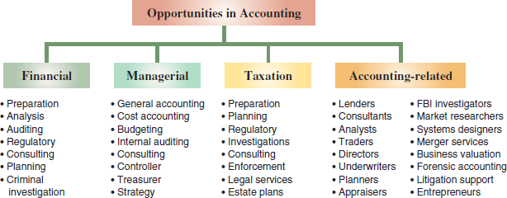

FUNDAMENTALS OF ACCOUNTING
Accounting is guided by principles, standards, concepts, and assumptions. This section describes several of these key fundamentals of accounting.
Ethics—A Key Concept
The goal of accounting is to provide useful information for decisions. For information to be useful, it must be trusted. This demands ethics in accounting. Ethics are beliefs that distinguish right from wrong. They are accepted standards of good and bad behavior.
Identifying the ethical path is sometimes difficult. The preferred path is a course of action that avoids casting doubt on one's decisions. For example, accounting users are less likely to trust an auditor's report if the auditor's pay depends on the success of the client's business. To avoid such concerns, ethics rules are often set.

Guidelines for Ethical Decision Making
Providers of accounting information often face ethical choices as they prepare financial reports. These choices can affect the price a buyer pays and the wages paid to workers. They can even affect the success of products and services. Misleading information can lead to a wrongful closing of a division that harms workers, customers, and suppliers. There is an old saying: Good ethics are good business.

Fraud Triangle
The fraud triangle is a model created by a criminologist, which asserts the following three factors must exist for a person to commit fraud: opportunity, pressure, and rationalization.
Opportunity is one side of the fraud triangle. A person must envision a way to commit fraud with a low perceived risk of getting caught. Employers can directly reduce this risk.
Pressure, or incentive, is another side of the fraud triangle. A person must be motivated to commit fraud.
Rationalization, or attitude, is the third side of the fraud triangle. A person who rationalizes fails to see the criminal nature of the fraud or justifies the action.
The key to dealing with fraud is to focus on prevention. It is cheaper and more effective to prevent fraud from happening than it is to try to detect the crime. By the time the fraud is discovered, the money is gone and chances are slim to none that it will be recovered. Additionally, it is costly and time consuming to investigate a fraud.
It is important to recognize that all three factors of the fraud triangle must usually exist for fraud to occur. The absence of one or more factors suggests fraud is unlikely. When we focus on fraud prevention, it almost always involves reducing opportunity. It is generally less costly to prevent fraud than to cover losses from fraud.
International Standards
In today's global economy, there is increased demand by external users for comparability in accounting reports. This demand often arises when companies wish to raise money from lenders and investors in different countries. To that end, the International Accounting Standards Board (IASB), an independent group (consisting of individuals from many countries), issues International Financial Reporting Standards (IFRS) that identify preferred accounting practices.
If standards are harmonized, one company can potentially use a single set of financial statements in all financial markets. Differences between U.S. GAAP and IFRS are slowly fading as the FASB and IASB pursue a convergence process aimed to achieve a single set of accounting standards for global use.

Sarbanes–Oxley (SOX)
Congress passed the Sarbanes-Oxley Act, also called SOX, to help curb financial abuses at companies that issue their stock to the public. SOX requires that these public companies apply both accounting oversight and stringent internal controls. The desired results include more transparency, accountability, and truthfulness in reporting transactions.
Compliance with SOX requires documentation and verification of internal controls and increased emphasis on internal control effectiveness. Auditors also must verify the effectiveness of internal controls.
A listing of some of the more publicized accounting scandals in recent years follows.
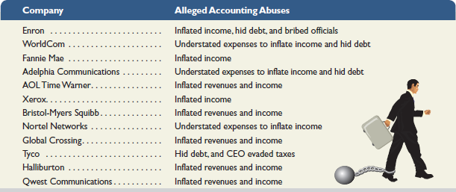

Dodd-Frank
Congress recently passed the Dodd-Frank Wall Street Reform and Consumer Protection Act, or Dodd-Frank, in a desire to (1) promote U.S. financial stability by improving accountability and transparency in the financial system, (2) put an end to the notion of “too big to fail,” (3) protect the taxpayer by ending bailouts, and (4) protect consumers from abusive financial services practices. It includes provisions whose impacts are unknown until regulators set detailed rules. This section provides a preview of its key financial reporting implications.

