

**IMPORTANCE OF ACCOUNTING**

**Accounting** is an information and measurement system that identifies, records, and communicates relevant, reliable, and comparable information about an organization's business activities.

*Identifying* business activities requires selecting transactions and events relevant to an organization.

*Recording* business activities requires keeping a chronological log of transactions and events measured in dollars and classified and summarized in a useful format.

*Communicating* business activities requires preparing accounting reports such as financial statements. It also requires analyzing and interpreting such reports.

**Recordkeeping**, or **bookkeeping**, is the recording of transactions and events, either manually or electronically. This is just one part of accounting. Accounting also identifies and communicates information on transactions and events, and it includes the crucial processes of analysis and interpretation.

**FUNDAMENTALS OF ACCOUNTING**

Accounting is guided by principles, standards, concepts, and assumptions. This section describes several of these key fundamentals of accounting.

**GENERALLY ACCEPTABLE ACCOUNTING PRINCIPLES**

Financial accounting practice is governed by concepts and rules known as **generally accepted accounting principles (GAAP).** To use and interpret financial statements effectively, we need to understand these principles, which can change over time in response to the demands of users.

GAAP aims to make information in financial statements *relevant, reliable*, and *comparable*. Relevant information affects the decisions of its users. Reliable information is trusted by users. Comparable information is helpful in contrasting organizations.

In the United States, the **Securities and Exchange Commission (SEC)**, a government agency, has the legal authority to set GAAP. The SEC also oversees proper use of GAAP by companies that raise money from the public through issuances of their stock and debt. The SEC has largely delegated the task of setting U.S. GAAP to the **Financial Accounting Standards Board (FASB)**, which is a private-sector group that sets both broad and specific principles.

Principles and Assumptions of Accounting Accounting principles (and assumptions) are of two types. *General principles* are the basic assumptions, concepts, and guidelines for preparing financial statements. *Specific principles* are detailed rules used in reporting business transactions and events. General principles stem from long-used accounting practices. Specific principles arise more often from the rulings of authoritative groups.

We need to understand both general and specific principles to effectively use accounting information. Several general principles are described in this section are relied on in later chapters. General principles and assumptions are the building blocks of GAAP. The specific principles are described as we encounter them in the book.

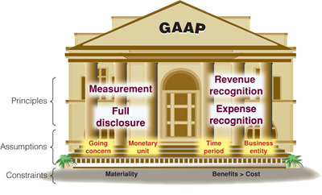

Building Blocks for GAAP

Accounting Principles General principles consist of at least four basic principles, four assumptions, and two constraints.

Basic Principles:

The **measurement principle**, also called the **cost principle**, usually means that accounting information is based on actual cost (with a potential for subsequent adjustments to market). Cost is measured on a cash or equal-to-cash basis. This means if cash is given for a service, its cost is measured as the amount of cash paid. If something besides cash is exchanged (such as a car traded for a truck), cost is measured as the cash value of what is given up or received.

The cost principle emphasizes reliability and verifiability, and information based on cost is considered objective. *Objectivity* means that information is supported by independent, unbiased evidence; it demands more than a person's opinion.

Revenue (sales) is the amount received from selling products and services. The **revenue recognition principle** provides guidance on when a company must recognize revenue. To *recognize* means to record it. If revenue is recognized too early, a company would look more profitable than it is. If revenue is recognized too late, a company would look less profitable than it is.

Three concepts are important to revenue recognition. (1) *Revenue is recognized when earned*. The earnings process is normally complete when services are performed or a seller transfers ownership of products to the buyer. (2) *Proceeds from selling products and services need not be in cash*. A common noncash proceed received by a seller is a customer's promise to pay at a future date, called *credit sales.* (3) *Revenue is measured by the cash received plus the cash value of any other items received*.

The **expense recognition principle**, also called the **matching principle**, prescribes that a company record the expenses it incurred to generate the revenue reported. The principles of matching and revenue recognition are key to modern accounting.

The **full disclosure principle** prescribes that a company report the details behind financial statements that would impact users' decisions. Those disclosures are often in footnotes to the statements.

**Accounting Assumptions** There are four accounting assumptions: the going concern assumption, the monetary unit assumption, the time period assumption, and the business entity assumption.

The **going-concern assumption** means that accounting information reflects a presumption that the business will continue operating instead of being closed or sold. This implies, for example, that property is reported at cost instead of, say, liquidation values that assume closure.

The **monetary unit assumption** means that we can express transactions and events in monetary, or money, units. Money is the common denominator in business. The monetary unit a company uses in its accounting reports usually depends on the country where it operates, but many companies today are expressing reports in more than one monetary unit.

The **time period assumption** presumes that the life of a company can be divided into time periods, such as months and years, and that useful reports can be prepared for those periods.

**Accounting Constraints**

There are two basic constraints on financial reporting.

The **materiality constraint** prescribes that only information that would influence the decisions of a reasonable person need be disclosed. This constraint looks at both the importance and relative size of an amount.

The **cost-benefit constraint** prescribes that only information with benefits of disclosure greater than the costs of providing it need be disclosed.

The **business entity assumption** means that a business is accounted for separately from other business entities, including its owner. The reason for this assumption is that separate information about each business is necessary for good decisions. A business entity can take one of three legal forms: *proprietorship, partnership*, or *corporation.*

1. A **sole proprietorship**, or simply **proprietorship**, is a business owned by one person in which that person and the company are viewed as one entity for tax and liability purposes. No special legal requirements must be met to start a proprietorship. It is a separate entity for accounting purposes, but it is *not* a separate legal entity from its owner. This means, for example, that a court can order an owner to sell personal belongings to pay a proprietorship's debt. This *unlimited liability* of a proprietorship is a disadvantage. However, an advantage is that a proprietorship's income is not subject to a business income tax but is instead reported and taxed on the owner's personal income tax return.

|  |
| --- |
|  |

1. A **partnership** is a business owned by two or more people, called *partners*, which are jointly liable for tax and other obligations. Like a proprietorship, no special legal requirements must be met in starting a partnership. The only requirement is an agreement between partners to run a business together.

A partnership, like a proprietorship, is *not* legally separate from its owners. However, at least three types of partnerships limit liability. A *limited partnership* (*LP*) includes a general partner(s) with unlimited liability and a limited partner(s) with liability restricted to the amount invested.

**Most proprietorships and partnerships are now organized as LLCs.**

1. A **corporation** is a business legally separate from its owner or owners, meaning it is responsible for its own acts and its own debts. Separate legal status means that a corporation can conduct business with the rights, duties, and responsibilities of a person. A corporation acts through its managers, who are its legal agents.

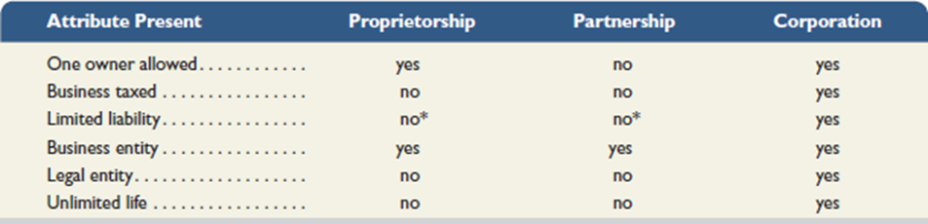

**TRANSACTION ANALYSIS AND THE ACCOUNTING EQUATION**

To understand accounting information, we need to know how an accounting system captures relevant data about transactions, and then classifies, records, and reports this data.

**Accounting Equation**

The accounting system reflects two basic aspects of a company: what it owns and what it owes.

Assets (What you have) = Liabilities (What you owe) and Owner’s Equity (What you own)

*Assets* are resources a company owns or controls. Examples are cash, supplies, equipment, and land, where each carries expected benefits. An asset has future benefits associated with it.

The claims on a company's assets—what it owes—are separated into owner and non-owner claims.

*Liabilities* are what a company owes its non-owners (creditors) in future payments, products, or services.

*Equity* (also called owner's equity or capital) refers to the claims of its owner(s).

Together, liabilities and equity are the source of funds to acquire assets.

The relationship of assets, liabilities, and equity is reflected in the following **accounting equation:**

http://textflow.mcgraw-hill.com/figures/007742994X/wiL25389_eq0101.png

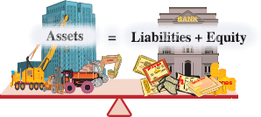

Liabilities are usually shown before equity in this equation because creditors' claims must be paid before the claims of owners.

(The terms in this equation can be rearranged; for example, Assets − Liabilities = Equity.)

The accounting equation applies to all transactions and events, to all companies and forms of organization, and to all points in time.

**Assets** are resources a company owns or controls. These resources are expected to yield future benefits. The term *receivable* is used to refer to an asset that promises a future inflow of resources such as cash. A company that provides a service or product on credit or on account is said to have an account receivable from that customer.

**Liabilities** are creditors' claims on assets. These claims reflect company obligations to provide assets, products, or services to others. The term *payable* refers to a liability that promises a future outflow of resources. Examples are wages payable to workers, accounts payable to suppliers, notes payable to banks, and taxes payable to the government. A company that has promise to provide a benefit has an transaction “on account.”

**Equity** is the owner's claim on assets. Equity is equal to assets minus liabilities. This is the reason equity is also called *net assets* or *residual equity*.

**A corporation's equity**—often called stockholders' or shareholders' equity—has two parts: contributed capital and retained earnings.

**Contributed capital** refers to the amount that stockholders invest in the company—included under the title **common stock.** **Retained earnings** refer to **income** (revenues less expenses) that has *not* been distributed to its stockholders. The distribution of assets to stockholders is called **dividends**, which reduce retained earnings.

**Revenues** increase retained earnings (via net income) and are resources generated from a company's earnings activities. **Expenses** decrease retained earnings and are the cost of assets or services used to earn revenues.

In sum, retained earnings are the accumulated revenues less the accumulated expenses and dividends since the company began.

This breakdown of equity yields the following **expanded accounting equation:**

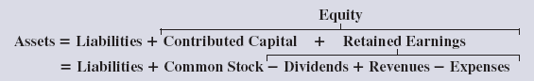

**Net income** occurs when revenues exceed expenses. Net income increases equity. A **net loss** occurs when expenses exceed revenues, which decreases equity.

**Business activities can be described in terms of transactions**

**External transactions** are exchanges of value between two entities, which yield changes in the accounting equation.

**Internal transactions** are exchanges within an entity, which may or may not affect the accounting equation.

**Fast Forward**

This section uses the accounting equation to analyze 11 selected transactions and events of FastForward, a start-up consulting (service) business, in its first month of operations. Remember that each transaction and event leaves the equation in balance and that assets *always* equal the sum of liabilities and equity.

There are 3 basic types of company operations: (1) **Services** — providing customer services for profit, (2) **Merchandisers** — buying products and re-selling them for profit, and (3) **Manufacturers** — creating products and selling them for profit. We will start with a service company. Later, we will learn about a merchandising company.

**FINANCIAL STATEMENTS**

This section introduces us to how financial statements are prepared from the analysis of business transactions. The four financial statements and their purposes are:

1. **Income statement**—describes a company's **revenues and expenses** along with the resulting net income or loss over a **period of time** due to earnings activities.
2. **Statement of retained earnings**—explains changes in retained earnings from net income (or loss) and from any dividends over a **period of time.**
3. **Balance sheet**—describes a company's financial position (types and amounts of assets, liabilities, and equity) **at a point in time**.
4. **Statement of cash flows**—identifies cash inflows (receipts) and cash outflows (payments) over a period of time. – Last time we will look at this statement until Ch 12 when we will learn about categories for this statement.

We will look at these transactions and prepare financial statements. We will classify the equity transactions according to which financial statement they belong to. Assets, liabilities and Common Stock are found only on the Balance Sheet. Revenue and expenses are found only on the Income Statement. Dividends are found only on the Statement of Retained Earnings. Ending retained earnings are found both on the Balance Sheet and the Statement of Retained Earnings.

The financial statements are prepared in a specific order. First, the income statement—information from the income statement is needed to prepare the statement of retained earnings. Secondly, the statement of retained earnings—the ending retained earnings amount is needed to prepare the balance sheet. Next, the balance sheet is prepared.



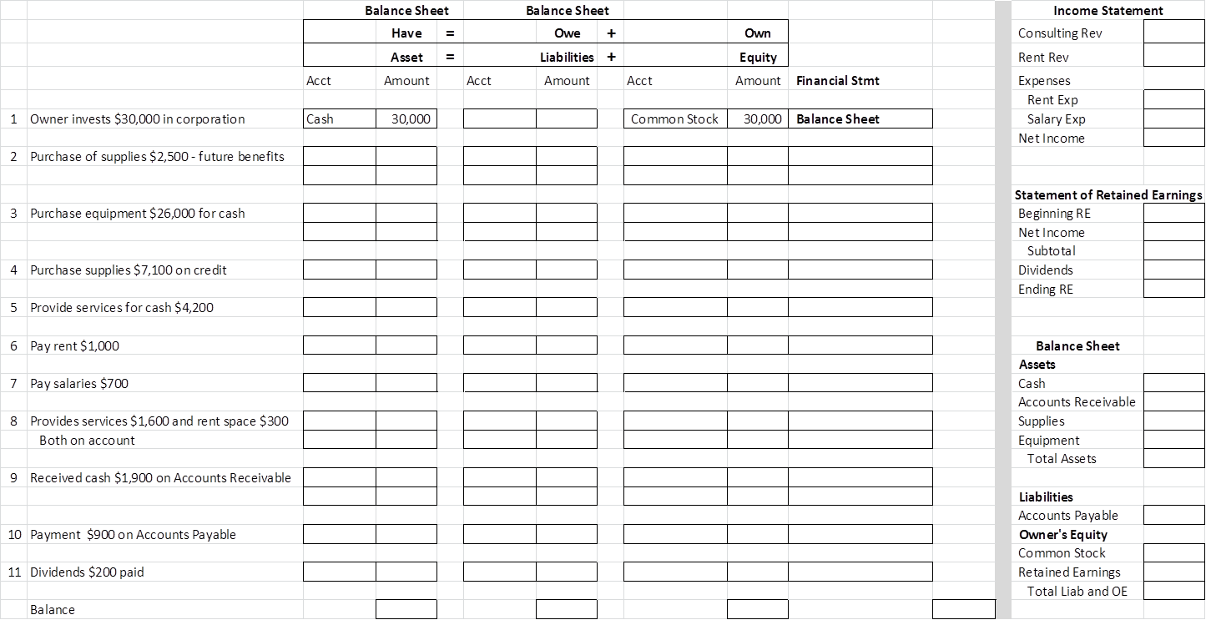

**Transaction 1: Investment by Owner**

On December 1, Chas Taylor forms a consulting business, named FastForward and set up as a corporation focusing on assessing the performance of footwear and accessories. Taylor owns and manages the business.

Taylor personally invests $30,000 cash in the new company and deposits the cash in a bank account opened under the name of FastForward.

After this transaction, the cash (an asset) and the stockholders' equity each equal $30,000. The source of increase in equity is the owner's investment (stock issuance), which is included in the column titled Common Stock.

**Transaction 2: Purchase Supplies for Cash**

FastForward uses $2,500 of its cash to buy supplies of brand name footwear for performance testing over the next few months. This transaction is an exchange of cash, an asset, for another kind of asset, supplies. It merely changes the form of assets from cash to supplies. The decrease in cash is exactly equal to the increase in supplies. The supplies of footwear are assets because of the expected future benefits from the test results of their performance.

**Transaction 3: Purchase Equipment for Cash**

FastForward spends $26,000 to acquire equipment for testing footwear. Like transaction 2, transaction 3 is an exchange of one asset, cash, for another asset, equipment. The equipment is an asset because of its expected future benefits from testing footwear.

This purchase changes the makeup of assets but does not change the asset total. The accounting equation remains in balance.

**Transaction 4: Purchase Supplies on Credit**

Taylor decides more supplies of footwear and accessories are needed. These additional supplies total $7,100, but as we see from the accounting equation in transaction 3, FastForward has only $1,500 in cash.

Taylor arranges to purchase them on credit from CalTech Supply Company. Thus, FastForward acquires supplies in exchange for a promise to pay for them later. This is a purchase on account. This purchase increases assets by $7,100 in supplies, and liabilities (called *accounts payable* to CalTech Supply) increase by the same amount.

**Transaction 5: Provide Services for Cash**

In one of its first jobs, FastForward provides consulting services to a power-walking club and immediately collects $4,200 cash. The accounting equation reflects this increase in cash of $4,200 and in equity of $4,200 in the form of revenues.

**Transactions 6 and 7: Payment of Expenses in Cash**

FastForward pays $1,000 rent to the landlord of the building where its facilities are located. Paying this amount allows FastForward to occupy the space for the month of December.

FastForward also pays the biweekly $700 salary of the company's only employee. This is reflected in the accounting equation as transaction 7.

Both transactions 6 and 7 are December expenses for FastForward. The costs of both rent and salary are expenses, as opposed to assets, because their benefits are used in December (they have no future benefits after December). These transactions also use up an asset (cash) in carrying out FastForward's operations.

The accounting equation shows that both transactions reduce cash and equity in the form of expenses.

*By definition, increases in expenses yield decreases in equity. – Revenues – You own more and expenses- you own less*

**Transaction 8: Provide Services and Facilities for Credit**

FastForward provides consulting services of $1,600 and rents its test facilities for $300 to a podiatric services center. The rental involves allowing members to try recommended footwear and accessories at FastForward's testing area. The center is billed for the $1,900 total.

This transaction results in a new asset, called *accounts receivable*, from this client. It also yields an increase in equity from the two revenue components.

**Transaction 9: Receipt of Cash from Accounts Receivable**

The client in transaction 8 (the podiatric center) pays $1,900 to FastForward 10 days after it is billed for consulting services. This transaction 9 does not change the total amount of assets and does not affect liabilities or equity. It converts the receivable (an asset) to cash (another asset).

**It does not create new revenue.** Revenue was recognized when FastForward rendered the services in transaction 8, not when the cash is now collected. This emphasis on the earnings process instead of cash flows is a goal of the **revenue recognition principle** and yields useful information to users.

**Point:** Receipt of cash is not always revenue.

**Transaction 10: Payment of Accounts Payable**

FastForward pays CalTech Supply $900 cash as partial payment for its earlier $7,100 purchase of supplies (transaction 4), leaving $6,200 unpaid.

The accounting equation shows that this transaction decreases FastForward's cash by $900 and decreases its liability to CalTech Supply by $900. Equity does not change.

This event does not create an expense even though cash flows out of FastForward (instead the expense is recorded when FastForward derives the benefits from these supplies).

**Transaction 11: Payment of Cash Dividend**

FastForward declares and pays a $200 cash dividend to its owner. Dividends (decreases in equity) are not reported as expenses because they are not part of the company's earnings process. Since dividends are not company expenses, they are not used in computing net income.

*By definition, increases in dividends yield decreases in equity.*

**Summary of Transactions**

First, we see that the accounting equation remains in balance after each transaction. Second, transactions can be analyzed by their effects on components of the accounting equation. For example, in transactions 2, 3, and 9, one asset increased while another asset decreased by equal amounts.

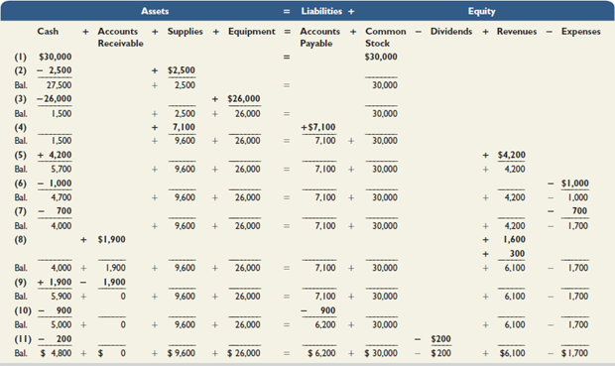

**Point:** Knowing how financial statements are prepared improves our analysis of them. We develop the skills for analysis of financial statements throughout the book.

**Income Statement**

Net income (or loss) is reported at the bottom of the statement and is the amount earned in December. Stockholders' investments and dividends are *not* part of income.

A statement's heading identifies the company, the statement title, and the date or time period. Net income is used to compute equity. Retained earnings are used to prepare the balance sheet.

The income statement, the statement of retained earnings, and the statement of cash flows are prepared for a *period* of time. The balance sheet is prepared as of a *point* in time. A single ruled line denotes an addition or subtraction. Final totals are double underlined. Negative amounts are often in parentheses.

**Statement of Retained Earnings**

The statement of retained earnings reports information about how retained earnings changes over the reporting period. This statement shows beginning retained earnings, events that increase it (net income), and events that decrease it (dividends and net loss). Ending retained earnings is computed in this statement and is carried over and reported on the balance sheet.

**Point:** The statement of retained earnings is also called the *statement of changes in retained earnings.* Note: Beginning Retained Earnings + Net Income − Dividends = Ending Retained Earnings

**Balance Sheet**

This statement refers to a company’s financial condition at the close of business on December 31. It is valid for one day only. The left side of the balance sheet lists FastForward's assets: cash, supplies, and equipment. We see the accounting equation applies: Assets of $40,400 = Liabilities of $6,200 + Equity of $34,200.

