Chapter 3. Adjusting and Closing Accounts and Preparing Financial Statements

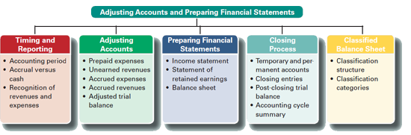

TIMING AND REPORTING
The value of information is often linked to its timeliness. Useful information must reach decision makers frequently and promptly. To provide timely information, accounting systems prepare reports at regular intervals. This results in an accounting process impacted by the time period (or periodicity) assumption. The time period assumption presumes that an organization's activities can be divided into specific time periods such as a month, a three-month quarter, a six-month interval, or a year.
Accrual Basis versus Cash Basis
After external transactions and events are recorded, several accounts still need adjustments before their balances appear in financial statements. This need arises because internal transactions and events remain unrecorded. Accrual basis accounting uses the adjusting process to recognize revenues when earned and expenses when incurred (matched with revenues).
Cash basis accounting recognizes revenues when cash is received and records expenses when cash is paid. This means that cash basis net income for a period is the difference between cash receipts and cash payments. Cash basis accounting is not consistent with generally accepted accounting principles (neither U.S. GAAP nor IFRS).
It is commonly held that accrual accounting better reflects business performance than information about cash receipts and payments. Accrual accounting also increases the comparability of financial statements from one period to another. Yet cash basis accounting is useful for several business decisions — which is the reason companies must report a statement of cash flows.

CLASSIFIED BALANCE SHEET
Our discussion to this point has been limited to unclassified financial statements. This section describes a classified balance sheet. The next chapter describes a classified income statement. An unclassified balance sheet is one whose items are broadly grouped into assets, liabilities, and equity. A classified balance sheet organizes assets and liabilities into important liquidity subgroups that provide more information to decision makers.
A classified balance sheet has no required layout, but it usually contains the following categories. One of the more important classifications is the separation between current and noncurrent items for both assets and liabilities.
Current items are those expected to come due (either collected or owed) within one year or the company's operating cycle, whichever is longer. The operating cycle is the time span from when cash is used to acquire goods and services until cash is received from the sale of goods and services. The length of a company's operating cycle depends on its activities. For a service company, the operating cycle is the time span between (1) paying employees who perform the services and (2) receiving cash from customers. For a merchandiser selling products, the operating cycle is the time span between (1) paying suppliers for merchandise and (2) receiving cash from customers.
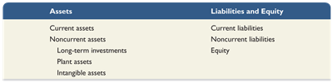
Most operating cycles are less than one year. This means most companies use a one-year period in deciding which assets and liabilities are current.
A balance sheet lists current assets before noncurrent assets and current liabilities before noncurrent liabilities. This consistency in presentation allows users to quickly identify current assets that are most easily converted to cash and current liabilities that are shortly coming due. Items in current assets and current liabilities are listed in the order of how quickly they will be converted to, or paid in, cash.

Classification Categories
This classified balance sheet shows the typical categories. Its assets are classified as either current or noncurrent. Its noncurrent assets include three main categories: long-term investments, plant assets, and intangible assets. Its liabilities are classified as either current or long-term.
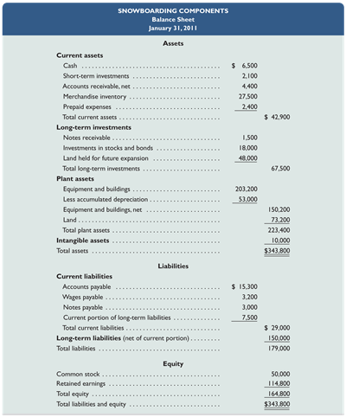

Current Assets
Current assets are cash and other resources that are expected to be sold, collected, or used within one year or the company's operating cycle, whichever is longer.
Examples are cash, short-term investments, accounts receivable, short-term notes receivable, goods for sale (called merchandise or inventory), and prepaid expenses. The individual prepaid expenses of a company are usually small in amount compared to many other assets and are often combined and shown as a single item. The prepaid expenses likely include items such as prepaid insurance, prepaid rent, office supplies, and store supplies. Prepaid expenses are usually listed last because they will not be converted to cash (instead, they are used).
Long-Term Investments A second major balance sheet classification is long-term (or noncurrent) investments. Notes receivable and investments in stocks and bonds are long-term assets when they are expected to be held for more than the longer of one year or the operating cycle. Land held for future expansion is a long-term investment because it is not used in operations.
Plant assets are tangible assets that are both long-lived and used to produce or sell products and services. Examples are equipment, machinery, buildings, and land that are used to produce or sell products and services. The order listing for plant assets is usually from most liquid to least liquid such as equipment and machinery to buildings and land.
Intangible assets are long-term resources that benefit business operations, usually lack physical form, and have uncertain benefits. Examples are patents, trademarks, copyrights, franchises, and goodwill. Their value comes from the privileges or rights granted to or held by the owner.
Current liabilities are obligations due to be paid or settled within one year or the operating cycle, whichever is longer. They are usually settled by paying out current assets such as cash. Current liabilities often include accounts payable, notes payable, wages payable, taxes payable, interest payable, and unearned revenues.
Also, any portion of a long-term liability due to be paid within one year or the operating cycle, whichever is longer, is a current liability. Unearned revenues are current liabilities when they will be settled by delivering products or services within one year or the operating cycle, whichever is longer. Current liabilities are reported in the order of those to be settled first.
Long-term liabilities are obligations not due within one year or the operating cycle, whichever is longer. Notes payable, mortgages payable, bonds payable, and lease obligations are common long-term liabilities. If a company has both short- and long-term items in each of these categories, they are commonly separated into two accounts in the ledger.
Equity is the owner's claim on assets. The equity section for a corporation is divided into two main subsections, common stock and retained earnings.

