**Financial Statement Effects of Costing Methods**

When purchase prices do not change, each inventory costing method assigns the same cost amounts to inventory and to cost of goods sold. When purchase prices are different, however, the methods nearly always assign different cost amounts.

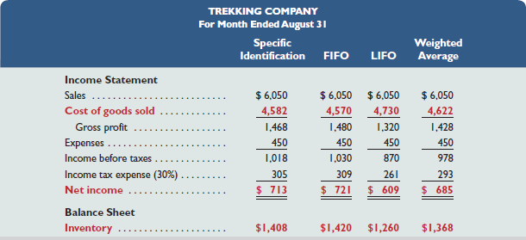

This exhibit reveals two important results. First, **when purchase costs *regularly rise*,**

* FIFO assigns the lowest amount to cost of goods sold — yielding the highest gross profit/net income. **Low COGS; High Profit; High Ending Inventory or Low, High, High**
* LIFO assigns the highest amount to cost of goods sold — yielding the lowest gross profit/net income, which also yields a temporary tax advantage by postponing payment of some income tax. **High COGS; Low Profit; Low Ending Inventory or High, Low, Low**
* Weighted average yields results between FIFO and LIFO.
* Specific identification always yields results that depend on which units are sold.

Second, **when costs *regularly decline*,** the reverse occurs for FIFO and LIFO. Namely, FIFO gives the highest cost of goods sold—yielding the lowest gross profit/net income as well as low ending inventory. However, LIFO then gives the lowest cost of goods sold—yielding the highest gross profit/net income as well as high ending inventory. **FIFO High, Low, Low and LIFO Low, High, High**

All four inventory costing methods are acceptable. However, a company must disclose the inventory method it uses in its financial statements or notes. Each method offers certain advantages as follows:

* FIFO assigns an amount to inventory on the balance sheet that approximates its current cost; it also mimics the actual flow of goods for most businesses.
* LIFO assigns an amount to cost of goods sold on the income statement that approximates its current cost; it also better matches current costs with revenues in computing gross profit.
* Weighted average tends to smooth out erratic changes in costs.
* Specific identification exactly matches the costs of items with the revenues they generate.

**Consistency in Using Costing Methods**

The **consistency concept or principle** prescribes that a company use the same accounting methods period after period so that financial statements are comparable across periods — the only exception is when a change from one method to another will improve its financial reporting. The *full-disclosure principle* prescribes that the notes to the statements report this type of change, its justification, and its effect on income.

**Financial Statement Effects of Inventory Errors**

Companies must be careful both in taking a physical count of inventory and in assigning a cost to it. An inventory error causes misstatements in cost of goods sold, gross profit, net income, current assets, and equity. It also causes misstatements in the next period's statements because ending inventory of one period is the beginning inventory of the next. Remember,



Income Statement Effects on key amounts in the current and next periods' income statements.

|  |
| --- |
| *http://textflow.mheducation.com/figures/007742994X/wiL25389_0510.png* |



|  |
| --- |
| http://textflow.mheducation.com/figures/007742994X/wiL25389_0511.png |

* Correct amount is $20,000. † Correct amount is $60,000.

**Balance Sheet Effects**

Balance sheet effects of an inventory error can be seen by considering the accounting equation: Assets = Liabilities + Equity. For example, understating ending inventory understates both current and total assets. An understatement in ending inventory also yields an understatement in equity because of the understatement in net income.

