DEMONSTRATION PROBLEM 1
The following information relates to Fanning's Electronics on December 31. The company, which uses the calendar year as its annual reporting period, initially records prepaid and unearned items in balance sheet accounts (assets and liabilities, respectively).
- The company's weekly payroll is $8,750, paid each Friday for a five-day workweek. Assume December 31, falls on a Monday, but the employees will not be paid their wages until Friday, January 4.
- Eighteen months earlier, the company purchased equipment that cost $20,000. Its useful life is predicted to be five years, at which time the equipment is expected to be worthless (zero salvage value).
- On October 1, the company agreed to work on a new housing development. The company is paid $120,000 on October 1 in advance of future installation of similar alarm systems in 24 new homes. That amount was credited to the Unearned Services Revenue account. Between October 1 and December 31, work on 20 homes was completed.
- On September 1, the company purchased a 12-month insurance policy for $1,800. The transaction was recorded with an $1,800 debit to Prepaid Insurance.
- On December 29, the company completed a $7,000 service that has not been billed or recorded as of December 31.
Prepare any necessary adjusting entries on December 31. Prepare a T-account for unearned services revenue and determine the adjusted balance.

DEMONSTRATION PROBLEM 2
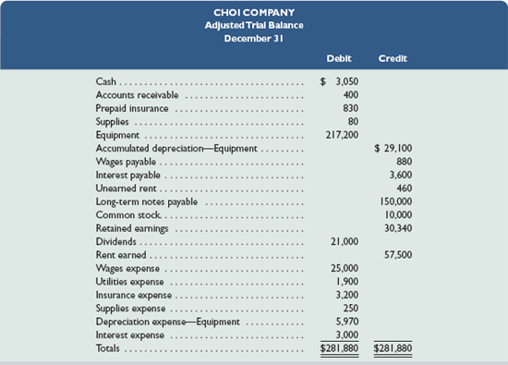
- Prepare the closing entries
- Prepare a post-closing trial balance

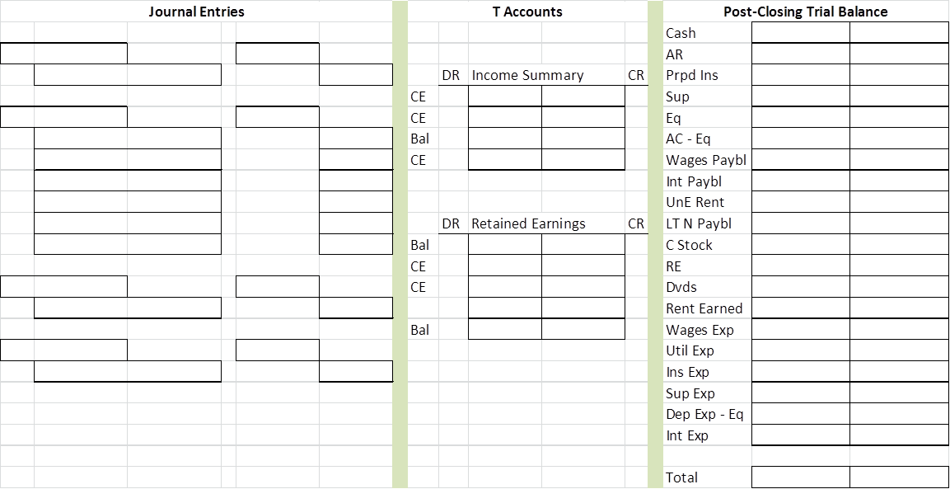

QS 3-14

For each separate case below, follow the 3-step process for adjusting the prepaid asset account: Step 1: Determine what the current account balance equals. Step 2: Determine what the current account balance should equal. Step 3: Record an adjusting entry to get from step 1 to step 2.Assume no other adjusting entries are made during the year.

- Prepaid Insurance. The Prepaid Insurance account has a $4,700 debit balance to start the year. A review of insurance policies and payments shows that $900 of unexpired insurance remains at year-end.
- Prepaid Insurance. The Prepaid Insurance account has a $5,890 debit balance at the start of the year. A review of insurance policies and payments shows $1,040 of insurance has expired by year-end.
- Prepaid Rent. On September 1 of the current year, the company prepaid $24,000 for 2 years of rent for facilities being occupied that day. The company debited Prepaid Rent and credited Cash for $24,000.

QS 3-15
For each separate case below, follow the 3-step process for adjusting the supplies asset account: Step 1: Determine what the current account balance equals. Step 2: Determine what the current account balance should equal. Step 3: Record an adjusting entry to get from step 1 to step 2.Assume no other adjusting entries are made during the year.
- Supplies. The Supplies account has a $300 debit balance to start the year. No supplies were purchased during the current year. A December 31 physical count shows $110 of supplies remaining.
- Supplies. The Supplies account has an $800 debit balance to start the year. Supplies of $2,100 were purchased during the current year and debited to the Supplies account. A December 31 physical count shows $650 of supplies remaining.
- Supplies. The Supplies account has a $4,000 debit balance to start the year. During the current year, supplies of $9,400 were purchased and debited to the Supplies account. The inventory of supplies available at December 31 totaled $2,660.
QS 3-16
Accumulated depreciation adjustments P1
For each separate case below, follow the 3-step process for adjusting the accumulated depreciation account: Step 1: Determine what the current account balance equals. Step 2: Determine what the current account balance should equal. Step 3: Record an adjusting entry to get from step 1 to step 2. Assume no other adjusting entries are made during the year.
- Accumulated Depreciation. The Krug Company's Accumulated Depreciation account has a $13,500 balance to start the year. A review of depreciation schedules reveals that $14,600 of depreciation expense must be recorded for the year.
- Accumulated Depreciation. The company has only one fixed asset (truck) that it purchased at the start of this year. That asset had cost $44,000, had an estimated life of 5 years, and is expected to have zero value at the end of the 5 years.
- Accumulated Depreciation. The company has only one fixed asset (equipment) that it purchased at the start of this year. That asset had cost $32,000, had an estimated life of 7 years, and is expected to be valued at $4,000 at the end of the 7 years.

QS 3-17

For each separate case below, follow the 3-step process for adjusting the unearned revenue liability account: Step 1: Determine what the current account balance equals. Step 2: Determine what the current account balance should equal. Step 3: Record an adjusting entry to get from step 1 to step 2. Assume no other adjusting entries are made during the year.
- Unearned Rent Revenue. The Krug Company collected $6,000 rent in advance on November 1, debiting Cash and crediting Unearned Rent Revenue. The tenant was paying twelve months rent in advance and occupancy began November 1.
- Unearned Services Revenue. The company charges $75 per month to spray a house for insects. A customer paid $300 on October 1 in advance for four treatments, which was recorded with a debit to Cash and a credit to Unearned Services Revenue. At year-end, the company has applied three treatments for the customer.
- Unearned Rent Revenue. On September 1, a client paid the company $24,000 cash for six months of rent in advance (the client leased a building and took occupancy immediately). The company recorded the cash as Unearned Rent Revenue.

QS 3-18
For each separate case below, follow the 3-step process for adjusting the accrued expense account: Step 1: Determine what the current account balance equals. Step 2: Determine what the current account balance should equal. Step 3: Record an adjusting entry to get from step 1 to step 2. Assume no other adjusting entries are made during the year.
- Salaries Payable. At year-end, salaries expense of $15,500 has been incurred by the company, but is not yet paid to employees.
- Interest Payable. At its December 31 year-end, the company owes $250 of interest on a line-of-credit loan. That interest will not be paid until sometime in January of the next year.
- Interest Payable. At its December 31 year-end, the company holds a mortgage payable that has incurred $875 in annual interest that is neither recorded nor paid. The company intends to pay the interest on January 7 of the next year.

