DCC 201 Sole Proprietor Closing Entries In Class Assignments Student Version
Exercise 4-9
Preparing closing entries and a post-closing trial balance P2 P3
The following adjusted trial balance contains the accounts and balances of Cruz Company as of December 31, 2015, the end of its fiscal year. (1) Prepare the December 31, 2015, closing entries for Cruz Company. Assume the account number for Income Summary is 901. (2) Prepare the December 31, 2015, post-closing trial balance for Cruz Company.
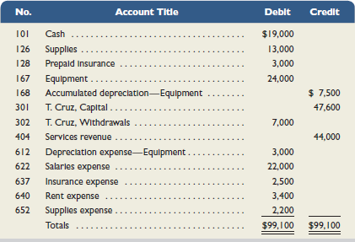
Check (2) T. Cruz, Capital (ending), $51,500; Total debits, $59,000

Exercise 4-11
Preparing the financial statements C2
Use the following adjusted trial balance of Wilson Trucking Company to prepare the (1) income statement and (2) statement of owner's equity for the year ended December 31, 2015. The K. Wilson, Capital account balance is $175,000 at December 31, 2014.
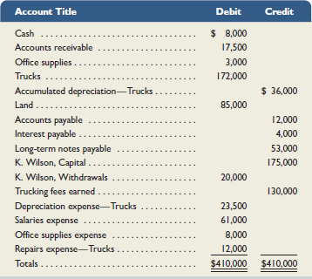
Exercise 4-12
Preparing a classified balance sheet C3
Use the information in the adjusted trial balance reported in Exercise 4-11 to prepare Wilson Trucking Company's classified balance sheet as of December 31, 2015.
Check Total assets, $249,500; K. Wilson, Capital, $180,500 (ending)

