In Class Assignments Student Version

EXERCISE 13-2 Financial Ratios for Common Stockholders [LO2]
Comparative financial statements for Heritage Antiquing Services for the fiscal year ending December 31 appear below and on the following page. The company did not issue any new common or preferred stock during the year. A total of 600 thousand shares of common stock were outstanding. The interest rate on the bond payable was 14%, the income tax rate was 40%, and the dividend per share of common stock was $0.75. The market value of the company's common stock at the end of the year was $26. All of the company's sales are on account.
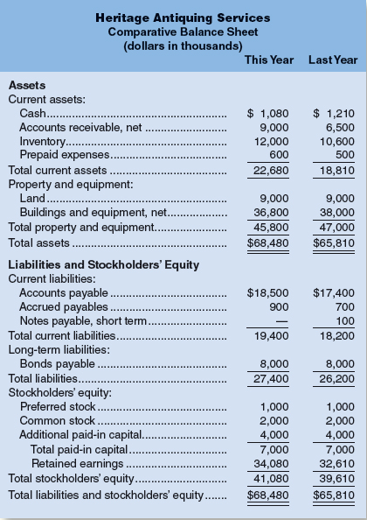
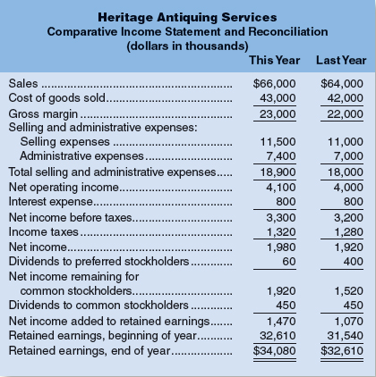
Compute the following financial ratios for common stockholders for this year:
- Gross margin percentage.
- Earnings per share of common stock.
- Price-earnings ratio.
- Dividend payout ratio.
- Dividend yield ratio.
- Return on total assets.
- Return on common stockholders' equity.
- Book value per share.
EXERCISE 13-3 Financial Ratios for Short-Term Creditors [LO3] Compute the following financial data for short-term creditors for this year:
- Working capital.
- Current ratio.
- Acid-test ratio.
- Accounts receivable turnover.
- Average collection period.
- Inventory turnover.
- Average sale period.

EXERCISE 13-4 Financial Ratios for Long-Term Creditors [LO4] Refer to the data in Exercise 13-2 for Heritage Antiquing Services. Compute the following financial ratios for long-term creditors for this year:
- Times interest earned ratio.
- Debt-to-equity ratio.

EXERCISE 13-5 Selected Financial Measures for Short-Term Creditors [LO3]
Rightway Products had a current ratio of 2.5 on June 30 of the current year. On that date, the company's assets were as follows:
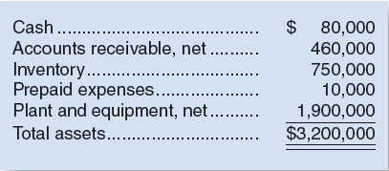
Required:
- What was the company's working capital on June 30?
- What was the company's acid-test ratio on June 30?
- The company paid an account payable of $100,000 immediately after June 30.
  - What effect did this transaction have on working capital? Show computations.
  - What effect did this transaction have on the current ratio? Show computations.

EXERCISE 13-6 Selected Financial Ratios [LO3, LO4]
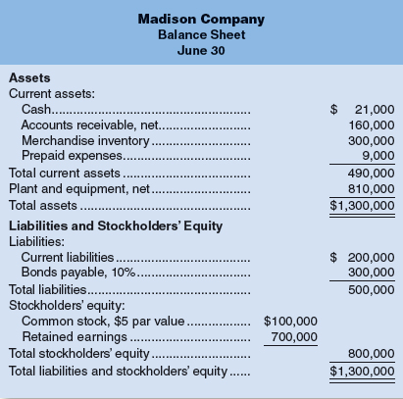
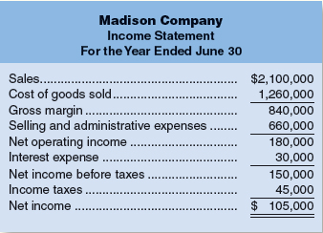
Account balances at the beginning of the company's fiscal year were: accounts receivable, $140,000; and inventory, $260,000. All sales were on account.
Compute financial ratios as follows:
- Gross margin percentage.
- Current ratio.
- Acid-test ratio.
- Average collection period.
- Average sale period.
- Debt-to-equity ratio.
- Times interest earned.
- Book value per share

EXERCISE 13-7 Selected Financial Ratios for Common Stockholders [LO2]
Refer to the financial statements for Madison Company in Exercise 13-6. In addition to the data in these statements, assume that Madison Company paid dividends of $3.15 per share during the year. Also assume that the company's common stock had a market price of $63 per share on June 30 and that there was no change in the number of outstanding shares of common stock during the fiscal year.
Compute the following:
- Earnings per share.
- Dividend payout ratio.
- Dividend yield ratio.
- Price-earnings ratio.
EXERCISE 13-8 Selected Financial Ratios for Common Stockholders [LO2]
Refer to the financial statements for Madison Company in Exercise 13-6. Assets at the beginning of the year totaled $1,100,000, and the stockholders' equity totaled $725,000.
Required:
Compute the following:
- Return on total assets.
- Return on common stockholders' equity.
- Was financial leverage positive or negative for the year? Explain.

