Quick Books first class project.
Take your time. I am not a QuickBooks expert and only want you to follow these exact steps. If you go someplace you didn’t want to go in the software, I can try to help you but most likely will tell you to start over again with a new company name.
We will go through these steps and save screen shots of what you are doing. I only want you to grab screen shots using the Snip tool. Here is the video link to the Snip instructions https://youtu.be/QfuaRMc59pY
Open up a word document and save the screenshots into it. You will then email it to me at the end of class to document your work. The email time stamp will have to be within the hours of class.

Open up Quickbooks
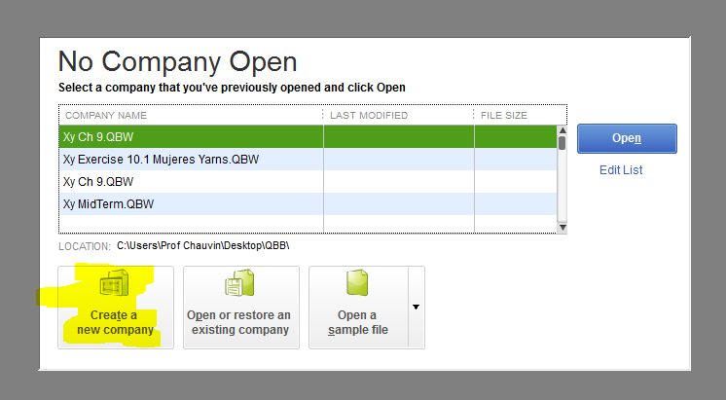
- Create a new company
When you start a new company file, QuickBooks creates a preset chart of accounts based on your type of business. You can customize the chart of accounts by adding, modifying, or deleting accounts as needed.

To create a new company file with a blank chart of accounts, select the options that will minimize the number of preset accounts that QuickBooks creates. QuickBooks will still create a chart of accounts for the new company file, but it will contain only a few accounts, which can be deleted or marked inactive.
- Open QuickBooks
- Choose File > New Company.
- Click Express Start.
- Create the new company file:
- Enter the information about your business.
- Enter your Company Name. –
Enter Your Name Consulting Group – Example Christy Chauvin Consulting Group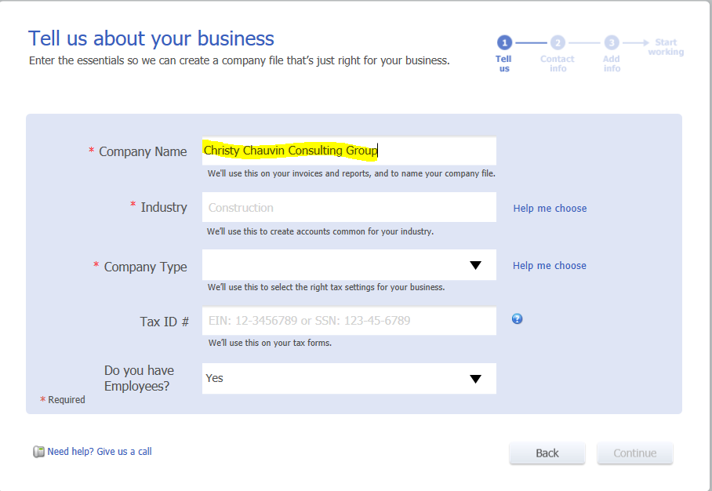

- Enter your Industry. Click Help Me Choose, scroll to the bottom of the list, and choose Other/None.
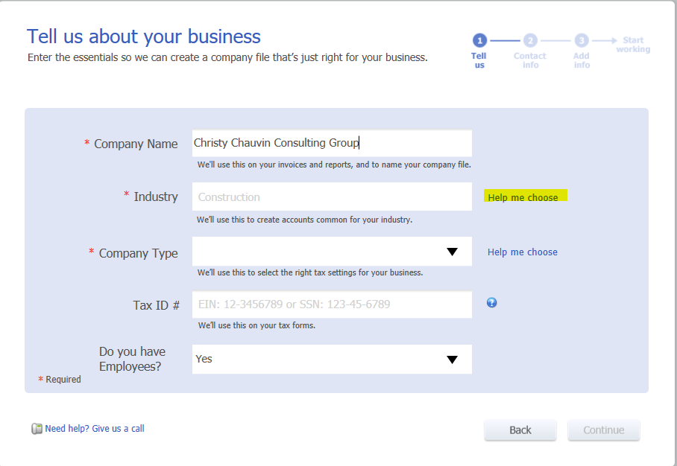
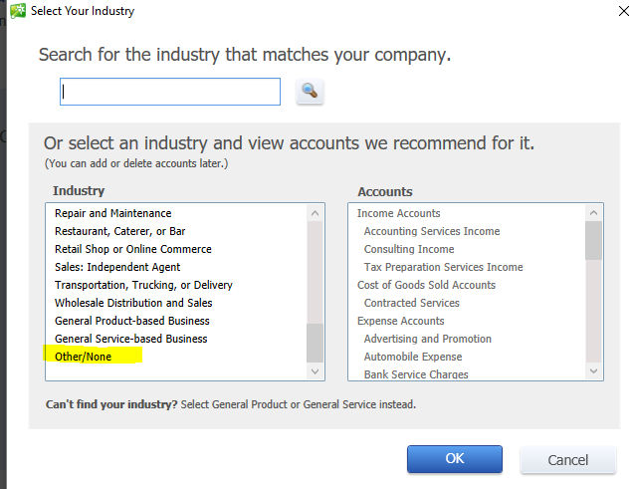

- Enter your Company Type as a Sole Proprietorship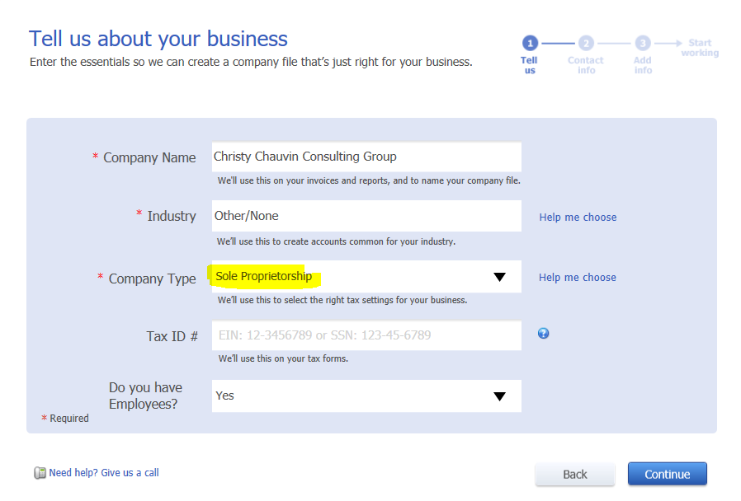
- Enter your Tax ID Number or Social Security Number – We will use 123-45-6789
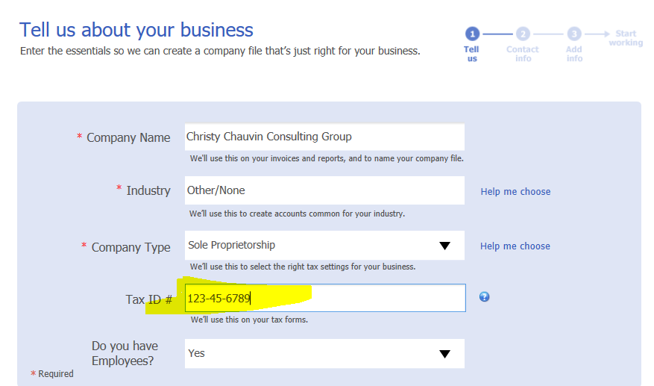
- Do you have any employees – Answer Yes
GRAB A SCREENSHOT as described below AND SAVE TO YOUR WORD DOCUMENT

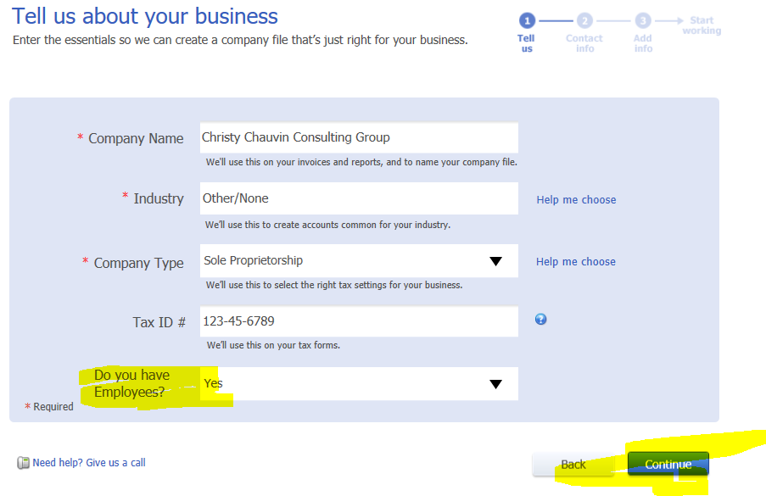
- Click Continue.

- Enter your business contact information. – Use your company name, add the following but put in your email address.
- Click Create Company File.
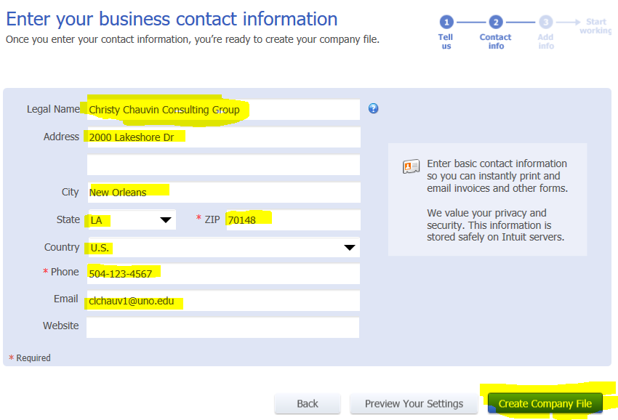
GRAB A SCREENSHOT AND SAVE TO YOUR WORD DOCUMENT

- The next step in the process of inputting a new company is to add the people you do business with – Watch the See how it works
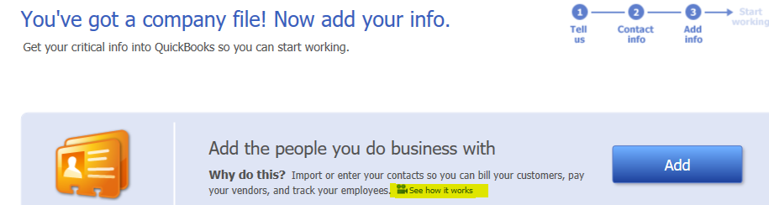
Add these people as people you do business with.
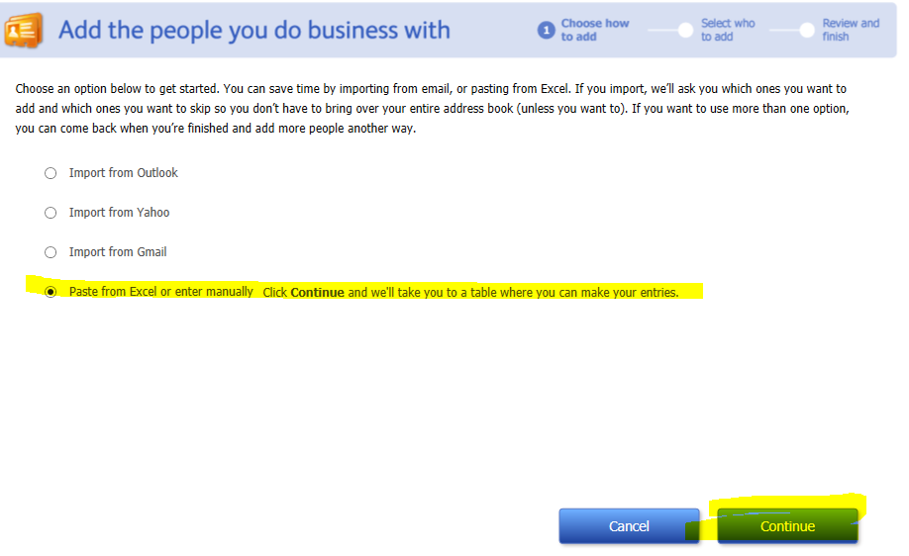

If you can’t read this, there is a file in Moodle where the information is easier to read. Look for QB Day 1 Project Inputs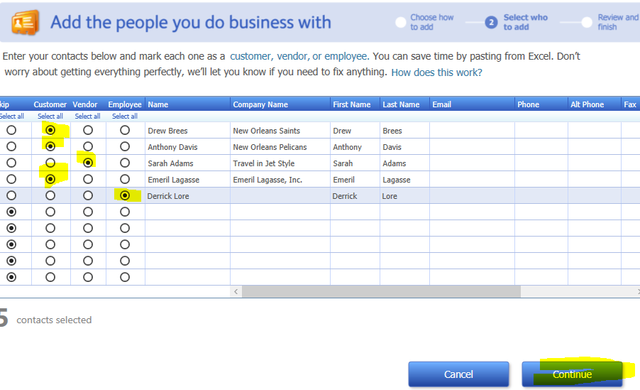
GRAB A SCREENSHOT AND SAVE TO YOUR WORD DOCUMENT

You will see this when you finish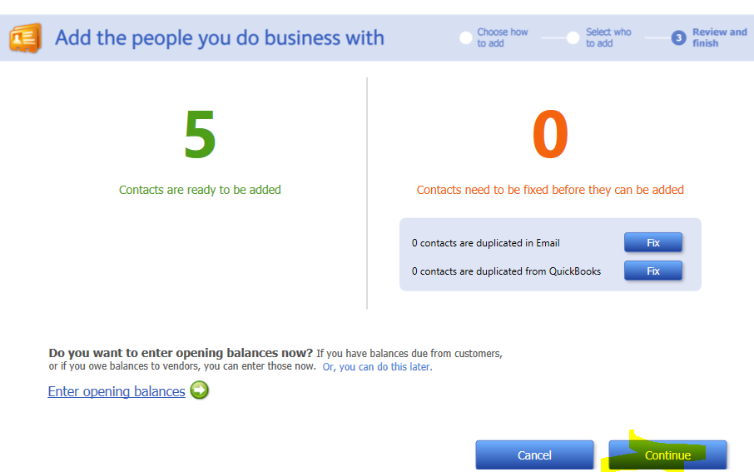

- Next, Add the products and services you sell – Watch See How it works
- Next click Add Services and Continue
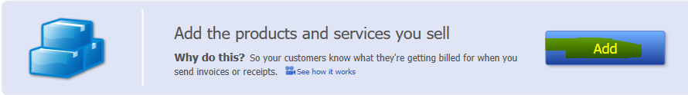
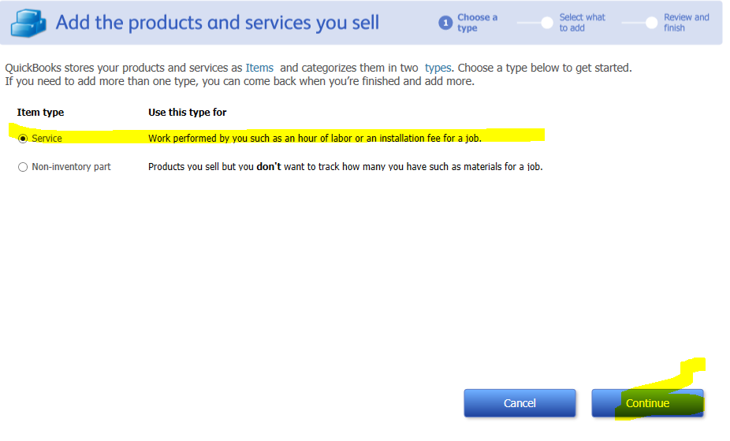

- Add these
If you can’t read this, there is a file in Moodle where the information is easier to read. Look for QB Day 1 Project Inputs
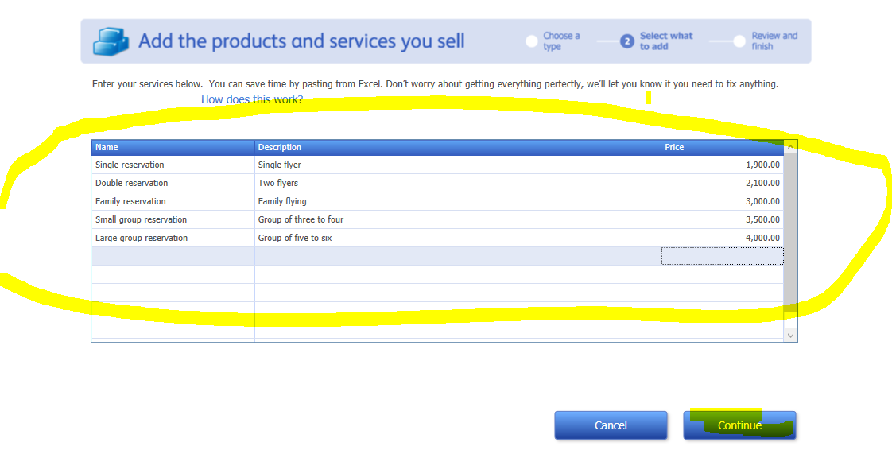
GRAB A SCREENSHOT AND SAVE TO YOUR WORD DOCUMENT
You will see this when you finish
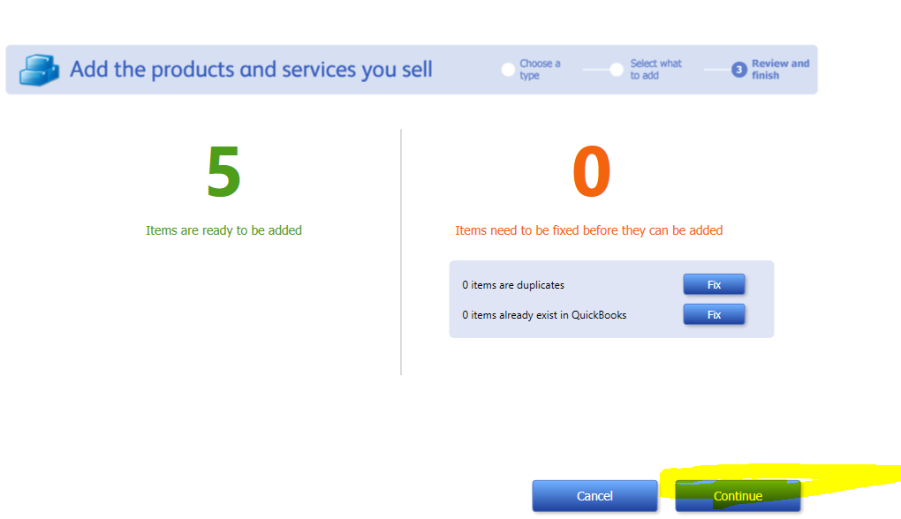

- Add Bank Account – Watch See how this works
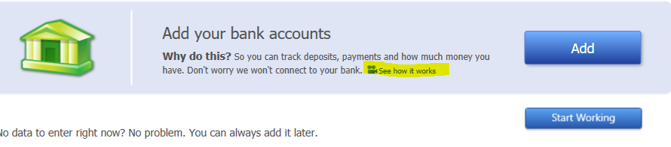
If you can’t read this, there is a file in Moodle where the information is easier to read. Look for QB Day 1 Project Inputs
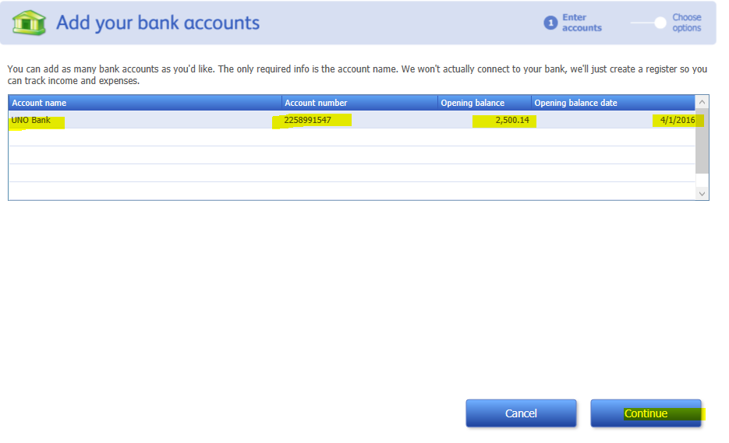
GRAB A SCREENSHOT AND SAVE TO YOUR WORD DOCUMENT

You will see this when you finish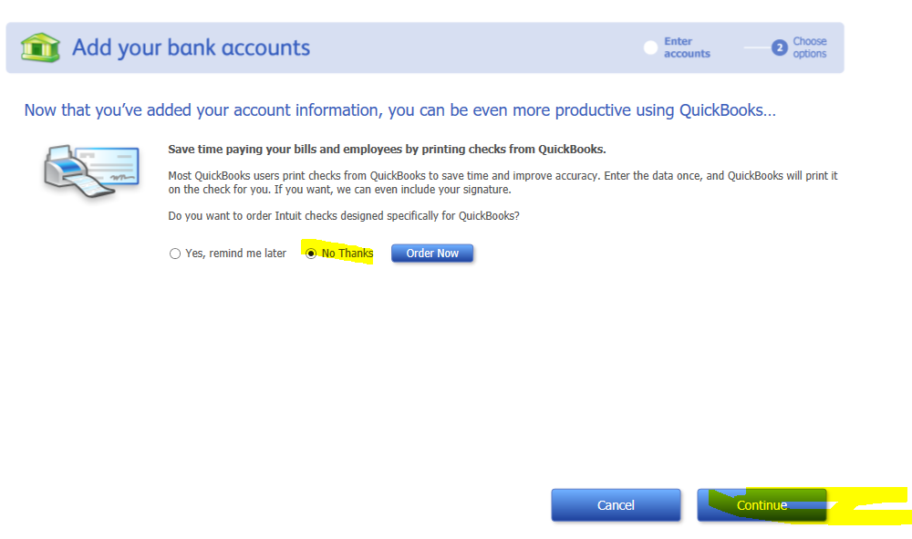
- Start Working.
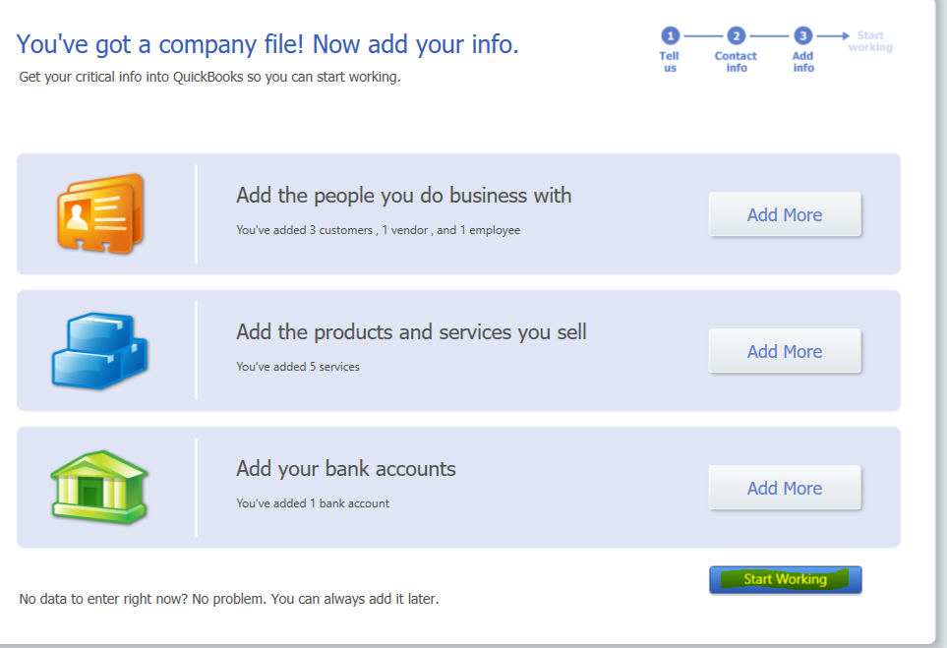

- Next, you will see the module view of Quickbooks. You can use modules or pull down menus – whatever your preference is
One note: Under modules, you can spheres of duties or segregation of duties between Vendors, Customers, Employees, Company and Banking. Duties are siloed to keep them separate.
If you can’t read this, there is a file in Moodle where the information is easier to read. Look for QB Day 1 Project Inputs

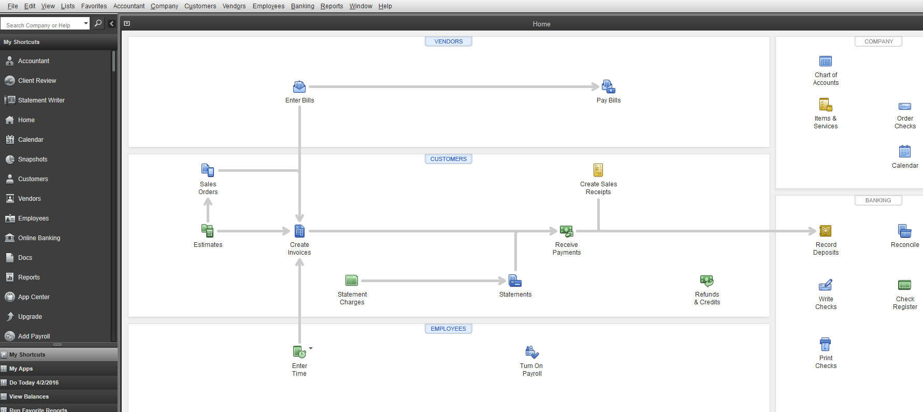
- Choose Lists > Chart of Accounts.
List view
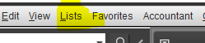
Or Module View
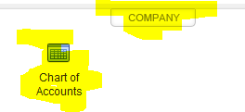

- Your Chart of Accounts will be populated.
  - If you will not use payroll, you can make the payroll accounts inactive.
  - You can delete the other accounts, but we strongly recommend that you do not.

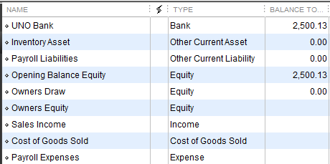
GRAB A SCREENSHOT AND SAVE TO YOUR WORD DOCUMENT

Next Project:
To move back to module view, use the pull down menu from the top under Window and select home
- Next, we want to bill a customer, Drew Brees, for a family flight to Florida. Go to the customer section of the modules and select create invoices
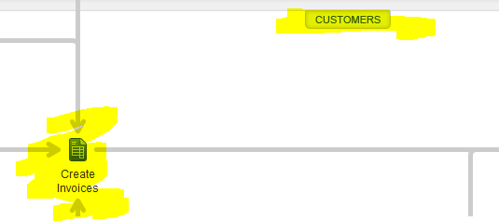

Switch to fixed fee invoice by using the template pull down menu
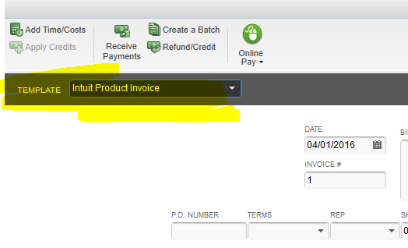
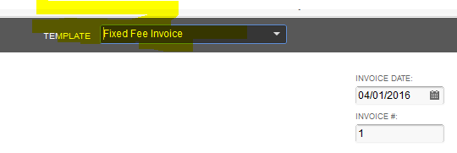
Next input the following highlighted areas. The pull down menu under item will populate with the commissions we charge—select from these and add to the descriptions.
If you can’t read this, there is a file in Moodle where the information is easier to read. Look for QB Day 1 Project Inputs

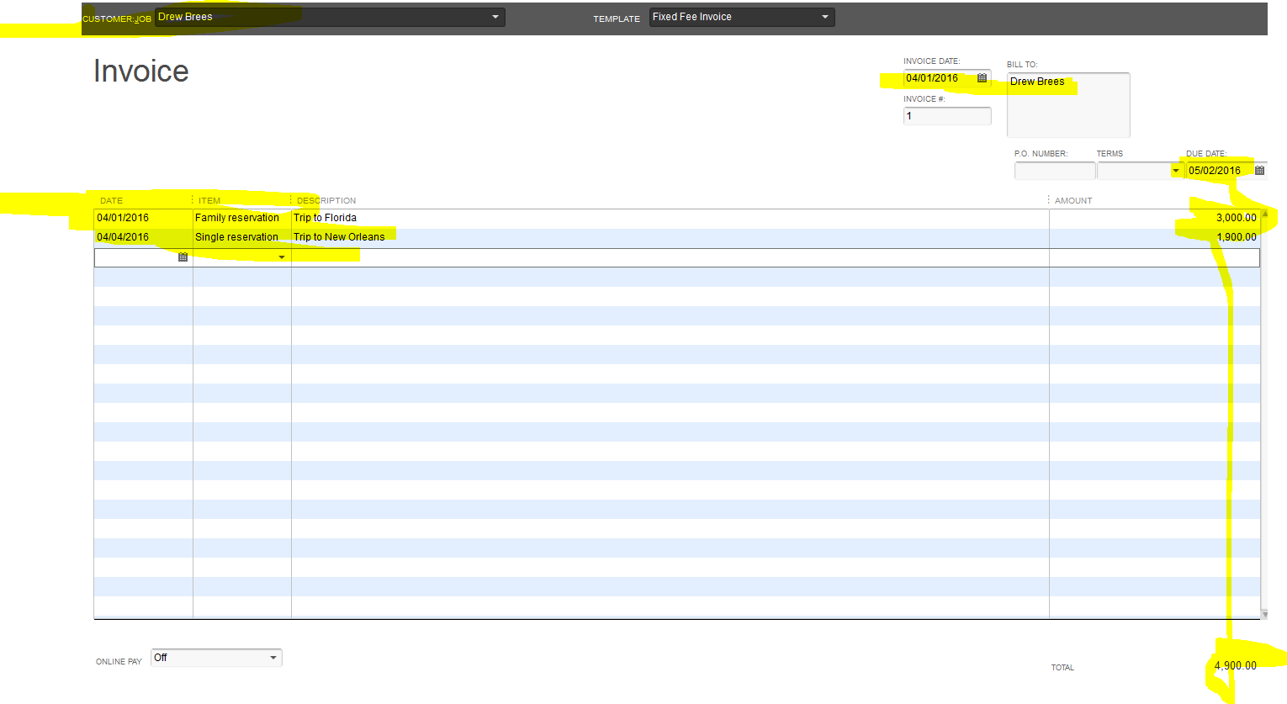

GRAB A SCREENSHOT AND SAVE TO YOUR WORD DOCUMENT

Next: Select Save&Close at the bottom of the invoice
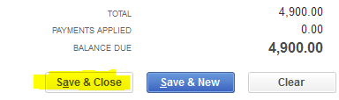
Next: Go to the top menu, select Reports, select Accountant and Taxes, Select Trial Balance
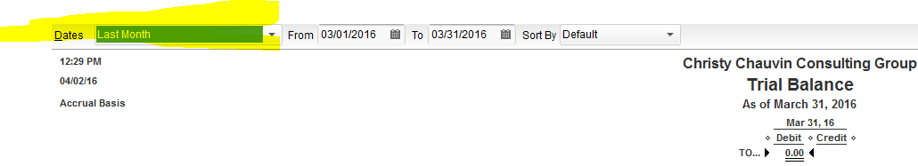
We will want to select this month to date instead of last month

GRAB A SCREENSHOT AND SAVE TO YOUR WORD DOCUMENT

We can see Quickbooks has recorded the journal entry for us.
Accounts Receivable 4,900
Sales 4,900

Next project – Receive payment
Using the Window pull down menu, go to home and select receive payments in the customer section
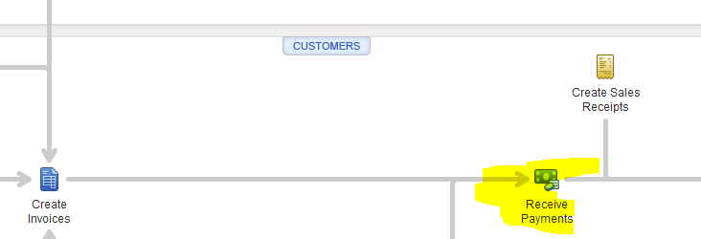

If you can’t read this, there is a file in Moodle where the information is easier to read. Look for QB Day 1 Project Inputs

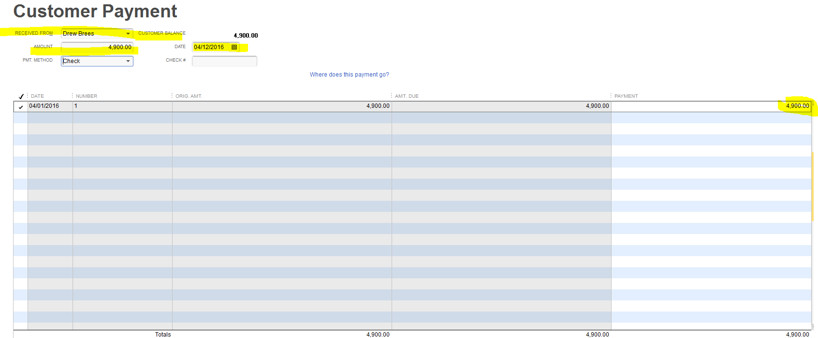

GRAB A SCREENSHOT AND SAVE TO YOUR WORD DOCUMENT
Save and close

Next: Go to the top menu, select Reports, select Accountant and Taxes, Select Trial Balance. Use a custom date this time to capture the April 12 payment. We can see Quickbooks is generating the journal entries.

GRAB A SCREENSHOT AND SAVE TO YOUR WORD DOCUMENT

Next Project: Record Payment
Go back to Home Module and under Banking, we will record the deposit. Why so many steps? Segregation of duties. One person may be responsible for payment receipt but that person may not be responsible for recording deposits.
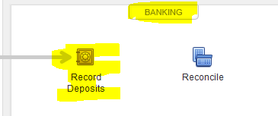

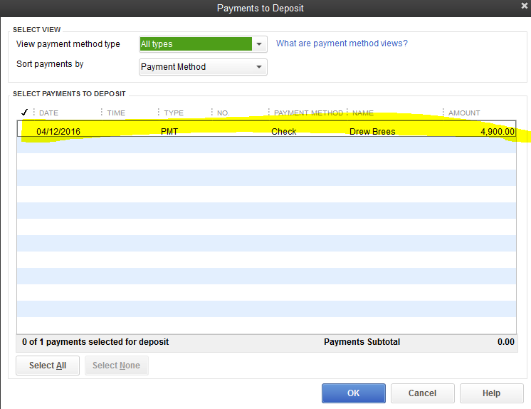
GRAB A SCREENSHOT AND SAVE TO YOUR WORD DOCUMENT

Save and close
Now run another trial balance and see the changes. Make sure to use the custom date
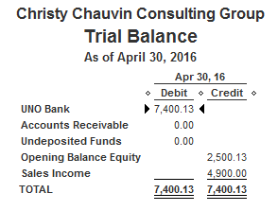
GRAB A SCREENSHOT AND SAVE TO YOUR WORD DOCUMENT

To Save:
- Select File in the top left hand corner
- Back up company
- Create local backup
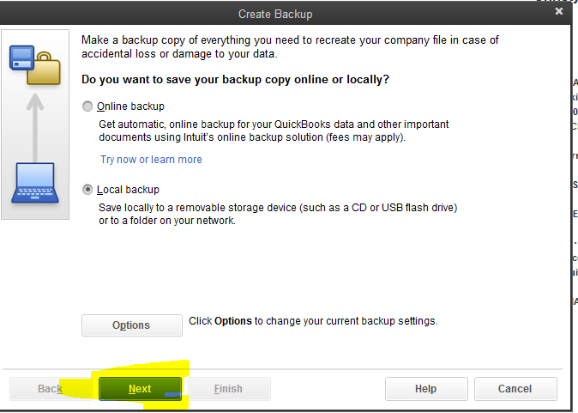

- Local back up has been selected for you.
- Click on Next
- The following screen will appear, under browse, select the drive to which you wish to save the back up (Should be your jump or portable drive)
- The recommended complete verification has been selected for you

- Click OK

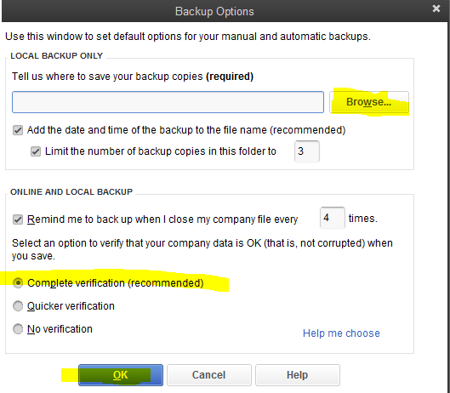

- You will see this message box and save it now has been selected for you, click next
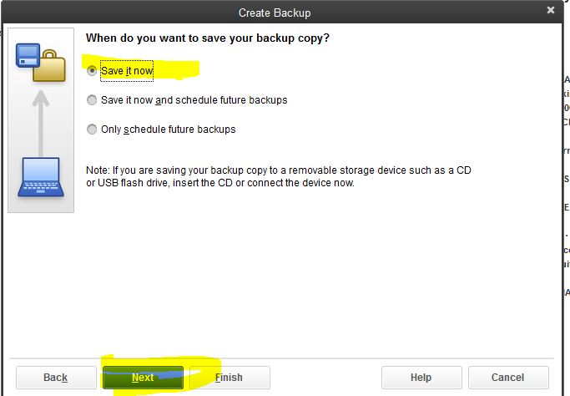

- You will see this message box, the software has named and dated your back up. Select save
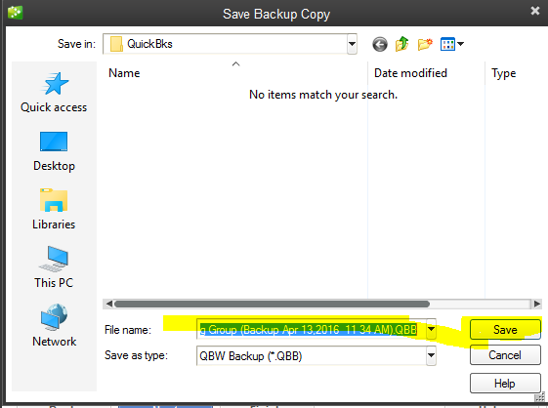

This is all for today.

