**Bingham Chapter 7**

**Recording Transactions Affecting the Enterprise Fund and Business-Type Activities**

Governmental funds owe their existence to legal constraints placed on the raising of revenues and the use of resources. In contrast to the governmental funds, proprietary funds rely primarily on exchange transactions, specifically charges for services, to generate revenues. As a result, proprietary funds follow accounting principles that are similar to those of investor-owned businesses.

Proprietary funds can be either an enterprise fund or an internal service fund. The focus on exchange transactions with parties outside of the government is the reason that the enterprise funds are reported in a separate Business-type Activities column at the government-wide level. In contrast, the exchange transactions recorded in internal service funds are primarily undertaken with other funds and departments within the government; hence internal service funds are typically reported as governmental activities at the government-wide level.

**Proprietary Funds**

Traditionally, the reason for the creation of proprietary funds was to improve the management of resources. As governments become more complex, efficiencies can be gained by combining or centralizing services that are commonly found in several departments or funds. Examples of common services or functions that are frequently centralized by governments include purchasing, information systems, insurance, and central motor pools. More recently, with increased citizen resistance to tax increases, many governmental entities also rely on user charges as a means of financing operations formerly financed by tax revenues and intergovernmental revenues. Thus, proprietary funds are now frequently used to account for activities formerly found in governmental funds.

Because proprietary funds operate on user charges, it is important to determine whether user charges are sufficient to cover operating costs. Additionally, administrators and governing bodies need information that will allow them to determine that the costs of operating the fund are reasonable in relation to the benefits provided by the fund. For these reasons, accounting and operating activities of proprietary funds are conducted in a business-like manner, focusing on the economic flow of resources using accrual accounting.

Internal service funds are used to account for the acquisition or production and the distribution of centralized goods and services that are provided to departments or agencies of the government, or to other governments, on a cost-reimbursement basis. Although internal service funds are accounted for internally as business-type activities, their transactions predominantly involve sales of goods and services, or other transactions with the General Fund and other governmental funds.

**Financial Reporting Requirements**

Accounting for proprietary funds is similar to an investor-owned business enterprises of the same type. An enterprise fund established to account for a government-owned electric utility, for example, should follow accounting principles similar to those of investor-owned electric utilities. Accordingly, proprietary funds focus on the flow of economic resources recognized on the accrual basis, both within the fund and at the government-wide level. Thus, these funds account for all capital assets used in their operations and for all long-term liabilities to be paid from the revenues generated from their operations, as well as for all current assets, current liabilities, and deferred inflows and outflows, if applicable.

Because proprietary funds follow business-type accounting principles, these funds prepare essentially the same financial statements that businesses do: a balance sheet (os statement of net position); a statement of revenues, expenses, and changes in fund net position (equivalent to an income statement); and a statement of cash flows. These statements are prepared per GASB standards, which differ in some respects from the statements identified by FASB for business organizations.

**Statement of Net Position**

For proprietary funds, governments generally present a statement of net position in a format that displays assets, plus deferred outflows of resources, less liabilities, less deferred inflows of resources, equals net position.

Similar to profit-seeking businesses, the statement of net position (or a traditional balance sheet) for proprietary funds is classified; that is, current assets are shown separately from capital assets and other assets, and current liabilities are shown separately from long-term debt. Additionally, current assets are listed in the order of liquidity.

If applicable, deferred outflows of resources should be reported in a separate section following assets and deferred inflows of resources should be reported in a separate section following liabilities.

Unlike businesses, there is no owners’ or stockholders’ equity section on the statement of net position. Instead, GASB standards require the reporting of net position, which is divided into three components: **net investment in capital assets**; **restricted** (distinguishing among major categories of restrictions); and **unrestricted**.

**Net investment in capital assets is calculated as the total of gross capital assets, net of accumulated depreciation, less any outstanding debt related to the acquisition or construction of capital assets.**

Restricted net position represents net resources with restrictions on use imposed by law or external parties. For example, if a bond is issued for construction of a capital asset, but is unspent at year-end, the proceeds from the bond would be considered restricted net position.

Unrestricted net position represents the residual amount of net position after separately identifying net investment in capital assets and restricted net position.

**Statement of Revenues, Expenses, and Changes in Fund Net Position**

The period results of operations for a proprietary fund should be reported in a statement of revenues, expenses, and changes in fund net position, which is similar to the income statement of a profit-seeking business.

GASB standards state that revenues are to be reported by major revenue source, with revenues used as security for revenue bonds identified.

Unlike FASB standards, GASB standards also indicate that revenues should be shown net of any discounts or allowances. For example, rather than reporting bad debt expense, proprietary funds would record and report a contra-revenue account, such as Provision for Bad Debts or Uncollectible Accounts, which would be netted against the Revenues account in the financial report.

In the statement of revenues, expenses, and changes in fund net position, revenues and expenses are to be identified as operating or non-operating, with subtotals for operating revenues, operating expenses, and operating income.

Operating revenues and expenses are those related to the primary functions of the proprietary fund. Management judgment is necessary when defining which revenues and expenses are primary to the operations of the fund.

The distinction between operating and non-operating revenues and expenses is important for achieving effective management control, as well as for complying with GASB requirements. If inter-fund transfers, special items, extraordinary items, or capital contributions are also reported in the statement of revenues, expenses, and changes in fund net position they appear after the Nonoperating Revenues/Expenses section.

**Statement of Cash Flows**

GASB financial reporting standards require the preparation of a statement of cash flows as a part of the full set of financial statements for all proprietary funds.

Unlike FASB, GASB requires the statement to be prepared using the direct method of presentation.

Categories of cash flows provided by FASB ASC 230 were deemed insufficient to meet the needs of users of governmental financial reports. Consequently, GASB standards provide four categories of cash flows: operating, noncapital financing, capital and related financing, and investing.

**Budgetary Comparison Schedule**

Unlike the General Fund and other major governmental funds for which a budget is legally adopted, proprietary funds are not required by GASB standards to record budgets in their accounting systems, nor are they required to present a budgetary comparison schedule.

**INTERNAL SERVICE FUNDS**

Internal service funds are established to improve financial management of governmental resources; yet, it is important to remember that establishment of a fund is ordinarily subject to legislative approval. The ordinance or other legislative action that authorizes the establishment of an internal service fund should also specify the source or sources of financial resources to be used for fund operations.

For example, to start up an internal service fund, the General Fund or an enterprise fund may contribute assets to the fund, or the internal service fund may receive the assets in the form of a long-term inter-fund loan to be repaid over a number of years. Alternatively, the resources initially allocated to an internal service fund may be acquired from the proceeds of a tax-supported bond issue or by transfer from other governments that anticipate utilizing the services to be rendered by the internal service fund. Since internal service funds are established to improve the management of resources, it is generally considered that their accounting and operations should be maintained on a business basis.

Managers of internal service funds must prepare operating plans—budgets—as a management tool. The budgets of internal service funds are submitted to the legislative body and to the public for information but not for legal action. **Therefore, the budget is not formally recorded in internal service fund accounts.** Similarly, managers of businesses must be kept informed of the status of outstanding purchase orders and contracts, but encumbrances need not be recorded in the accounts to accomplish this.

The internal service fund is generally reported as a part of the Governmental Activities column of the government-wide financial statements. To ensure that double counting of revenues, expenses, and other transactions does not occur, GASB standards require the elimination of the effect of transactions between governmental funds and internal service funds. Those activities involving a transaction between a governmental fund and an internal service fund are not recorded for governmental activities at the government-wide level.

**Special Topics Associated with Internal Service Funds**

**Administrative Issues**

The accounting and operating of a fund on a business basis can lead to conflict between managers, who want the freedom to operate the fund like a business, and legislators, who wish to exercise considerable control over funds.

The customers of an internal service fund are, by definition, other funds and departments of the government or of other governments. Therefore, each using fund and department must include in its appropriations budget request the justification for the amount to be spent (i.e., paid to the internal service fund) for supplies, so the legislative branch continues to exercise budgetary review over the amount each fund and department budgets for supplies. Departments and programs that require legislative appropriations to expend resources for goods and services should account for purchases of goods or services from internal suppliers (i.e., internal service funds or enterprise funds) in essentially the same manner as goods and services purchased from external suppliers. By setting pricing policies for the internal service fund and policies governing the use and retention of current earnings, the legislature can maintain considerable control over the function performed by the internal service fund but leave the fund managers freedom to operate at their discretion within the policies set by the legislative branch.

One of the more difficult problems to resolve to the satisfaction of persons with opposing views is the establishment of a pricing policy. “Cost” is obviously an incomplete answer: Historical cost of the supplies, whether defined as first-in, first-out; last-in, first-out; average; or specific identification, will not provide sufficient revenue to replace supplies issued if replacement prices have risen since the last purchase. Nor will it allow for an increase in the inventory quantities if the scale of governmental operations is growing. Pricing should cover full costs, plus an additional charge for capital maintenance and anticipated expansion needs.

Payroll and other cash operating expenses of the internal service fund must be met; if the internal service fund has received a loan from another fund or another government, prices must be set at a level that will generate cash needed for debt retirement. If the internal service fund is to be operated on a true business basis, it must also be able to finance from its operations the replacement, modernization, and expansion of plant and equipment used in fund operations.

Prices charged by the internal service fund, however, should be less than the using funds and departments would have to pay outside vendors for equivalent products and services if the existence and continued operation of the internal service fund is to be justified. Because of the considerations mentioned in this section, many different approaches to internal service fund operations are found in practice.

**Internal Service Funds with Manufacturing Activities**

Many states and local governments funds and departments have printing shops, asphalt plants, and other service units that produce a physical product or that facilitate the operations of the other funds and departments by performing maintenance or repair jobs or even performing a temporary financing function.

If an internal service fund performs a continuous process manufacturing operation, its accounting system should provide process cost accounts. If a service fund performs a manufacturing, maintenance, or repair operation on a job-order basis, the fund's accounting system should provide appropriate job-order cost accounts. To the extent that operations, processes, or activities are capable of being standardized, cost standards for materials, direct labor, and overhead should be established; in such cases, the accounting system should provide for the routine measurement and reporting of significant variances from the standards.

**ENTERPRISE FUNDS**

Enterprise funds and internal service funds are both classified by the GASB as proprietary funds, although **enterprise funds are used by governments to account for services provided to the general public on a user charge basis**. Under GASB standards, a government must report certain activities in an enterprise fund if any of the following criteria are met.

1. The activity is financed with debt that is secured solely by a pledge of the revenues from fees and charges of an activity.
2. Laws or regulations require that the activity's costs of providing services, including capital costs (such as depreciation or debt service), be recovered with fees and charges, rather than with taxes or similar revenues.
3. Pricing policies are designed to recover the costs of the activity, including capital costs.

These criteria are quite specific regarding when an enterprise fund must be used. If governments support the activities primarily with general or special revenue sources rather than user charges, accounting for the activities is more appropriate in the General Fund or a special revenue fund. Consequently, it need not be reported as an enterprise fund.

Because the word enterprise is often used as a synonym for “business-type activity,” it is logical that enterprise funds should use accrual accounting and account for all assets used in the production of goods or services offered by the fund. Similarly, if long-term debt is to be serviced by the fund, the fund does the accounting for the debt. So, any interest and principal on an enterprise fund revenue bond would be recorded within the records of the fund, and any premiums or discounts on bonds payable would be accounted for in the same manner as a comparable business entity.

It follows that enterprise funds are generally reported as part of the Business-type Activities column of the government-wide financial statements.

The most common examples of governmental enterprises are public utilities, notably water and sewer utilities. Electric and gas utilities, transportation systems, airports, ports, hospitals, toll bridges, produce markets, parking lots, parking garages, and public housing projects are other examples frequently found. Because services of the types mentioned are intended to be largely self-supporting, they are generally accounted for by enterprise funds.

Almost every type of enterprise operated by a government has its counterpart in the private sector. In order to take advantage of the work done by regulatory agencies and trade associations to develop useful accounting information systems for the investor-owned enterprises, it is recommended that governmentally owned enterprises use the accounting structures developed for investor-owned enterprises of the same nature.

Budgetary accounts should be used only if required by law. The accounting for debt service and construction activities of a governmental enterprise occurs within the enterprise fund rather than by separate debt service and capital projects funds. Thus, the financial statements of enterprise funds are self-contained, and creditors, legislators, or the general public can evaluate the performance of a governmental enterprise on the same bases as they can the performance of investor-owned enterprises in the same industry.

By far the most numerous and important enterprise services rendered by local governments are public utilities.

The city water utility is owned and operated by the City of Bingham. The water utility was originally constructed and operated by a private corporation, but it was sold to the city 30 years before the year for which transactions are given. The post-closing trial balance of the Water Utility Fund, as of December 31, 2016, follows:

**CITY OF BINGHAM**

**Water Utility Fund**

**Trial Balance**

**As of December 31, 2016**

Debits Credits

Cash $ 513,395

Restricted Cash—Customer Deposits 62,920

Customer Accounts Receivable 176,484

Accumulated Provision for

Uncollectible Accounts $ 5,192

Inventory of Supplies 103,560

Due from Other Funds 14,300

Utility Plant in Service 20,900,429

Accumulated Depreciation—

Utility Plant 4,612,406

Construction Work in Progress 1,308,340

Vouchers Payable 81,662

Customer Deposits 62,920

Accrued Interest Payable 477,510

Revenue Bonds Payable 15,917,000

Unamortized Bond Discounts

on Revenue Bonds Payable 71,720

Net Position—Net Investment in Capital

Assets 1,751,083

Net Position—Unrestricted 243,375

Totals $23,151,148 $23,151,148

Additional information:

Accrued Interest Payable represents six months’ accrual of interest on 6% revenue bonds payable. Interest is payable semiannually on January 1 and July 1 of each year. Unamortized Bond Discount is credited on January 1 and July 1 for the amortization applicable to the interest payment period. Amortization is computed by the straight-line method. The balance of $71,720 is to be amortized over the remaining 20 years of the bond maturity.

Customers place deposits on their accounts. Restricted Cash – Customer Deposits represents the amounts paid, and **Customer Deposits reflects the liability of the fund associated with these payments.** Refunds to customers discontinuing services are made out of these deposits and requires reducing the liability and the restricted cash. If the deposit is used to pay the final bill of a discontinuing customer, the liability would be decreased as well as the customer receivable. Additionally, the amounts are reclassed from cash for restricted customer deposits to cash.

**Note: No transactions will be recorded in the Govt Wide general journal.**

#### Required

1. Record the beginning balances. Open a general journal as of December 31, 2016 for the Water Utility Fund by entering each of the accounts and amounts shown in the above post-closing trial balance. Enter **2016** and use **Beginning Balance** as the **[Transaction Description]** and enter the appropriate paragraph number for all subsequent journal entries. Verify the accuracy of your journal entry and post it to the general ledger by clicking **[Post Entries].**

Entries in this enterprise fund do not have to be recorded at the government-wide level since enterprise funds and business-type activities at the government-wide level both use the same (accrual) basis of accounting and same (economic resources) measurement focus. Thus, the same information recorded in the accounts of the enterprise fund can also, with only slight modification, be reported as business-type activities at the government-wide level.

**Note: GASB does not require a budget for an enterprise fund.**

**b.** Record the following events and transactions, which occurred during the year ended December 31, 2017. Be sure to record as **2017**.

1. **[Para. 7-b-1]** Bond interest due on January 1, 2017 was paid to holders of the revenue bonds.

This transaction affects cash as well as Accrued Interest Payable for six months’ accrual of interest on 6% revenue bonds payable. Refer to the beginning balance for the amount.



2. **[Para. 7-b-2]** Billings to customers for water service for the year totaled $3,076,500. Billings to the City of Bingham General Fund for water service totaled $50,000.

The customer billings are receivables. Due from Other Funds represents the inter-governmental portion of this transaction. This is an enterprise fund with sales.



3. **[Para. 7-b-3]** Collections from customers totaled $2,996,100; $14,300 was also received from the city’s General Fund.



4. **[Para. 7-b-4]** A $625,000 contract was signed for a construction project expected to cost

$970,000. Water utility employees will complete $345,000 of the project.

Note: An enterprise fund does not use encumbrance accounting. Will these facts give rise to an entry?

5. **[Para. 7-b-5]** Materials and supplies were ordered and received during the period in the amount of $610,500. The invoices agreed with the purchase orders and receiving reports and were recorded as vouchers payable. A perpetual inventory system is used for all materials and supplies; and thus, the account, Inventory of Supplies, is affected by this transaction. (Eventually, these supplies will be distributed/reclassed to various departments within the utility).



6. **[Para. 7-b-6]** Payrolls were paid totaling $685,250 for operations; $155,400 for maintenance; and $170,500 for construction. These are expenses for operations and maintenance. Construction costs would be recorded as construction work in progress.

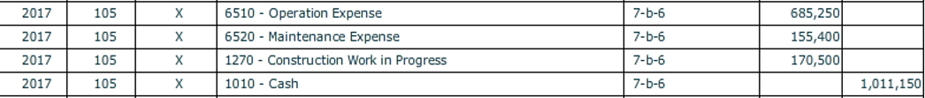

7. **[Para. 7-b-7]** Materials and supplies issued during the period amounted to $255,000 for operations; $132,000 for maintenance; and $166,000 for construction. Same as above as the explanation for these expenses but the materials and supplies were previously paid for and recorded in the Inventory of Supplies account. (This is essentially a reclassification entry).

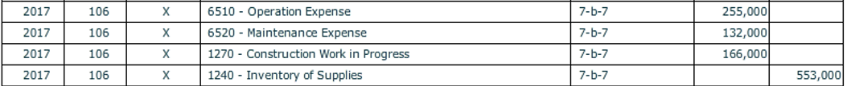

8. **[Para. 7-b-8]** Bond interest due on July 1, 2017 was paid. (Bond interest is paid in equal amounts for each payment). As part of the journal entry, 1/40th of the Unamortized Bond **Discount** on Revenue Bonds Payable (beginning balance) should be amortized.



9. **[Para. 7-b-9]** Interest on long-term debt of $32,000 that was recorded as an expense was determined to have been incurred during construction and should be charged to Construction Work in Progress. This is a correcting journal entry. An enterprise fund capitalizes interest as construction work in progress.



10. **[Para. 7-b-10]** A progress billing for $385,000 was received from the construction contractor and paid.



11. **[Para. 7-b-11]** Some assets under construction at the start of the year and some started during the year were completed and placed in service. The costs incurred on this construction totaled $1,102,750. This is a reclassification from construction work in progress to utility plant in service.



12. **[Para. 7-b-12]** Collection efforts were discontinued on bills amounting to $5,150; the customers owing the bills had paid deposits and interest to the water utility in the amount of $1,450. (Note: Cash recorded as restricted for customer deposits can now be considered unrestricted and reclassified to cash.) Why is the accumulated provision for uncollectible accounts being debited?



13. **[Para. 7-b-13]** Customer deposits and interest thereon amounting to $2,500 were applied to the final bills of customers discontinuing service. Record this as a reduction of accounts receivable and a relief of the liability for customer deposits.

Also, record the reclassification from restricted cash for customer deposits to cash.

Additional deposits and interest amounting to $2,950 were refunded by check to customers discontinuing service. This transaction relieves the amount due to customers for deposits and is paid out of restricted cash for customer deposits.

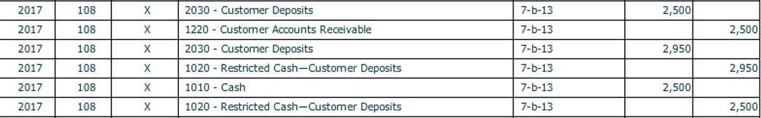

14. **[Para. 7-b-14]** Deposits totaling $7,304 were received from new customers. (Cash is restricted). Record the liability.



15. **[Para. 7-b-15]** Vouchers Payable paid during the year amounted to $343,600 for operating supplies and $166,000 for materials used in construction, or $509,600 in total. Decrease the vouchers payable liability and record the payment.



16. **[Para. 7-b-16]** Interest paid on customer deposits amounted to $2,154 (charge Operation Expense for the interest). This interest will increase the liability the utility has for customer deposits. What account will be affected? The restricted cash for customer deposits will be affected as well as cash for this payment. Which should be debited and which should be credited.

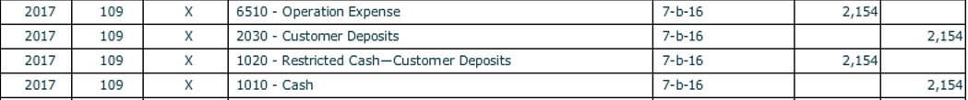

17. **Adjusting entries**

**[Para. 7-b-17a]** Depreciation on utility plant was calculated using a straight-line rate of 2 percent of the beginning gross balance. The amount so calculated yields $418,009 in depreciation.



**[Para. 7-b-17b]** The **Accumulated Provision for Uncollectible Accounts** should equal $5,820 at year-end. Make the adjusting journal entry and debit Uncollectible Accounts (essentially bad debts expense for the utility).



**[Para. 7-b-17c]** An adjusting entry for accrual of six months’ interest on bonds payable and amortization of 1/40 of the debt discount using the straight-line basis was recorded.



The payable should equal the prior year’s amount since interest is paid in equal amounts.

1. **Closing Entries:**

Be sure that the check mark for **[Closing Entry]** is on for each account being closed and that “Closing Entry” appears in the **[Transaction Description]** box.

Run a pre-closing trial balance and use it to close the books. Prepare entries to close all operating statement accounts (Sales and Expenses) at the end of 2017 as you would for a for profit entity. Any “profit” or “loss” will be recorded in Net Position – Unrestricted.

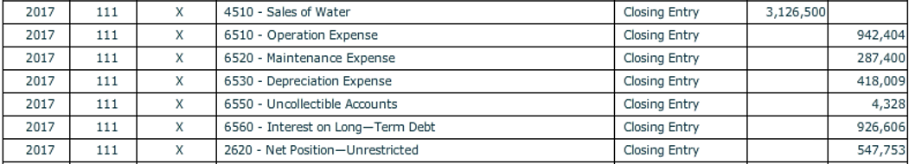

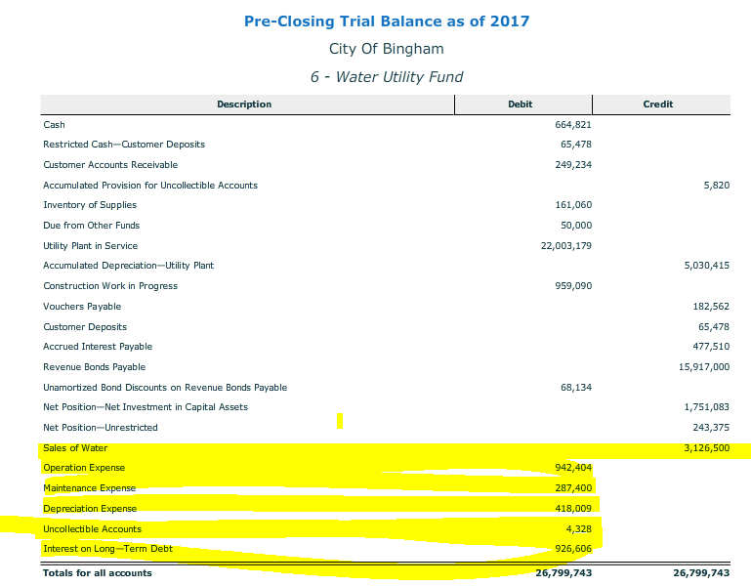

1. Prepare entries to reclassify the two net position accounts, as appropriate.

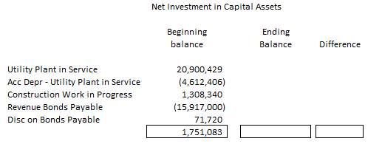

Calculate what the balance should be in the Net Investments in Capital Assets now. To do this, run the post closing trial balance as it is now. The difference between the beginning balance and the newly calculated balance will be the closing journal entry amount. The entry will reclassify the amount between the two net position accounts.

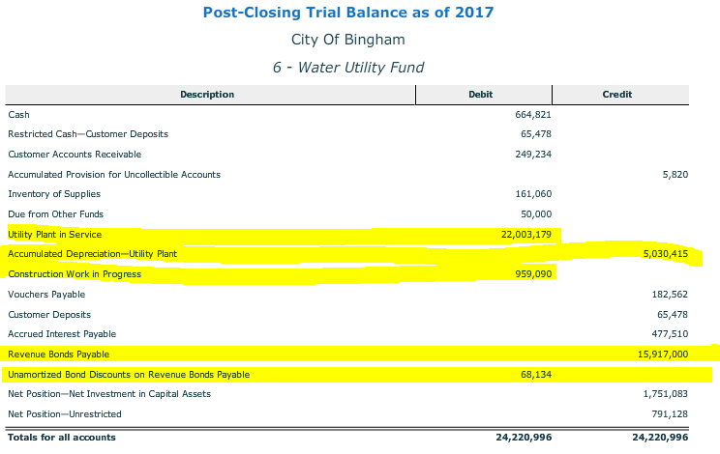

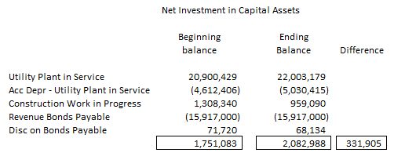



1. **Refer to Document listing to show your work**