Chapter 9 – Reporting Results

Chapters 1 and 2 provided overviews of Governmental Accounting Standards Board (GASB) financial reporting requirements, and financial reporting requirements for specific fund types. Chapters 2 through 8 present extended discussions of the principles of accounting for governmental, proprietary, and fiduciary funds and governmental and business-type activities at the government-wide level. Prior to examining reporting requirements, a brief conceptual discussion of financial reporting is provided.

GASB Concepts Statement 1 identifies two objectives of government financial reports: to provide information that can be used to assess a government's accountability and to assist users in making economic, social, and political decisions. But the primary objective of financial reports is to provide information useful in determining the accountability of the government.

The primary users of government financial reports are those external to government; principally, citizens, legislative and oversight bodies, and creditors. For the financial reports to be useful in meeting identified objectives, the GASB indicates that the information provided in the reports should be understandable, reliable, relevant, timely, consistent, and comparable.

An important part of providing useful information is communicating the information in a manner that is helpful to the user.

The areas identified for communicating items of information are recognition in the financial statements, disclosures in the notes to the financial statements, presentation as required supplementary information, or presentation as supplementary information. The GASB indicates that an item of information that meets the definition of an element and is measurable with sufficient reliability should be recognized in the financial statements. A note should be used if it can help support an item recognized in a financial statement or provide information that is essential to the user's understanding of the item. An example of the relationship between recognized items and notes can be conveyed with the Investments account. Without a note disclosure relating information on fair values and risk exposure, the user is left without information that is relevant in assessing the quality and management of the government's investments.

Required supplementary information (RSI) and supplementary information are used to communicate information that is essential and useful, respectively. Without RSI the financial statements and related notes cannot be placed in the correct context. An examples of RSI includes the budget to actual schedules. Other supplementary information is useful but not essential in understanding the financial statements and related notes. Much of the supplementary information is found in the statistical section of the comprehensive annual financial report (CAFR).

As indicated, before an item can be recognized in the financial statements it must meet the definition of an element. GASB Concept Statement 4 identifies the seven financial statement elements. The elements are assets, liabilities, deferred outflows of resources, deferred inflows of resources, net position, outflows of resources, and inflows of resources. Since governments use two bases of accounting, the GASB defines the elements in terms that will allow for recognition under both modified accrual and accrual accounting. For example, an outflow of resources can mean an expenditure or an expense.

THE GOVERNMENTAL REPORTING ENTITY

The average citizen—including accountants whose only experience has been with business organizations—has only a vague knowledge and little understanding of the overlapping layers of general purpose and special purpose governments that have some jurisdiction over us wherever we may live and work.

Different levels of general purpose governments can levy taxes on property, including special districts, which in many instances they were created as a means to finance the services demanded by residents of a general purpose government. The services demanded could not be financed by the general purpose government because of constitutional or statutory limits on the rates or amounts the general purpose government could raise from taxes, other revenue sources, and debt. Building authorities are examples of special districts created to finance general purpose government projects.

In addition to independent special districts, certain governmental activities are commonly carried out by commissions, boards, and other agencies that are not considered as independent of a general purpose government by the Bureau of the Census but that may have some degree of fiscal and administrative independence from the governing board of the general purpose government. In past years, some governments included in their annual reports the financial statements of such semi-independent boards and commissions and even certain of the special districts, whereas other governments excluded them.

To improve uniformity in reporting and to promote the preparation of financial reports consistent with GASB Concepts Statement 1, the GASB Codification provides authoritative guidance on defining the reporting entity, and guidance on reporting entity and component unit presentations and disclosure. The GASB Codification also provides guidance for reporting certain affiliated organizations, such as fund-raising foundations. These sections provide the basis for the following discussion.

Defining the Financial Reporting Entity

Elected officials of state and local governments (primary governments) are accountable to their constituents. That accountability extends not only to the financial performance of the primary government, but also to any organizations that are financially dependent on the primary government or over which the primary government can impose its will. Thus, GASB takes the position that governmental financial reporting should report on all governments and organizations for which elected officials are accountable. Collectively, these governments and organizations are referred to as the financial reporting entity. Before proceeding further with the explanation of a financial reporting entity, it is important to more formally define the terms primary government and financial reporting entity.

As defined by the GASB, a primary government is a state government or general purpose local government. It can also be a special purpose government that has a separately elected governing body, is legally separate, and is fiscally independent of other state or local governments. A legally separate organization has an identity of its own as an “artificial person” with a personality and existence distinct from that of its creator and others. A fiscally independent organization has the authority to determine its budget, levy its own taxes, set rates or charges, and issue bonded debt without approval of another government.

The GASB defines a financial reporting entity as the primary government and organizations for which the primary government is financially accountable. A primary government may also need to include an organization that does not meet the financial accountability criteria in order to prevent the financial statements from being misleading. Such an organization should be included as a component unit.

As seen in the preceding definition, a primary government is generally the basis for the financial reporting entity. However, other types of governments can also be the basis for a financial reporting entity if they issue separate financial statements. Examples of other types of governments that may serve as their own reporting entity are component units, government joint ventures, jointly governed organizations, or other stand-alone governments.

A primary government is financially accountable for another organization if the primary government appoints a voting majority of the organization's governing board and it is (a) able to impose its will on the organization or (b) there is a potential for the organization to provide specific financial benefits to, or impose specific financial burdens on, the primary government.

The ability of the primary government to impose its will on an organization exists if the primary government can significantly influence the programs, projects, or activities of, or the level of services performed or provided by, the organization. Examples of activities that indicate significant influence is being exerted could include removing an organization's board members at will, modifying or approving an organization's budget or fee structures, overruling or modifying decisions made by an organization's governing body, and the hiring/dismissing of an organization's management. A financial benefit or burden relationship exists if the primary government (a) is entitled to the organization's resources; (b) is legally obligated or otherwise assumes the obligation to finance the deficits of, or provide financial support to, the organization; or (c) is obligated in some manner for the debt of the organization.

The primary government is also financially accountable for another organization if the organization is fiscally dependent on the primary government. A fiscally dependent organization is one that provides specific financial benefits to, or imposes specific financial burdens on, the primary government. Under these circumstances the primary government is considered financially accountable regardless of whether the organization has a separately elected governing board, a governing board appointed by another level of government, or a jointly appointed board.

Component Units

Component units are included as part of the reporting entity. A component unit is defined as a legally separate organization for which the elected officials of the primary government are financially accountable. A component unit can also be another organization for which the nature and significance of its relationship with the primary government is so important that excluding it from the reporting entity's financial statements would make the statements misleading. Examples of component units include not-for-profit organizations, for-profit firms, or a non-primary government. Because the reporting entity must include the component unit's financial information in its financial statements, the GASB has provided that the information can be included by blending the information or discretely presenting the information.

GOVERNMENTAL FINANCIAL REPORTS

Need for Periodic Reports

GASB requires that annual financial reports be prepared at a minimum.

Individuals concerned with the day-to-day operations and activities of governmental funds should be familiar with much of the data processed by the accounting information system because it results from the events and transactions with which they are involved. However, it is easy for these individuals to become overconfident of their understanding of the data with which they are daily involved. Past events are not always as remembered, and the relative significance of events changes over time. Similarly, administrators at succeedingly higher levels in the organization may feel that participation in decision making and observation of the apparent results of past decisions make it unnecessary to conduct periodic analysis of accounting and statistical reports prepared objectively and with neutrality. The memory and perceptions of administrators at higher levels are also subject to failure. Therefore, it is generally agreed that it is useful for financial reports to be prepared and distributed at intervals throughout a fiscal period as well as at period-end.

Interim Financial Reports

Government administrators have the greatest need for interim financial reports, although members of the legislative branch of the government (particularly those on its finance committee) may also find interim reports useful. Although the particular statements and schedules that should be prepared on an interim basis are a matter of local management preference, the authors believe the following interim schedules provide the minimum useful information for budgetary and cash management purposes.

- Schedule of actual and budgeted revenue (for the General Fund and special revenue funds and other funds for which budgets have been legally adopted).

- Schedule of actual and budgeted expenditures (for the General Fund and special revenue funds and other funds for which budgets have been legally adopted).

- Comparative schedule of revenue and expense (for each enterprise and internal service fund).

- Combined schedule of cash receipts, disbursements, and balances—all funds

- Forecast of cash positions—all funds.

Other statements and schedules, in addition to those just listed, may be needed, depending on the complexity and scope of a government's activities. A statement of investments held and their cost and fair values is an example of an additional statement that may be useful. Schedules of past-due receivables from taxes, special assessments, and utility customers may also be needed at intervals. Interim reports of government-wide activities can be done only if the information system can capture the information.

Annual Financial Reports

Governmental annual financial reports are needed by the same individuals and groups receiving interim reports. They are also often required to be distributed to agencies of higher governmental jurisdictions and to major creditors. Other users include citizens and citizen groups; news media; financial underwriters; debt insurers; debt rating agencies; debt analysts; libraries; other governments; associations of governmental administrators, accountants, and finance officers; and college professors and students.

Most larger governments prepare a comprehensive annual financial report (CAFR). The CAFR is the government's official annual report prepared and published as a matter of public record. A CAFR provides information beyond the minimum requirements of general purpose external financial reporting, which includes management's discussion and analysis (MD&A), basic government-wide and fund financial statements and related notes, and required supplementary information (RSI). In addition, the CAFR includes individual fund and combining financial statements, schedules, narrative explanations, a statistical section, and other material management deems relevant. For CAFRs containing audited financial statements, the auditor's report should also be included.

Introductory Section

As discussed in Chapter 1, the introductory section of a CAFR generally includes the table of contents, a letter of transmittal, and other material deemed appropriate by management.

The letter of transmittal should cite legal and policy requirements for the report. The introductory section may also include a summary discussion of factors relating to the government's service programs and financial matters. Matters discussed in the introductory section should not duplicate those discussed in the MD&A. Because the MD&A is part of the information reviewed (but not audited) by the auditor, it presents information based only on facts known to exist as of the reporting date. Since the introductory section is generally not covered by the auditor's report, it may present information of a more subjective nature, including prospective information such as forecasts or expectations.

Financial Section

The financial section should contain sufficient information to disclose fully and present fairly the financial position and results of financial operations during the fiscal year.

The GASB Codification, Section 2200 identifies the minimum content for the financial section of a CAFR as consisting of the:
- Auditor's report
- MD&A
- Basic financial statements
  - Government-wide financial statements
    - Statement of net position
    - Statement of activities
  - Fund financial statements
    - Governmental funds
      - Balance sheet
      - Statement of revenues, expenditures, and changes in fund balances
    - Proprietary funds
      - Statement of net position
      - Statement of revenues, expenses, and changes in fund net position
      - Statement of cash flows
    - Fiduciary funds (including component units that are fiduciary in nature)
      - Statement of fiduciary net position
      - Statement of changes in fiduciary net position
  - Notes to the financial statements
- Required supplementary information other than MD&A, including, but not limited to, the budgetary comparison schedule and defined benefit pension plan schedules
- Combining statements and individual fund statements and schedules

The MD&A should provide a narrative explanation of the contents of the CAFR, including the nature of the government-wide and fund financial statements, and the distinctions between those statements. The remainder of the MD&A should describe the government's financial condition, financial trends of the government as a whole and of its major funds, budgetary highlights, and activities affecting capital assets and related debt. Finally, the MD&A should discuss economic factors, budget, and tax rates for the next year.

Statistical Section

In addition to the output of the accounting information system presented in the financial section of the governmental annual report, statistical information reflecting social and economic data, financial trends, and the fiscal capacity of the government are needed by users interested in obtaining a better understanding of the activity and condition of the government. The GASB indicates that generally the statistical section should present information in five categories to assist the user in understanding and assessing a government's economic condition. To be most useful, the 10 most recent years of data should generally be included (unless otherwise indicated) in the schedules used to meet the requirements of the five categories defined by the GASB. Following are descriptions of the five categories.

- Financial trends information provides the user with information that is helpful in understanding and assessing how a government's financial position has changed over time. Schedules in this category are prepared at both the fund level and government-wide level. The focus is on showing the trend in fund balances and net position categories, including changes in net position and fund balances.

- Revenue capacity information assists the user with understanding and assessing the government's ability to generate its own revenues (own-source revenues), such as property taxes and user charges. The schedules presented should focus on the government's most significant own-source revenues. Suggested schedules provide information on the revenue base (sources of revenue), revenue rates (including overlapping tax rate information), the principal revenue payors, and property tax levy and collection information.

- Debt capacity information is useful in understanding and assessing the government's existing debt burden and its ability to issue additional debt. Four types of debt schedules are recommended—ratios of outstanding debt to total personal income of residents, information about direct and overlapping debt, legal debt limitations and margins, and information about pledged revenues.

- Demographic and economic information assists the user in understanding the socioeconomic environment in which the government operates and provides information that can be compared over time and across governments. Governments should present demographic and economic information that will be most relevant to users, such as information on personal income, unemployment rates, and employers.

- Operating information is intended to provide a context in which the government's operations and resources can be better understood. This information is also intended to assist users of financial statements in understanding and assessing the government's financial condition. At a minimum, three schedules of operating information should be presented—number of government employees, indicators of demand or level of service (operating indicators), and capital asset information.

Chapter 9 Adjusting and Closing Entries for Governmental Activities, Government-Wide Level; Preparation of Government-Wide and Major Fund Financial Statements

Before the 2017 basic financial statements, both government-wide and fund, can be prepared for the City of Bingham, you must first record and post adjusting and closing entries for governmental activities as described below.

a. [Para. 9-a] Record depreciation expense for the year 2017 in the governmental activities general journal at the government-wide level using the following information.

Debit Depreciation Expense Applied to Functions: (Use Expenses not Deprc Expense)
General Government $ 704,000
Public Safety 1,408,000
Public Works 528,000
Health and Welfare 352,000
Culture and Recreation 352,000
Total depreciation expense $3,344,000

Credit Depreciation Applicable to Asset Categories (Increases in accumulated depreciation):
Improvements Other Than
Buildings $ 198,000
Infrastructure 638,000
Buildings 506,000
Equipment 2,002,000
Total depreciation expense $3,344,000

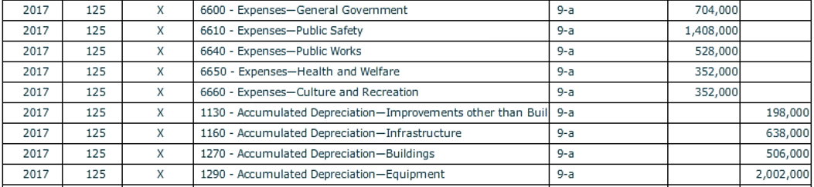

b. [Para. 9-b] Provide the journal entries to reclassify the current portion of long-term debt related to the two serial bonds payable.

We know from Chapter 2, the current portion of the long-term 2% 9,500,000 bond was $500,000 and from Chapter 5, the 3% 7,500,000 bonds are 10 year bonds, which would make their current portion 1/10th of the balance or $750,000. Therefore, reclass these amounts from each bond into Current Portion of Long-Term Debt.

Which accounts are you debiting and crediting?

c. Although closing entries were made in each governmental fund of this cumulative problem, they have not yet been recorded at the government-wide level.

View the pre-closing trial balance to see where these amounts are coming from.

Required: [Closing Entries] Record the journal entries required on December 31, 2017, to close all temporary accounts for governmental activities at the government-wide level. These entries should also recognize changes in:
- Net Position—Net Investment in Capital Assets and
- Net Position—Restricted for Debt Service.

For each account to be closed or reclassified, be sure the check mark for [Closing Entry] is on and that “Closing Entry” appears in the [Transaction Description] box.

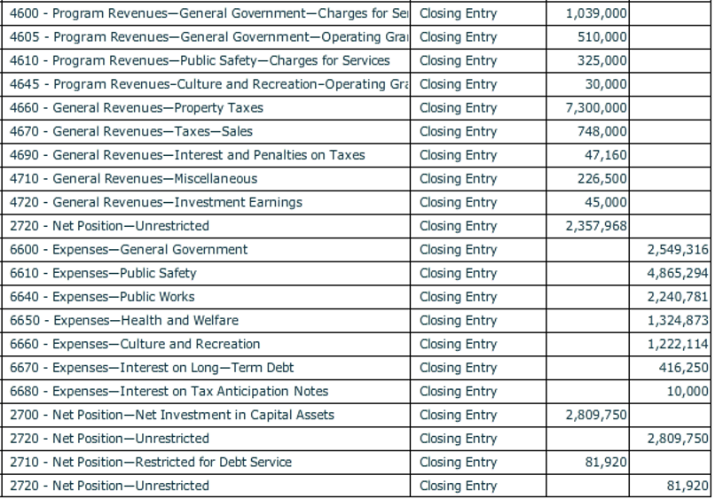

Before closing the City of Bingham, click on [File], and [Save/Save As] to save your work.

