Chapter 2 Opening the Books

The City of Bingham has installed a new computerized accounting system, which provides files for general journal entries and posting to appropriate general ledger/subsidiary ledger accounts. Budgetary, operating statement, and balance sheet accounts are provided for the General Fund and the other governmental fund types. Operating statement accounts and balance sheet accounts are also provided for governmental activities at the government-wide level and the proprietary and fiduciary funds used by the City of Bingham that you will use in Chapters 5-9 of the problem.

To begin this case, you must enter the city’s initial accounting information as of December 31, 2016, so that all transactions can be recorded for the next fiscal year beginning January 1, 2017.

Required

Open the City of Bingham software by double clicking on the Cities of Smithville and Bingham program. If creating a new project, click [Create New Project], when the [Create New Project] window appears choose City of Bingham from the [Choose a City] drop down menu. In addition, in the [Enter your name or Provided Number] box please type in your first and last name so that your name will appear on all printable reports and click [Create]. This will create the project and provide access to the funds and accounts that you will need to complete the “City of Bingham” cumulative problem.

If you have already created a new project, then open the existing project saved onto your jump drive.

To protect yourself from possible hard drive failure or corruption of your project data file, we recommended that you save your file to a removable device (e.g., flash drive or the cloud), creating a dated backup file for your project at the end of each session.

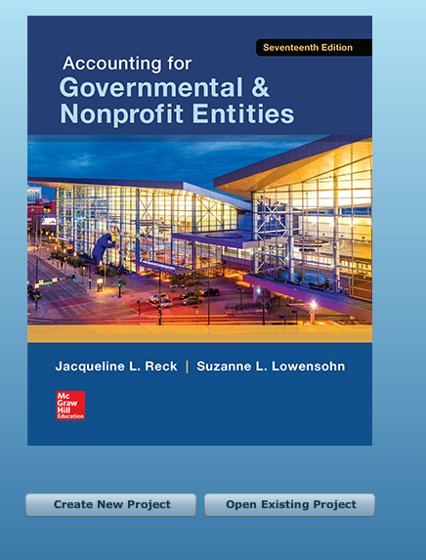

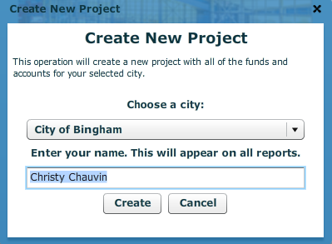

You will see this next
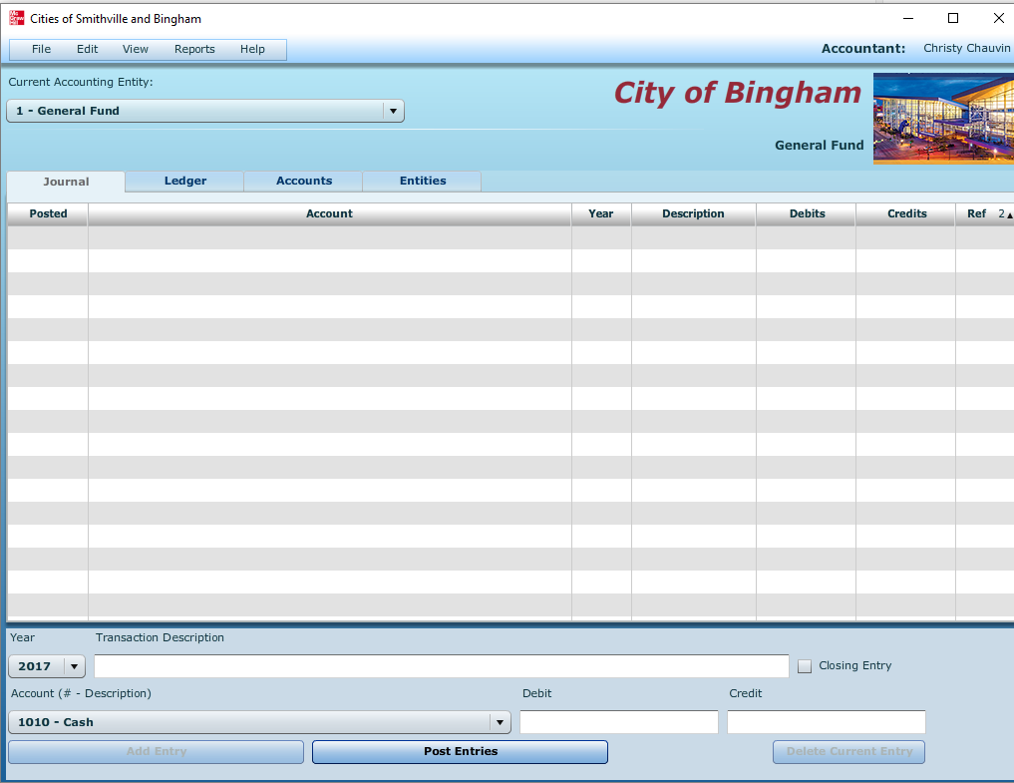

- If it is not already displayed, select [General Fund] in the [Current Accounting Entity] window and the [Accounts] tab. Clicking on the [Accounts] tab allows you to see the chart of accounts that will be used for the [General Fund]. A different chart of accounts is provided for each of the accounting entities.
- Next, select the [Journal] tab and click the drop down menu for [Account (# - Description)]. You should see the same general ledger accounts that were listed when you clicked on the [Accounts] tab. (Note: For purposes of this exercise, date suffixes are omitted from the Expenditures and Encumbrances accounts as expenditures from more than one year’s appropriations do not occur in this problem.)

- The post-closing trial balance for the General Fund of the City of Bingham as of December 31, 2016, is shown on the following page. Select the [Journal] view and create a journal entry to enter the balance sheet accounts and amounts shown in the trial balance.

Be sure to enter 2016 from the drop-down [Year] menu and enter the paragraph number from these instructions in the [Transaction Description] box of the [Journal] view.

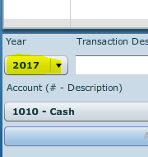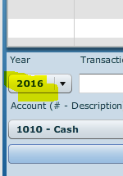

The year and transaction description need only be entered for the first line of the journal entry; it should remain in the boxes for the rest of the accounts. When you have completed entering all account data and amounts, verify the accuracy of all your entries, including date and paragraph numbers. When you are sure that your entries are correct, click [Post Entries] to post the items to the General Ledger of the General Fund.

For this entry you should enter Beginning Balance as the description. Select the appropriate accounts individually and insert the appropriate amounts.

(Note: Enter all dollar amounts without dollar signs, without commas, and without decimal points. All amounts in this project should be rounded to the nearest whole dollar. For all entries, it is vitally important that the correct year be selected.)

You must enter each account and amount one line at a time by clicking [Add Entry]

The following pages will provide more detailed screen shots.

CITY OF BINGHAM
General Fund
Post-closing Trial Balance
As of December 31, 2016

Account Title Debits Credits
Cash $ 151,000
Taxes Receivable—Delinquent 517,000
Allowance for Uncollectible Delinquent Taxes $ 46,750
Interest and Penalties Receivable on Taxes 26,059
Allowance for Uncollectible Interest and Penalties 1,434
Vouchers Payable 433,400
Due to Other Funds 14,300
Deferred Inflow of Resources—Operating
Grants and Contributions 30,000
Fund Balance—Committed—Public Safety 16,720
Fund Balance—Committed—Public Works 31,130
Fund Balance—Assigned—Health and Welfare 33,616
Fund Balance—Unassigned 86,709
Totals $ 694,059 $ 694,059

Unpost capability. As discussed in Chapter 1 of these instructions, the City of Bingham software program permits students to “unpost” a particular batch of posted transactions. Unposted entries then can be edited or missing entries can be inserted before re-posting entries. Prior to unposting a batch all batches must be posted.

- Select [Reports, Trial Balances, Post-Closing Trial Balance] and print when finished.

- Enter 2016 Post Closing Balances which are also 2017 Opening Balances for the General Fund.
When entering the numbers, no dollar signs or commas!
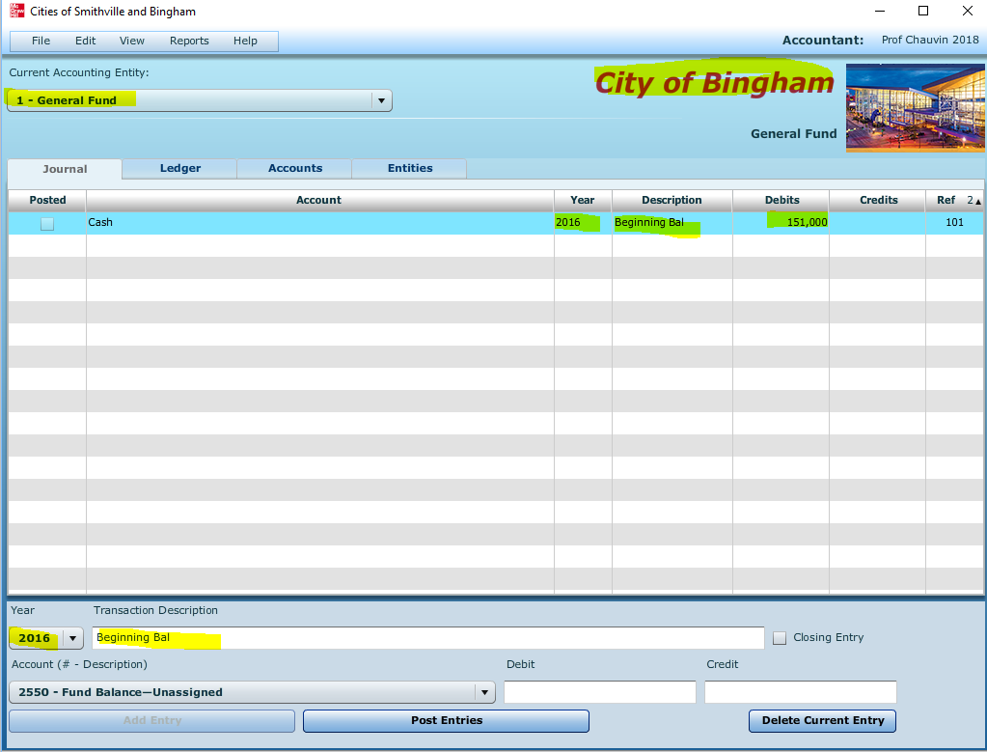
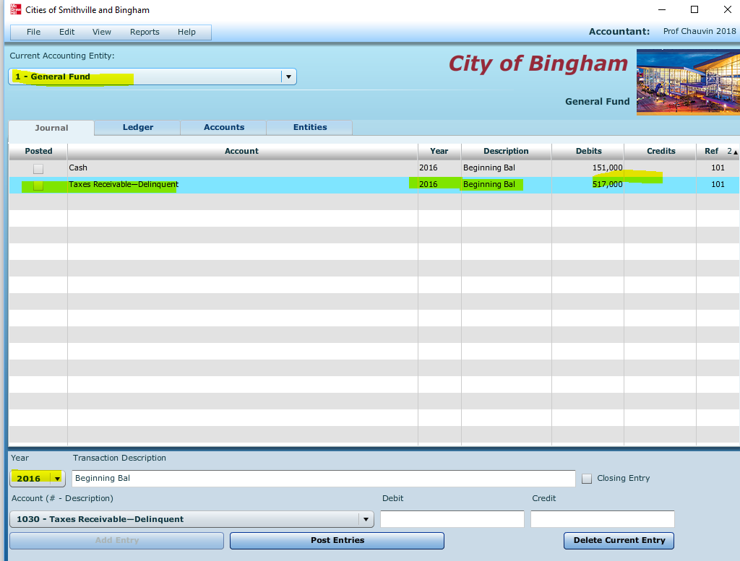

Screen will look like this after all entries are added
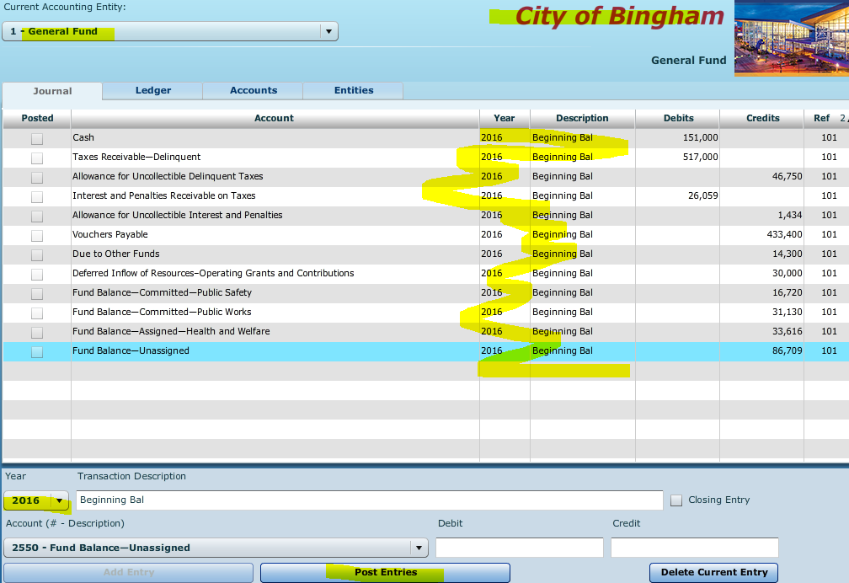

Review and then post
Before you post, you should see this
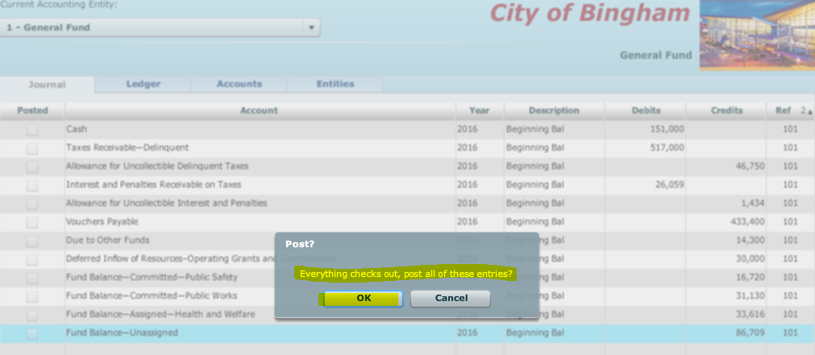

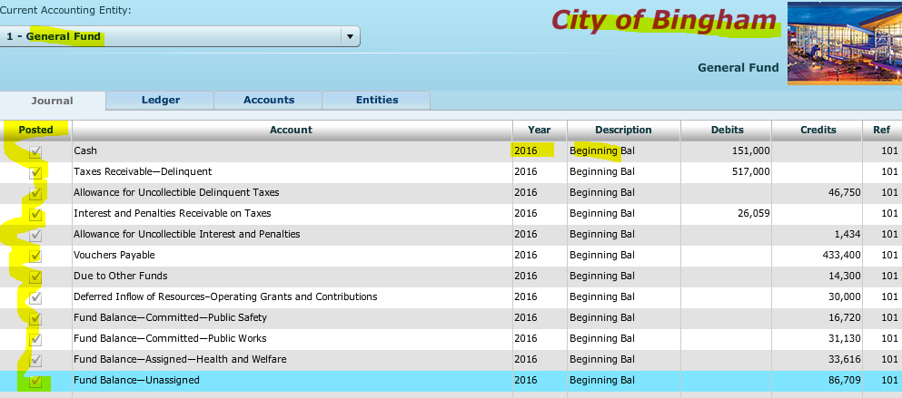

Review list of documents to be printed for this chapter. Access these by selecting reports.
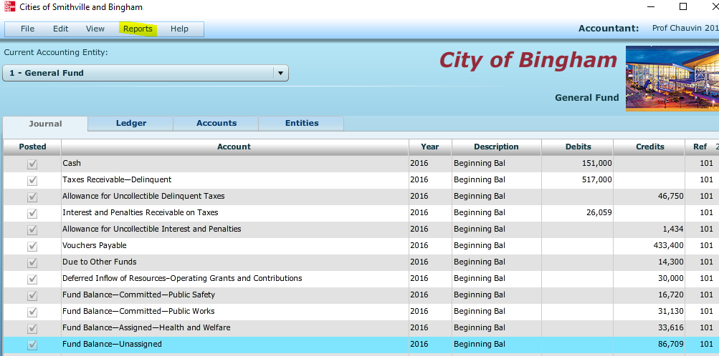
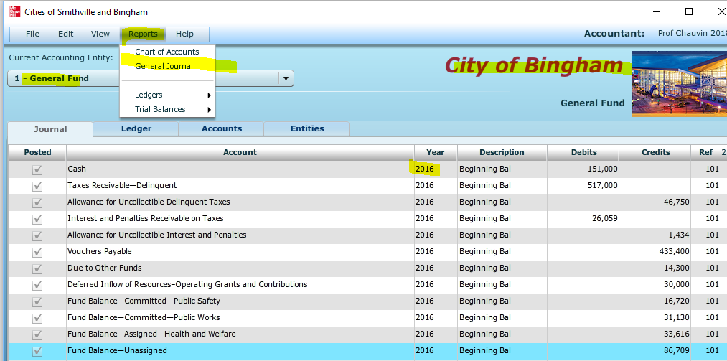

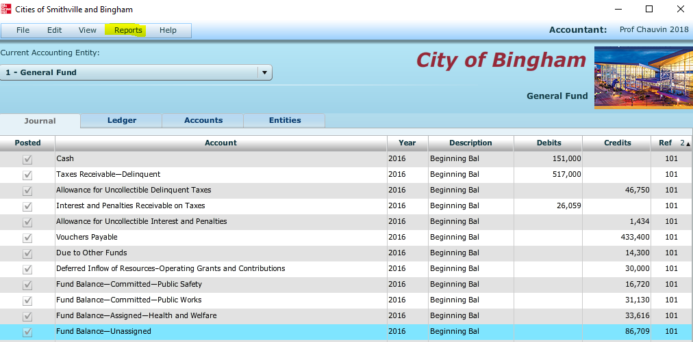
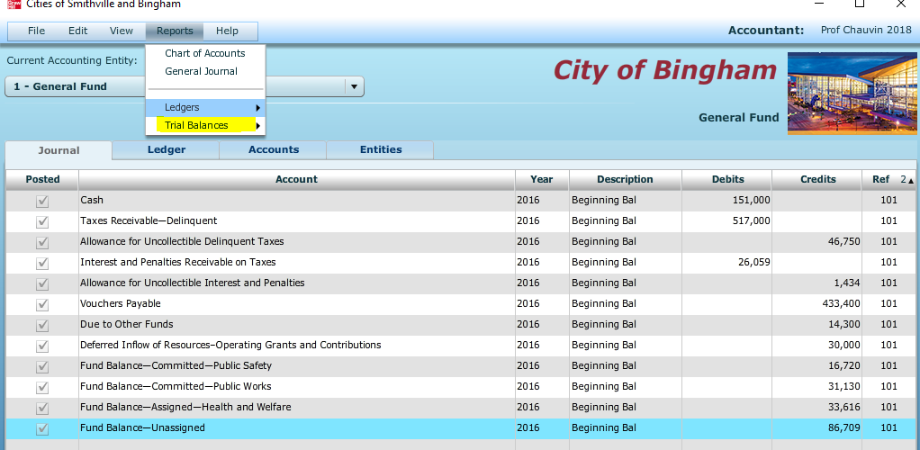
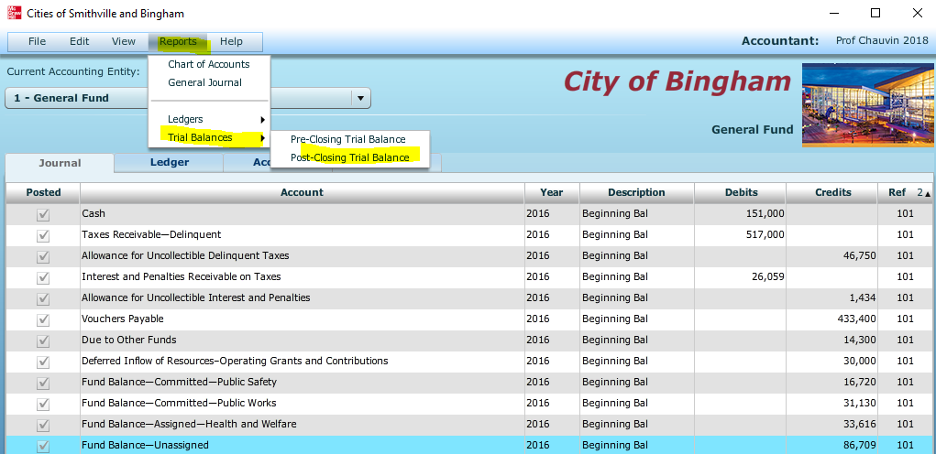
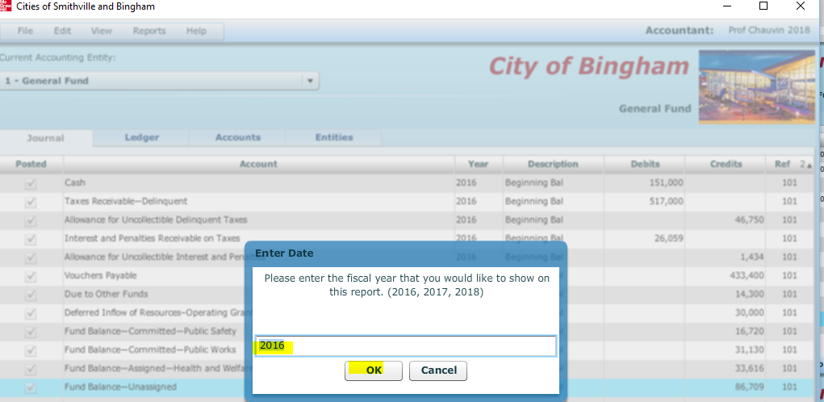

- Next project:
- Select [Governmental Activities—Government-Wide] in the [Current Accounting Entity] drop-down menu and the [Accounts] view tab. You will see the accounts included in the trial balance below, plus many other accounts that will be used in the various chapters of the City of Bingham project.

- Select the [Journal] view and create a journal entry to enter the statement of net position (i.e., balance sheet) accounts and amounts shown in the following trial balance.

It is necessary to enter these items in the accounts of the governmental activities category at the government-wide level as the general journal and general ledger for governmental activities comprise a separate “set of books” from those you inputted for the General Fund.

Be sure to enter 2016 from the drop-down [Year] menu and enter Beginning Balance in the Transaction Description box. Select each account individually and insert the appropriate debit or credit amount for each account. When you have completed entering the initial data, verify the accuracy of all entries and click [Post Entries] to post the entries to the governmental activities, government-wide general ledger.

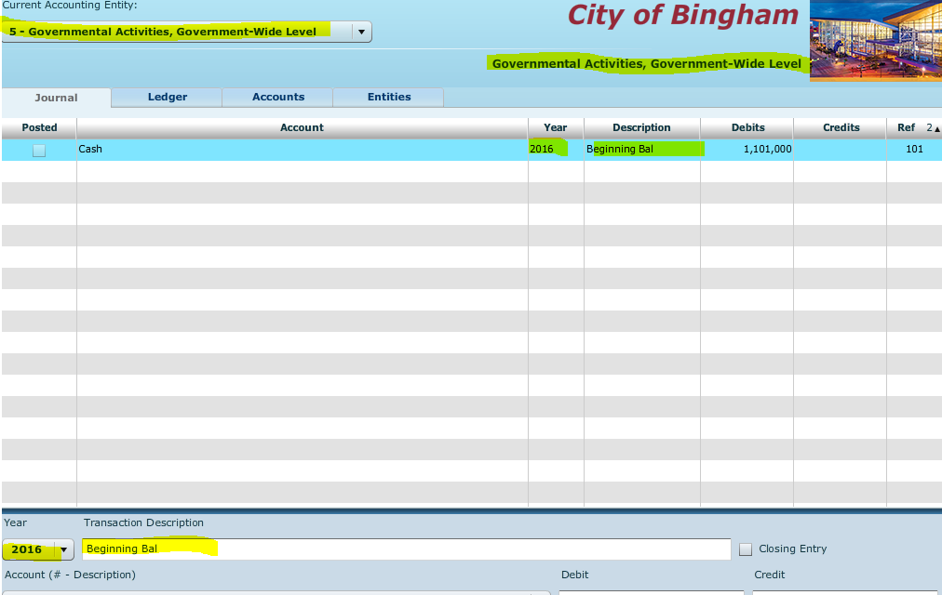

CITY OF BINGHAM
Governmental Activities, Government-wide Level
Post-closing Trial Balance
As of December 31, 2016

Account Title Debits Credits
Cash $ 1,101,000
Taxes Receivable—Delinquent 602,000
Allowance for Uncollectible Delinquent Taxes $ 100,750
Interest and Penalties Receivable on Taxes 35,659
Allowance for Uncollectible Interest and Penalties 2,394
Land 1,210,000
Improvements Other than Buildings 9,900,000
Accumulated Depreciation—Improvements
Other Than Buildings 2,310,000
Infrastructure 32,109,000
Accumulated Depreciation—Infrastructure 12,408,000
Buildings 10,230,000
Accumulated Depreciation—Buildings 2,310,000
Equipment 8,360,000
Accumulated Depreciation—Equipment 4,030,400
Vouchers Payable 433,400
Accrued Interest Payable on Long-term Debt 50,000
Internal Payables to Business-type Activities 14,300
Current Portion of Long-term Debt 500,000
Serial Bonds Payable—2% 9,500,000
Deferred Inflow of Resources—Operating Grants
and Contributions 30,000
Net Position—Net Investment in Capital Assets 30,750,600
Net Position—Restricted for Debt Service 939,640
Net Position—Unrestricted 168,175
Totals $63,547,659 $63,547,659

Repeat the process from the general fund entry of the 2016 Beginning Bal
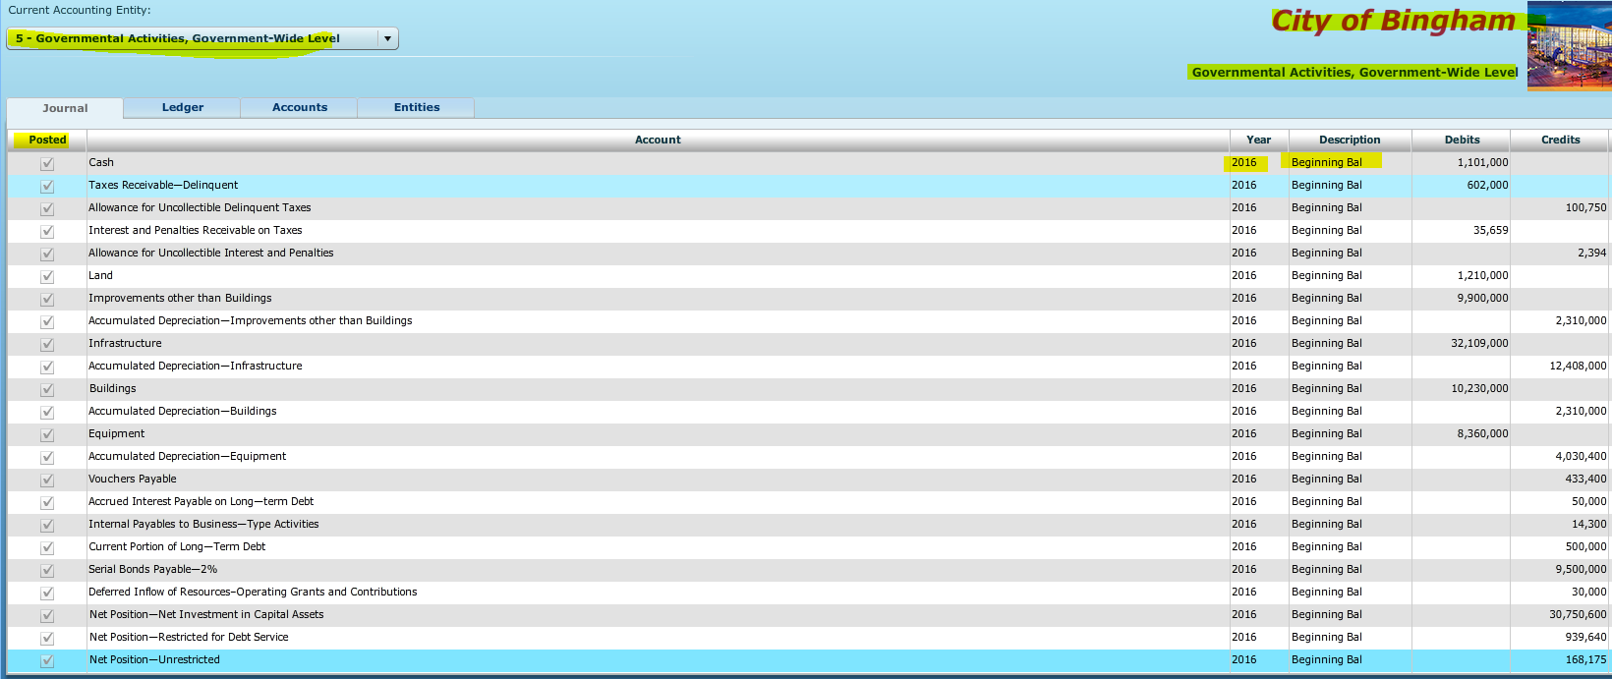

Post the entry – You will see a check in the box under Posted telling you it has been posted.

Review the listing of documents to be printed.

Finally, click on File, Save/Save as – Your Name Bingham to your device

