PROBLEM 4–15 Comprehensive Problem—Weighted-Average Method

Sunspot Beverages, Ltd., of Fiji makes blended tropical fruit drinks in two stages. Fruit juices are extracted from fresh fruits and then blended in the Blending Department. The blended juices are then bottled and packed for shipping in the Bottling Department.

The following information pertains to the operations of the Blending Department for June.

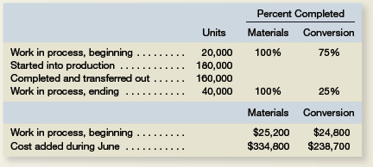

Required:

Assume that the company uses the weighted-average method.

1. Determine the equivalent units for June for the Blending Department.
2. Compute the costs per equivalent unit for the Blending Department.
3. Determine the total cost of ending work in process inventory and the total cost of units transferred to the Bottling Department.
4. Prepare a cost reconciliation report for the Blending Department for June.



PROBLEM 4–16 Comprehensive Problem—Weighted-Average Method

Builder Products, Inc., manufactures a caulking compound that goes through three processing stages prior to completion. Information on work in the first department, Cooking, is given below for May:

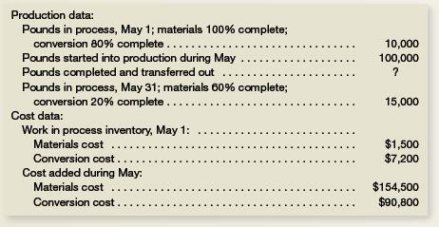

The company uses the weighted-average method.

Required:

1. Compute the equivalent units of production.
2. Compute the costs per equivalent unit for the month.
3. Determine the cost of ending work in process inventory and of the units transferred out to the next department.
4. Prepare a cost reconciliation report for the month.

