**Cost Concepts Classifications**

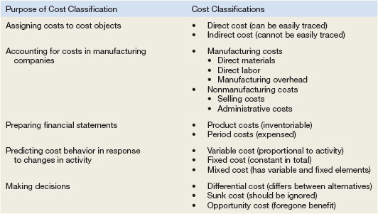

|  |
| --- |
| **Summary of Variable and Fixed Cost Behavior** |

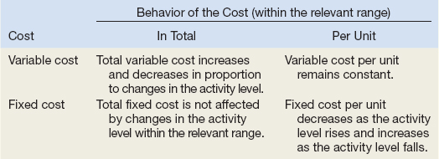

**Steps for Hi Lo**

1. Determine variable costs per unit
   1. Identify the period with the lowest level and highest level of activity.
   2. Identify the costs associated with the lowest level and highest level of activity.
   3. In the numerator (top) subtract the lowest level activity cost from the highest activity level cost
   4. In the denominator (bottom) subtract the lowest level of activity from the highest.
2. Take either the high level **total cost** and subtract the product of the variable cost per unit times the activity level at the high point
3. The remainder will be the fixed portion of the mixed cost.
4. The formula can then be restated as Total cost = fixed + variable cost per unit (x volume) for future planning or decision making.

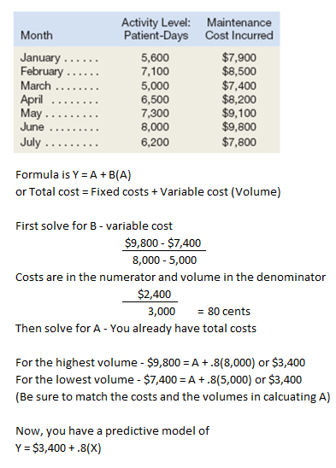

**Contribution Format Income Statement**

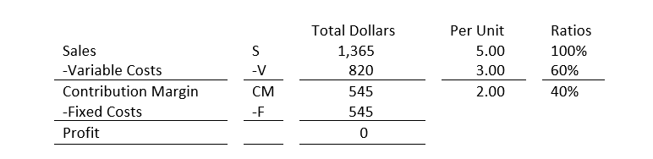

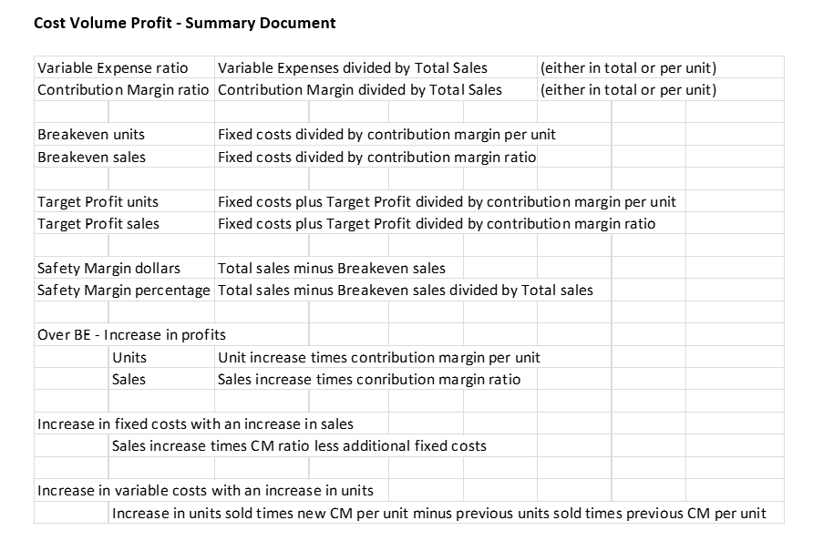

**Differential Analysis**

**Relevant v Irrelevant**

In general, ask

1. What costs are associated with each alternative = potentially relevant
2. Is the cost common to both alternatives? Yes = Irrelevant No = Relevant

|  |  |
| --- | --- |
| **Adding and Dropping Product Lines and Other Segments** |  |

Step 1: Calculate the contribution margin that would disappear if the segment is dropped. Put this number in parentheses to denote it as a negative number.

Step 2: Calculate the fixed costs that would be avoided (relevant) if the segment is dropped. Do not put this number in parentheses. This number will be added as an offset to the loss of the contribution margin.

Step 3: Add the amounts from steps 1 and 2. If the result is a negative number, then do not drop the segment. If it is a positive number, then choose to drop the segment

**The Make or Buy Decision**

Step 1: Calculate the total amount that would be paid to the supplier if the buy option is chosen.

Step 2: Calculate the total differential manufacturing costs. These are the variable manufacturing costs and traceable fixed manufacturing costs that will be incurred if the company chooses to make, but avoided if the company chooses to buy.

Step 3: Calculate the difference between the amounts from steps 1 and 2. If the amount from step 1 exceeds the amount from step 2, then choose the make option. If the amount from step 1 is less than the amount from step 2, then choose the buy option.

**Special Orders**

Step 1: Calculate the total revenue generated by the special order.

Step 2: Calculate the total incremental costs that will be incurred to produce the special order.

Step 3: Take the amount in step 1 and subtract from it the amount in step 2. If the result is a positive number, then accept the special order. If it is a negative number, then reject the special order.

**Utilization Of A Constrained Resource**

Step 1: Calculate each product's contribution margin per unit.

Step 2: Identify the constraining resource and the quantity of that resource that is consumed to make one unit of each product.

Step 3: Calculate each product's contribution margin per unit of the constraining resource.

Step 4: Rank the products from the highest contribution margin per unit of the constraining resource to the lowest.

**Sell or Process Further Decisions**

Step 1: Calculate the sales value if processed further minus the sales value at the split-off point.

Step 2: Determine the cost of further processing beyond the split-off point.

Step 3: Take the amount in step 1 and subtract from it the amount in step 2. If the result is a positive number, then choose to process further. If it is a negative number, then choose to sell at the split-off point.

**Flexible Budget**



**Standard Costs**





**Process Costing**

