Instructor: Prof Christy Lynch

Office: GW500

Office Hours: MWF 12:30-1:30

Course Meeting Day & Time: MW 9:10

Office Phone: 504.314.7921

E-mail: clynch8@tulane.edu

Canvas Site: https://tulane.instructure.com/courses/2221324

Course Location: GWBC 470

Course Description: This course covers generally accepted accounting principles (GAAP) that govern the reporting of assets, liabilities, revenues, transfers, expenditures, gains, losses, and net assets of governmental and not-for-profit entities. Discussion of the theoretical underpinnings of GAAP, as well as the ‘disconnects’ still present in governmental GAAP vs. ‘for profit’ GAAP, will be included in this course.

Course Prerequisites: ACCN 6010 or equivalent

Course Goals:
This course is designed to teach students the elements of fund accounting and the reasons for its use in governmental and not-for-profit entities.

Student Learning Objectives:
As the result of this course, you will understand how the different operating purposes, goals, objectives and requirements for governmental and not-for-profit entities influence the accounting methods used. You will be able to critically assess the accounting for both public (governmental) and private not-for-profit entities such as health care organizations and colleges and universities.

Course Structure:
Pre-Lecture assignments will introduce topical information to you. Lecture style class There is an enormous amount of material, and it is difficult to memorize all important concepts and points. Therefore, I will refer to my lecture slides to deliver pertinent concepts. We will also work some of your homework assignments in class to aid in your ability to learn the material. Some classes will be devoted to a governmental serial problem project. You should be prepared to be called upon during class to discuss concepts and solutions after the lecture to reinforce learning.

Course Material:
Required Text:
Essentials of Accounting for Governmental and Not-for-Profit Organizations by Paul A Copley, 14th ed. You need not purchase the book.

We will use my notes published in a website I have created entitled NumberKnowlege.com The password for the class is TUL7420Learn

We will use the homework management system (Connect) extensively for this class; therefore, I require you to purchase Connect access for this class. This will also give you access to the ebook.

We will access Connect the first day of class where you can purchase access, request a 14-day free trial, or use your pass code if you have purchased one.

Pre-Lecture Assignments: You will be responsible for true/false pre-lecture assignments which will require you to read the book chapter before class.

Homework Assignments: Your homework will be comprised of multiple-choice questions as well as lengthier exercises we will often review in class.

Chapter Review: Practice sets of even-numbered multiple-choice questions.

Class Supplies:

You should bring a laptop or iPad device to read your notes in class but not a phone. Please stow your phones during class. If I see your phone out, I may be tempted to take it and give it back to you after class. Simple calculator (four-function), mechanical pencil, a white polymer eraser, and notebook.

Evaluation Procedures and Grading Criteria:

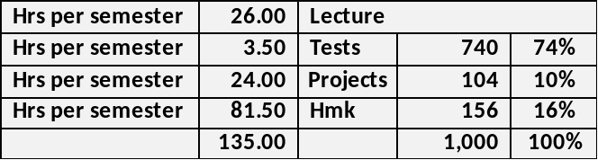

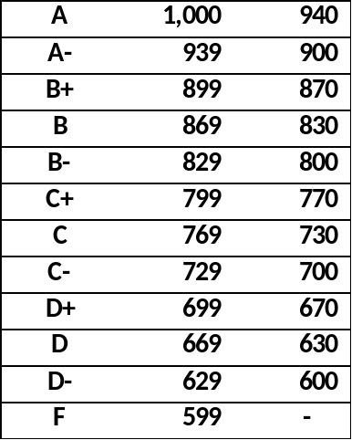
Grade Symbols: All graduate programs in the Freeman School use a letter grade system with the following quality point equivalents:

A | = | 4.00
A- | = | 3.67
B+ | = | 3.33
B | = | 3.00
B- | = | 2.67
C+ | = | 2.33
C | = | 2.00
C- | = | 1.67
D+ | = | 1.33
D | = | 1.00
D- | = | 0.67
F | = | 0.00

The quality point total for each course is computed by multiplying the numerical value of the grade received by the course credit hours.

Grading Guidelines: The Freeman School faculty approved the recommended grading policy for a class GPA by program. 6000-level courses are expected to have a mean class GPA in the range of 3.00 to 3.33. 7000-level courses are expected to have a mean class GPA in the range of 3.33 to 3.67.

Faculty members teaching more than one section of the same course may pool the students in the different sections and compute one class GPA.
Grade challenges: Grades must be challenged within five (5) business days of the test; otherwise, the grade will not change.

After each test, your total grade will be updated.
Tests:
- There are practice sets in Connect which consist of your pre-lecture and homework assignments. Please use these to study for tests as they will remain open throughout the semester.

- Exams will consist exclusively of multiple-choice questions with four answers or true/false questions. All material in the lecture notes is considered when preparing tests. Your tests will be on-line.

Your Connect assignments (pre-lecture and homework) are of pool of the even numbered assignments and lengthier exercises. Your test will be comprised of a pool of all the odd numbered Connect assignments and perhaps lengthier exercises.

- Make-up exams will not be given unless you provide legitimate documentation regarding your absence. Typically, a make-up exam will be given at the end of the semester and will be a comprehensive final.

- Bring a simple calculator, pencil, and eraser. You cannot use your phone as a calculator.

- Be sure your phone is off and put away in your bag. Ringing or vibrating phones are distracting to test takers and may result in a loss of points.

- Your book bags, purses, keys, phones etc. must be placed either at the front of the room or along the walls.

- You may not ask questions during an exam unless there is a word you do not understand.

- My aim is to post grades generally within two days of your tests or the due date of a project.

Course Schedule:
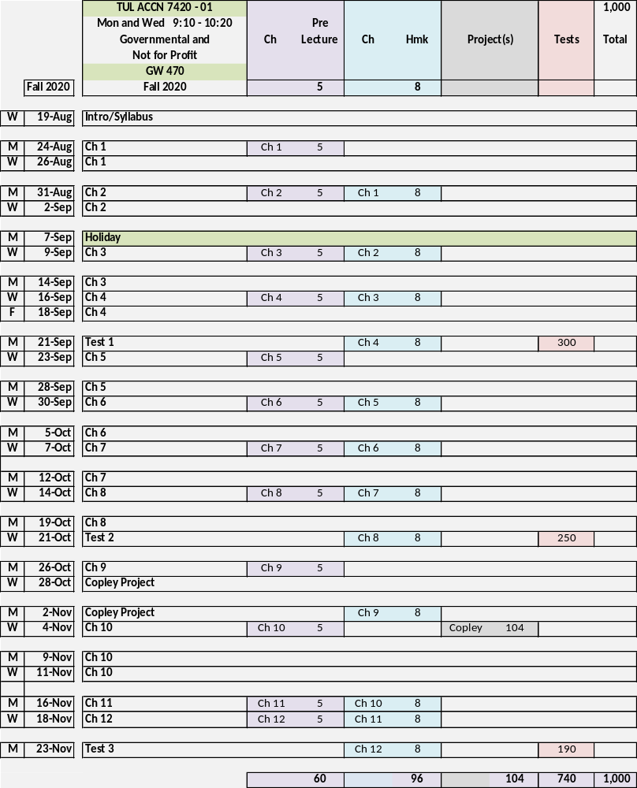

Course schedules will follow the Freeman Graduate Semester calendars, either day or evening, which are posted to the Freeman Graduate current students’ website.

Office Hours Policy:
MWF 12:30-1:30 Virtually through Zoom; however, I will meet in person if you make an appointment.

Recording of Class Sessions:
All class sessions will be recorded in Zoom, these recordings will be posted to accessible in Canvas. Students are prohibited from posting these recordings or sharing them elsewhere, either wholly or in part.

Specific Course Policies:
- Canvas Use and Requirements
  - Your lecture materials, homework link, syllabus, and schedule are located in NumberKnowledge.com
  - Your graded assignments including pre-lecture assignments, homework, and tests are located in Connect.
  - Canvas will house your syllabus, schedule, grades, and all Zoom recordings.

Problems with the Connect System: The help number for Connect is 1-800-331-5094. I cannot fix problems with the Connect system; you must call them. If there is a documented case problem with Connect or a documented internet outage, send me the documentation if you need an extension. Don’t wait until the last minute and say there is a problem with Connect. You must call them in sufficient time to iron out any problem. Connect works best with Firefox, Chrome and Safari.

Class Attendance/Participation:
Attendance is taken. If you miss a class, you are still responsible for the material and all lecture notes.

Studying for tests:
Everything in your notes and experiential learning will prepare you for your tests. There is nothing on your test which is not in your notes or something we did not cover in class.

Class Communication:
I will use Canvas and email to communicate outside of class. Please check these often to remain abreast of changes. Please follow up any verbal communication with an email. I will be better able to remember our conversation if you send me a follow up email.

When you send me an email, use these instructions to prepare a screen snip which is easier to read than a screen shot.

Disruptive Behavior:
Disruptive or disrespectful behavior is not allowed in class and will not be tolerated. I define any such behavior. Any instances will require a meeting between us. You must meet with me before you return to class or you will be asked to leave class until we have met. Disruptive behavior will affect your overall grade.

Syllabus Changes:
Circumstances may warrant additions or clarifications to the Syllabus for anything except your grade determination. I reserve the right to make any changes.

- Class Attendance Policy
Faculty and students must comply with University policies on COVID-19 testing and isolation, which are located here https://tulane.edu/covid-19/health-strategies. Faculty and students must wear face coverings in all common areas, including classrooms, and follow social distancing rules. Failure to comply is a violation of the Code of Student Conduct, and students will be subject to University discipline, which can include suspension or permanent dismissal.

If a student cannot attend a class for any reason, the student is responsible for communicating with their instructors to make up any work they may miss. Faculty will provide online options for class participation, outlined in this document, and unless a student is seriously ill, they are expected to use this option. The University Health Center will provide documentation verifying a student is ill, as well as verification that a student may return to class.

With the approval of the Freeman School Associate Dean for Graduate Programs, students may have been approved for Remote/Online instruction for Fall 2020. Such students will attend all class sessions remotely and are not permitted to attend in person. Course policies and grading will accommodate all students including those approved for Remote/Online learning.

Statement about Academic Integrity:
This class will be conducted in full accordance with Tulane’s policies about academic integrity including, but not limited to, the Unified Code of Graduate Student Academic Conduct (https://academicaffairs.tulane.edu/policies/academic-policies) and the Tulane University Code of Student Conduct (https://conduct.tulane.edu/resources/code-student-conduct).

Any member of the university community may file charges against a student for violations of the code. A charge shall be prepared in writing and directed to Associate Dean John Clarke at jfc@tulane.edu.

Norms and Expectations:
This class will be conducted in full accordance with published Norms and Expectations for Students in Freeman Classes. Please review the Norms and Expectations in your graduate program handbook which can be found on the Freeman School website https://freeman.tulane.edu/current-students.

Goldman Center for Student Accessibility and ADA/Accessibility Statement:
Under the Americans with Disability Act and Section 504 of the Rehabilitation Act, if you have a disability, you may have the right to an accommodation; however, the right is contingent upon your taking certain steps. You should review the steps that you need to take, as well as Tulane’s policy concerning accommodations at https://accessibility.tulane.edu/.

Any student with a disability, in need of course or examination accommodation, should request an accommodation through the University’s Goldman Center for Student Accessibility, located on the first floor of the Science and Engineering Lab Complex. http://accessibility.tulane.edu or 504.862.8433

At the beginning of the semester, please provide me with a copy of your approved accommodation form. I am committed to working with the Goldman Center to ensure that I provide you with all approved accommodations. If you do not deliver the approved accommodation form to me, I will not know that the Goldman Center approved your accommodation and I will have no basis to provide those accommodations.

Religious accommodation policy
Per Tulane’s religious accommodation policy, I will make every reasonable effort to ensure that students can observe religious holidays without jeopardizing their ability to fulfill their academic obligations. Excused absences do not relieve the student from the responsibility for any course work required during the period of absence. Students should notify me within the first two weeks of the semester about their intent to observe any holidays that fall on a class day or on the day of the final exam.

Discrimination and Harassment
Tulane University recognizes the inherent dignity of all individuals and promotes respect for all people. As One Wave, Tulane is committed to providing an environment free of all forms of discrimination and sexual harassment, including sexual assault, domestic and dating violence, and stalking. If you (or someone you know) has experienced or experiences gender-based violence, know that you are not alone. Learn more at https://campushealth.tulane.edu/well/one-wave.

Emergency Preparedness & Response
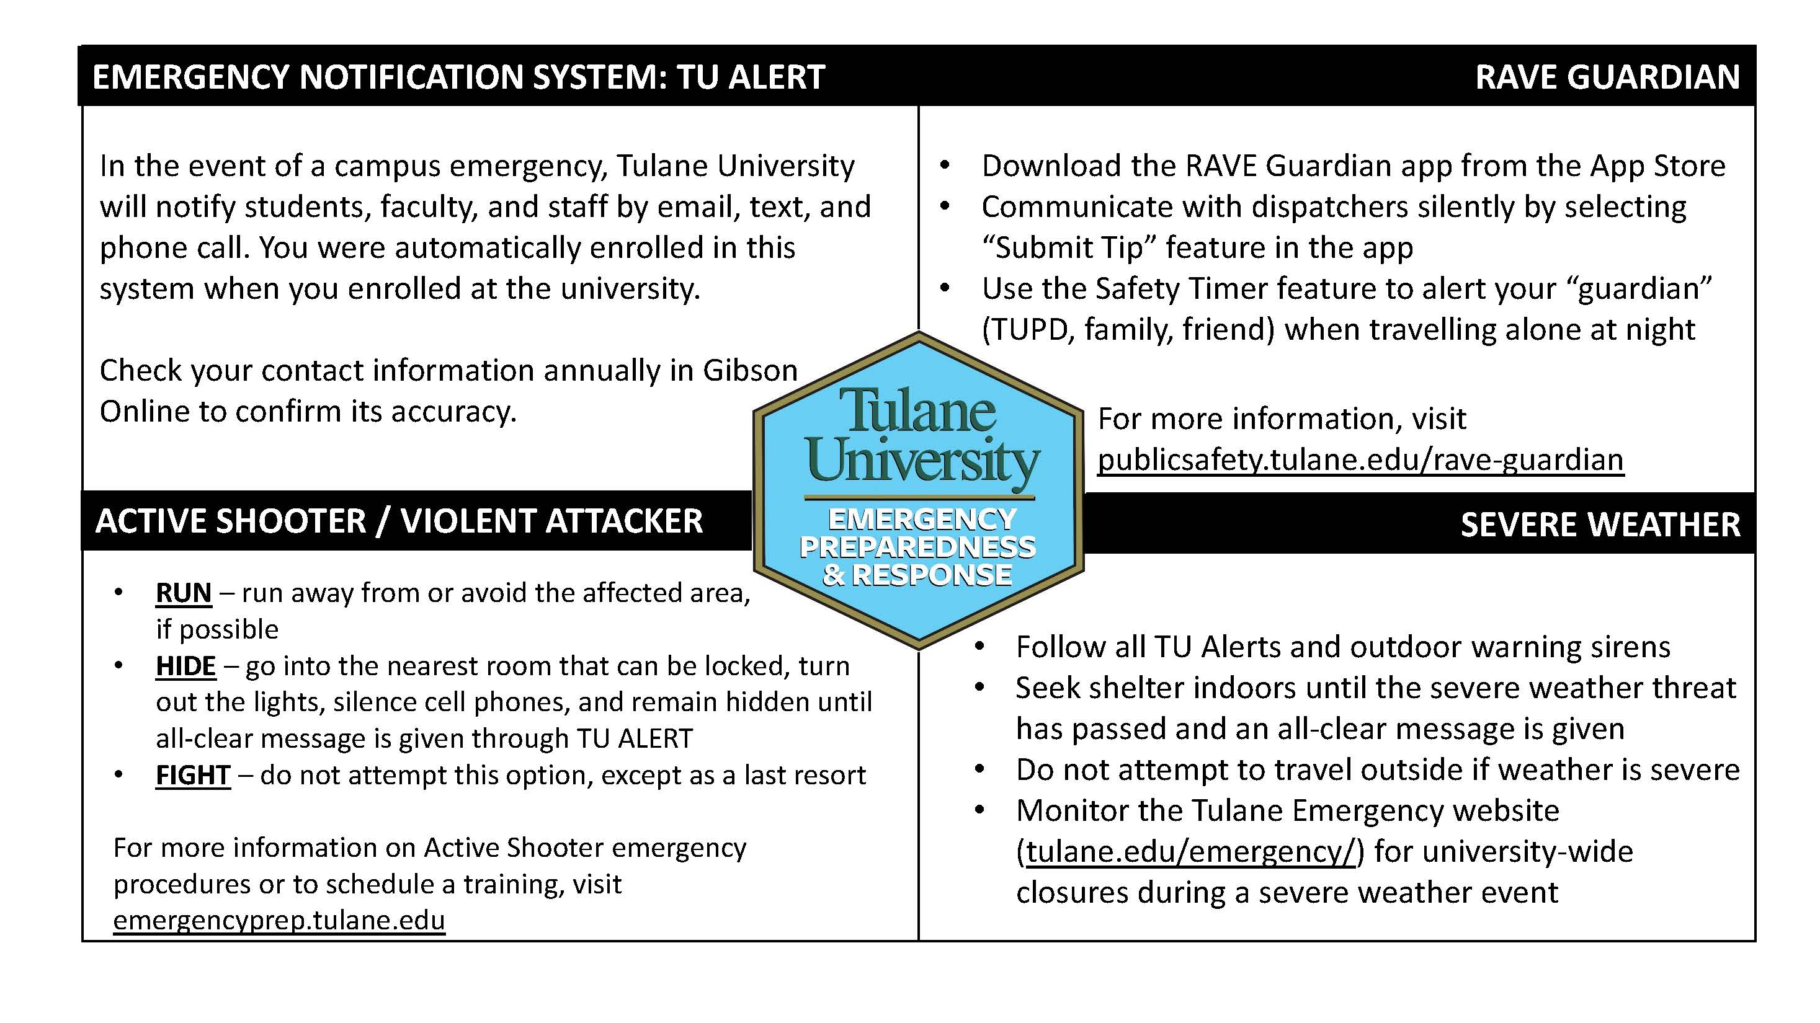

Title IX:
Tulane University recognizes the inherent dignity of all individuals and promotes respect for all people. As such, Tulane is committed to providing an environment free of all forms of discrimination including sexual and gender-based discrimination, harassment, and violence like sexual assault, intimate partner violence, and stalking. If you (or someone you know) has experienced or is experiencing these types of behaviors, know that you are not alone. Resources and support are available: you can learn more at allin.tulane.edu. Any and all of your communications on these matters will be treated as either “Confidential” or “Private” as explained in the chart below.

Please know that if you choose to confide in me I am mandated by the university to report to the Title IX Coordinator, as Tulane and I want to be sure you are connected with all the support the university can offer. You do not need to respond to outreach from the university if you do not want. You can also make a report yourself, including an anonymous report, through the form at tulane.edu/concerns.

Confidential | Private
Except in extreme circumstances, involving imminent danger to one’s self or others, nothing will be shared without your explicit permission. | Conversations are kept as confidential as possible, but information is shared with key staff members so the University can offer resources and accommodations and take action if necessary for safety reasons.
Counseling & Psychological Services (CAPS) | (504) 314-2277 or  The Line (24/7) | (504) 264-6074 | Case Management & Victim Support Services | (504) 314-2160 orsrss@tulane.edu
Student Health Center | (504) 865-5255 | Tulane University Police (TUPD) | Uptown - (504) 865-5911. Downtown – (504) 988-5531
Sexual Aggression Peer Hotline and Education (SAPHE) | (504) 654-9543 | Title IX Coordinator | (504) 314-2160 or msmith76@tulane.edu

