**CONVERSION FROM FUND FINANCIAL RECORDS TO GOVERNMENT-WIDE FINANCIAL STATEMENTS**

At the end of the reporting period and in accordance with GASB, governments adjust governmental fund records (modified accrual/current resources focus) to the accrual basis/economic resources focus required in the government-wide statements.

This is accomplished through worksheet entries. Worksheet entries differ from other journal entries, in that they are not posted to the general ledger—in effect, they are never “booked.”

The government-wide statements are separated into governmental activities and business-type activities (discretely presented component units are also separately displayed).

The governmental-type funds’ Balance Sheet and Statement of Revenues, Expenditures, and Changes in Fund Balances serve as inputs to the governmental activities sections of the government-wide statements. The internal service fund transactions would also be added to the governmental activities.

No adjustments are necessary for internal service funds as they are prepared on the accrual basis and economic resource focus.

In contrast, balances from the enterprise funds are entered directly to the business-type activities sections of the government-wide statements.

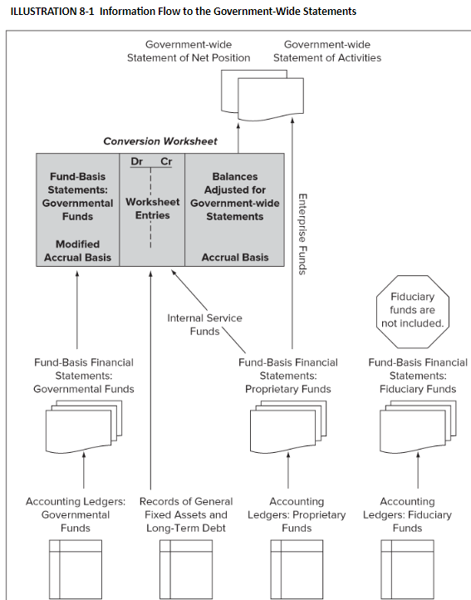

The fund-basis financial statements for the governmental funds are entered directly into the left-hand column of the worksheet.

With respect to the worksheet, the focus is on what should be added and what is presently there.

General capital assets, general long-term debt, and internal service funds are added through worksheet journal entries and are reported on the Government-Wide Statement of Net Position.

In addition, worksheet entries adjust the accounts from modified accrual basis fund statements to accrual accounting.

The resulting balances appearing in the far-right column are entered into the governmental activities portion of the government-wide statements.

Enterprise funds are added directly into the business-type section.

No entries are necessary to eliminate fiduciary funds; they are simply left out of the worksheet and therefore never appear in the government-wide statements.

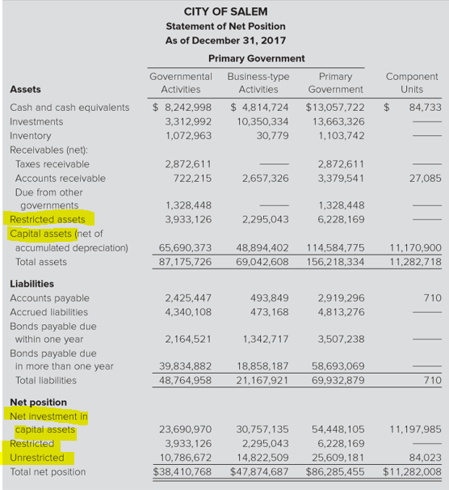

Statement of Net Position includes capital assets, long-term debt, and net position comprised of Net Investment in Capital Assets, Restricted, and Unrestricted balances. The classified approach is not required.

The second financial statement in Government-Wide report is a Statement of Activities. 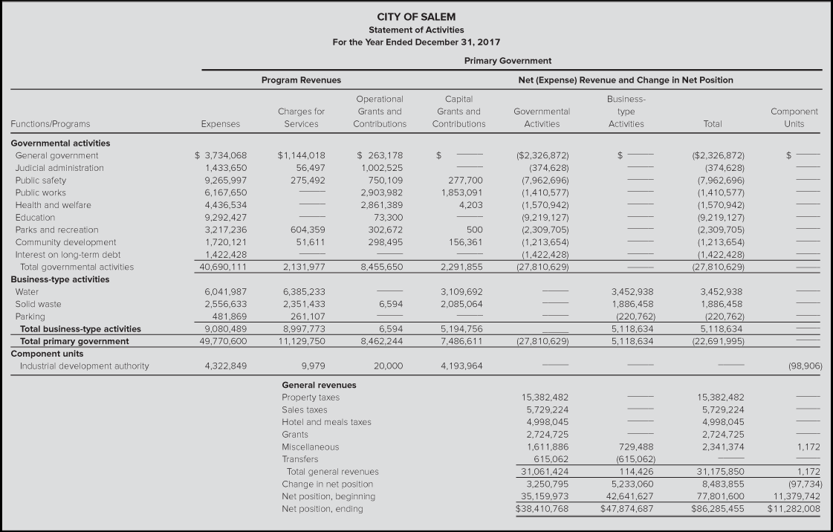

**The process to convert intra-governmental funds to government-wide**

1. **Long-term Capital assets**
   1. Assets in existence at the beginning of the year
      1. Add assets (debit) and accumulated depreciation (credit) in existence at the beginning of the year
      2. Any difference would be recorded to net position
   2. Assets added during the year
      1. Debit the asset by category
      2. Credit Expenditures-Capital Outlay
   3. Assets sold during the year
      1. Credit the asset sold
      2. Eliminate (credit) the proceeds from the sale
      3. Record any gain or loss
   4. Record any depreciation
2. **Long-Term Liabilities – Bonds (usually)**
   1. Bonds in existence at the beginning of the year related to the governmental funds
      1. Add bonds (credit) and premiums (credit) if any
      2. Any difference would be recorded to net position
   2. Bonds added during the year
      1. Credit bonds payable
      2. Debit other financing sources – proceeds of bond
   3. *Any interest accrual added into the government-wide financial statements worksheet but recorded as an expenditure in the current year should be eliminated*
      1. *Debit net position*
      2. *Credit interest expense*
   4. Record any interest payable at the end of the current year under the accrual method
      1. Debit interest expense
      2. Credit interest payable
   5. Bond principal paid during the year
      1. Credit/eliminate the expenditure for principal
      2. Debit/reduce bonds payable
   6. Bond principal amortization not previously recorded during the year
      1. Debit the premium to record the amortization
      2. Credit bond interest expense previously recorded (reduces a portion of interest expense recorded which did not consider bond amortization).
   7. Interest expense in the current year related to the current year would not require adjustment.
3. **Revenue recognition under modified accrual accounting.**

Revenues are recognized when available and measurable. Revenues are deemed to be *available* if they are collectible within the current fiscal year or soon enough after the year-end that they could be used to settle current period liabilities. A special rule applied to property taxes—the 60-day rule. Under modified accrual, property taxes, sales taxes, and income taxes expected to be collected more than 60 days following year-end are deferred and recognized as revenue in the following year.

1. Revenue recognition
   1. Accrual - The entire amount of the property tax levied would be recognized minus any uncollectible amounts
   2. Modified accrual – The amount levied recognized minus the amount deferred and any uncollectible amounts
   3. Any amount previously deferred would require adjustment as follows

**Explanation:**

**In 2019,** the general fund deferred inflows of property taxes in the amount of $51,200 because this amount will not be paid for 60 days after year end.

That 2019 journal entry would have been

12/31/19 Revenue 51,200 (temporary account)

Deferred Inflow 51,200 (permanent account)



**In 2020,** the general fund will reverse this entry to recognize the revenue since it is now “available” in 2020. Additionally, the general fund will zero out the deferred inflow since it is no longer deferred.

1/1/2020 Deferred Inflow 51,200 (permanent account)

Revenue 51,200 (temporary account)



**Worksheet entry** to convert general fund accounting from modified accrual basis to accrual basis:

12/31/20 Revenue 51,200 (temporary account)

Net Position 51,200 (permanent account)

This negates the revenue recognized in 2020 related to 2019. Net position is affected since the amounts were closed out to net position when closing revenue accounts for 2019.

1. To convert to accrual basis, any amount deferred during the current year, would be added back as revenue
   1. Debit deferred inflows
   2. Credit revenue
2. **Expenses**
   1. Recognize any expenses not previously recorded.
   2. Pension expenses
      1. Any unfunded amount related to the **current year** would be accrued and expensed.
3. **Inter-governmental activities transactions**
   1. Eliminate any inter-governmental activities (between governmental/internal services funds) such as
      1. Transfers in/out
      2. Accounts receivable/payable
      3. Would not include transactions with an enterprise fund.
4. **Internal Service Funds**
   1. Assets and liabilities would be added to government-wide financial statements governmental activities.
   2. The Net Position will be assessed for
      1. Revenue related to outside parties such as interest revenue would be added to revenue
         1. Debit net position
         2. Credit interest revenue
      2. Exchange transactions within the net position (essentially operating income) should be eliminated so that the expenditures (in total) are not overstated.
         1. Debit net position
         2. Credit expenditures by category

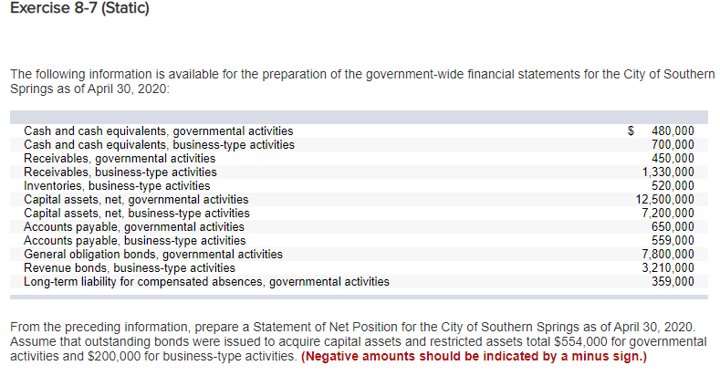

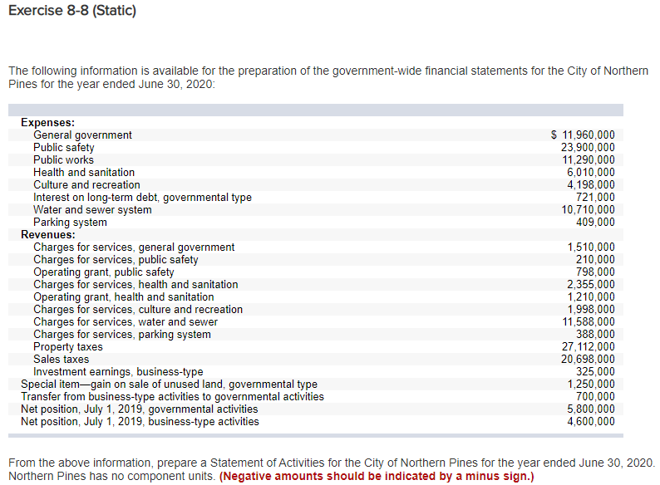

**It is assumed the transfer from the business-type activity is an internal service fund.**

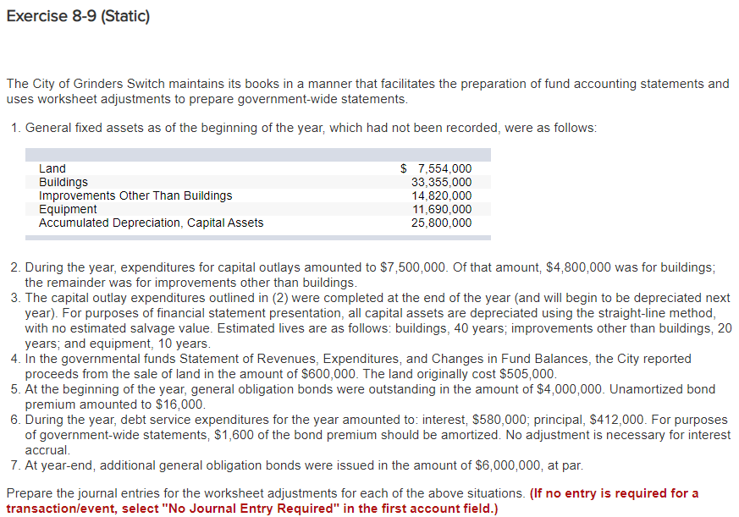

**NOTE: These are worksheet adjustments**

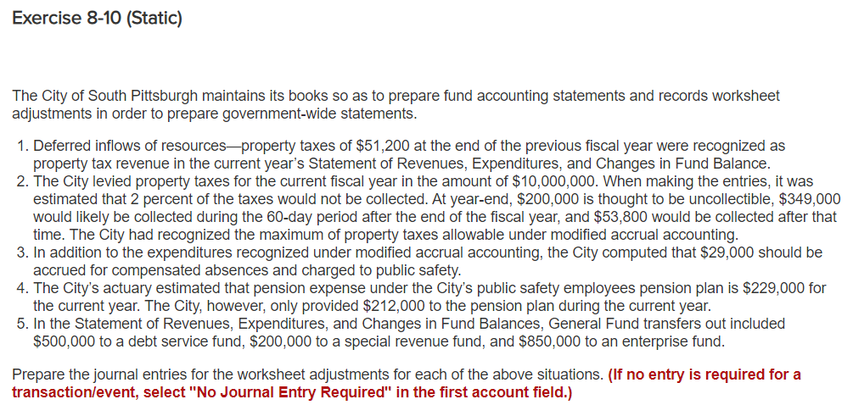

**NOTE: These are worksheet entries**

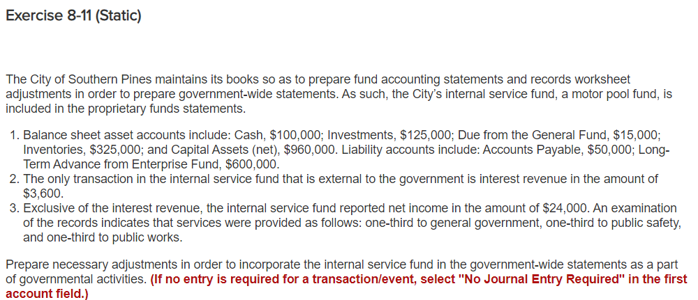

**TB MC Qu. 08-80**

The City of Eugene reported property tax revenues in 2020 in the amount of $10 million. The *deferred inflow*—*property taxes* reported in the General Fund’s balance sheet was $475,000 on December 31, 2019 and was $400,000 on December 31, 2020. During 2020, $9,000,000 was collected. What amount should the city report for Property Tax Revenue in its year ended December 31, 2020 government-wide Statement of Activities?

$9,625,000

$9,925,000

$10,075,000

$8,975,000