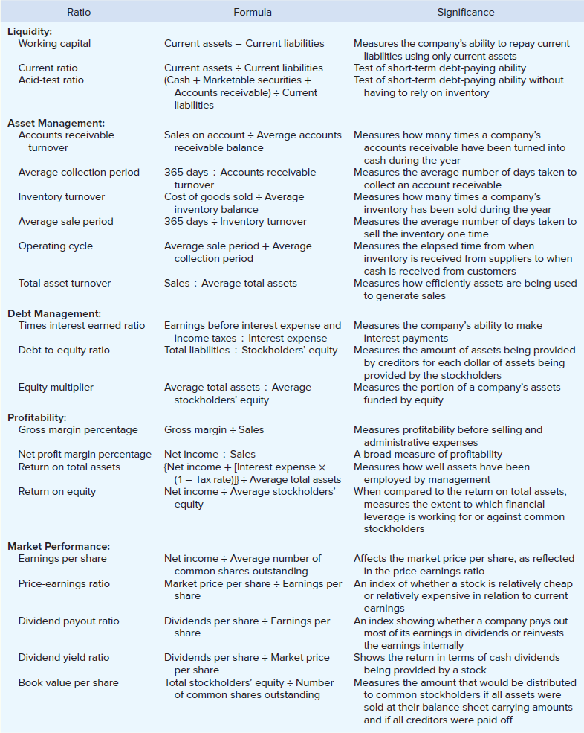
Financial Leverage
Stockholders look at debt from a financial leverage perspective.
Financial leverage refers to borrowing money to acquire assets in an effort to increase sales and profits. A company can have either positive or negative financial leverage depending on the difference between its rate of return on total assets and the rate of return that it must pay its creditors.
If the company’s rate of return on total assets exceeds the rate of return the company pays its creditors, financial leverage is positive.
If the rate of return on total assets is less than the rate of return the company pays its creditors, financial leverage is negative.
If a company has positive financial leverage, having debt can substantially benefit common stockholders. Conversely, if a company has negative financial leverage, common stockholders suffer.
Given the potential benefits of maintaining positive financial leverage, managers do not try to avoid debt, rather they often seek to maintain a level of debt that is considered to be normal within their industry.

Return on Total Assets
The return on total assets is a measure of operating performance that is defined as follows:
Interest expense is added back to net income to show what earnings would have been if the company had no debt. With this adjustment, a manager can evaluate his company’s return on total assets over time without the analysis being influenced by changes in the company’s mix of debt and equity over time.

Furthermore, this adjustment enables managers to draw more meaningful comparisons with other companies that have differing amounts of debt.

Notice that the interest expense is placed on an after-tax basis by multiplying it by the factor (1 − Tax rate).

