Instructor: Prof Christy Lynch

Office: GW500 – 5th Floor of GW

Office Hours: Zoom appt TTh 12:30 to 1:30

Course Meeting Day & Time: MW 9:00

Office Phone: 504.314.7921

E-mail: clynch8@tulane.edu

Canvas Site:

Course Location: GWBC 124

ACCN 6050 Accounting Measurement, Reporting, and Control:
This course introduces basic concepts underlying the measurement and reporting of a business’s economic activities, how to use this information to inform managerial decisions, and how accounting information is used as part of the managerial control system. The course is loosely divided into three topics: 1) The concepts and relationships underlying the income statement, balance sheet and statement of cash flows; 2) Using accounting information to make decisions about resource allocations and to evaluate the performance of firms, business units and managers; and 3) Using accounting information as part of an overall control system to ensure that the organization is meeting its goals. The course is intended as an introduction for individuals who will make business decisions, evaluate other firms, business units, or managers, or be evaluated themselves via accounting information.

Course Prerequisites: None

Course Goals:
This course is designed to develop the student’s ability to understand how a business’s economic activities are measured and reported, including the impact of managerial judgment and financial accounting standards on these measures and reports. This understanding will help students, as future managers, to improve their ability to seek, analyze and interpret accounting information to improve the quality of their judgments and decisions. While developing this understanding, the course will explicitly recognize that businesses and individuals respond to the methods used to measure their performance and the implications this has for discretionary accounting choices and control system design.

Student Learning Objectives:
As the result of this course, students should be able to:
- Read and understand financial statements.
- Understand how economic transactions are reflected on the financial statements.
- Understand the links among the different financial statements.
- Use financial statements and other accounting information to help evaluate firm and business unit performance.
- Identify, understand, and apply fundamental techniques to generate decision-useful accounting information for both cost management and managerial control purposes.

Course Structure:
This course will have students in attendance and those who are distance learning. Zoom will be used for each class and is accessible in Canvas. It is expected students will attend class. It is expected distance learners will have their cameras on and in an appropriate location.

Students will have both pre-lecture and homework assignments for each module.

Measurement and Reporting: The first half of the class will concentrate on financial accounting—recording and analyzing amounts in the financial statements.

Control: The second half of the class will concentrate on decision making and performance assessment tools used by companies.

There are two tests—one for each half.

The class is designed with your success in mind. Pre-lecture assignments introduce you to topics before class, thus making class time a richer environment. The class is interactive. There will be student participation in problem solving scattered throughout our time in class. This will provide real-time learning and reinforcement of material. Each topic is followed by practice in homework modules.

The graded pre-lecture and homework assignments are effort based, and you have this grade entirely within your control in amassing points.

Tests are given through an on-line proctored environment through your book publisher.

All graded assignments are taken in the assignment site called “Connect” from your book publisher. There will also be practice sets of these assignments which can be used for test study.

All lecture material and in-class assignment material will be delivered through my website called “NumberKnowledge” It is password protected, and the password is TUL6050Learn (case sensitive). Additionally, there are post-lecture videos recorded by me resourced there as well.

All links to these resources are populated in Canvas.

Course Material:
Required Text:
Financial Accounting: Information for Decisions by John Wild, 10th ed. We will use an electronic version of the book which can be accessed through purchasing it through the bookstore or through the links in Canvas.

NOTE: It is expected you will have purchased access by the first day of class.

Problems with the Connect System: The help number for Connect is 1-800-331-5094. I cannot fix problems within the Connect system; you must call them. If there is a documented case problem with Connect or a documented internet outage, send me the documentation if you need an extension. You should call them in sufficient time to iron out any problem. Connect works best with Firefox, Chrome and Safari.

Team Assignments and Projects:
You may work together in naturally occurring teams on the project assignment in Connect by sharing information and ideas.

Class Supplies:
You should bring a laptop or iPad device to read your notes in class but not a phone.

(Please stow your phones during class. If I see your phone out, I may be tempted to take it and give it back to you after class.)

A calculator will be necessary and if you chose, a notebook.

Evaluation Procedures and Grading Criteria:

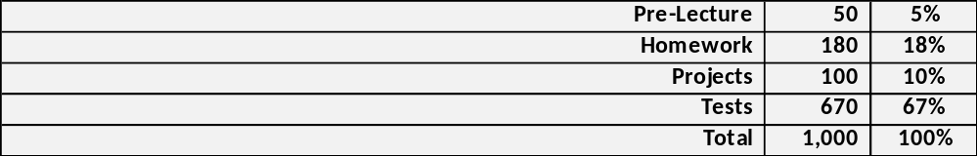

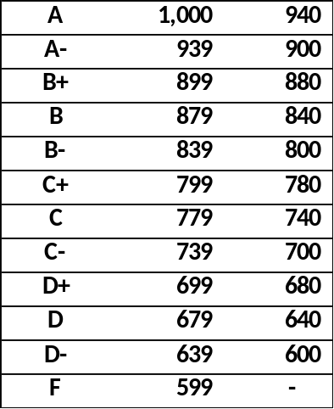

Grade Symbols: All graduate programs in the Freeman School use a letter grade system with the following quality point equivalents:
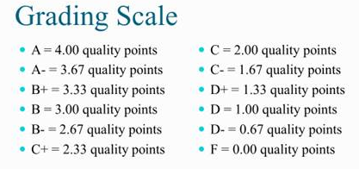
The quality point total for each course is computed by multiplying the numerical value of the grade received by the course credit hours.

Grading Guidelines: The Freeman School faculty approved the recommended grading policy for a class GPA by program. 6000-level courses are expected to have a mean class GPA in the range of 3.00 to 3.33.

Grade challenges: Grades must be challenged within five (5) business days after the test; otherwise, the grade will not change.

After each test, your total grade will be updated.
Tests:
- There are practice sets in Connect which consist of your pre-lecture and homework assignments. Please use these to study for tests as they will remain open throughout the semester.

- Your first test will consist of two projects. Your second test will consist of multiple-choice or true/false questions. All material in the lecture notes is considered when preparing tests. Your tests will be on-line.

- Make-up exams will not be given unless you provide legitimate documentation regarding your absence. Typically, a make-up exam will be given at the end of the semester and will be a comprehensive final.

- Bring a scratch paper, calculator, pencil, and eraser. You cannot use your phone as a calculator.

- Be sure your phone is off and put away in your bag. Ringing or vibrating phones are distracting to test takers and may result in a loss of points.

- Do not anticipate asking questions during an exam unless there is a word you do not understand.

- My aim is to post grades generally within two days of your tests.

Course Schedule:

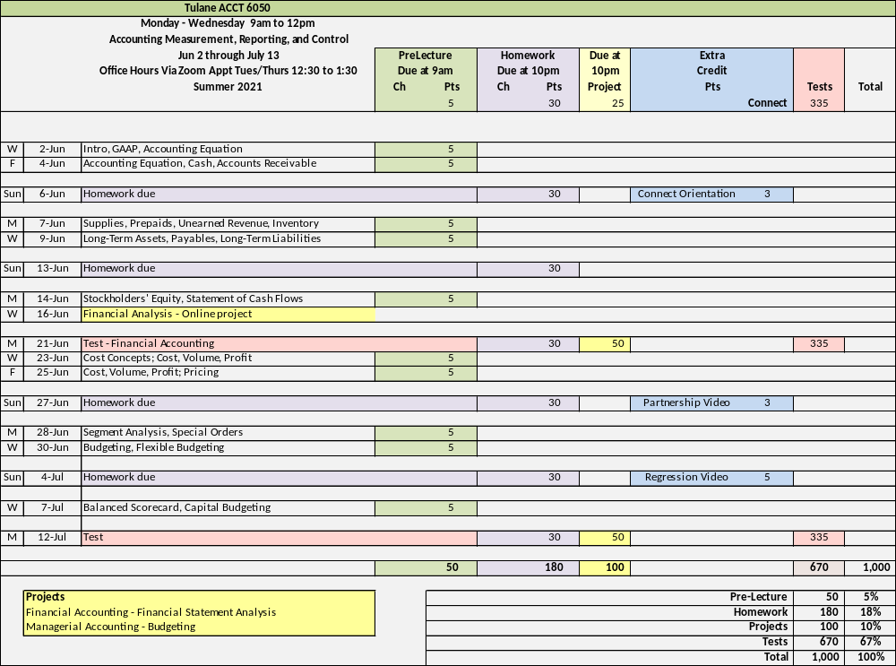

Office Hours Policy:
Via Zoom appointment Tuesday and Thursday 12:30 to 1:30. The office hours link will be posted in Zoom.

Class Communication:
I will use Canvas and email to communicate outside of class. Please check these often to remain abreast of changes. Please follow up any verbal communication with an email. I will be better able to remember our conversation if you send me a follow up email.

Recording of Class Sessions:
All class sessions will be recorded in Zoom, these recordings will be posted to accessible in Canvas. Students are prohibited from posting these recordings or sharing them elsewhere, either wholly or in part.

Specific Course Policies:

Disruptive Behavior:
Disruptive or disrespectful behavior is not allowed in class and will not be tolerated. I define any such behavior. Any instances will require a meeting between us. You must meet with me before you return to class or you will be asked to leave class until we have met. Disruptive behavior will affect your overall grade.

Syllabus Changes:
Circumstances may warrant additions or clarifications to the Syllabus for anything except your grade determination. I reserve the right to make any changes.

Canvas Use and Requirements:
Canvas will host our permalinks to the syllabus, schedule, graded assignments in Connect, and lecture material in NumberKnowledge (Case-sensitive password TUL6050Learn).

Class Attendance Policy:
Faculty and students must comply with University policies on COVID-19 testing and isolation, which are located here https://tulane.edu/covid-19/health-strategies. Faculty and students must wear face coverings in all common areas, including classrooms, and follow social distancing rules. Failure to comply is a violation of the Code of Student Conduct, and students will be subject to University discipline, which can include suspension or permanent dismissal.

If a student cannot attend a class for any reason, the student is responsible for communicating with their instructors to make up any work they may miss. Faculty will provide online options for class participation, outlined in this document, and unless a student is seriously ill, they are expected to use this option. The University Health Center will provide documentation verifying a student is ill, as well as verification that a student may return to class.

With the approval of the Freeman School Associate Dean for Graduate Programs, students may have been approved for Remote/Online instruction for the current semester. Such students will attend all class sessions remotely and are not permitted to attend in person. Course policies and grading will accommodate all students including those approved for Remote/Online learning.

Statement about Academic Integrity:
This class will be conducted in full accordance with Tulane’s policies about academic integrity including, but not limited to, the Unified Code of Graduate Student Academic Conduct (https://academicaffairs.tulane.edu/policies/academic-policies) and the Tulane University Code of Student Conduct (https://conduct.tulane.edu/resources/code-student-conduct).

Any member of the university community may file charges against a student for violations of the code. A charge shall be prepared in writing and directed to Associate Dean John Clarke at jfc@tulane.edu.

Norms and Expectations:
This class will be conducted in full accordance with published Norms and Expectations for Students in Freeman Classes. Please review the Norms and Expectations in your graduate program handbook which can be found on the Freeman School website https://freeman.tulane.edu/current-students.

Goldman Center for Student Accessibility and ADA/Accessibility Statement:
Under the Americans with Disability Act and Section 504 of the Rehabilitation Act, if you have a disability, you may have the right to an accommodation; however, the right is contingent upon your taking certain steps. You should review the steps that you need to take, as well as Tulane’s policy concerning accommodations at https://accessibility.tulane.edu/.

Any student with a disability, in need of course or examination accommodation, should request an accommodation through the University’s Goldman Center for Student Accessibility, located on the first floor of the Science and Engineering Lab Complex. http://accessibility.tulane.edu or 504.862.8433

At the beginning of the semester, please provide me with a copy of your approved accommodation form. I am committed to working with the Goldman Center to ensure that I provide you with all approved accommodations. If you do not deliver the approved accommodation form to me, I will not know that the Goldman Center approved your accommodation and I will have no basis to provide those accommodations.

Religious accommodation policy
Per Tulane’s religious accommodation policy, I will make every reasonable effort to ensure that students can observe religious holidays without jeopardizing their ability to fulfill their academic obligations. Excused absences do not relieve the student from the responsibility for any course work required during the period of absence. Students should notify me within the first two weeks of the semester about their intent to observe any holidays that fall on a class day or on the day of the final exam.

Discrimination and Harassment
Tulane University recognizes the inherent dignity of all individuals and promotes respect for all people. As One Wave, Tulane is committed to providing an environment free of all forms of discrimination and sexual harassment, including sexual assault, domestic and dating violence, and stalking. If you (or someone you know) has experienced or experiences gender-based violence, know that you are not alone. Learn more at https://campushealth.tulane.edu/well/one-wave.

Emergency Preparedness & Response
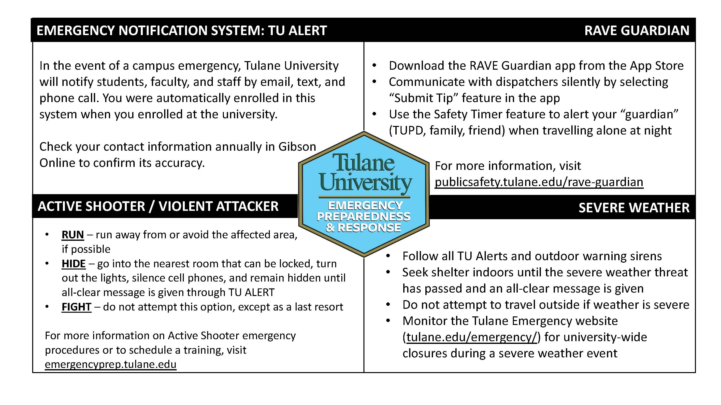
Title IX:
Tulane University recognizes the inherent dignity of all individuals and promotes respect for all people. As such, Tulane is committed to providing an environment free of all forms of discrimination including sexual and gender-based discrimination, harassment, and violence like sexual assault, intimate partner violence, and stalking. If you (or someone you know) has experienced or is experiencing these types of behaviors, know that you are not alone. Resources and support are available: you can learn more at allin.tulane.edu. Any and all of your communications on these matters will be treated as either “Confidential” or “Private” as explained in the chart below.

Please know that if you choose to confide in me, I am mandated by the university to report to the Title IX Coordinator, as Tulane and I want to be sure you are connected with all the support the university can offer. You do not need to respond to outreach from the university if you do not want. You can also make a report yourself, including an anonymous report, through the form at tulane.edu/concerns.

Confidential | Private
Except in extreme circumstances, involving imminent danger to one’s self or others, nothing will be shared without your explicit permission. | Conversations are kept as confidential as possible, but information is shared with key staff members so the University can offer resources and accommodations and take action if necessary, for safety reasons.
Counseling & Psychological Services (CAPS) | (504) 314-2277 or  The Line (24/7) | (504) 264-6074 | Case Management & Victim Support Services | (504) 314-2160 orsrss@tulane.edu
Student Health Center | (504) 865-5255 | Tulane University Police (TUPD) | Uptown - (504) 865-5911. Downtown – (504) 988-5531
Sexual Aggression Peer Hotline and Education (SAPHE) | (504) 654-9543 | Title IX Coordinator | (504) 314-2160 or msmith76@tulane.edu

